Attachment 3
Make-over for Michaelina’s 'Saint Catherine'

On 1 June 2018, the exhibition 'Michaelina' opens in the MAS and the oeuvre of this outstanding artist Michaelina Wautier (1604-1689) is shown together for the first time ever. One of the key works is 'The Mystic Marriage of Saint Catherine'. However, the painting is in rather poor condition, for which a thorough restoration is necessary in order to allow this masterpiece to shine in 2018.

The monumental canvas with 'The Mystic Marriage of Saint Catherine' that Michaelina Wautier painted in 1649 belongs to the collection from the Notre-Dame Seminary in Namur. It received an honorary place there in the dining hall. Thanks to the signature present, the early dating and the original iconography, this masterful work takes on a special position within the oeuvre of Michaelina. The masterpiece can thus also not be missing from the overview exhibition that The Rubens House is organising in the MAS.

The restoration in the KIK
The numerous over-paintings, craqueleurs and lacunae ensure that the painting is, however, in a very bad condition. A restoration treatment is necessary in order to be able to present the work in its full glory. Thanks to the support of the Baillet-Latour Foundation, the monumental painting shall be restored in the coming months in the Royal Institute for Cultural Heritage (KIK/IRPA) in Brussels. And so, 'The Mystic Marriage of Saint Catherine' leaves its fixed place in the Seminary for the first time in years. Starting from 1 June 2018, the result of the restoration shall be able to be admired in the MAS.

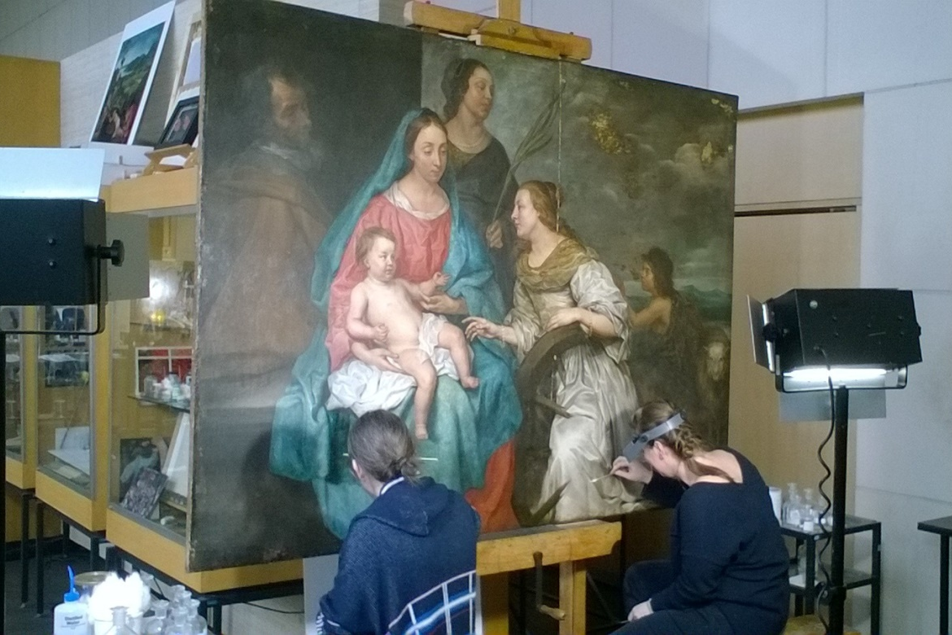

© KIK-IRPA, Brussels

