

Biuro prasowe better. gaming agency
bettergamingagency.prowly.com

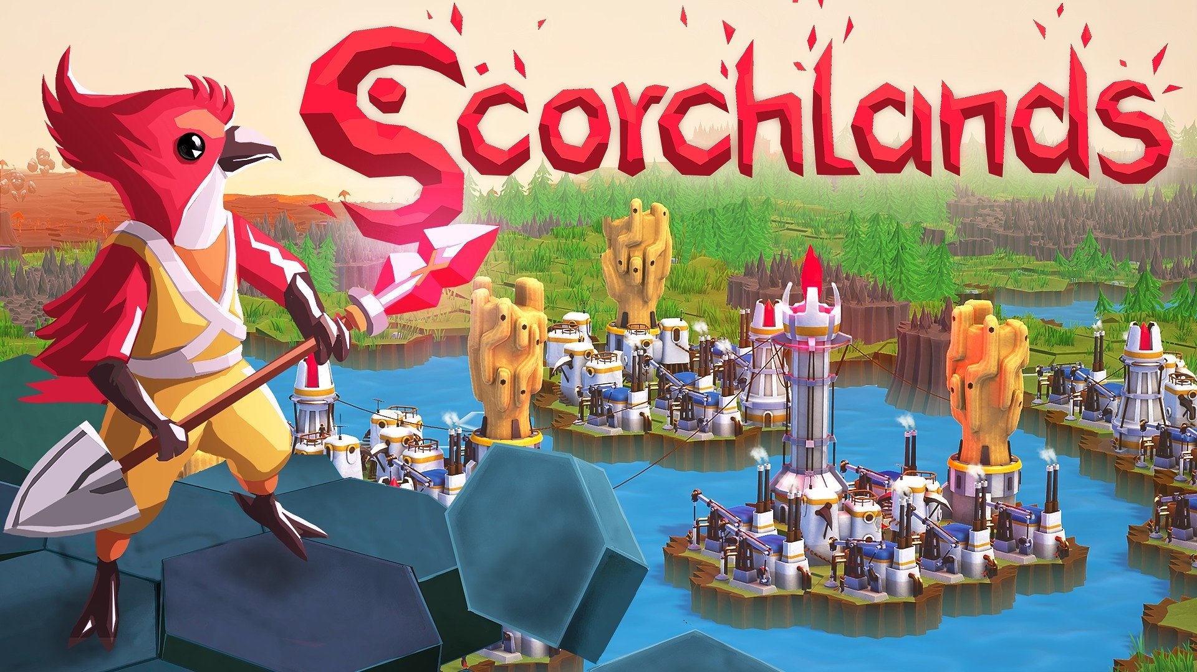

Hidden gem from the moon of Helia. Scorchlands leaves Early Access today

After over a year in Early Access, preparations for the expedition launch have been completed, and the birdfolk of Giwi are ready to reach for the stars. Scorchlands is a passion project created by a solo indie developer, Jakub Rogalski, and published by Star Drifters. The game launched in Early Access in February 2023, was exceptionally well-received and garnered great reviews – 95% positive opinions among Steam users. Release of version 1.0 brings new content prepared with the enthusiasm and support of the community.

Scorchlands is a strategy game where players explore the story of the birdfolk of Giwi, a brave nation that has always dreamt of exploring space. Despite numerous obstacles, these daring birds have finally embarked on a research expedition to the moon of Helia. The Giwi will need to transform the barren surface into meadows, forests, lakes, and vibrant settlements. They will be aided not only by impressive technological achievements, but also by magic. However, they must remember that everything comes at a cost, and with every next step and new settlement built, terraforming will become more challenging and the gameplay more demanding.

Scorchlands – launch trailer

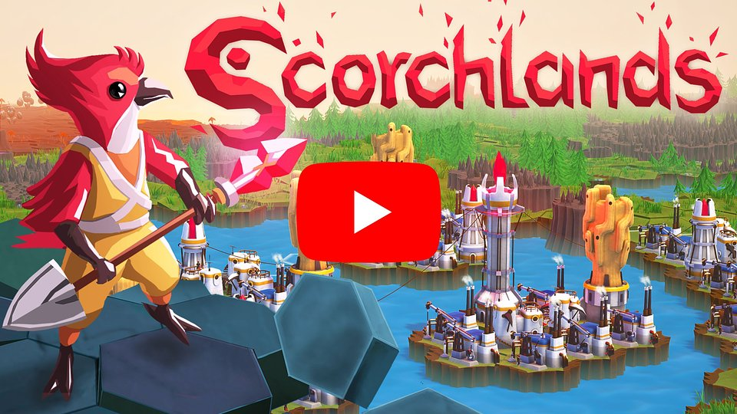
https://www.youtube.com/watch?v=y1ZWLgdJT7s

Scorchlands – what awaits you during the expedition:

🐦 Hex grid-based city-building – construct various buildings in your colonies. Each structure's productivity depends on neighboring resources and other constructions.

🐦 Complex resource management – it’s not only about extracting materials. Scorchlands takes account of logistics – the movement of resources between colonies and combining them in robust processing chains. And yes, we move resources using LASERS!

🐦 Terraforming for the greater good – utilize magic and technology to change the biomes on procedurally generated maps and exploit the new environment to gain its unique resources.

🐦 Technology designed to give fun – there’s no fun in a sandbox, if you don’t have the toys to play with. The technology system in Scorchlands is key for player progression and new discoveries open up new ways to play with the game world.

🐦Minimalistic combat system – when you get into a fight, positioning will be key. Destroy your enemies by surrounding them and placing your forces in optimal locations.

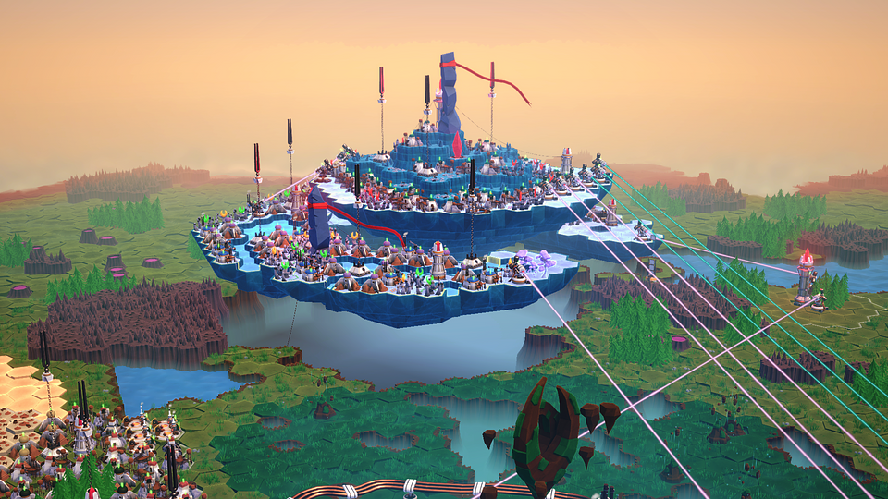

With the release of the full version of Scorchlands, new content will be added to the game, fulfilling all the objectives set after the launch in Early Access. You can find the full list of changes here, with the most important ones including:

● Faster building and structure relocation – colonizing the surface of Helia has gained momentum. Now, all buildings will be constructed much faster, and players will have the ability to relocate structures or exchange them between colonies.

● New models – with the full release, many models have been improved and enhanced, making both the village and its inhabitants look even better.

● Additional languages – the game has received new localizations, bringing the total to 53. This allows players from all around the world to enjoy a comfortable gaming experience.

● Controller support – in Scorchlands, players can use controllers comfortably with the assistance of a special radial menu.

● Achievements – Ringlab has prepared a total of 20 diverse achievements, and completing all of them will be a satisfying challenge.

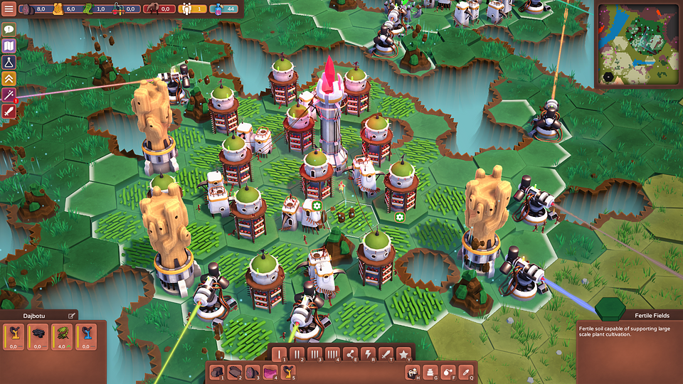

To celebrate the launch of Scorchlands, the game will be available on Steam for just $5.99. Players can take advantage of this 50% discount for two weeks after the release.

The full press kit is available here.

About Ringlab:
Ringlab is an indie gamedev studio based in Łódź, Poland. It was initially started by Jakub Rogalski who also worked on all SUPERHOT titles. Since 2020 the studio focuses on the development of Scorchlands.

About Star Drifters:
Star Drifters is an independent game development studio based in Warsaw, Poland. The company was founded in 2014 by two industry veterans: Michal Sokolski and Krzysztof Jakubowski. During a nearly two-decades-long career, they’ve worked on numerous titles for all major gaming platforms and gained extensive experience in game development and management.
Since 2020, the team has begun incubating selected indie titles and the teams behind them. The scope of support is individually tailored and covers areas from production, design, and positioning through financing to the sale of the final product. Star Drifters’ mission is to create engaging, challenging, and highly replayable games that will remain in players’ memories for a long time.
The studio is known for creating and publishing the real-time 4X strategy game Driftland: The Magic Revival, the rogue-lite game Danger Scavenger, and the top-down shooter with base-building mechanics Lumencraft.



Jakub Smolak
PR Specialist at better. gaming agency
jakub.smolak@bettergaming.pro
Twitter

