Neumann M 49 V: The Return of an Icon

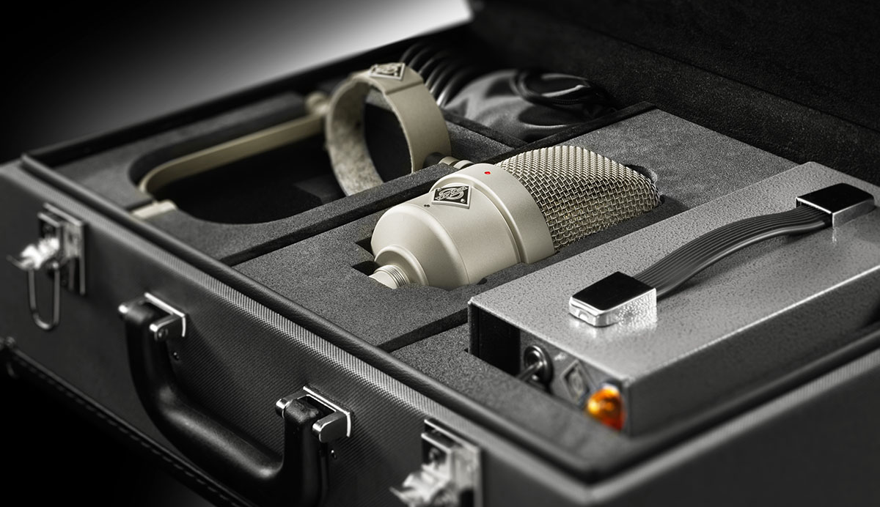

Berlin, August 9, 2022 – Microphone connoisseurs around the world have awaited this news for decades: German studio specialist Neumann.Berlin announces a reissue of the legendary M 49. Ever since its introduction in 1951, the M 49 has been regarded as a studio microphone par excellence. With its continuously remote controlled polar pattern, it revolutionized studio technology and its incomparably silky sound has graced countless recordings, from the cool jazz of the 1950s until today's chart toppers. As a result, the M 49 is in great demand not only among collectors, but also as a vital recording tool: The digital age has made its characterful sound even more desirable.
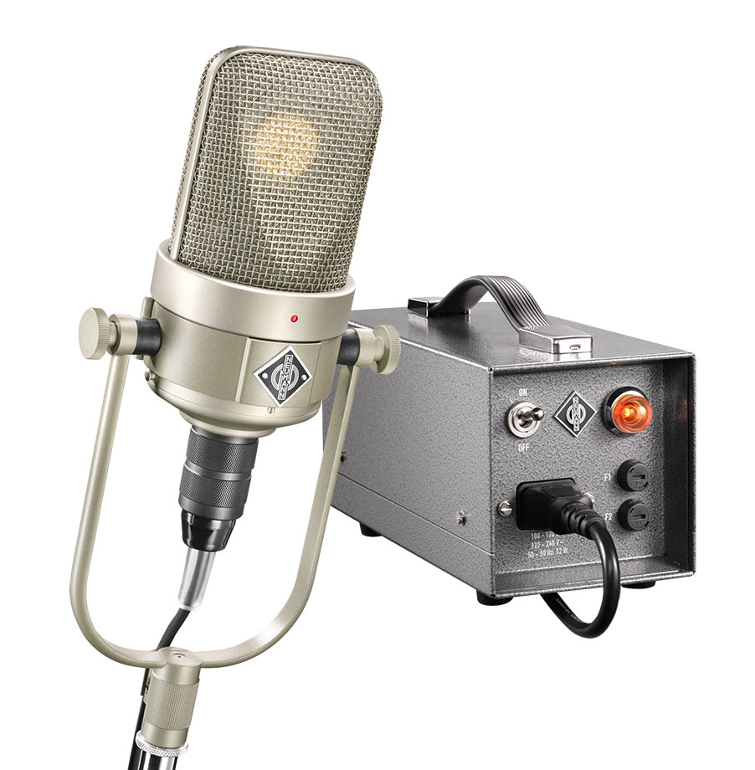
The M 49 V is a reissue according to original specifications and design documents from the Neumann archive. It uses the same circuitry as the last and most popular historical revision, the M 49 c, but with an even lower noise, hand-selected subminiature tube. “In our field tests, even renowned microphone experts could not detect any difference in sound,” explains Portfolio Manager Sebastian Schmitz. “In timbre and dynamic behavior, the M 49 V is identical to a historic M 49 in top condition. The circuitry and acoustic design have been adopted from the M 49 c. And the most important component, the classic K 49 large diaphragm capsule, has been manufactured by Neumann with no changes since the 1950s – what company could claim anything like that?

V for Variabel
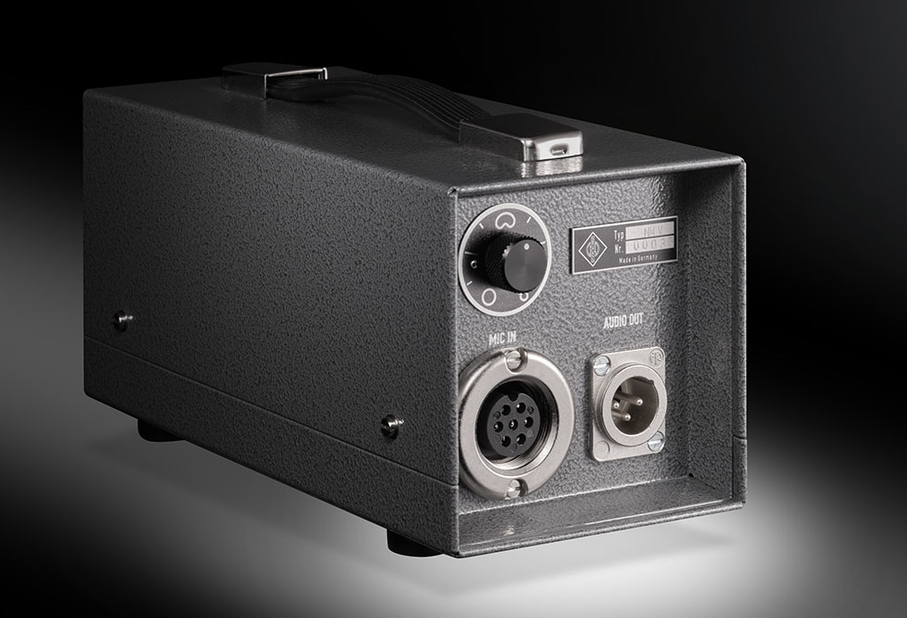
Detail improvements have been made to the pattern control unit, which now automatically adapts to the mains voltage and is also compatible with old M 49 microphones. Instead of the old bayonet connector, the M 49 V uses the RF-tight connector of the historic broadcast version M 249. In addition, the M 49 V can be configured via internal switches, either as a made-to-order option or post-sales by Neumann Service.

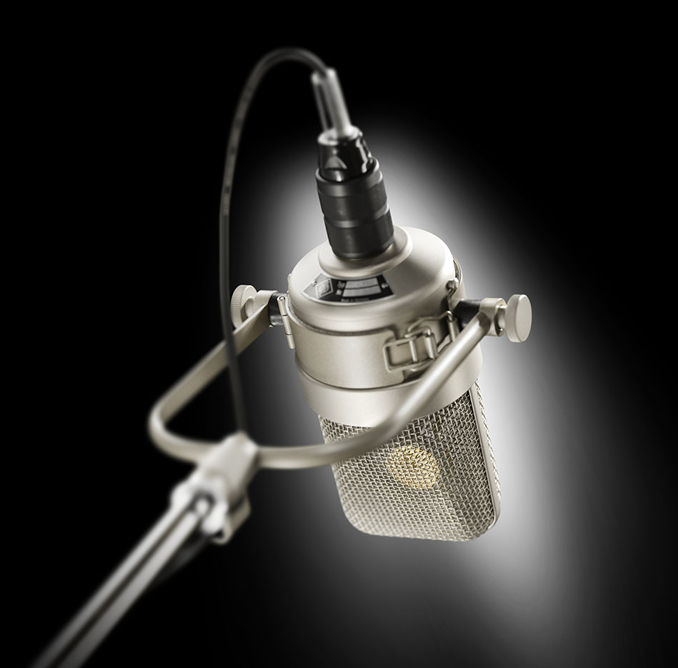
The infrasonic filter, which protects the BV11 output transformer from unwanted distortion, can be lowered from 30 Hz to 12 Hz, resulting in the frequency response of the early M 49 (without suffix) up to 1957. Like the historical M 49 b model variant, the M 49 V can be set to fixed cardioid pickup pattern, which improves the signal-to-noise ratio by about 3 dB. This option is useful if the M 49 V is to be used exclusively in cardioid mode, for example for vocals and speech.

“The M 49 is a very special microphone not only for a large number of our customers, but also for me personally. It is an icon of recording technology and is inextricably linked to some of the most extraordinary voices and instrumentalists of the last 70 years. Its physical presence alone, and even more so its incomparable sound, lend that magic and authority for which the Neumann name has become synonymous,” explains Ralf Oehl, CEO of Georg Neumann GmbH. “That gleam in the eyes of our mostly Grammy-awarded testers, after they sang or played into a new M 49 V for the first time, cannot be put into words. But it touched me incredibly every time. That’s exactly what we work for so passionately.” Regarding availability, Ralf Oehl states: “Less than 48 hours after the official sales launch, we already have more than 200 orders. That’s overwhelming. Especially when you consider that we can only hand manufacture about 25 pieces per month with three specially trained employees. We must therefore hope for your patience. I promise ... it will be worth the wait!”

The M 49 V comes as a set with remote pattern control unit, microphone cable, and the classic "yoke" swivel mount, delivered in a high-quality, handcrafted case. The list price is 8,495 € / 8,499 $. Available in August 2022. More information at https://m49v.neumann.com
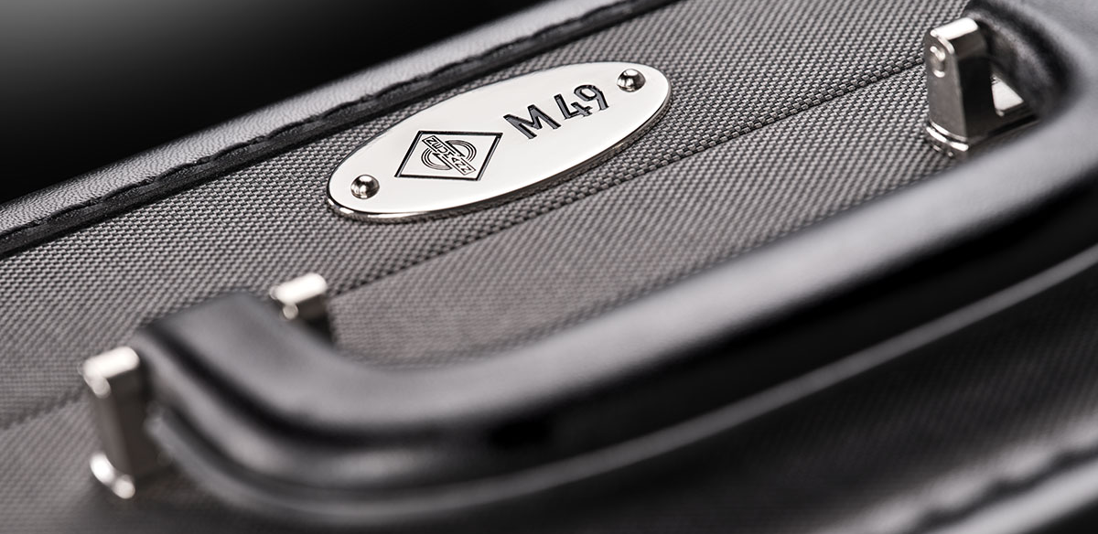
- Superb vocal microphone for male and female voices
- Versatile microphone for all types of instruments
- Classic tube circuit with output transformer
- Continuously variable polar pattern, remote controlled
- Made to original specifications using archived documentation
- New pattern control unit (compatible to historic M 49 microphones) automatically adapts to mains voltage
- Handmade and hand soldered in Germany
- Handmade vintage case manufactured in Germany

About Neumann
Georg Neumann GmbH, known as “Neumann.Berlin”, is one of the world’s leading manufacturers of studio-grade audio equipment and the creator of recording microphone legends such as the U 47, M 49, U 67 and U 87. Founded in 1928, the company has been recognized with numerous international awards for its technological innovations. Since 2010, Neumann.Berlin has expanded its expertise in electro-acoustic transducer design to also include the studio monitor market, mainly targeting TV and radio broadcasting, recording, and audio production. The first Neumann studio headphones were introduced in 2019, and since 2022, the company has put an increased focus on reference solutions for live audio. Georg Neumann GmbH has been part of the Sennheiser Group since 1991, and is represented worldwide by the Sennheiser network of subsidiaries and long-standing trading partners.

Press Contact Neumann:
Andreas Sablotny
andreas.sablotny@neumann.com
T +49 (030) 417724-19

