

Biuro prasowe better. gaming agency
bettergamingagency.prowly.com

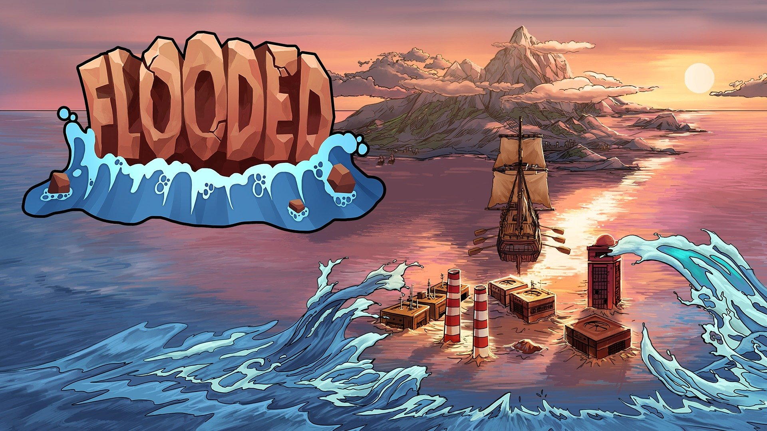

Attention, gaming alert: Today Flooded will swamp Nintendo Switch!

In April Flooded sank tons of PCs, but since then, the wave has only grown larger. The game from Artificial Disasters studio is now swamping another significant part of the gaming world. The title is already available on Nintendo Switch, ready to challenge a new group of players.

Artificial Disasters together with Forever Entertainment and Storm Trident took the well-known formula and turned it upside down to create a unique experience. Flooded is not a typical city-builder in which you calmly and peacefully watch the growth of your city. In this game every second and minute has a significant impact on your situation. The flood is unstoppable, and the world you once knew is sinking in front of your eyes. Are you capable of protecting your people?

Flooded will test your ability to quickly make correct decisions. You start on a small, but rich in various resources island. Iron, copper, lead - all these raw materials will help you build a provisional city. You also need to take care of water and electricity which is necessary to develop new technologies. Your goal is to build an ark that can save a group of survivors. And once you find a new island - even more challenges await.

Flooded - trailer (Nintendo Switch)

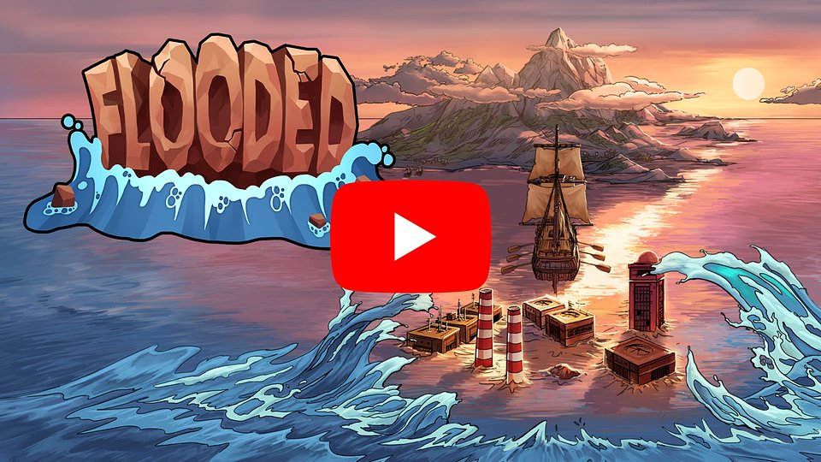
https://youtu.be/W8YK0wexaPA

Gameplay is designed to keep players focused and busy, as the island is getting smaller with every phase of the game, called era. You are running out of time, so you must think in advance about your next steps. Get more workers and build mines, power plants, or drilling platforms, which will help you control your internal economy. As you complete mission goals, you will grant yourself access to more advanced structures, but be sure to keep your defense systems in good shape - ruthless pirates are waiting for any chance to strike.

During the single-player campaign, players will get to know the story hidden behind the mysterious cataclysm. Moreover, this is not the only available mode in Flooded. Quick Game allows you to customize the game conditions using various factors and parameters. This way, you can tailor the experience to match your skills and abilities, taking on challenges that are both exciting and manageable. With the Endless mode, players can challenge themselves on an island which periodically recovers a piece of land previously taken by the water.

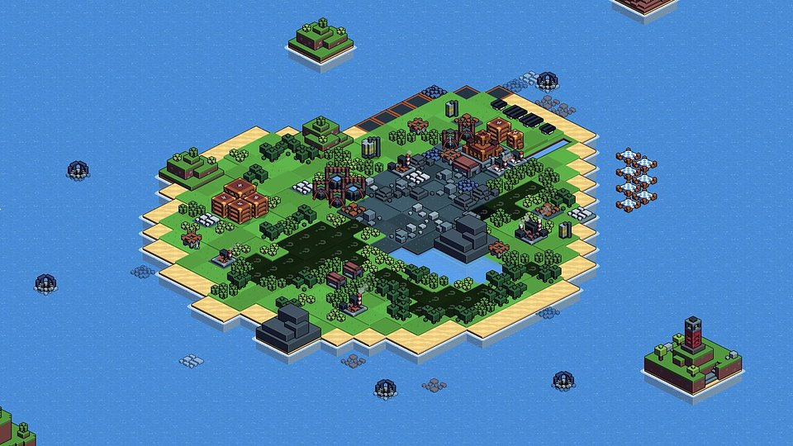

Flooded - key features:

🌊 Run for your lives! – controls have been fully adapted for Nintendo Switch, so the apocalypse is just as enjoyable, no matter where you hide from the wave

🌊 Redefinition of a city-builder – Flooded is a reversed city-builder; we don’t mean turning back time (although some decisions would probably require such ability), but a decreasing island that shrinks with every tide.

🌊 Find something for yourself – There are three game modes: story-driven Campaign, customized challenge in Quick Play or the Endless in which you try to survive for as long as possible. Thanks to procedurally-generated lands, there will be no identical playthroughs!

🌊 Play on your own – It’s possible thanks to a variety of commanders with passive skills and starting bonuses, but also because of various relics that enrich the gameplay. Players will be able to create their own combinations and individual strategies.

🌊 Land on the horizon! – While traveling across the ocean, players can discover one of the six biomes that differ in weather conditions as well as mechanics that significantly affect the gameplay and selected strategy.

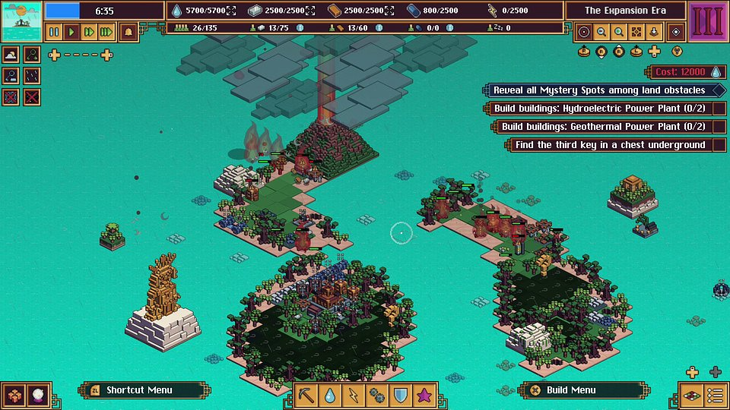

Flooded is now available on Nintendo Switch (EU),(NA), and until November 30th the game can be purchased with a 15% launch discount. Owners of select games from Forever Entertainment can enjoy a special 50% Owner Discount. Anyone interested can find a demo in the Nintendo eShop. Flooded is also available on PC through Steam and GOG.

If you want to learn more about the game, follow its profiles on Twitter andFacebook.A full press kit is available here.

About Artificial Disasters:Artificial Disasters is a single-developer studio founded by Tymoteusz Piasek. His portfolio is full of small projects, born during different game jams and events. Tymoteusz fell in love with video games while playing titles like „Claw”, ”Gothic 2" or "Icewind Dale". For sure, Flooded is not his last strike in the game industry.



Jakub Smolak
PR Specialist at better. gaming agency
jakub.smolak@bettergaming.pro
Twitter

