YO LA TENGO ANNOUNCES NEW ALBUM
THERE’S A RIOT GOING ON

FIRST ORIGINAL FULL-LENGTH SINCE 2013
OUT MARCH 16 ON MATADOR RECORDS

FOUR NEW SONGS OUT NOW – ‘YOU ARE HERE’, ‘SHADES OF BLUE’, ‘SHE MAY, SHE MIGHT’, AND ‘OUT OF THE POOL’, LISTEN HERE

SPRING 2018 UK TOUR DATES

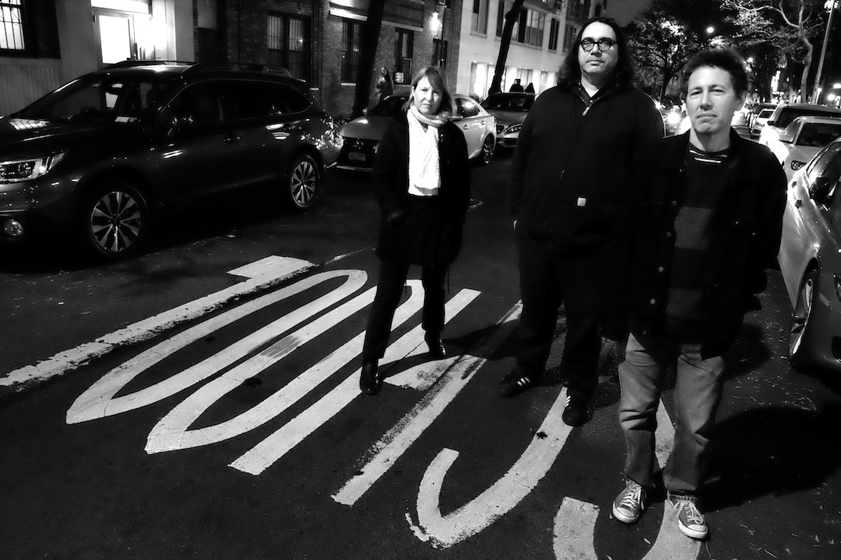
(credit: GODLIS, hi-res)

Yo La Tengo’s new album There’s a Riot Going On will be released on March 16th on Matador Records and can be pre-ordered HERE. This is a warm, ambitious record, a striking self-produced creation from one of the most celebrated and adventurous bands in rock history, whose dynamic range touches on pure noise and serene beauty and everything in between.

To showcase the full depth of this fearless fifteen-track album, Yo La Tengo have released four new songs today (‘You Are Here’, ‘Shades of Blue’, ‘She May, She Might’, and ‘Out of the Pool’), which can be heard HERE.

Following their sold-out eight night run of Hanukkah shows in NYC this past December, Yo La Tengo commence their world tour on March 28th in the US. They continue to UK and European dates through April and May, including a date at London’s Royal Festival Hall on May 4th. A full list of upcoming shows can be found below Luc Santé’s bio.

###

There's a riot going on. You don't need me, or Yo La Tengo, to tell you that. These are dark times, in our heads as much as in the streets. It's easy to lose contact with the ground, flying through endless banks of storm clouds day after day. Confusion and anxiety intrude into daily life and cause you to lose your compass. There are times that call for anthems, something to lift you out of your slump and put fire in your feet. And then there are times when what is indicated is a balm, a sound that will wrap around you and work out the knots in your neck.

While there's a riot going on, Yo La Tengo will remind you what it's like to dream. The sound burbles and washes and flows and billows. If records were dedicated to the cardinal elements, this one would be water. There are shimmery hazes, spectral rumbles, a flash of backward masking, ghostly flamingos calling "shoo-bop shoo-bop." You are there. And even if your mind is not unclouded--shaken, misdirected, out of words and out of time--you can still float, ride the waves of an ocean deeper than your worries, above the sound and above the Sound.

For Yo La Tengo this is a slow-motion action painting, and Georgia Hubley, Ira Kaplan and James McNew did it all themselves, in their rehearsal studio, with no outside engineer (John McEntire later did the mix). They did not rehearse or jam together beforehand; they turned on the recorder and let things coalesce. Songs came together over long stretches, sometimes as much as a year going by between parts. You'd never guess this, since the layers are finessed with such a liquid brush. You'd imagine most of the songs had sprung forth whole, since they will enter your head that way. Within two listens you will be powerless to resist the magnetic draw of "Shades of Blue," will involuntarily hear "She May, She Might" on your internal jukebox first thing in the morning and "Let's Do It Wrong" late at night. While there's a riot going on you will feel capable of bobbing through like a cork.

In 1971, when the nation appeared to be on the brink of violently coming apart, Sly and the Family Stone released There's a Riot Goin’ On, an album of dark, brooding energy. Now, under similar circumstances, Yo La Tengo have issued a record with the same name but with a different force, an album that proposes an alternative to anger and despair. Their first proper full-length since 2013’s Fade, There's a Riot Going On is an expression of freedom and sanity and emotional expansion, a declaration of common humanity as liberating as it is soft-spoken.

-Luc Sante, December 2017

(hi-res)

Tracklisting:
1. You Are Here
2. Shades of Blue
3. She May, She Might
4. For You Too
5. Ashes
6. Polynesia #1
7. Dream Dream Away
8. Shortwave
9. Above the Sound
10. Let’s Do It Wrong
11. What Chance Have I Got
12. Esportes Casual
13. Forever
14. Out of the Pool
15. Here You Are

Tour Dates:
28.3 - Minneapolis, MN - First Avenue
29.3 - Chicago, IL - Thalia Hall
30.3 - Chicago, IL - Thalia Hall
31.3 - Toronto, ON - Phoenix
02.4 - Burlington, VT - Higher Ground
03.4 - Boston, MA - Paradise
04.4 - Washington, DC - 9:30 Club
06.4 - Brooklyn, NY - Brooklyn Steel
07.4 - Philadelphia, PA - Union Transfer
08.4 - Charlottesville, VA - Jefferson
10.4 - Carrboro, NC - Cat’s Cradle
11.4 - Carrboro, NC - Cat’s Cradle
12.4 - Atlanta, GA - Terminal West
13.4 - Nashville, TN - Basement East
14.4 - Nashville, TN - Basement East
28.4 - Dublin, IE - Olympia
29.4 - Glasgow, UK - SWG3
30.4 - Manchester, UK - Academy
01.5 - Birmingham, UK - Town Hall
03.5 - Leeds, UK - Church Leeds
04.5 - London, UK - Royal Festival Hall
06.5 - Amsterdam, NL - Paradiso
07.5 - Berlin, DE - Heimathafen
08.5 - Cologne, DE - Gloria Theatre
09.5 - Munich, DE - Muncher Kammerspiele
11.5 - Zagreb, HR - Pogon Jedinstvo
12.5 - Belgrade, RS - Dom Omladine
13.5 - Budapest, HU - A38 Ship
15.5 - Milan, IT - Fabrique
16.5 - Fribourg, CH - Fri-Son
17.5 - Schorndorf, DE- Manufaktur
19.5 - Paris, FR - Le Caberet Sauvage
20.5 - Brussels, BE - Ancienne Belgique
31.5 - Seattle, WA - Neptune Theater
01.6 - Seattle, WA - Neptune Theater
02.6 - Portland, OR - Wonder Ballroom
03.6 - Portland, OR - Wonder Ballroom
05.6 - San Francisco, CA - Fillmore Theater
06.6 - San Francisco, CA - Fillmore Theater
08.6 - Los Angeles, CA - Teragram Ballroom
09.6 - Los Angeles, CA - Teragram Ballroom

YO LA TENGO
Website / Facebook / Twitter / Instagram / Store

Press Contact: Noam Klar – noam@matadorrecords.com
Matador Records, 17-19 Alma Road, London, SW18 1AA

