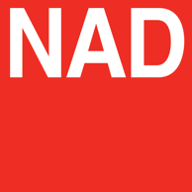

NAD Announces New Custom Install Amp Update featuring new Firmware & Chassis Drivers
Offering custom installers an improved user interface and additional features allowing for greater control and efficiency

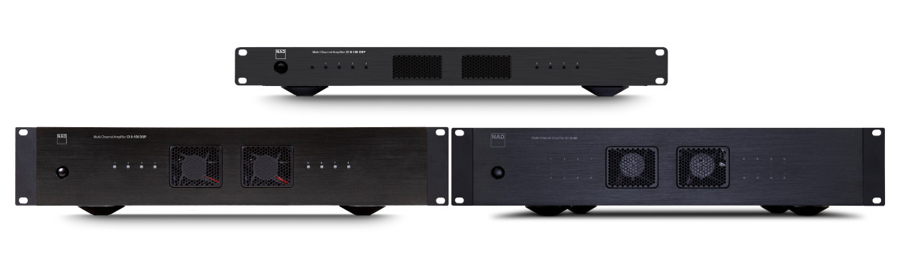
NAD Electronics CI 8-120 DSP, CI 8-150 DSP & CI 16-60 DSP

ISE 2022, BARCELONA, SPAIN MAY 5, 2022 – NAD Electronics, the highly regarded manufacturer of high-performance audio/video components, extends its value and performance offering for the versatile NAD CI 8-120 DSP, CI 8-150 DSP and CI 16-60 DSP distribution amplifiers through new firmware updates.

With immediate effect, the latest firmware updates bring new features and functions to NAD's high-performance rack-mounted multi-channel amplifiers including mute, flexible signal routing, and improved on- and off- site calibration and service delivery. The corresponding chassis driver updates create additional configuration options for major smart home control systems including Crestron, Control4, ELAN, RTI and URC. All updates and drivers are available for download from NADelectronics.com.

Below is a summary of improvements and additions introduced in this firmware release:
- Improved functionality of input/output gain knobs
- Added “Power Status/Mute Status/Output Gain” status command for IP codes
- Improved volume range in Test Signal
- Improved “Load pre-set” functionality
- Added “Mute” function for every Output Channel
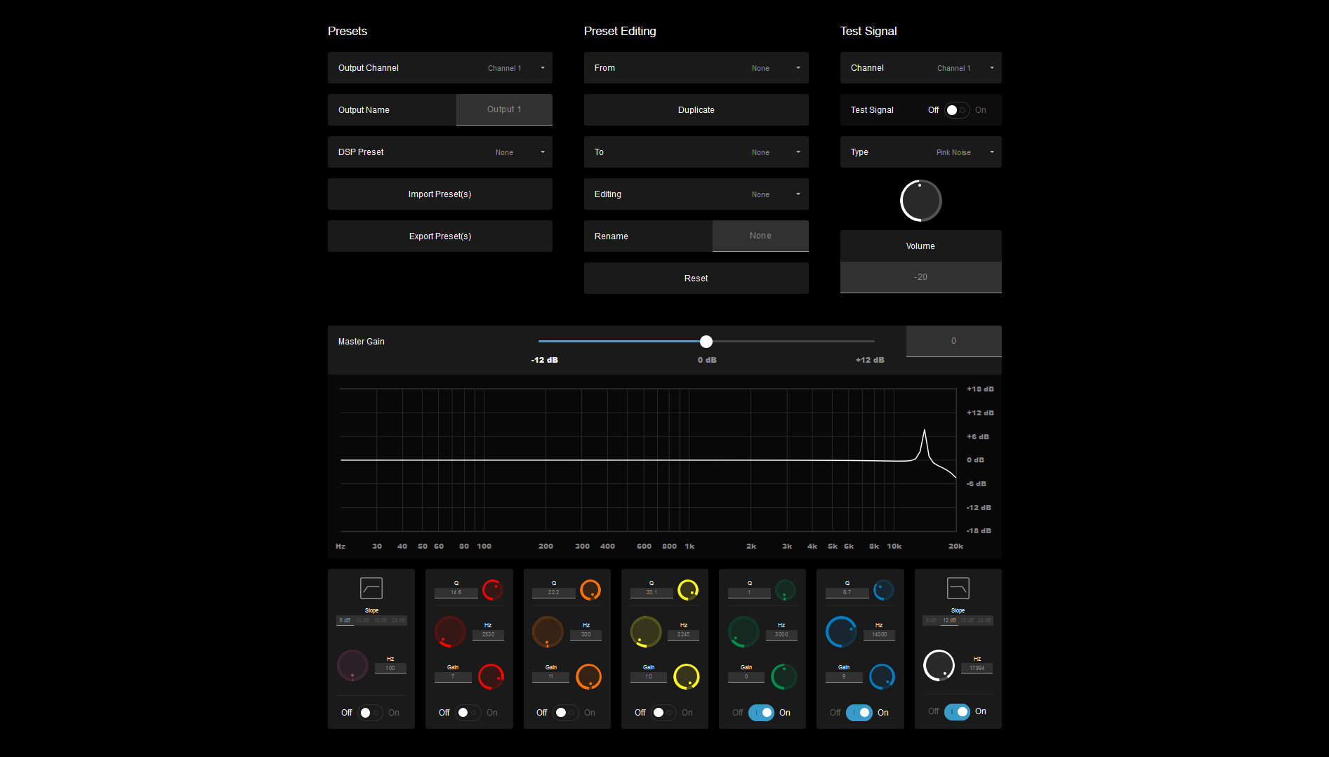
Web browser Screenshot

Greater Control & Flexibility
Chassis drivers for the major smart home control systems, including Crestron, Control4, Elan, RTI, and URC, allow for the control of basic amplifier functions via IP control. Features such the ability to mute any channel, flexible signal routing by changing any input to any output, and improved functionality of zone pre-set and calibration control extend the flexibility and value of these DSP multi-channel amplifiers.

The slick interface allows custom installers quick fine-tuning control over individual zone calibration using the 5-band parametric EQ to improve the sound quality for various applications such as, Hi-Fi music listening, low level background music or home theatre, and saving each zone's calibration attributes to pre-sets that are easily called up by the chassis driver.

According to Joe de Jesus, NAD’s Custom Install Product Manager, “we continually look to provide outstanding products that push boundaries on performance and value. The new firmware updates and chassis drivers offer custom integrators more control of the legendary amplification technologies and are only the first in a series of improvements, as the platform evolves within NAD's rack-mounted amplifier solutions.”

Powerful & Reliable Performers
NAD's DSP distribution amplifiers combine smart CI solutions with legendary NAD performance. The three NAD CI distribution amps deliver flexibility, reliability, and installer-friendly features.

Using NAD's custom web app the installer can manage DSP calibration and IP control. Once the unit is connected to the network, the amp can be set up, configured, calibrated, reboot, factory reset, custom settings restored, and firmware updated making both on and off-site service highly efficient.
The workhorse of NAD's CI multi-channel distribution amps is the CI 8-120 DSP. Designed to contend with the demands of a wide range of integration applications, it retains the same sonic characteristics found in NAD's traditional Classic Series products. Delivering a conservative 8 x 120 watts per channel at 8 ohms, with any consecutive channel pair bridgeable to 200 watts. A parametric EQ allows the installer the ability to fine tune each channel to the characteristics of the zone. The CI 8-120 DSP delivers power and control with rock-solid reliability in a 1U rack space. Latest firmware version for this amp is “V2.26”.

The CI 8-150 DSP is designed to deliver uncompromised audio performance within the custom environment. With nCore amplification, the CI 8-150 DSP shares the same pedigree as some of NAD's prestigious Masters Series amplifiers. What makes this amplifier unique is its ability to deliver a conservative 8 x 150 watts per channel at 8 ohms (280 watts per channel when bridged) with a level of detail and refinement unmatched by any distribution amplifier on the market today. Latest firmware version for this amp is “V2.15”.
The CI 16-60 DSP amplifier offers NAD’s world-renowned sonic performance at an unrivalled price per zone. Delivering a conservative 16 x 60 watts per channel at 8 ohms or bridgeable to 140 watts per channel, the CI 16-60 DSP offers the necessary flexibility to handle most scenarios while remaining on budget. Latest firmware version for this amp is “V2.05”.

About NAD Electronics
Founded in 1972 and now sold in over 80 countries, NAD Electronics is renowned for its
award-winning line of high-quality components for audio, home theatre and custom
installation applications. Since the beginning, NAD’s commitment to four core values –
innovation, innovation, simplicity, performance, and value – have earned it a cult-like
following that catapulted it to becoming a household name amongst audiophiles and
music lovers alike. To this day, the brand continues to design and manufacture some of
the most acclaimed and affordable hi-fi components that include modern features and
technologies meant to appeal to a new generation of audiophiles.

contacts

Corporate Contact
June Ip
Marketing, NAD Electronics
media@nadelectronics.com

Corporate Contact
Jeff Touzeau (OLEX Communications – US/Canada)
Phone: 914-602-2913
E-mail: jeff@olexcommunications.us

Steve Dalton (OLEX Communications - UK)
Phone: +44 (0) 7748-117-864
E-mail: steve@olexcommunications.co.uk

Links
Website: https://nadelectronics.com
Images: https://brandlibrary.lenbrook.com/portals/nadelectronics
Facebook: https://www.facebook.com/nadelectronics
Twitter: https://twitter.com/NADElectronics
Instagram: https://www.instagram.com/nadelectronics/

# # #

