Pilar Zaragozá reaffirms her international projection as an AIPP finalist
The spanish hairdresser is eligible for the Best Men category with her collection ALÚMINA. This is a major achievement since it is the first time that she has participated in these awards, which are the most important in the world.

Pilar Zaragozá, director of the Eos|Men and Eos|Women salons, and Leticia Martínez are the creators of this collection, Alúmina, which was already chosen as a finalist in the International Visionary Awards. However, it is not only admirable that they managed to be finalists in the awards given by the International Association of Professional Press on the first occasion they participated, it is also worth doing it in a complicated year in which Zaragozá has bet on her entrepreneurship too. The hairdresser not only stands out for her creative talent, but she is also a successful businesswoman and her salons are a benchmark in Valencia (Spain). In addition, at this very unusual moment she has decided to continue working on her projects, recently opening her third salon, specialized in female hairdressing, which shows that she has plenty of passion for her job.
The finalist collection is inspired by alumina, an oxide present in nature that gives resistance to some precious stones, hence her work reveals the powerful force that emerges from pureness. In her own words: “This year has been very different from what we thought it would be, but I have shown that with desire and positive energy, you can achieve anything. Despite the complicated situation we are experiencing, I have committed myself to the growth of my brand, opening a new salon, this time a female salon. Also, I have created a collection along with Leticia Martínez, who is making our work travel around the world. Success is where you least expect it, that has been my prize. "

About:
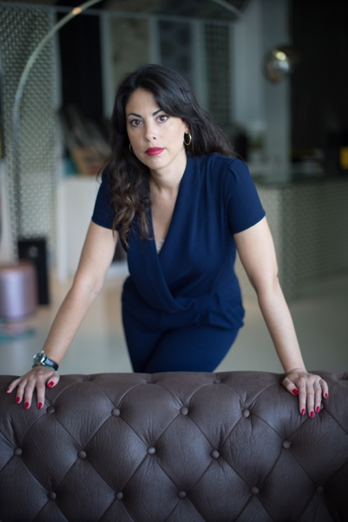
Pilar Zaragozá has been attracted to hairdressing since childhood and from her desire and her constant search for excellence, she has managed to make of her passion her profession.
She started in the profession with great enthusiasm and from below, in a barbershop, and thus she knows it completely and from within. Without mentors or acquaintances, but with a lot of motivation to progress, she has been continuously training, not only in hairdressing but also in male aesthetics and business management. To make this life project come true, she has spared no effort in offering excellence and a careful and personal vision of the male image.
During her professional career, she has taken on different challenges that have proven that, in addition to being an excellent hairdresser, she is extraordinary at directing businesses and managing teams. Hence, she currently runs three salons, two for men, with male aesthetics, Eos | Men, and one for women, Eos | Women, which she recently opened. Based on her constant training as a driver of excellence, she has also created her own method of masculine haircut, design and branding. This new methodology and evolutionary technique have managed to introduce her and her entire team to the forefront of male aesthetics. In addition, she also has a more artistic side. She has designed and made collections that have achieved international renown.

Awards and nominations:
- Finalist International Visionary Awards 2020, men’s category
- Finalist AIPP Awards 2020/2021 Best Men category

