About Ivo Burum

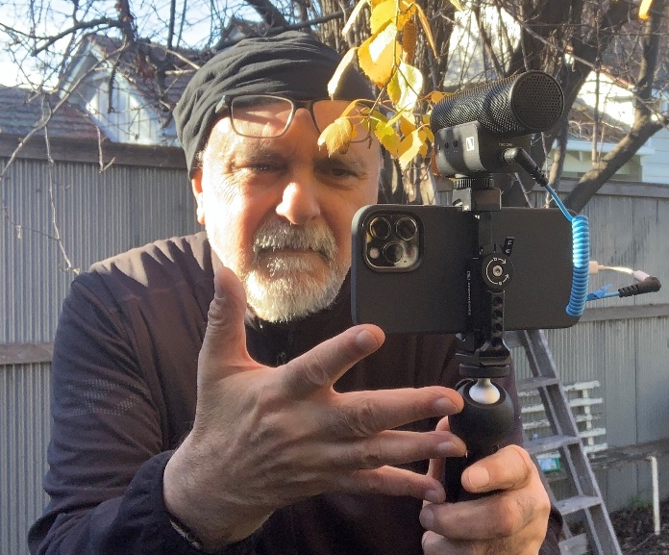 | Dr Ivo Burum

Ivo Burum is a journalist and award-winning television executive producer. A writer, director and producer of documentary and self-shot content series, he has worked across genres including international frontline current affairs for more than 30 years. A mobile journalism pioneer, his company Burum Media provides mojo training in remote communities and to many of the world’s largest media groups. Dr Burum has written five books on mobile journalism. His latest, The Mojo Handbook: Theory to Praxis, published with Focal/Routledge, has just been chosen as one of 12 must-read books for investigative journalists in 2021. Ivo lectures in mobile and digital storytelling and in television production and is discipline convener of Media Industries at Latrobe University, Australia. Twitter: @citizenmojo

All image links:
Mojo Guide – Chapter 1 and About: https://sennheiser-brandzone.com/c/181/fiR3nvNKu1CYxoz
Mojo Guide – Chapter 2: https://sennheiser-brandzone.com/c/181/HkafFWzPMH4XhgX
Mojo Guide – Chapter 3: https://sennheiser-brandzone.com/c/181/fnq9uVsY46xuYJK
Mojo Guide – Chapter 4: https://sennheiser-brandzone.com/c/181/d7EEU8VkHTXbHMX
Mojo Guide – Chapter 5: https://sennheiser-brandzone.com/c/181/rPt89y8PdgAfpXQ
Mojo Guide – Chapter 6: https://sennheiser-brandzone.com/c/181/YJrtD1E6R3TVabZ
Mojo Guide – Chapter 7: https://sennheiser-brandzone.com/c/181/PQawpfAzhK9EZPg

