The Goethe-Institut Mexiko overcomes the challenges of distance language learning with Sennheiser
Mexico City, July 27, 2022 - The Goethe-Institut, the institution that represents German culture around the world, has chosen Sennheiser, the first choice for advanced audio technology that makes collaboration and learning easier, to ensure high-quality audio during in-person and hybrid meetings at its location in Mexico City. The Goethe-Institut has been present in Mexico City for more than 50 years and has become a point of interaction between the German and Mexican cultures. With Sennheiser’s TeamConnect Ceiling 2 (TCC2) beamforming microphone, the Goethe-Institut continues to foster cooperation between the nations in which it is present and the Federal Republic of Germany by promoting knowledge of the German language, educational and cultural activities.
The arrival of the COVID-19 pandemic meant a change in the day-to-day activities of companies, businesses and educational institutions around the world. While for some it represented great losses and difficulties, for institutions such as the Goethe-Institut, it inspired them to offer new solutions - which are still available today - to more than 1,200 students, such as high-quality distance learning technology. Before the pandemic, the institute had begun to develop online classes, and the early start-up of these classes allowed them to foresee the difficulties involved and to resolve them in time when the lockdown in Mexico caused the total closure of their facilities.
This challenge was faced with the support of Sennheiser and Gilsama, representative and integrator of the brand in Mexico City. In collaboration, TCC2 microphones were installed in seven classrooms of the institute, allowing teachers to continue to provide classes in a hybrid format from the classrooms of the Goethe-Institut Mexiko with the assurance of being heard by their students clearly, regardless of their location in the room.
"Traditional teaching must be very clear, but language teaching, and especially a language like German, must be even clearer and more understandable." mentioned Noé Isaac Becerril Vega, Technology and Website Manager at the Goethe-Institut Mexiko. "That's why we needed tools that would allow us to make the teaching and experience as good as possible for our students."
With Noé Becerril's leadership, the Goethe-Institut Mexiko acquired all the solutions to make distance learning easier and later become hybrid. From high-definition cameras and automation technology for each classroom, audio remained one of the most important parts of the equation.
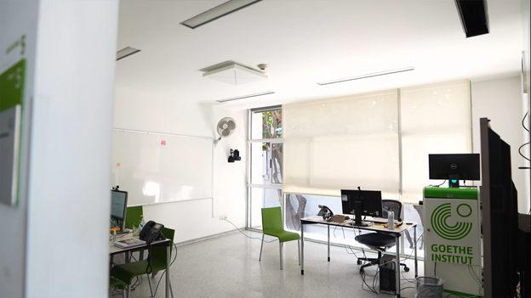
One of the seven TeamConnect Ceiling 2 microphones installed at the Goethe-Institut Mexiko

The TCC2 's 28 capsules, which automatically detect the speaker's position, allow them to talk and move freely without compromising the audio - an important benefit to provide more freedom and dynamism to remote or hybrid education spaces, such as those offered by the Goethe-Institut Mexiko.
"Another great feature of the product is that you can block some areas to avoid the natural echoes of the spaces. That is a very interesting attribute that improves the experience of our students," said Noé Becerril, referring to the advantages of the product. “The TeamConnect Ceiling 2 ​ microphone features TruVoicelift that enhances the voice and reduce noise, this significantly increases the volume of the voice without distorting it.”
Although the TCC2 came to revolutionize the way hybrid classes were conducted, the Goethe-Institut Mexiko was no stranger to the benefits of Sennheiser products. The Institute is also equipped with 160 Tourguide 2020-D headsets, two Digital Transmitters and a Mobile Transmitter that they use as a simultaneous translation system. This intuitive system requires no special technical knowledge, Tourguide 2020-D is the right solution for guided tours, conferences, assisted listening or simultaneous translation, and synchronizes quickly and easily at the touch of a button.
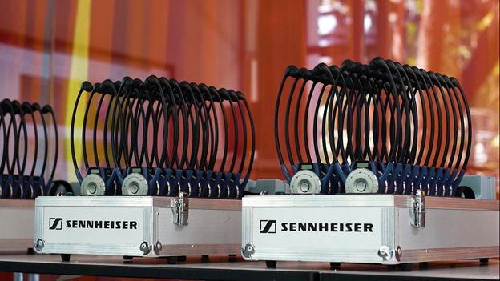
The Goethe-Institut Mexiko has been working with Sennheiser for several years now, relying on 160 TourGuide 2020-D headsets.

The Goeth-Institut Mexiko controls all its audio technology solutions with the free Sennheiser Control Cockpit, the master coordination software for multiple Sennheiser devices, allowing digitizing AV management flows.
Thanks to the initiative of the Goethe- Institut Mexiko and the support of Sennheiser and Gilsama, students will be able to break the language barrier, enriching their experience and education in-person and online.
Watch this video to learn how the Goethe-Institut Mexiko solved the challenge of quickly setting up remote teaching solutions for all language students who were no longer able to attend classes face-to-face due to the outbreak of the COVID-19 pandemic.

Learn all about Goethe-Institut in Mexico City here.
Learn all about the Sennheiser Team Connect Ceiling 2 here.

