
DECT NR+ selvennettynä
Miksi tämä OFDM-teknologia on parempi kuin kaikki aiemmat DECT-versiot ja samalla vahva lupaus ammattiaudiolle

Vaikka DECT NR+ -siirtoteknologia on vasta alkuvaiheissaan, se on jo herättänyt laajaa huomiota alalla. Audioasiantuntijat uskovat, että tämä on se lupaukset lunastava teknologia, joita 5G antoi ammattiaudiosovellusten suhteen. Tässä haastattelussa palaamme DECT NR+:n juurille ja tarkastelemme sen nykytilaa, etuja aiempiin DECT-versioihin nähden, alan tämänhetkisiä toimijoita, rahoituksen merkitystä sekä sitä, miten yritykset, yliopistot ja asiantuntijat voivat osallistua ja kehittää teknologiaa yhdessä. Sennheiserin Dr. Andreas Wilzeck (taajuuspolitiikan ja standardoinnin johtaja), Mareike Zocher (rahoituspäällikkö), Anton Xaver Witting (vanhempi projektipäällikkö) ja Jérôme Zastrow (vanhempi digitaalisen liiketoimintamallinnuksen päällikkö) perehdyttävät meidät DECT NR+:n maailmaan.
Lisää alla englanniksi.
Let’s go back to the beginning – who invented DECT NR+?
Andreas Wilzeck: DECT NR+ was developed – and is continuously being evolved – by the Technical Committee DECT, which is part of the standards body ETSI, the European Telecommunications Standards Institute. If this sounded as if the new technology was limited to Europe: DECT NR+ has been officially recognised by the International Telecommunications Union, and included in their family of IMT-2020 (5G) standards.

DECT NR+ - NR stands for ‘new radio’ – is actually a commercial brand name used by the DECT Forum industry association. In standardisation, the technology is called DECT-2020 NR, with its specifications laid down in the ETSI TS 103 636 series of technical standards.

A broad industry coalition has contributed to the work of the Technical Committee DECT, including, among others, Wirepas, the IoT technology experts, Nordic Semiconductor, a leader in low-power wireless connectivity solutions, and Sennheiser with its expertise in professional wireless audio applications. The contributions of these and other companies cover both the actual radio specification and the surrounding ecosystem of DECT NR+.

 | Andreas Wilzeck, Head of Spectrum Policy and Standards

Why did the Technical Committee DECT develop DECT NR+? What problems were to be solved by this new wireless technology?
Wilzeck: DECT NR+ was created to close a gap that existing standards were not able to address properly: There was a demand for a wireless technology that would (a) be licence-exempt; (b) infrastructure-free, meaning no base stations would be required but the devices themselves would build the infrastructure; (c) combining mid-range coverage, low latency, high reliability and massive device density, and last but not least (d) without any cellular subscriptions, meaning not requiring any contracts with network operators like some alternative solutions do.

Xaver Witting: Examples of alternative radio solutions would be Wi-Fi or Bluetooth, which are known from many consumer applications. These do not require a cellular subscription, but are short-range. LTE-M (Long Term Evolution for Machines) and NB-IoT (Narrowband Internet of Things), on the other hand, are long-range but depend on a network operator, so cost money.

DECT NR+ combines the best of these worlds: it’s free of charge or operator-independent, as we call it, and has a range of more than 100 meters to up to seven kilometres line of sight depending on the selected mode and antenna type and height.

Also, DECT NR+ uses the – almost – globally available 1.9 GHz DECT frequency range, but it replaces the legacy DECT radio interface with a modern OFDM-based, 5G-class design. Orthogonal frequency division multiplexing is a popular technology for wideband digital transmission, and is used in WLANs or mobile communications, for example, or in our Spectera wireless wideband system, if we want to give an example from professional audio. OFDM is tailored to massive machine-type and ultra-reliable low-latency communication.

 | Anton Xaver Witting, Senior Project Manager

Can you give me an idea on the timescale involved? How long did it take to develop the DECT NR+ standard? How long has it taken the standard to get generally “accepted”? How long did it take to develop the first DECT NR+ chipsets? How long will product integration take?
Wilzeck: ETSI began work on what became the DECT-2020 NR standard in the mid-2010s. ETSI TS 103 636 Release 1 is stable, with the last release version 1.6.1 published in July 2025. Now Release 2 is under active development in ETSI TC DECT, so features can still be added.

On the regulatory side, DECT NR+ was included in IMT 2020 (5G) by the International Telecommunications Union – Radiocommunication Sector (ITU-R) in February 2022. In addition, the European Commission’s Implementing Decision 2025/2425 significantly extended the DECT NR+ spectrum beyond 1.9 GHz and harmonised NR+ operation in 3.8–4.2 GHz across the EU.

DECT NR+ is now moving from standardization to deployment. The first commercial NR+ chipsets and dev kits appeared around 2023–2024. From chipsets to mainstream products, the typical industry cycle would be two to five years, thus putting the main integration window between 2025 and 2030.

With this window starting in 2025, has DECT NR+ already been used in a commercially available product? If yes, what kind of product?
Mareike Zocher: We see early implementations and first deployments in industrial wireless and mesh-networked IoT, so smart meters, sensors and the like. Also, the first products enter the market space, such as Stratum 9’s DECT NR+ Gateway. Early-moving companies can control their own local networks and benefit from NR+, no network operator needed. The impressive bandwidth of possibilities that DECT NR+ offers was shown at the final workshop of MERCI, the Franco-German DECT NR+ research project, where demonstrators ranged from customised audio transmissions to metering and autonomous guided vehicles.

 | Mareike Zocher, Funding Manager

Witting: These early products and implementations use the primary DECT NR+ hardware platform, the Nordic Semiconductor nRF9151 chip, a fully integrated System-in-Package module developed for cellular IoT and DECT NR+ applications. If we want to dive a bit deeper, the nRF9151 is a multimode modem that supports DECT NR+, LTE-M, NB-IoT, and NTN – which stands for Non-Terrestrial Networks, so connecting devices via satellites or ballons. It also features GNSS, which stands for Global Navigation Satellite System, so GPS for instance, which is important for autonomous guided vehicles, for example.

Jérôme Zastrow: To take a look at the very near future, intended use cases for DECT NR+ products span industrial IoT – for example factory automation and the autonomous guided vehicles or robots that Xaver just mentioned – but also smart metering, remote and predictive maintenance, smart agriculture, building automation, medical applications and professional audio. Here, improved robustness, a latency of just a few milliseconds and high device density make NR+ so attractive, for example for wireless microphones.

The nice thing is, that all DECT NR+ devices will be able to co-exist or work together where required. Earlier this year, Legrand and Schneider Electric demonstrated the world’s first multi-vendor NR+ interoperability for smart buildings.

 | Jérôme Zastrow (Senior Digital Business Modelling Manager)

Can you perhaps shed some light on the usual road from development to implementation and exploitation? When a new transmission scheme has been developed, what comes next?
Witting: Turning a new transmission scheme into a product – or rather many different products as with DECT NR+ – follows a three-stage path: from chip to stack to ecosystem.

The chip is the hardware foundation of it all. Nordic’s nRF9151 has been commercially available since late 2023 and is the main platform today. Another company, Last Mile Semiconductor, is currently developing a dedicated NR+-only System on Chip, which will bring the cost down further.

Then we get to the stack, i.e. to the software that implements the DECT-2020 NR specification. In general, the stack, or protocol stack, is the software implementation of a set of protocols communicating in a larger system. It’s called a stack because each protocol usually only communicates with two others, which must have conjured up the mental image of a stack of papers, where each sheet of paper only has contact with its direct neighbours. Anyway, put very simply, the stack knows how to run the entire system when you want something specific to happen and input a command at its top layer – which can be as simple as pressing a button.

Several companies now offer commercial NR+ stacks, but there is also the Opener Initiative, which is coding an open implementation to provide a shared reference for both commercial and academic use.

Finally, the ecosystem. This is, short and sweet, all the modules, reference designs, tools and certified interoperable products that rely on the DECT NR+ chip and stack.

 | “While preserving the licence-exempt, plug-and-play nature that have made classic DECT so successful, DECT NR+ delivers lower latency, higher connection densities and flexible topologies,” says Witting.

What are the main differences between the existing DECT or DECT Evolution standards and the new DECT NR+?
Wilzeck: Classic DECT and DECT Evolution are incremental updates on the same EN 300 175 basis. DECT NR+, however, is a clean-sheet radio redesign using the very latest digital transmission techniques. These include CP-OFDM, Cyclic Prefix-Orthogonal Frequency Division Multiplexing, an improvement on OFDM, modern channel coding, HARQ [Hybrid Automatic Repeat Request] for reliable data transmission, and advanced scheduling of time slots. At the same time, DECT NR+ remains fully co-existent with legacy DECT as it uses the 1.9 GHz slot timing and channel grid.

Crucially, as an ITU-R IMT-2020 radio interface, DECT-2020 NR is not limited to 1.9 GHz but can operate across bands below 6 GHz, including IMT spectrum such as the 3.8–4.2 GHz band that was recently harmonised in the European Union.

Witting: While preserving the licence-exempt, plug-and-play nature that have made classic DECT so successful, DECT NR+ delivers lower latency, higher connection densities and flexible star topologies and mesh/tree topologies.

So will future DECT NR+ applications just require a general type approval via the manufacturer, or will end-users need to apply for frequency licenses in addition?
Zastrow: Like any wireless equipment, DECT NR+ devices require normal radio type approval, for example RED compliance in the EU. A separate frequency licence is only needed if the chosen band is not licence-exempt but subject to local or individual licensing by the national regulator.

Wilzeck: The good news is that DECT technologies often benefit from licence-exempt access to 1.9 GHz, and the new EU framework for 3.8–4.2 GHz aims to make local NR+ deployments administratively light, too.

What benefits will DECT NR+ bring for users? What problems can get solved?
Zastrow: The biggest benefit for IoT and industrial users is that DECT NR+ enables private networks without operator subscriptions or costly licensed spectrum. Networks can scale from hundreds to millions of devices per square kilometre, latency is a few milliseconds only and the mesh topologies that Xaver just mentioned are self-healing, they remove that single point of failure as any device can relay its information to the devices it’s networked with.

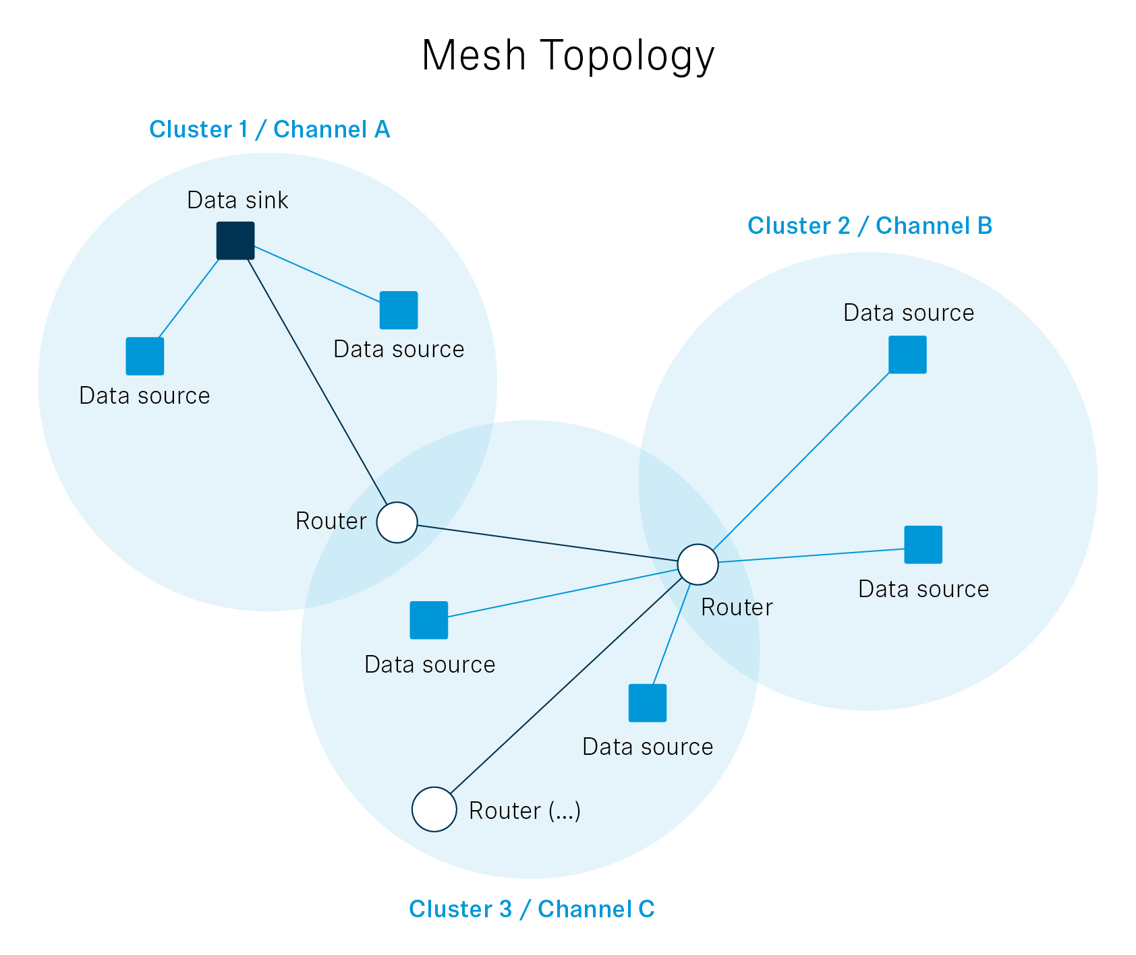 | A typical DECT NR+ mesh topology. The devices create their own network without requiring a base station to oversee them

Witting: When we look at the professional audio domain, NR+ promises higher device densities in venues and halls, an end-to-end latency around a few milliseconds, improved robustness in challenging indoor RF due to the CP-OFDM technique it uses, and, via additional bands beyond 1.9 GHz, better global spectrum options than classic DECT. Classic DECT devices cannot be used in Mainland China, for example.

Zocher: In healthcare, NR+ can support reliable, real-time wireless monitoring and alarms without the complexity of a full cellular infrastructure.

“NR+ is designed for an ‘anywhere, by anyone, at any time’ deployment: a licence-exempt, infrastructure-light standard that does not require agreements with network operators or heavy network planning to get started,” explains Zastrow. | 

Zastrow: Overall, NR+ is designed for an “anywhere, by anyone, at any time” deployment: a licence-exempt, infrastructure-light standard that does not require agreements with network operators or heavy network planning to get started.

Can any company, university, etc., chime in regarding development, testing, whatever? If they want to, how would they do this?
Witting: Anyone can start developing and testing DECT NR+ today, using the publicly available ETSI standards and off-the-shelf development kits, for example based on Nordic Semiconductor’s nRF9151.

Zocher: The DECT Forum offers free academic membership and discounted membership for start-ups, with their Academia Industry Roundtable (AIR) as a no-fee entry point for research collaboration and networking for everyone who is interested in working on and with DECT NR+.

Wilzeck: To participate directly in NR+ standardisation at ETSI, companies and organisations need an ETSI membership; academia and micro-enterprises benefit from reduced membership fees to lower the barrier for contributions.

I hadn’t heard about AIR yet. Could you give us another rundown of the major bodies and initiatives connected with DECT NR+?
Wilzeck: DECT-2020 NR / DECT NR+ standards are drawn up by ETSI’s Technical Committee DECT, which maintains the TS 103 636 series of standards and the DECT technology roadmap.

The DECT Forum industry association and its NR+ working groups coordinate the broader industry initiatives, interoperability profiles, and regulatory outreach.

Zocher: Research collaboration and community networking are fostered through the DECT Forum’s Academia Industry Roundtable (AIR). AIR helps connect industry, universities and research institutions on the research and ecosystem side of DECT NR+ under a clear legal and funding framework. It supports the exchange of research needs, funding opportunities and collaborative project ideas, and helps give visibility to results. AIR therefore plays an important role in aligning the pre-competitive innovation community around DECT NR+, and in linking academic research with industrial development. AIR also connects naturally to initiatives such as the Opener Initiative and to publicly funded projects like MERCI, helping ensure that research outputs and open development efforts contribute to the broader DECT NR+ ecosystem.



Another important funding project is OpenDECT-X, a ten-month project which launched on 1 May 2026 and is funded by the German Federal Ministry of Research, Technology and Space. The project aims to close a major gap in the DECT NR+ ecosystem: Although the standard itself has been defined, there is currently no open-source reference implementation that is freely available, modifiable and well-documented. The existing protocol stacks are proprietary, which creates high barriers to market entry for small and medium-sized enterprises and limits academic research to a black-box approach. OpenDECT-X lays the conceptual and organizational foundation for a modular and interoperable open DECT NR+ protocol stack. Project partners are the Ostfalia University of Applied Sciences as coordinator, Sennheiser and Last Mile Semiconductor as industry partners, and Nordic Semiconductor as associated partner. We bring academic knowledge, industrial application expertise and key chip-vendor perspectives to the table. What might be worth noting is that, due to some delay in the formal project approval process, some of the community-driven activities envisioned by OpenDECT-X like the Opener Initiative have started earlier. Xaver, Andreas, would you like to give more details about the Opener Initiative and also MERCI which created the basis for OpenDECT-X?

Witting: Certainly. The Opener Initiative develops and maintains Opener, an open reference implementation of the DECT-2020 NR protocol stack covering the Media Access Control (MAC) and upper layers. The initiative brings together different existing stacks developed by its members and aims to consolidate them into a unified open-source solution that supports the full range of DECT NR+ use cases. Opener is guided by three core principles: It is designed to be ready for commercial use; is application- and platform-agnostic to support a wide range of industries and hardware environments; and is fully interoperable and standards-compliant. The Opener initiative combines community-driven development with industrial usability, implementing the OpenDECT-X vision of an open ecosystem.

“The MERCI final public workshop in 2025 impressively mapped the state of the art of DECT NR+ and the huge potential of this technology,” states Wilzeck. | 

Wilzeck: As briefly mentioned, MERCI was a Franco-German research project, a 30-month research collaboration between the media & events sector, industry partners, and universities, which concluded at the end of July 2025. This was the first non-cellular 5G research project to involve professional audio and entertainment right from the start, and I had the absolute pleasure of being the consortium lead.
MERCI stands for Media and Event production via Resilient Communication on IoT Infrastructure. The initiative was jointly funded by the German Federal Ministry for Economic Affairs and Climate Action, the French Ministère de l’Economie et des Finances et de la Relance (MEFR) and bpi France. The public MERCI final workshop took place in 2025 and impressively mapped the state-of-the-art of DECT NR+ as well as the huge potential of this technology. For example, ATEME demoed an immersive audio solution using MPEG-H object audio, thereby implementing the world’s first object audio transmission via DECT NR+. On a virtual end device, the end user could arrange the individual audio objects – in this case the individual members of our guest band, the Sonic Crusaders – as he or she liked, changing prominence, azimuth, elevation and much more.

Which companies and universities are driving this new transmission standard? Can you outline their interests?
Zastrow: Today, DECT NR+ is mainly driven by the large smart-building players like Legrand, Schneider Electric and Siemens, specialist chipset and stack vendors like Nordic Semiconductor and Wirepas, but also by research teams at universities like Leibniz University Hannover and the Ostfalia University of Applied Sciences. Sennheiser plays a central role for professional audio, and has demoed NR+ wireless mics and cloud-connected production workflows. So there are the classic in-building and industrial IoT verticals, but also emerging verticals like pro audio and media, where NR+ aims to make wireless “as good as wired”.

 | “Government grants and projects like MERCI fund high-risk, early work on DECT NR+ that individual companies cannot easily justify from product budgets, even if they are financially strong,” says Zocher.

Why do government grants and programs like MERCI play such a vital role for DECT NR+? Is there not enough money with the companies that work on this standard and want to use it in products or their own company-wide applications?
Zocher: Government grants and projects like MERCI fund high-risk, early work on DECT NR+ that individual companies cannot easily justify from product budgets, even if they are financially strong. They also create a safe legal environment for collaboration – with clear frameworks for funding, intellectual property and competition law. Companies and universities can work together on cross-industry research, multi-vendor demos and reference architectures that benefit the whole ecosystem but don’t immediately pay off for any single firm.

Public funding helps de-risk the development of technologies by validating standards and proving interoperability across industries. Grants like those for the MERCI project accelerate ecosystem maturity, broaden participation, especially as regards small and medium-sized enterprises, and ensure that open standards like DECT NR+ can reach a level of readiness where large-scale industrial deployment becomes economically viable. Once a technology like DECT NR+ enables concrete products, business cases and revenues, companies are ready to invest.

How transformative will DECT NR+ be for the industry as a whole? And: Will people even notice?
Zastrow, smiles: That’s the fate of good technology – end users very likely won’t see too much of it. They will use a low-latency wireless microphone but won’t necessarily know which transmission technology is behind. They will experience smoother building automation, but not care that it’s DECT NR+ based, or they will set up stable industrial systems, with DECT NR+ doing all the data communications in the background.

For the industry, NR+ is transformative because it offers an open, 5G-grade, wideband radio platform that vendors and site owners can operate themselves, without mobile operators or proprietary narrowband islands.

You mentioned wireless mics, but professional audio applications have quite stringent requirements on latency, and require consistently high transmission quality. How is DECT NR+ going to fulfil these requirements?
Witting: : DECT NR+ targets IMT-2020 URLLC-class performance, URLLC stands for ultra-reliable, low latency communication, with end-to-end latencies of a few milliseconds and extremely high reliability thanks to CP-OFDM, advanced coding and HARQ. Older DECT standards were optimised for telephony and low-rate data; they lack the spectral efficiency, flexible scheduling and Quality of Service required for dense, phase-coherent, low-latency audio, which NR+ now addresses.



That sounds very promising. How do you judge the future success of DECT NR+ in general?
Witting: DECT NR+ is the first non-cellular technology in the 5G IMT-2020 family and specifically targets local private networks in both licence-exempt and locally licensed bands. Its strongest success is likely where Wi-Fi and cellular networks are a poor fit, not replacing these technologies, but adding an extremely viable option for industrial IoT, smart buildings, private 5G-class networks and verticals such as professional audio.

(Ends)

The interview images can be downloaded as web-resolution jpgs and as high-resolution jpgs.

Useful links:

DECT NR+ Technical Specification:
ETSI Technical Standard: TS 103 636-1 - V2.1.1 - DECT-2020 New Radio (NR); Part 1: Overview; Release 2

MERCI
For more information about MERCI, visit https://franco-german-5g-ecosystem.eu/merci/.
If you are interested in learning more about the MERCI final workshop and see the demonstrators that were presented, please read https://newsroom.sennheiser.com/merci-project-takes-dect-nr-from-vision-to-reality.

Open Stack Development
To learn more about the Opener Initiative, please visit http://opener-initiative.org

DECT NR+ interoperability
More information about the DECT NR+ interoperability demonstration is available at Legrand and Schneider Electric demonstrate world’s first NR+ interoperability demo for smart buildings – DECT Forum

About the Sennheiser brand
We live and breathe audio. We are driven by the passion to create audio solutions that make a difference. Building the future of audio and bringing remarkable sound experiences to our customers – this is what the Sennheiser brand has represented for 80 years. While professional audio solutions such as microphones, meeting solutions, streaming technologies and monitoring systems are part of the business of Sennheiser electronic SE & Co. KG, the business with consumer devices such as headphones, soundbars and speech-enhanced hearables is operated by Sonova Holding AG under the license of Sennheiser.
www.sennheiser.com
www.sennheiser-hearing.com

Press Contact:
Burson Finland Oy (previously Hill and Knowlton)
sennheiser.finland@hkstrategies.com

