EMBARGOED UNTIL WEDNESDAY, FEBRUARY 9TH, 2022 AT 11:59AM EST

New GIANTS Documentary Series Details the Early Days of Electronic Music
The new cinematic offering from Moog Music spotlights untold stories from some of the most important artists and innovators in modern music history. Watch the first episode here.

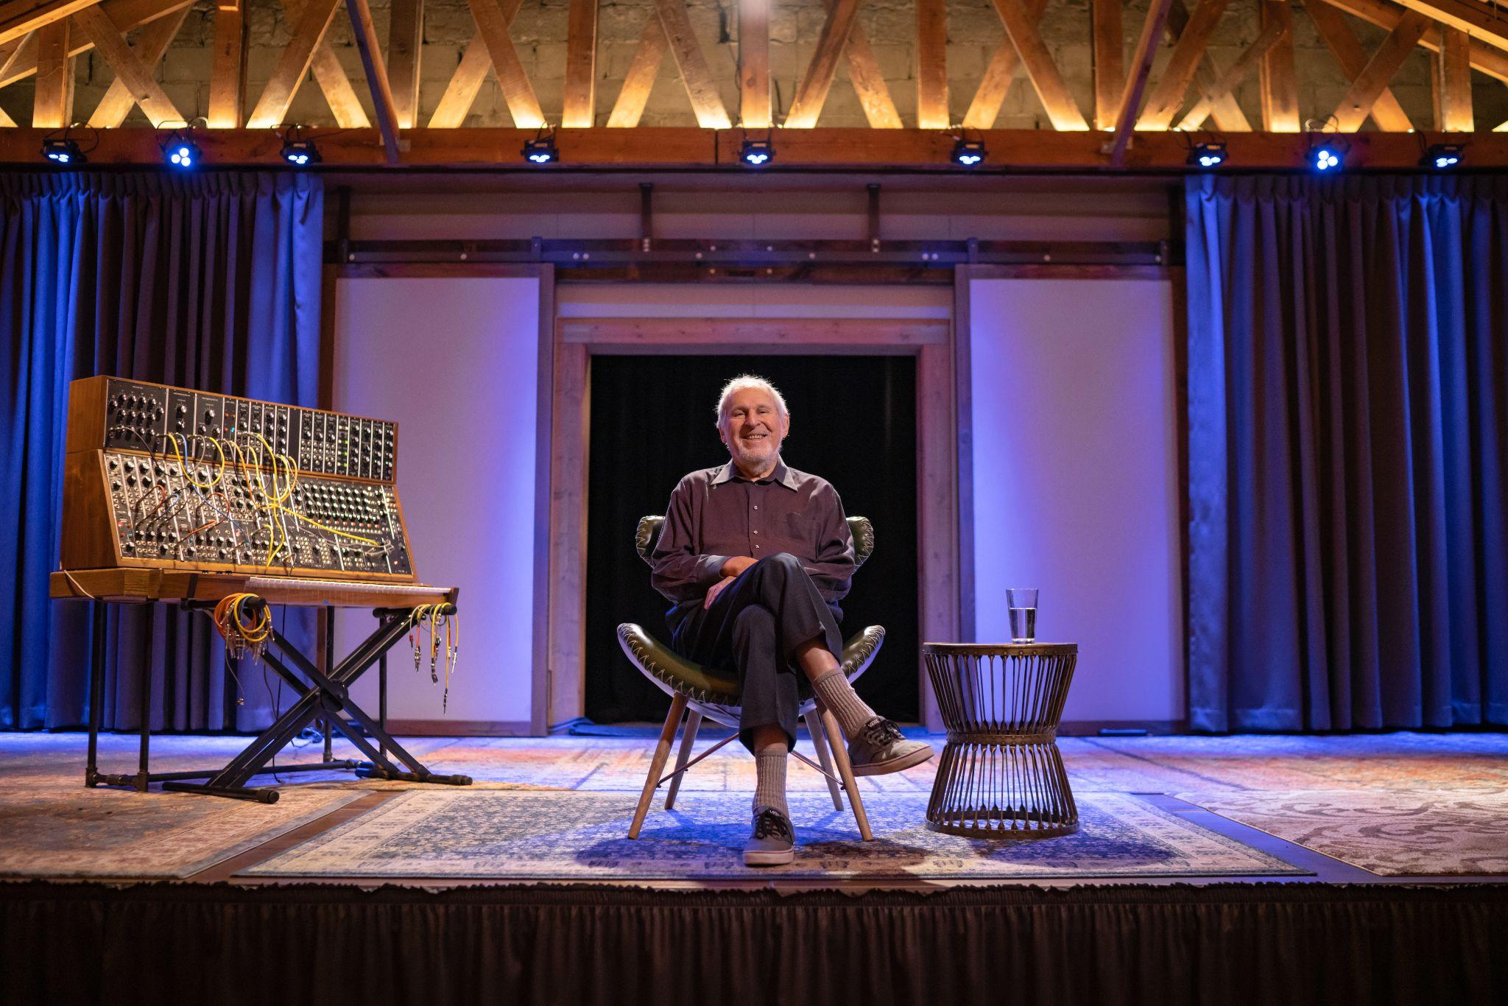
HI-RES PHOTOS FOR MEDIA USE
VIDEO CLIPS FOR MEDIA USE
GIANTS is a platform for legendary electronic musicians and innovators to express themselves through the art of storytelling. The artists in this series have left an indelible impact on electronic music history and culture, and their contributions have pushed the artform and industry forward. They are the “giants” whose shoulders we stand on—the pioneers who propelled synthesizers and analog instruments into the mainstream many years ago.

This new documentary series, filmed and produced by Moog Music, is about honoring and preserving the legacy of these artists and sharing their untold stories with the world.

Join trailblazers like Moog synthesizer co-inventor Herb Deutsch, early modular synthesizer adopter Bernie Krause, modular synthesis legend Suzanne Ciani, and Mute Records founder Daniel Miller as they describe their passions, inspirations, origin stories, and never-before-heard revelations. Through spoken interviews, original music, and visuals, these artists share their perspectives around how electronic music has evolved and provide context for their place in that story.

The first installment of GIANTS focuses on Herbert Deutsch, co-inventor of the Moog modular synthesizer. The composer, music educator, and friend and collaborator of Bob Moog journeys back in time to talk about some of music history’s most prolific moments and expand on “the perfect definition” of what music is and can be: sound organized in time.

Watch the first episode of GIANTS by Moog Music here.
To keep up with future releases of GIANTS, join Moog’s email newsletter list here.

