Moog Semi-Modular | The Mothership | Lisa Bella Donna
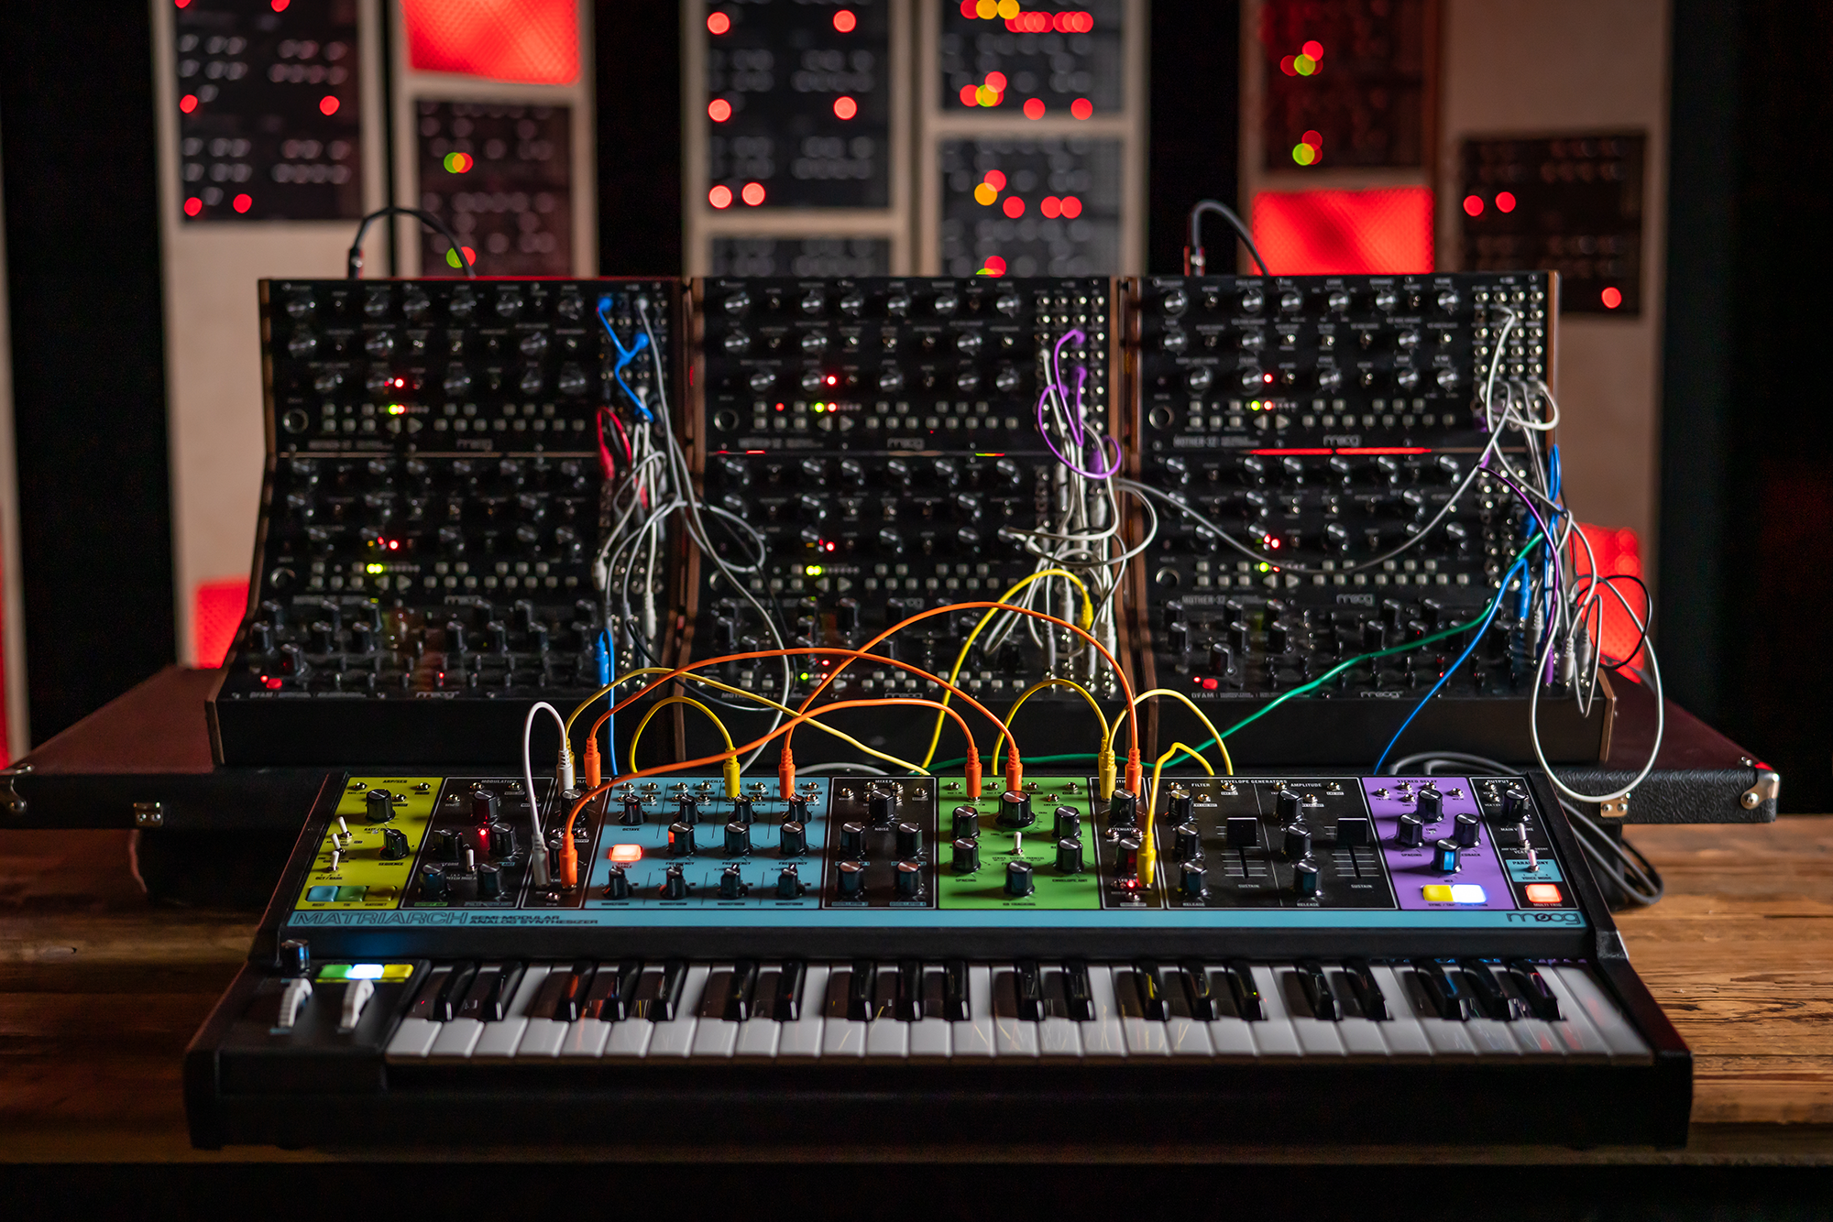

Welcome aboard The Mothership, Lisa Bella Donna’s fleet of 10 Moog semi-modular analog synthesizers. Seven powerful Mother-32s, two percussive DFAMs, and one paraphonic Matriarch make up the synthesist's out-of-this-world system.

This performance is a glimpse into the myriad of sonic possibilities the Moog Mother ecosystem can offer to musicians of all skill levels. Lisa Bella Donna unleashes the vast potential of these instruments, demonstrating just how thunderous their sound can be when connected together.

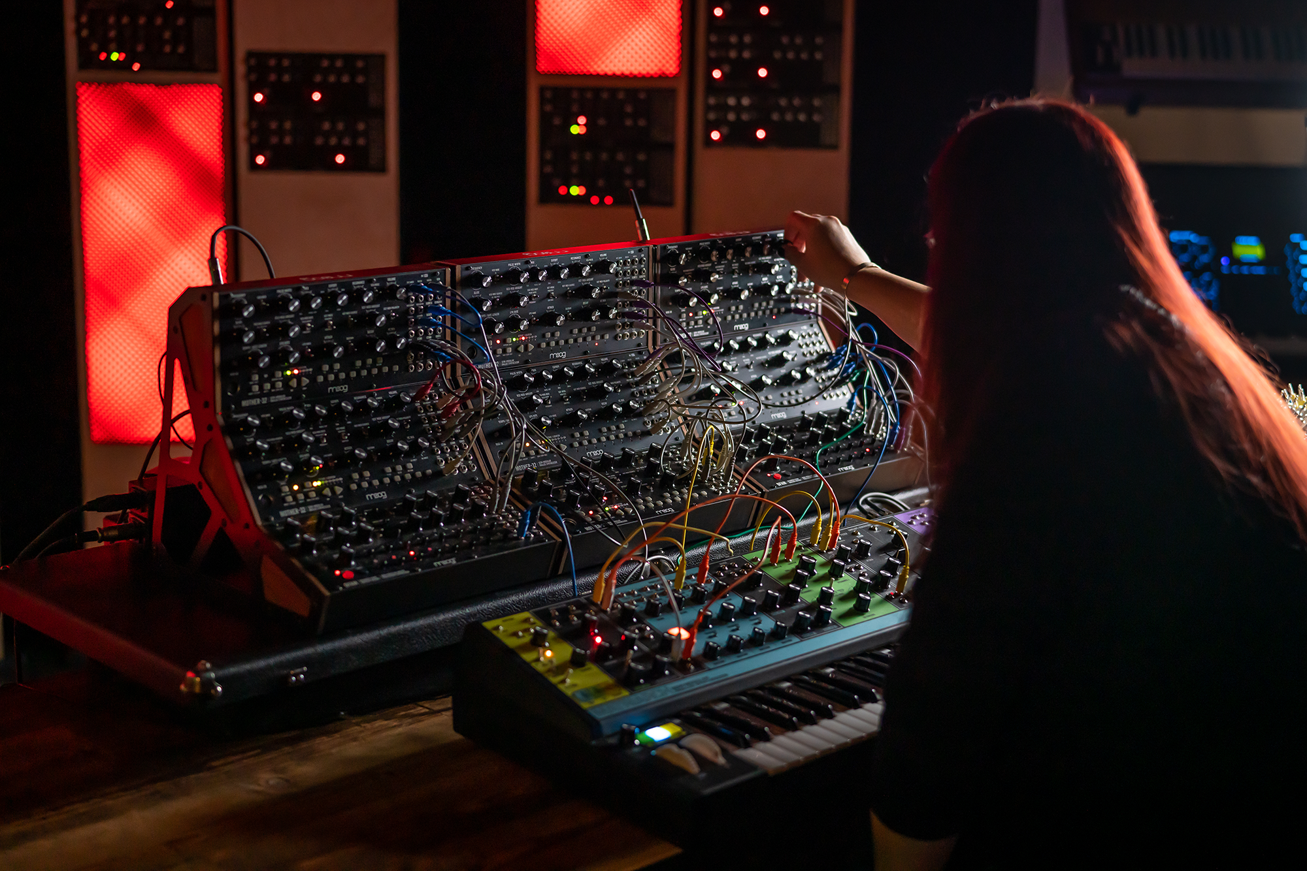

"The sequencer system in this setup is something very special and unveils so much more than meets the eye when you dig in. Then there’s the SOUND. These synths can move serious air and give you the flexibility of 10 octave oscillators, richly classic Moog filtering, and VCAs that can offer both musical dynamics and grit when you wish for it." -Lisa Bella Donna

Watch The Mothership here: https://www.youtube.com/watch?v=nIRQbIckYPo

Hi res photos: https://drive.google.com/open?id=1Z3T3DUVjEI-NUR7fya94vzO8PwTfVNT6

More about Mother-32: https://www.moogmusic.com/products/mother-32
More about DFAM: https://www.moogmusic.com/products/dfam-drummer-another-mother
More about Matriarch: https://www.moogmusic.com/products/matriarch
More about Lisa Bella Donna: https://lisabelladonna.bandcamp.com

