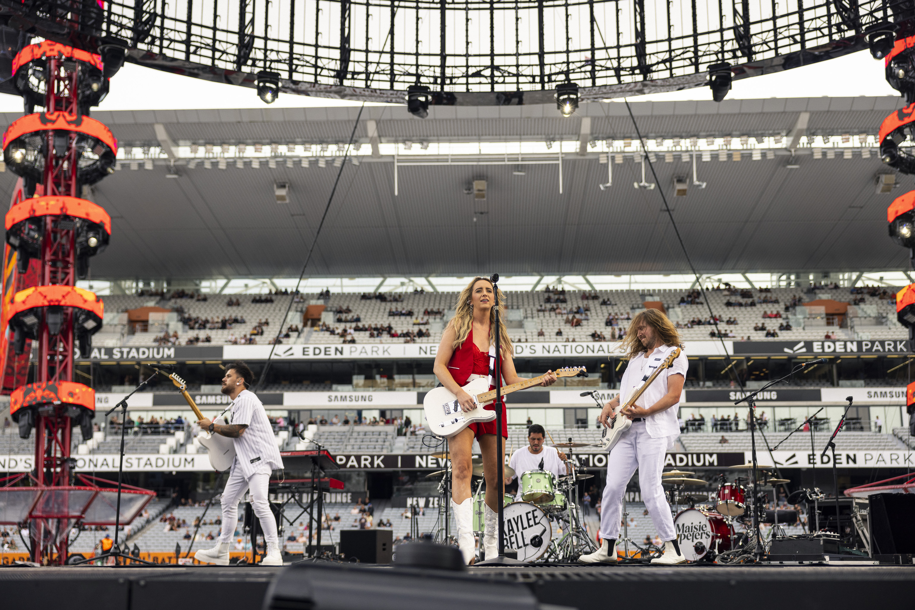

Evolution Wireless Digital empowers country pop artist, Kaylee Bell,

with the freedom to perform
Touring is made seamless for Kaylee and her band after adopting wireless audio

Auckland, New Zealand, May 9 2023 – Rising country pop artist, Kaylee Bell, fresh off a six-date stadium tour supporting the New Zealand leg of Ed Sheeran’s Mathematics World Tour, considers Sennheiser’s Evolution Wireless Digital (EW-D) family of wireless microphone systems an on-tour must-have. The EW-D has been Kaylee’s on tour companion as she warmed up the crowd for Ed, and now as she hits the road for her own debut tour, the EW-DX will take her full live band show to a powerful new level.

Kaylee and her band have exclusively used Sennheiser for as long as they’ve been touring, for the simple reason that, as Kaylee puts it, “Sennheiser always reliably produces the best sounds.” And whilst this quality has always been a constant, a huge reason that Sennheiser has driven the band forward as of late, is the ease and convenience that comes with using wireless gear.

Famed as the 'Most Streamed Country Artist for Australasia' in 2022, Kaylee is an independent, self-managed artist with over 40 million streams under her belt. The New Zealand-born star, kicked off 2023 with a bang, having won an Australian Golden Guitar Award for Vocal Collaboration of the Year. Gearing up to embark on her own ‘Boots ‘N All’ 16-date New Zealand tour, Kaylee is entrusting Sennheiser to deliver her unique curation of country meets pop sound.

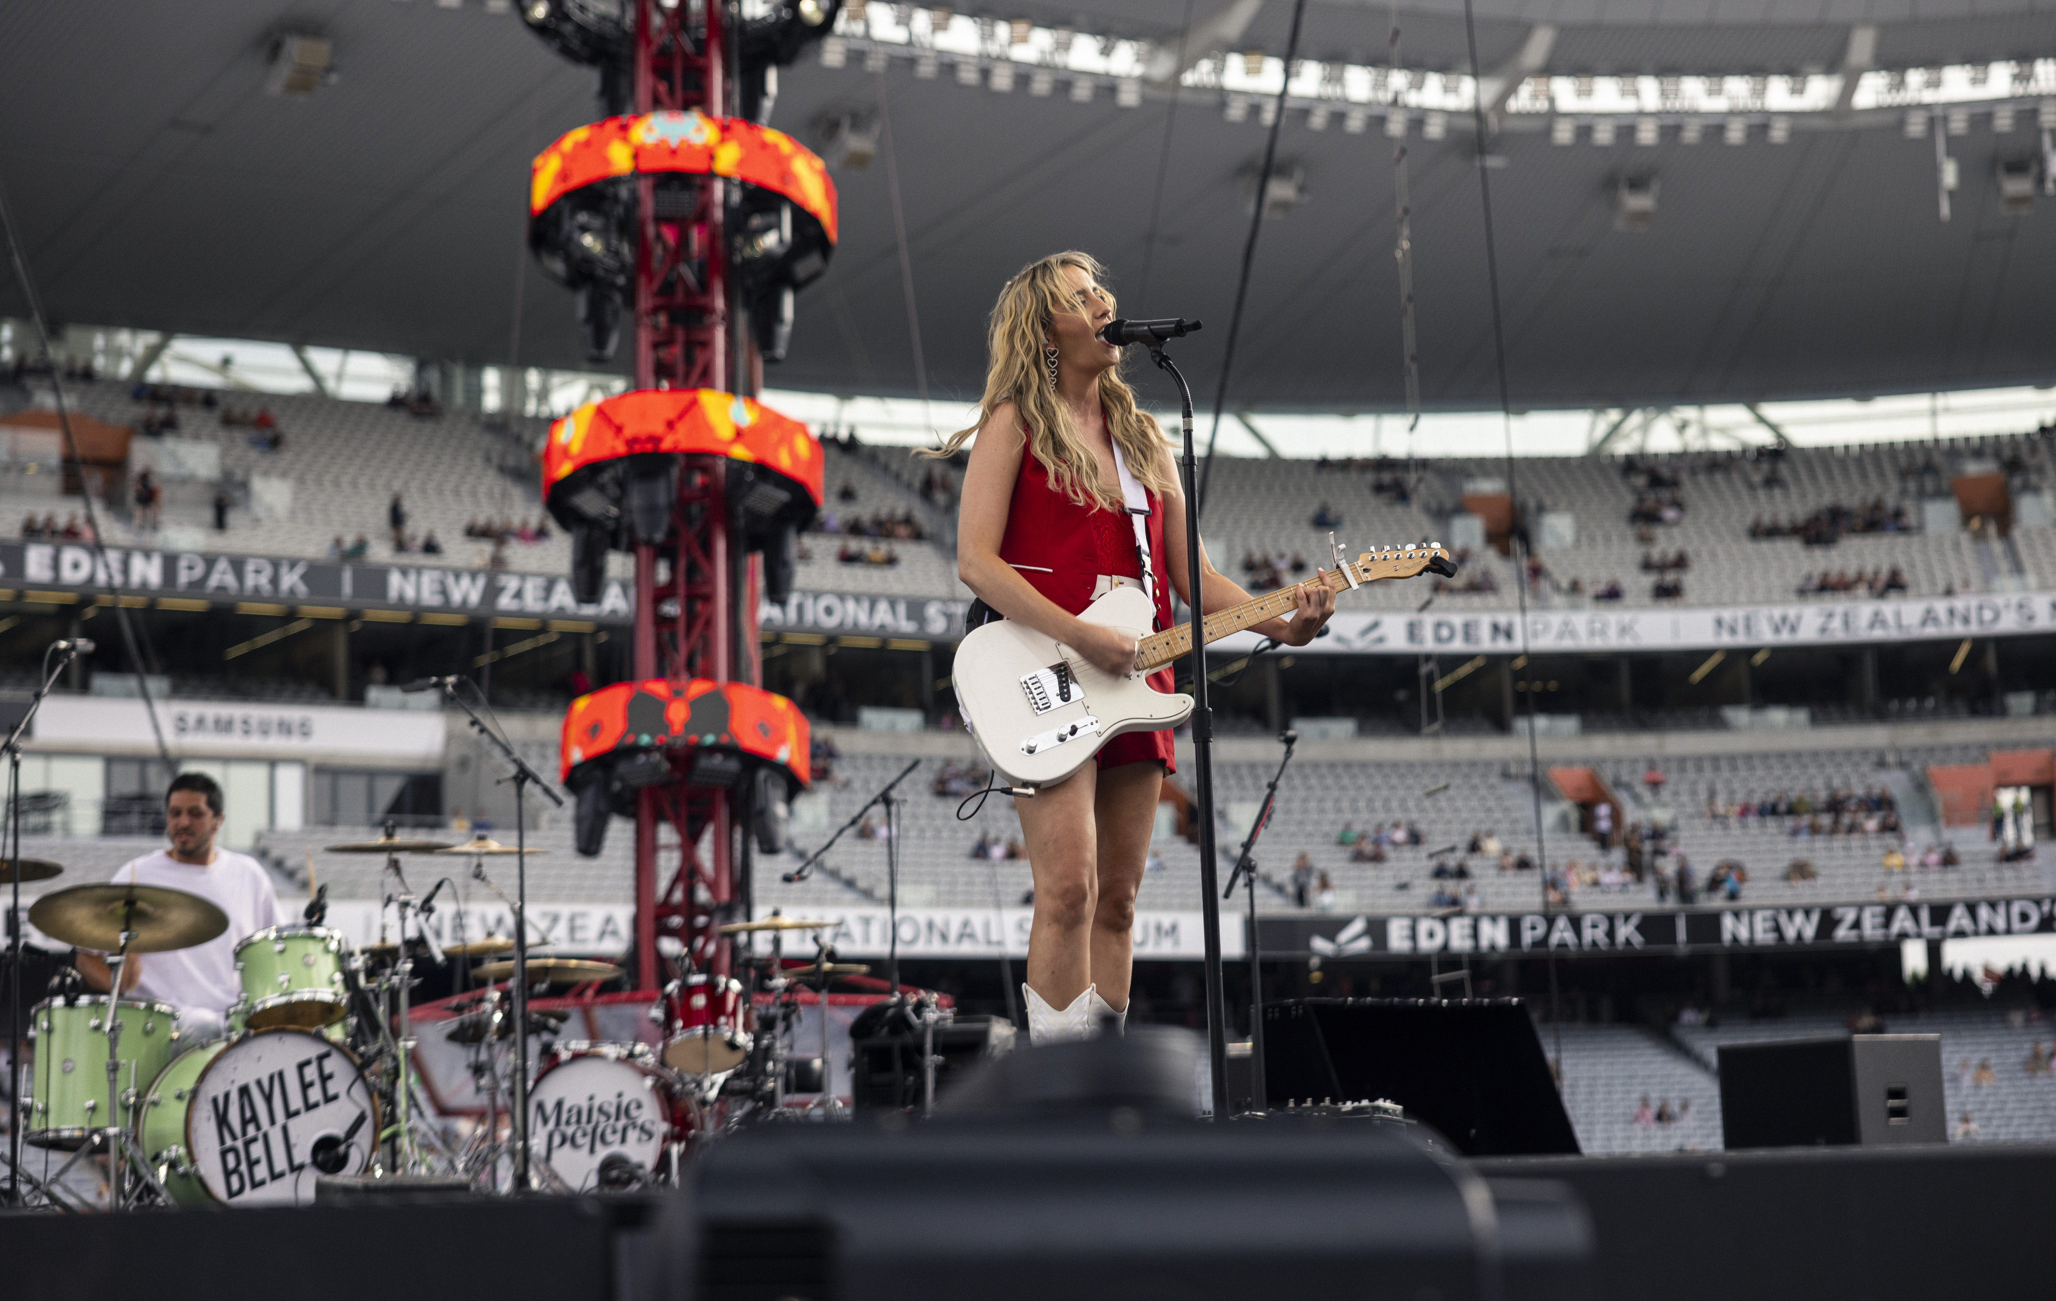
On Ed Sheeran’s Mathematics tour, Kaylee and her band performed with the EW-D. Photo credit: Mike Braid

Kiting themselves out with Sennheiser’s EW-D has “been a gamechanger for the band.” Kaylee loves the sense of freedom being wireless gives her when on stage, especially recently on the Ed Sheeran tour. “As a performer and especially with the Ed tour, with the stage being so big, we just had full freedom to run everywhere, which was amazing. Having such minimal gear on stage allows us to have so much fun as a band and gives a sense of unity as one crew. Being able to move around freely allows our personalities to come through.”

From a production point of view, the EW-D has been a revelation for audio technician, Nick Campbell to the point where he credits it as a “bit of a selling point when initially engaging with the Ed Sheeran team. When they asked what our set-up was like, we explained all we needed onstage was a drum kit because everything else is wireless, all our vocal mics, guitars, and all our backline sitting off stage. So, they were really happy about that and it just made things a whole lot easier.”

This has culminated in significant time savings for the band when arriving at gigs with Nick further pointing out that since going wireless, set up is one less thing he needs to worry about. “I really just take for granted the time it saves me, and its reliability, it just always works.” And it’s not just the convenience of setting up and packing down shows where the wireless Sennheiser gear shines. When on the road, travelling constantly, being able to fit all of your equipment “in a pelican box under 23 kilos is really important because it saves on costs and lets us take the whole rig everywhere with us.”

Kaylee and her band perform wireless with the EW-D. Photo credit: Mike Braid

When touring with Ed Sheeran, the team had unprecedented access and was able to bond with his stage management team. Kaylee’s front-of-house (FoH) engineer Josh Anderson confesses “the fact they use Sennheiser speaks massive volumes. They don’t have issues on their shows and run a very reliable set-up, so are very particular about what they use on the road.”

As a self-professed gearhead, Nick really enjoyed “geeking out” with Dave White, Ed’s RF & looper tech, where he was able to chat openly and gain insights into how a show of that scale works, as well as the role Sennheiser plays in bringing both shows to life.

What the experience on the Ed Sheeran tour taught Kaylee and the team, amongst other things, was the scalability of Sennheiser gear. “We can rock up to a pub and play to 50 people with the gear and then at the other end of the scale we can show up and support Ed Sheeran with the exact same gear with more or less the same set-up time,” shares Nick.

Currently using the EW-D, Kaylee and her band are soon transitioning to the EW-DX for the ‘Boots ‘N All’ tour. With an extended ultra-high frequency (UHF) range and expanded channel counts, the EW-DX is the next natural progression as Kaylee and the band continue their upward trajectory as headliners. By simplifying their workflow with scalable transmitter and receiver options and automatic multi-channel RF set-up, the EW-DX is setting the standard in the live audio industry.

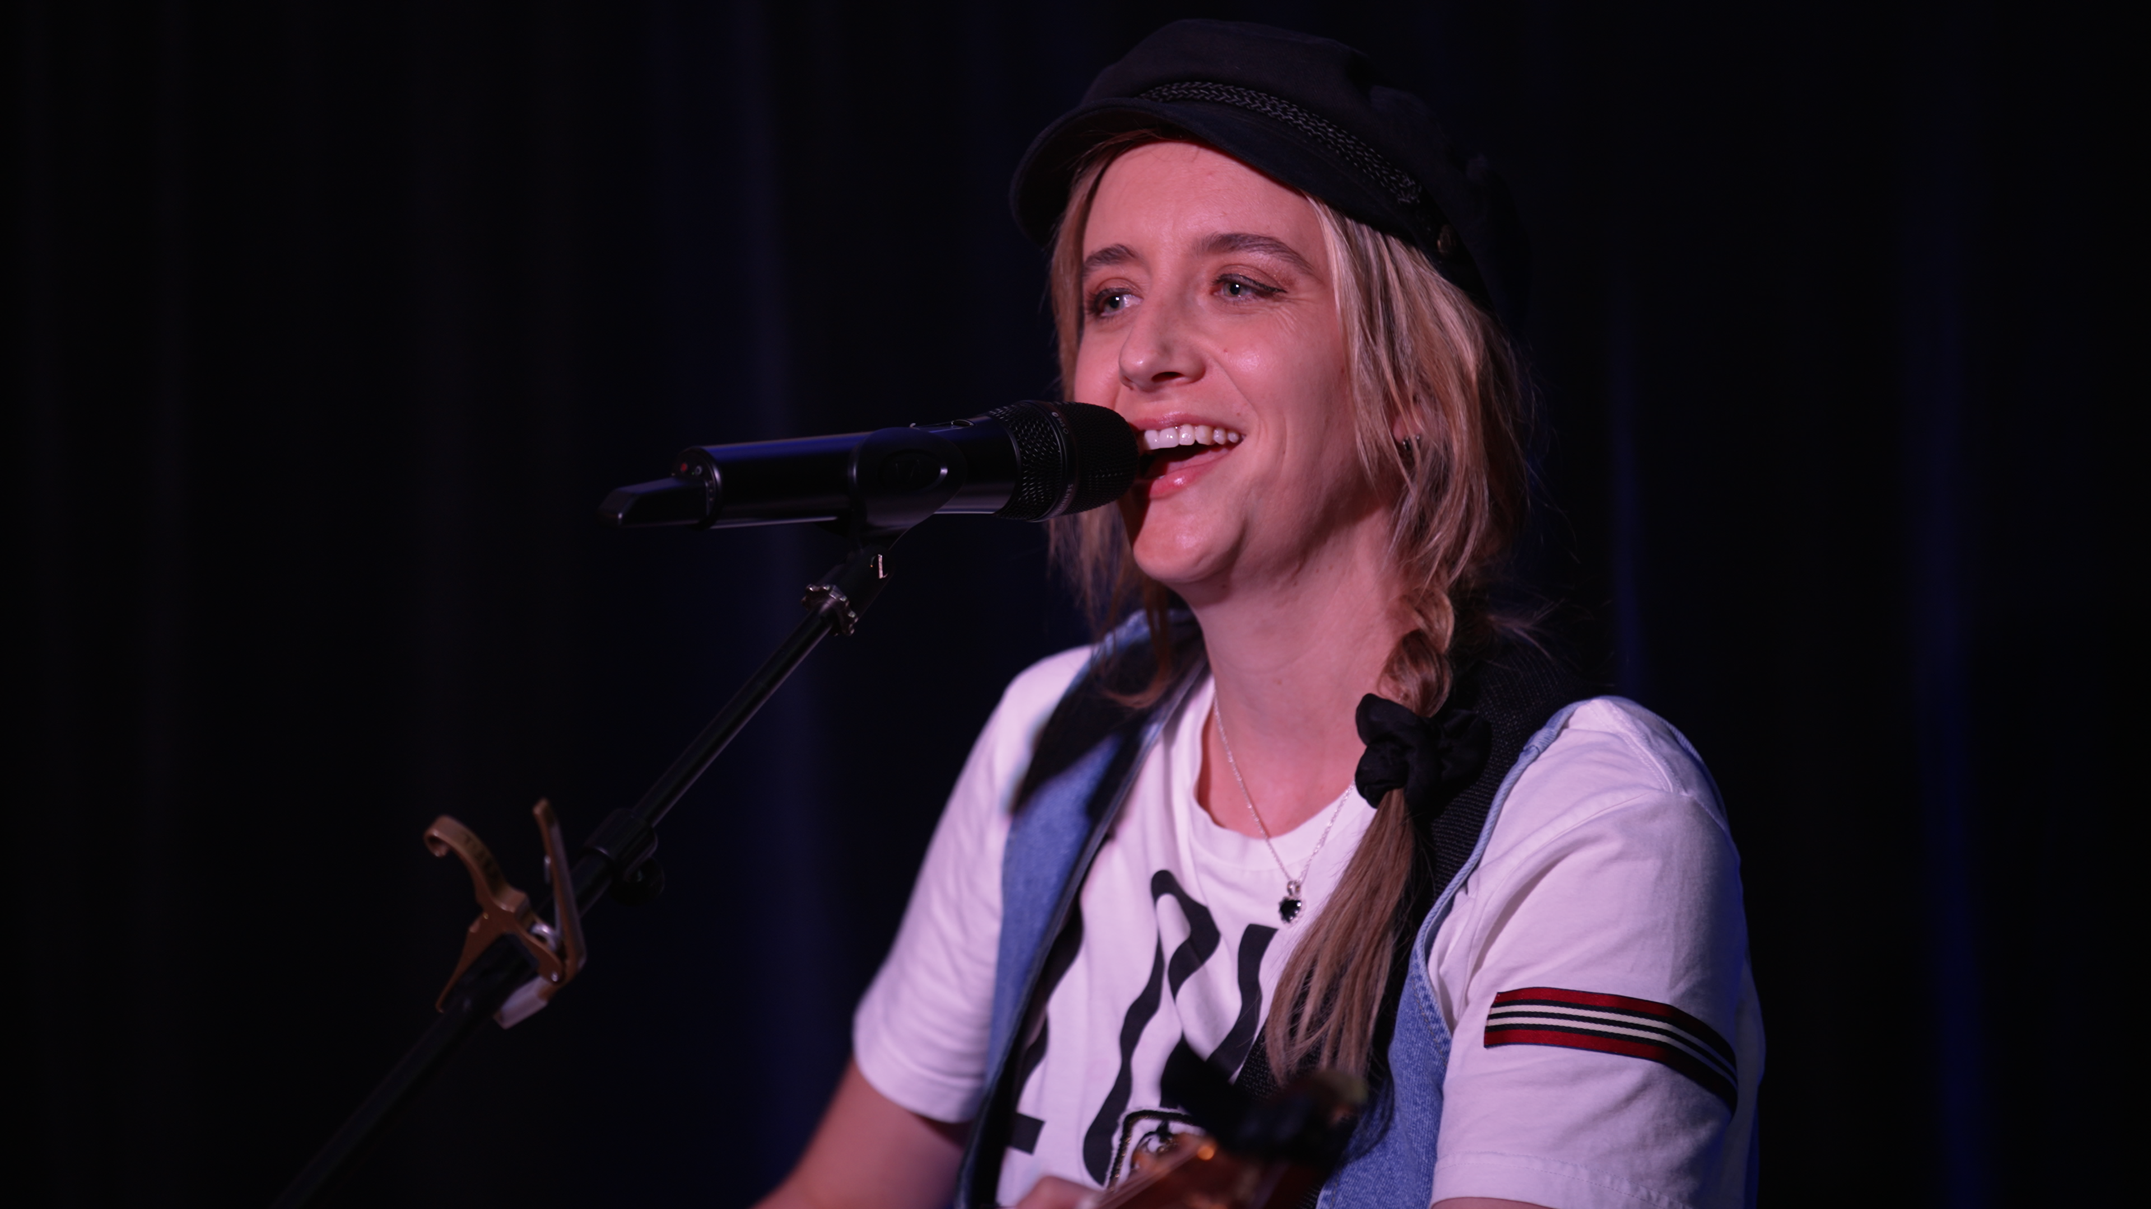
Kaylee performing with the EW-DX 835-S Set that she’ll be using for her upcoming tour.

“We don’t lose tone going wireless, all of our guitars have the same great level of consistency, and going forward using the EW-DX there will be no loss of quality which is the first thing we consider when adding gear into the rig,” says Josh. Paired with the Evolution Wireless Digital microphones are the G4 in-ear monitoring solution, helping Josh and Nick deliver an all-round professional-sounding production. As does the use of the Smart Assist app where Nick shares that “doing everything on mobile is really handy because I can be onstage to change the frequency.”

The Evolution Wireless Digital family of products bring a level of consistency and range that helps Kaylee and the band take their live shows to the next level, transcending genres floating across country, rock and pop. Having been inspired by the likes of Keith Urban and Shania Twain, Kaylee explains how Sennheiser enables this amalgamation of genres, “there is a strong reliance on guitars to create that rock element to our show. But then it's also important to then be able to deliver something quiet and inspired by someone like Maggie Rogers where you can beautifully break down a song with the acoustic guitar.”

Kicking off on 4 May 2023, Kaylee heads on her national NZ Boots ‘N All tour, for event dates and ticketing information visit here.
###

About Sennheiser

We live and breathe audio. We are driven by the passion to create audio solutions that make a difference. Building the future of audio and bringing remarkable sound experiences to our customers – this is what the Sennheiser brand has stood for since more than 75 years. While professional audio solutions such as microphones, conference systems, streaming technologies and monitoring systems are part of the business of Sennheiser electronic GmbH & Co. KG, the business with consumer devices such as headphones, soundbars and speech-enhanced hearables is operated by Sonova Holding AG under the license of Sennheiser.
www.sennheiser.com
www.sennheiser-hearing.com

Local Press Contact

Daniella Kohan
Communications Manager, Americas and ANZ, Sennheiser
Email: daniella.kohan@sennheiser.com
Phone: +1 860 598 7420

