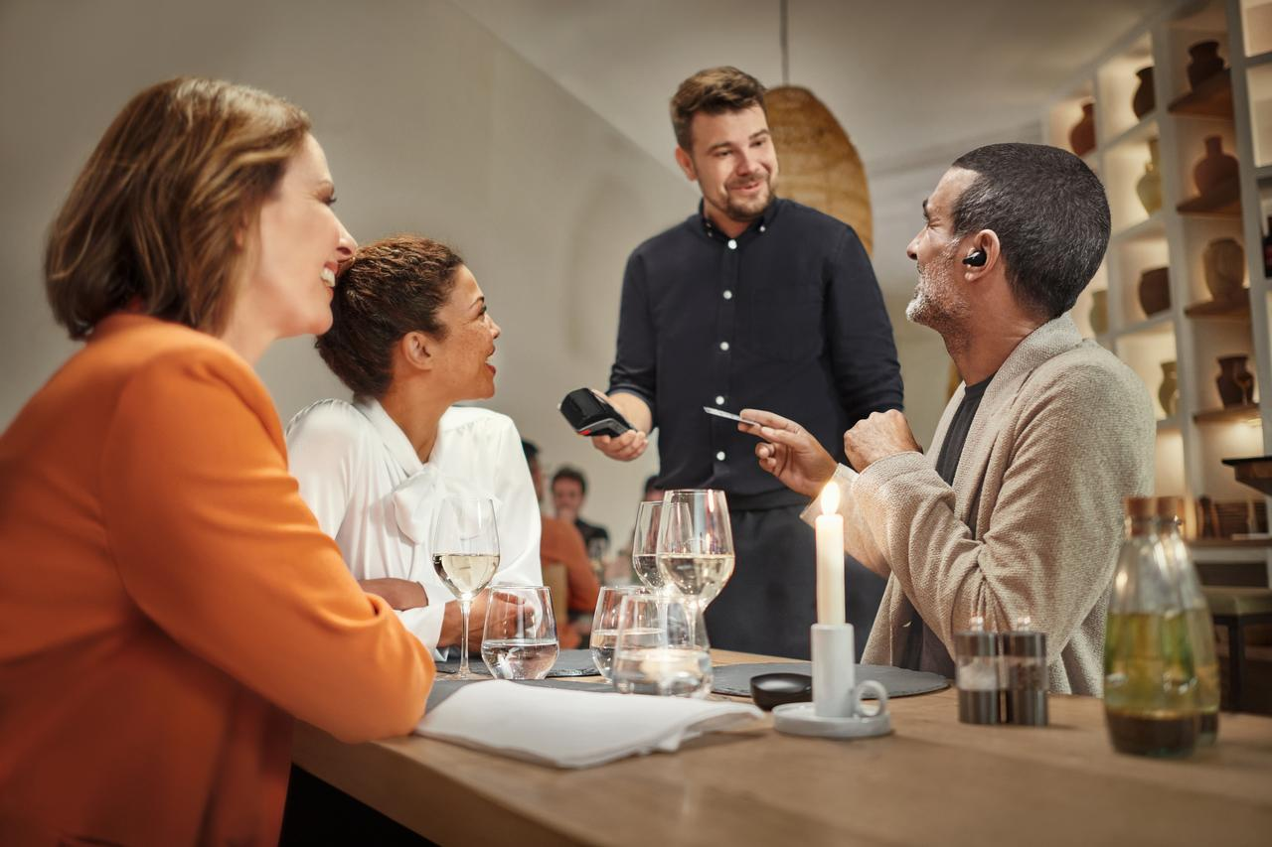
1 in 3 people feel a degree of embarrassment in wearing an assisted hearing device
Sennheiser survey: strong social stigma in wearing assisted hearing devices, especially when compared to wearing glasses.

Sydney, Australia, 3 March, 2023 – Wearing glasses is considered socially acceptable, but an assistive listening device is not? A new Sennheiser-commissioned independent study has found that 1 in 3 people aged between 45 and 70 would or do feel a degree of embarrassment wearing an assisted hearing device. This is in sharp contrast to only 1 in 10 people who feel the same way about wearing glasses. The survey was conducted to 2,500 respondents aged between 45 and 70, approximately 500 each from the US, UK, Germany, France, and Australia.

Today, the World Health Organization (WHO) mark World Hearing Day and highlight the importance of integrating ear and hearing care. Ear and hearing problems are remarkably common with approximately 1 in 5 people living with some form of hearing loss worldwide. * The World Health Organization warns that by 2030, nearly 630 million people worldwide will have a hearing disability. By 2050, that could jump to 900 million. Currently, 15% of American adults aged 18 and older report some trouble with their hearing. ** Untreated hearing loss in midlife remains the largest modifiable risk factor for dementia.
According to the Hearing Loss Association of America, people with hearing loss wait an average of seven years before seeking help. *** This may also help give context to some additional revelations in the Sennheiser-commissioned study which found that 36% of 45- to 70-year-olds struggle to hear conversations in loud environments, like in a restaurant. Moreover, 39% of this age group have pretended to have heard someone in a conversation but couldn’t hear them properly due to background noise – so they just acted as if they heard the person.
This is a remarkably common issue for 45- to 70-year-olds and new technologies and products are now coming to market to address this. The Sennheiser Conversation Clear Plus, launched in January 2023, is one such product. The true wireless earbuds enhance the voice of the person a user looks at while reducing background volumes from other people and things, making conversations much easier to follow in noisy environments.
“We conducted this survey to draw attention to the social stigma of wearing assisted hearing devices in public or with friends,” says Sonova Consumer Hearing GVP Martin Grieder. “We also want to highlight just how common certain hearing challenges are and hope that these results can help to start conversations and bring more awareness to make this stigma a thing of the past.”

* World Health Organization
** National Institute on Deafness and other Communication disorders
*** Hearing Loss Association of America

About the Sennheiser brand
We live and breathe audio. We are driven by the passion to create audio solutions that make a difference. Building the future of audio and bringing remarkable sound experiences to our customers – this is what the Sennheiser brand has represented for more than 75 years. While professional audio solutions such as microphones, meeting solutions, streaming technologies and monitoring systems are part of the business of Sennheiser electronic GmbH & Co. KG, the business with consumer devices such as headphones, soundbars and speech-enhanced hearables is operated by Sonova Holding AG under the license of Sennheiser.
www.sennheiser.com
www.sennheiser-hearing.com

About Sonova Consumer Hearing
Sonova Consumer Hearing offers premium headphones and hearables – primarily in the true wireless segment – as well as audiophile headphones, enhanced consumer hearing solutions and soundbars under the Sennheiser brand. The business is part of The Sonova Group, a global leader in innovative hearing care solutions with headquarters in Switzerland and 17,000 employees worldwide.

Press contact
Caitlin Todd
caitlin.todd@groundagency.com

