For immediate distribution

Oz Noy Chooses Sweetwater Studios to Record Latest LP, Booga Looga Loo
The album, recorded by Sweetwater Studios’ Mark Hornsby during Masterclass sessions, blends boogaloo, jazz and R&B with Noy’s quintessential sound
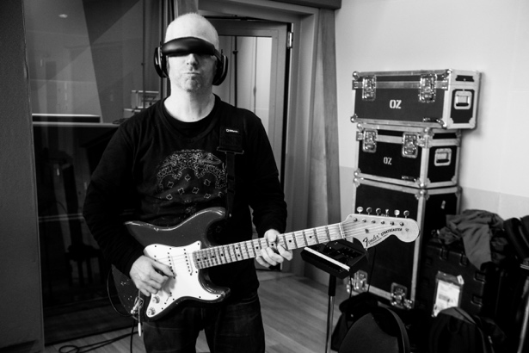
March 20, 2019, Fort Wayne, IN – Over the course of three separate masterclass sessions which took place in 2017 and 2018, New York-based guitar virtuoso Oz Noy laid down tracks for his latest album Booga Looga Loo at Sweetwater Studios in Fort Wayne, Indiana. The LP, which mixes boogaloo, jazz and R&B together with Noy's offbeat harmonic sensibilities and unpredictable phrasings, was engineered by Sweetwater Studios Senior Producer/Engineer Mark Hornsby, who taught a group of Masterclass students his recording process while simultaneously capturing the guitarists' signature sound.

"The experience of recording in Sweetwater studios was absolutely amazing and it’s really inspiring to work there,” commented Oz Noy. “This is a top of the line facility and I was so comfortable and relaxed. Going in to that studio was like entering into this amazing Sweetwater vortex and coming out the other side with a finished record — such a great vibe!”

Renowned for cultivating his own distinct voice within the context of classic structures, Booga Looga Loo features four original Noy arrangements alongside reinventions of songs by The Beach Boys (“God Only Knows”), Ray Charles (“I’ve Got a Woman”), Thelonious Monk (“Bemsha Swing”), plus a rendition of The Beatles’ “Eight Days a Week,” with bassist Will Lee on vocals. The album comes in the wake of Noy’s two-volume LP Twisted Blues, which explores the vast expanses of the genre and was recorded live in Shanghai.

A winning formula in Fort Wayne
Noy opted for Sweetwater Studios not just because of its reputation as world-class recording studio equipped with top-of-line equipment, but also because of Hornsby’s knack for working with stellar casts of musicians well-versed in stylistic fusion — including drummers Dave Weckl, Vinnie Colaiuta, and Steve Ferrone; bassists Will Lee, John Patitucci and James Genus; and keyboardists Jerry Z and Brian Charette — who joined Noy in recording Booga Looga Loo. Other contributors include Kevin Hays, Seamus Blake, and Anne Drummond.

Hornsby cites collaboration as the key to a successful record, giving due credit to the backup band. "With everything that I do, the core of it is a live rhythm section," Hornsby said. "A lot of what we do at Sweetwater Studios is based around people recording music in a room together. And that works with Oz, it works with Robben Ford, it works with Peter Erskine, it works with Carl Verheyen, and it works with all the jazz or progressive rock stuff that I get into. There are a lot of great musicians out there. Why not use them?"

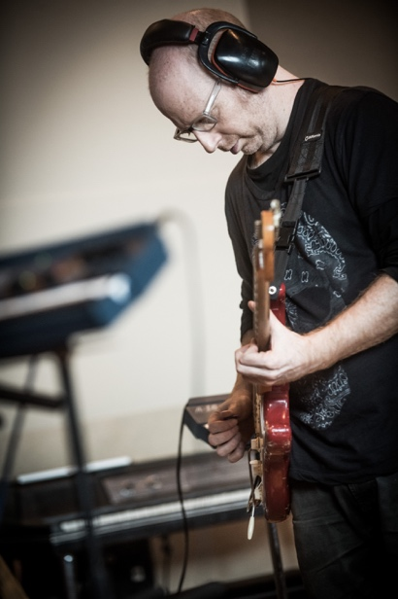
A student of the craft
Over a typical Thursday, Friday and Saturday, Masterclass students had a chance to witness Noy's collaborative process, which Hornsby said begins with demos and charts, "But that's basically related to form. The idea when you're hiring musicians of that caliber is to get them in the room, and then you work with them on interpreting it.

"Oz knew what songs he wanted to do, “Hornsby continued. “He had structure, and he had charts, and he's a great guitar player. But he also surrounds himself with great musicians, and everybody plays together, and that's what made it all seem to work on this record."

Like many guitarists, Noy was particular about his tone on the record, and worked with Hornsby to capture his ideal guitar sounds. "His go-to microphones are Shure SM57 & Royer 121," Hornsby explained. "He has two cabinets going at the same time and he likes to have those in an iso room with the door cracked, so he can be out in the main room in spirit. Then he puts a small combo amp next to him in the main room at a low volume, as a kind of confidence monitor, and we record that as well."
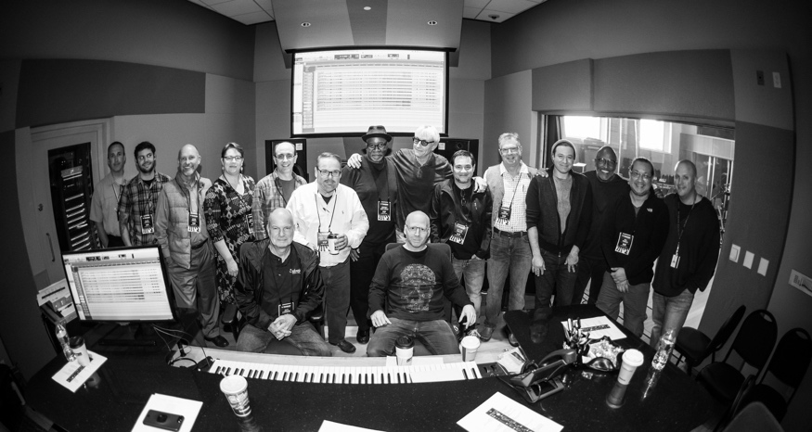
When it came to tracking the guitar, Hornsby says Noy was rigorously committed to the studio process. "He likes to play free form with a rhythm section or an ensemble, just like anyone else would do; but he makes sure he has enough takes and options, so that at the end of the day he has material that best serve the songs."

Bring out the boogaloo
The album, which is currently available for pre-sale and drops March 15, marks another left turn in Noy's multi-genre career and takes the artist's idiosyncratic musical sensibilities in whole new direction: boogaloo. "If you look at Oz's catalog, it seems like every time he does a record, he goes for a different vibe," Hornsby said. "He's always changing it up a bit.”

"Oz is a versatile player and he's always experimenting and trying new things, whether it's a pedal or a different style of music — and I like that about him,” Hornsby concluded. “He wanted to do this record because he's never done a boogaloo record. He's very self-aware, and as an established musician living in New York, he plays a lot of jazz clubs and gets clumped into that genre a bit. Since he's already playing to that type of audience, he's aware that you can't keep doing the same record over and over again. So when he's doing his own thing, you know he's going to make it special."

To purchase Oz Noy’s album, Booga Looga Loo, please click here.
About Sweetwater Studios
Sweetwater Studios is a wholly owned subsidiary of Sweetwater Sound, Inc., the largest online music instrument retailer in the country. With three world-class studios designed by Russ Berger and access to a greater diversity of musical equipment and professional audio gear than any other recording studio in the world, Sweetwater Studios is able to accommodate just about any recording, mixing or mastering project, no matter how simple or complex. With renowned staff producer Mark Hornsby at the helm, who has worked on many Grammy-award winning albums, Sweetwater Studios also has an exceptional staff of producers, engineers, session musicians and studio technicians. For more information on Sweetwater Studios, please visit http://www.sweetwaterstudios.com.

Media contacts
Steve Bailey
Public Relations
Hummingbird Media
+1 (508) 596 9321
steve@hummingbirdmedia.com

Jeff Touzeau
Public Relations
Hummingbird Media
+1 (914) 602 2913
jeff@hummingbirdmedia.com

