KING KRULE
NEW LP “THE OOZ”
Released October 13th on XL Recordings/ True Panther Sounds
Watch the video for new single “Dum Surfer” here:
Pre-Order “The OOZ” here: http://smarturl.it/theooz

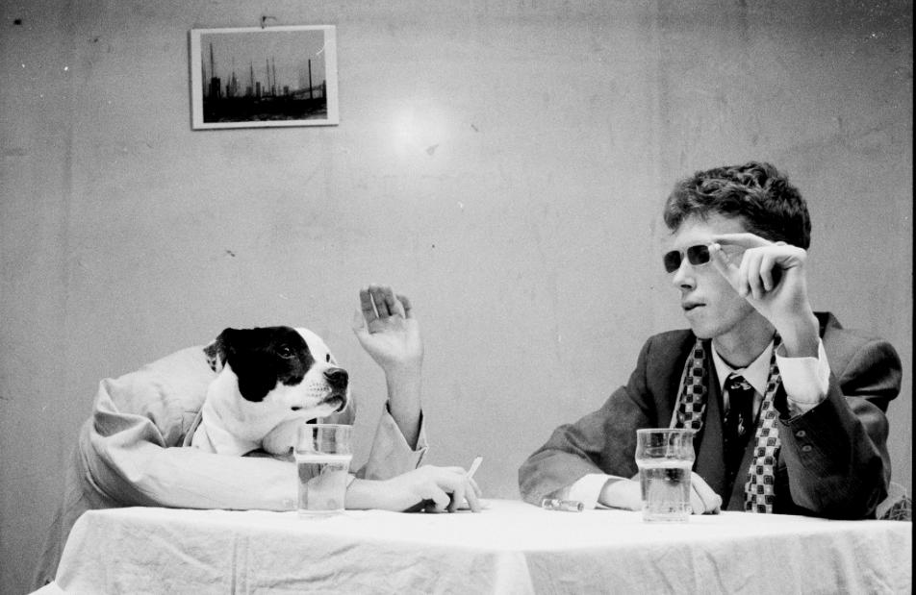

One of the most celebrated figureheads on the independent British scene, Archy Marshall returns with the dense, sprawling “The OOZ”, the much anticipated follow up to his debut “Six Feet Beneath the Moon”. Drifting and seeping through the cracks of South London like the album title, King Krule casts an unflinching eye over his kingdom, transforming his observations of all the disorientation and heartbreak of his youth into piercing narratives and poetry that are both startlingly honest and brutally beautiful. With “The OOZ”, Marshall finally takes the crown as poet laureate for the dazed and confused generation, painting a bleak and sometimes harrowing picture of a rapidly splintering city.

“The OOZ” is released October 13th on XL Recordings/ True Panther Sounds, and can be pre-ordered HERE. It also comes preceded by the raucous new single “Dum Surfer” which can be pre-ordered HERE, as well as a brilliant Brother Willis directed video which you can see HERE (link). This autumn also sees Marshall hitting the road for a worldwide tour this autumn; for further details head to http://kingkrule.co.uk/live

Where “Six Feet Beneath the Moon”, released in 2013, was a rigorous, rambling excavation of Marshall’s expansive body of work to date, “The OOZ” snaps into focus quickly and sharply, his modus operandi coming into view almost immediately. Over jazzy curlicues and guitars, the opener “Biscuit Town” sets out its stall irresistibly as Marshall sings about rapidly disintegrating romance and personal dissolution with acute, almost painful detail. These wrenching themes of self-annihilation and fraying relationships seem inextricably linked in Marshall’s eyes – once you lose yourself to someone else, you inevitably wind up losing yourself completely when they leave – and recur in other tracks. “Why’d you leave me? Because of my depression? You used to complete me but I guess I learnt a lesson” he spits on the roiling “Midnight 01 (Deep Sea Diver)”, and, even layered with the warm vocals of Okay Kaya, “Slush Puppy” is an unsparing dissection of a couple with nothing left to give, like a Gainsbourg and Birkin ballad gone toxic. Elsewhere, things only get darker, as Marshall desperately tries to find safe harbor in the city he knows and loves, only to be thwarted constantly, as on “The Cadet Leaps” and first single “Czech One”. Not even the synthetic high of chemicals, as shown in “Emergency Blimp” and “A Slide In (New Drugs)”, can stanch the suffering.

Although seeming at first abstract, “The OOZ” as a title proves oddly fitting. There are references littered throughout about its physical manifestation, or as Marshall himself says, “about earwax and snot and bodily fluids and skin and stuff that just comes out of you on a day to day basis”. But it works on a more figurative level too, with the OOZ also representing the unknown depths or horizons the solitary mind can travel to, whether it’s sinking into the deep sea or soaring through the night sky. It may be messy, unwieldy, even unsightly, Marshall seems to say - but we need The OOZ in order to exist.

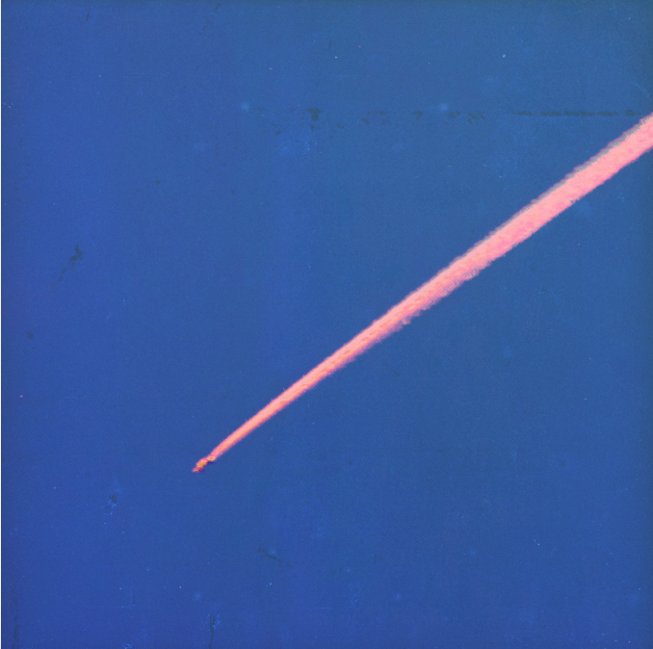

TRACKLISTING

- Biscuit Town
- The Locomotive
- Dum Surfer
- Slush Puppy
- Bermondsey Bosom (Left)
- Logos
- Sublunary
- Lonely Blue
- Cadet Limbo
- Emergency Blimp
- Czech One
- (A Slide In) New Drugs
- Vidual
- Bermondsey Bosom (Right)
- Half Man Half Shark
- The Cadet Leaps
- The Ooz
- Midnight 01(Deep Sea Diver)
- La Lune

Tour Dates:

10/21 - Washington, DC - Black Cat
10/22 - Philadelphia, PA - Union Transfer
10/24 - Brooklyn, NY - Warsaw
10/25 - Brooklyn, NY - Warsaw
10/26 - Boston, MA - Paradise
10/28 - Montreal, CAN - Corona Theatre
10/29 - Toronto, CAN - Danforth Music Hall
10/30 - Chicago, IL - Metro
10/31 - Minneapolis, MN - Fine Line Music Cafe
11/3 - Seattle, WA - The Showbox
11/4 - Portland, OR - Wonder Ballroom
11/5 - Vancouver, CAN - Vogue Theatre
11/7 - San Francisco, CA - The Fillmore
11/8 - Los Angeles, CA - Teragram Ballroom
11/9 - Los Angeles, CA - El Rey Theatre
11/20 - Bristol, UK - Marble Factory
11/21 - London, UK - Koko
11/22 - London, UK - Koko
11/23 - Leeds, UK - Belgrave Music Hall
11/26 - Paris, France - Casino De Paris
11/28 - Milan, Italy - Magazzini Generali
11/29 - Lyon, France - L’Epicerie Moderne
11/30 - Zurich, Switzerland - Rote Fabrik
12/1 - Cologne, Germany - Burgerhaus Stollwerck
12/3 - Hamburg, Germany - Uebel & Gefahrlich
12/4 - Berlin, Germany - Astra
12/5 - Copenhagen, Denmark - Vega
12/8 - Stockholm, Sweden - Vasateatern
12/10 - Amsterdam, Holland - Melkweg
12/11 - Antwerp, Belgium - De Roma
12/13 - Dublin, Ireland - Academy
12/14 - Manchester, UK - Academy 2
12/15 - Glasgow, UK - SWG3

