

Biuro prasowe better. gaming agency
bettergamingagency.prowly.com

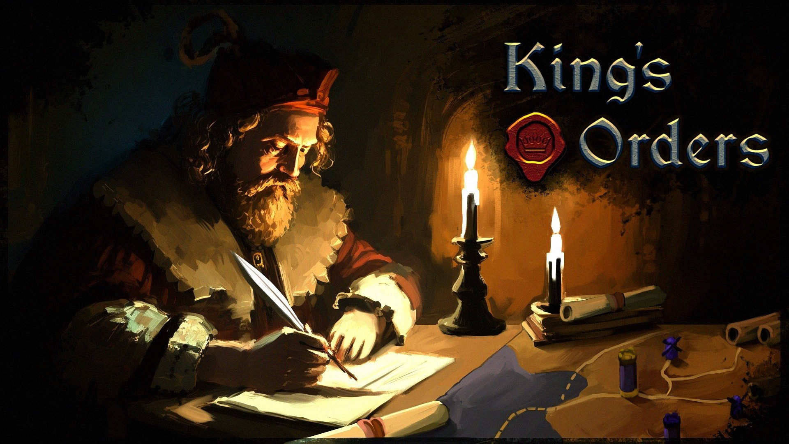

Knights! It’s time for your pledge! Your swords and strength are needed for King's Orders

Developers from the independent studio Afterlife and the publishing team from Games Operators are excited to announce the launch of a crowdfunding campaign for King's Orders. This announcement is accompanied by a trailer showcasing the game's key features. By supporting King's Orders on Kickstarter, you can secure access to the expanded preview version.

King's Orders is a medieval strategy game that is a bit different from other representatives of this genre. Gameplay focuses on specific aspects of managing the kingdom and armies, which are not that common in other games inspired by this historical period. A wise king knows that issuing orders is no simple matter, especially when armies and territories are hundreds, or even thousands of kilometers away from the castle. Spoiler alert! No, there were no smartphones and the internet back then, but there were horses and brave envoys.

King's Orders - the latest trailer

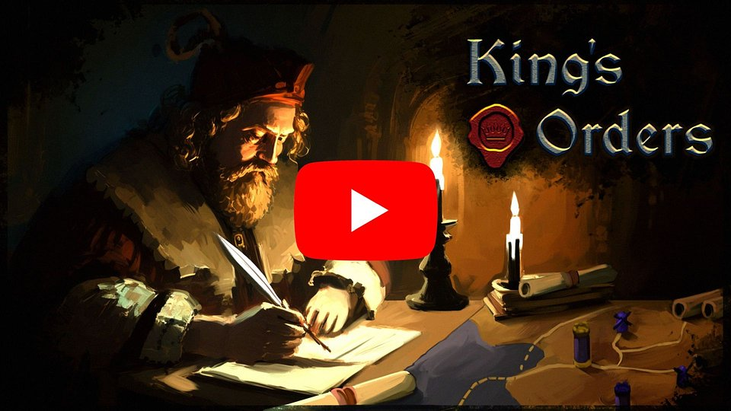
https://www.youtube.com/watch?v=MvKl55ik5Q0

Imagine a scenario where all modern means of communication disappear, and instead of emails and DMs, all you have at your disposal are couriers, your court members, and a stable full of horses. In such circumstances, trying to organize a board game night with friends would be like herding cats, while organizing a group camping trip would probably be impossible. However, our resourceful ancestors were able to organize defenses against hostile invaders, manage the economy, and maneuver armies, even over long distances. In King's Orders, players will often make decisions based on outdated reports and information, so the ability to predict is extremely valuable.

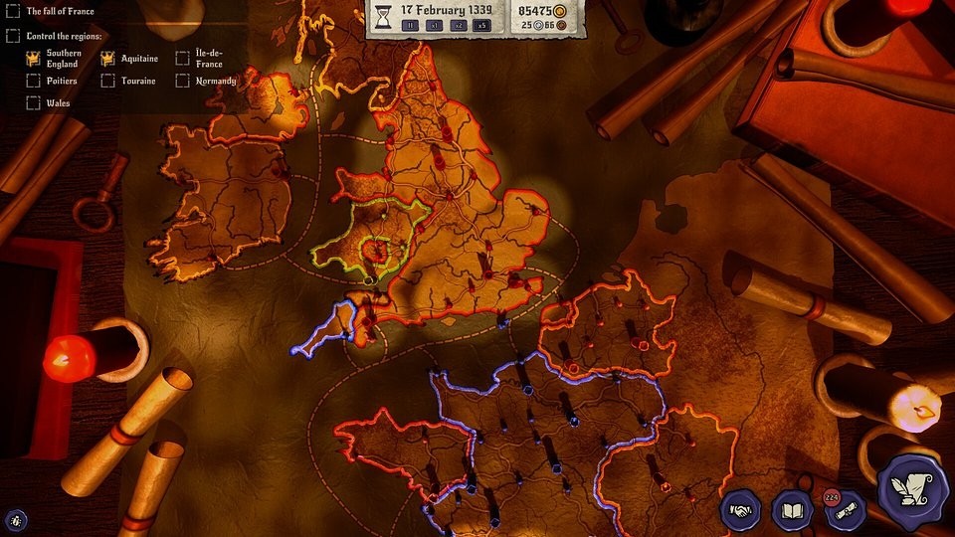

Thanks to King's Orders, players will not only have the opportunity to build an empire spanning from the frosty lands of Scandinavia to the coast of Africa, but they will also take part in major historical events, such as the Hundred Years' War, the Polish–Lithuanian–Teutonic War, the Reconquista. Based on their decisions, they will either witness these events or completely change the course of history.

The creators want to involve the community in the title's development process, which is why crowdfunding campaign supporters can gain access to a special preview build today, featuring even more maps and scenarios. The goal for the campaign is 10,000 €, and fundraising will last for 30 days.

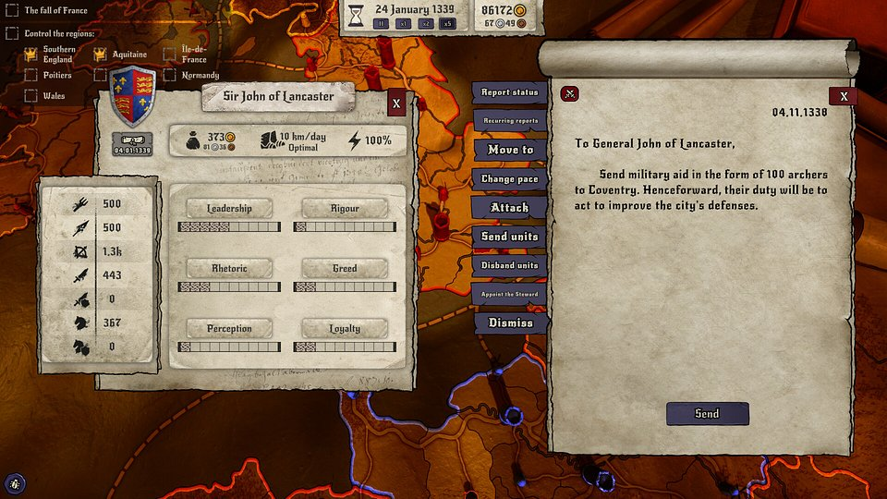

King's Orders - key features:

⚔️ Rule and Conquer! – King's Orders offers a fresh approach to strategy games. Rule the kingdom and issue orders by sending messages to generals and by making your decisions based on received reports.

⚔️⚔️ History is written by the victors – reverse the course of history by playing scenarios based on real historical events like the Hundred Years' War, the Polish–Lithuanian–Teutonic War, the Reconquista.

⚔️ The mind of a strategist – lead armies and manage the economy, relying on information and reports delivered by messengers. The absence of battlefield visibility and the risk that orders may not reach their destination on time require an exceptional strategic sense while ruling the kingdom.

⚔️ The power of loyalty – take care of your generals and their morale, because they'll support you in the toughest times. Citizens won't always agree with your decisions, but loyal knights can help resolve potential crises and rebellions.

⚔️ Treasury at your fingertips – the gold brought back from expeditions will be used not only to recruit and train new units, but also to expand the kingdom's borders. The direction of the empire's development depends on the ruler.

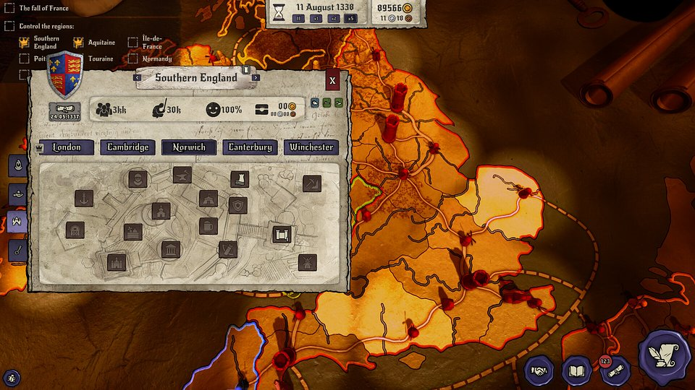

If you want to learn more about King's Orders, we encourage you to check out the game’s Steam page. For those interested in supporting the Kickstarter campaign, we direct you to the campaign page.

The full press kit is available here.

About Games Operators:Games Operators is a publishing company that invests in, releases, and promotes video games. The company helps develop innovative and unique video games like 911 Operator, Radio Commander, 112 Operator, Infection Free Zone, and Transport INC. by getting involved in projects at various levels of progress – from the conceptual phase to nearly-finished products. For more information visit: www.gameops.pl.



Jakub Smolak
PR Specialist at better. gaming agency
jakub.smolak@bettergaming.pro
Twitter

