For immediate distribution

Ferrofish’s A32 Dante AD/DA Converter Now Shipping
The 368-channel converter with Dante support streamlines integration for both live and installed sound applications, while supporting a plethora of audio formats

Fort Lauderdale, FL – August 16, 2017 – Ferrofish, German manufacturer of premium conversion solutions for the professional audio markets, announced that its new A32 Dante interface is now shipping. With a herculean 368-channel capacity that supports AD/DA Dante, MADI and ADAT formats, the A32 Dante delivers superior sound quality, unprecedented cabling efficiency, and is suitable for a vast range of applications in broadcast, live and installed sound environments.
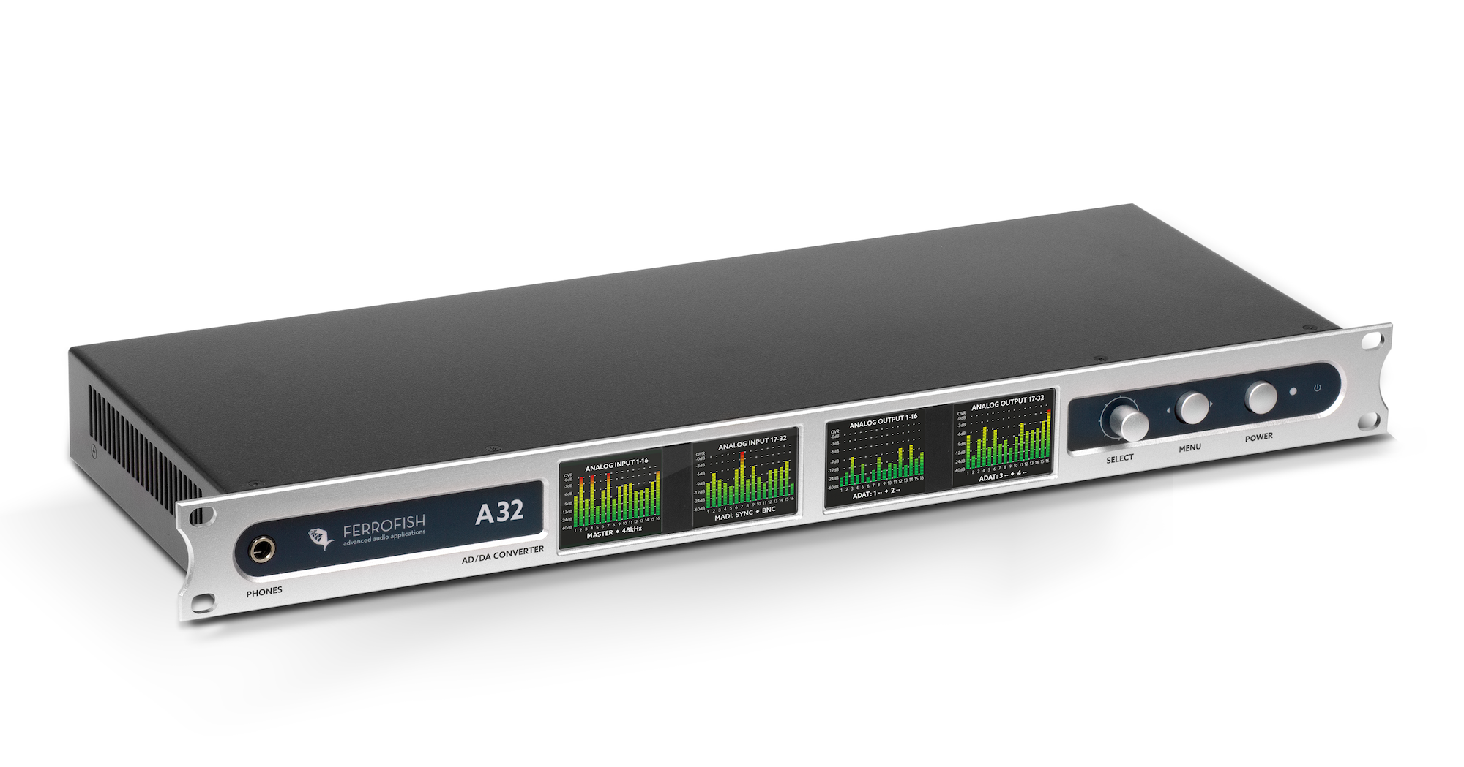
“The Ferrofish A32 Dante is a game-changer when it comes the way interface devices interact,” said Mathias von Heydekampf, managing director of Synthax, distributor of Ferrofish. “The A32 Dante is able to gracefully handle even the most complex conversion applications, while providing unrivaled sound quality, reliability and ease of integration."
The Right Choice for Dante Environments
With its Dante networking capability and support for MADI and ADAT formats, the Ferrofish A32 Dante excels in professional broadcast environments, complex AV installations and live sound productions. Its intelligent design enables users to eliminate the masses of cables often associated with large sound installations by leveraging uncompressed, multi-channel digital media networking technology with near-zero latency and synchronization. Dante removes heavy, expensive analog or multicore cabling, replacing it with affordable CAT5e, CAT 6 or fiber optic cable for a clean and lightweight solution over a single, standard IP network.
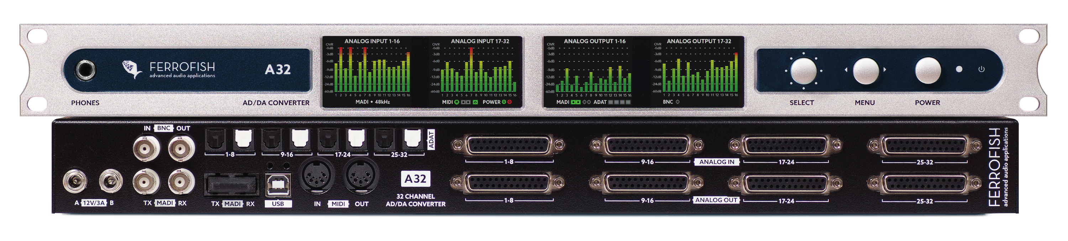
A Gargantuan I/O Capacity Made Easy
The A32 Dante supports 64 channels of MADI I/O, 32 channels of ADAT optical I/O and 32 channels of analog I/O, making it the ultimate plug and play, 'format agnostic' conversion system. Any ADAT optical connector can be used alternatively as an S/PDIF or AES/EBU interface. With its AD/DA capacity, the A32 Dante is able to convert audio in groups of eight among any connected device. Further, the unit provides four TFT screens that permit complete control of levels and adjustments on the equipment — including extensive routing possibilities that enable intuitive operation and greater control.
No Compromise Conversion, German Reliability
To ensure the finest audio quality, the A32 Dante employs the finest grade 24-bit, 192 kHz high-quality converters, complete with analog gain switches. The gain of each channel can be separately adjusted in 0.5 dB steps, and the standard levels are switches in the analog domain — ensuring the full analog performance of the converter is preserved.
The Ferrofish A32 Dante is now shipping and carries an MSRP of $3,799 USD.
For more information about the A32 Dante, visit a32.ferrofish.com.

About Synthax, Incorporated
Synthax Inc. is the exclusive USA distributor for RME digital audio solutions, Ferrofish advanced audio applications, myMix audio products, and ALVA cableware. We supply a nationwide network of dealers with these products for professional audio, broadcast, music industry, commercial audio, theater, military and government applications. For additional information, visit the company online at http://www.synthax.com.

Media contacts
Jeff Touzeau
Public Relations
Hummingbird Media
+1 (914) 602 2913
jeff@hummingbirdmedia.com

Katie Kailus
Public Relations
Hummingbird Media
+1 (630) 319-5226
katie@hummingbirdmedia.com

