Pianist Tanya Gabrielian to release debut album Remix, featuring piano arrangements of Bach solo cello and violin works, on MSR Classics September 12

The recording was inspired by a month-long hospitalization for a spinal injury, during which the music found on the album provided solace from the physical pain and psychological isolation

A nine-date tour will accompany the album release, including performances for occupants in chapter houses for the National Alliance on Mental Illness

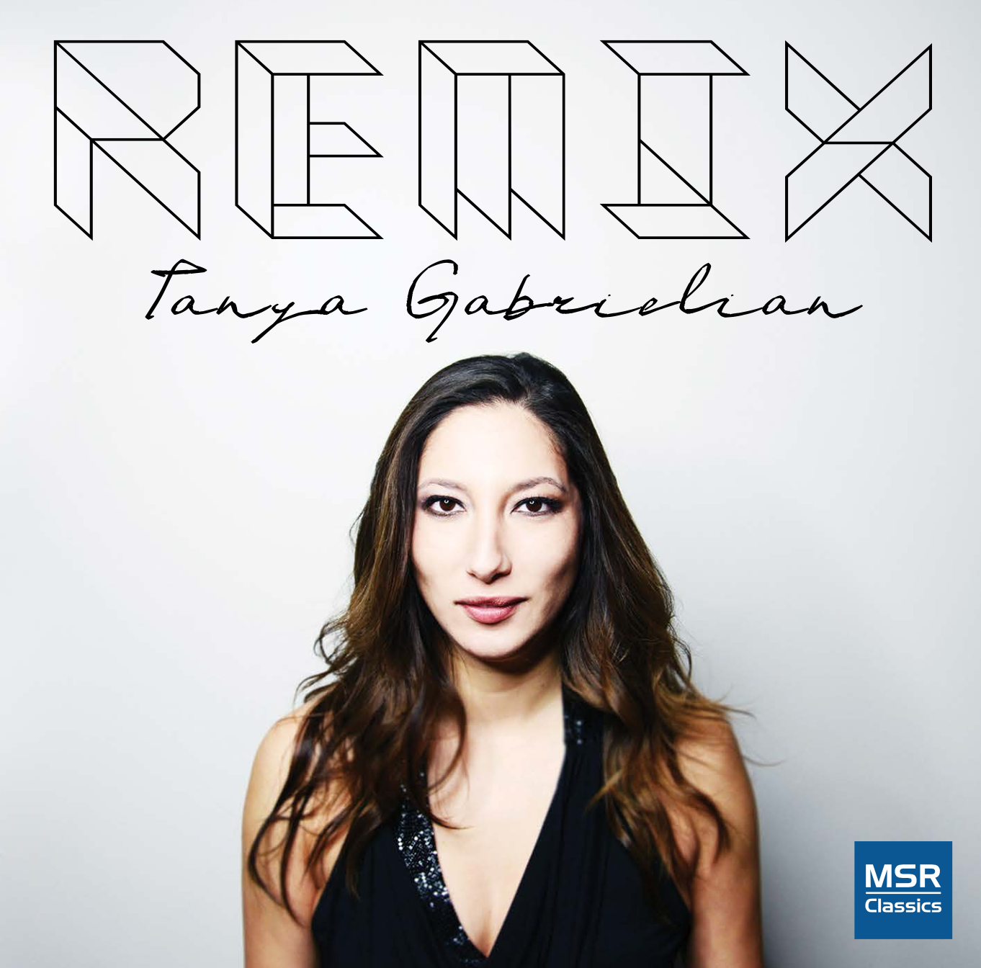
“A pianist of powerful physical and imaginative muscle”
- The London Times
Pianist Tanya Gabrielian will release her debut album Remix, September 12 on MSR Classics. The album features piano transcriptions of Bach’s solo cello and violin music, inspired by a physically and mentally trying stay in a hospital during which Gabrielian found solace in the music of Bach.
While studying abroad at London’s Royal Academy of Music, the pianist slipped during martial arts training and twisted her spine. During the month-long ordeal that followed – a teenager navigating a foreign medical system alone through nine hospitals and two operations – Gabrielian took comfort in her recordings of Bach’s unaccompanied works.
In addition to elevating her above the daily pain and struggle of her hospitalization, Gabrielian was also able to pause from the highly-focused practice of music in which she had been so immersed, and focus instead on the pure experience of music. So when the time came to choose the repertoire for her album, she decided to share this music that had had so profound and influence on her, via rarely-performed transcriptions for piano.
A nine-date tour will accompany the album release, including numerous performances at local chapters of the National Alliance on Mental Illness. Gabrielian has frequently partnered with NAMI in the past, performing for occupants in the hopes that the music which had such a healing effect during her time of need might offer similar support to them.

TRACKLIST
- CHACONNE from Violin Partita No. 2 in D minor, BWV 1004 Transcribed by Alexander Siloti
VIOLIN SONATA NO. 3 IN C MAJOR, BWV 1005
- Adagio | Transcribed by Johann Sebastian Bach
- Fuga | Transcribed by Camille Saint-Saëns
- Largo | Transcribed by Camille Saint-Saëns
- Allegro assai | Transcribed by Arturo Cardelús

- ANDANTE from Violin Sonata No. 2 in A minor, BWV 1003 4:59
Transcribed by Alexander Siloti
CELLO SUITE NO. 2 IN D MINOR, BWV 1008
Transcribed by Leopold Godowsky
- Prelude
- Allemande
- Courante
- Sarabande
- Minuet I & II
- Gigue

TOUR DATES
September 10
Southampton, NY
Southampton Arts Center
September 29/30
Denver, CO
Stratus Chamber Orchestra
October 5-8
Pennington, NJ
NAMI Mercer County
October 10
Charleston, SC
International Piano Series/NAMI Charleston
October 25
New York, NY
Meisel Gallery Soho
November 5
Ashland, OR
NAMI Southern Oregon
November 11
Santa Cruz, CA
Santa Cruz Symphony/NAMI Santa Cruz
November 12
Oakland, CA
Piedmont Piano Company
November 18
Stockton, CA
Stockton Symphony

