Make every song a love song
Valentine’s Day with Sennheiser

Sydney 31 January, 2020 – Showing a person what they mean to you can be tough, so why not use music as the medium and gift a pair of headphones from Sennheiser’s brilliant range this Valentine’s Day. Catering to different budgets, go above and beyond the usual gift of chocolates and flowers and give something that can be enjoyed long after the occasion is over, a pair of headphones and a list of your favorite love songs as a reminder of your thoughtfulness and care.

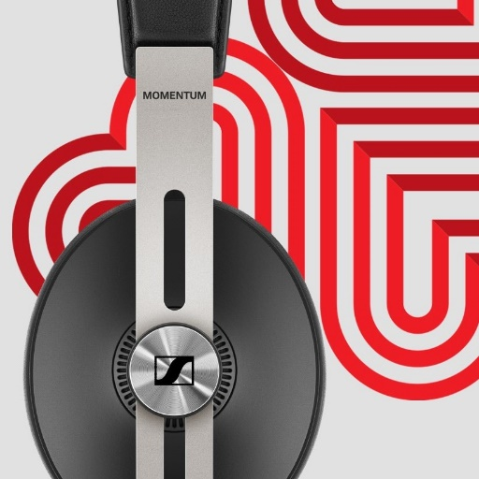
For the stylish someone
MOMENTUM WIRELESS
+ Smart features such as Auto On/Off and Smart Pause ensure you never miss a beat
of your favourite holiday song
+ Superior sound: reproduces the balanced depth and precision of a studio recording
+ Three Active Noise Cancellation modes and Transparent Hearing function
+ A touch of indulgence: genuine, soft leather on the earpads and headband
+ One-touch access to voice assistants
+ Almost impossible to misplace thanks to the integrated Tile Bluetooth tracker
MSRP: $599.95 AU
https://en-au.sennheiser.com/momentumwireless

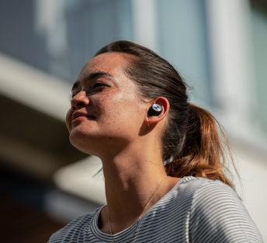
Something they’ll adore
MOMENTUM TRUE WIRELESS
+ Exceptional sound performance
+ Transparent Hearing feature for optional improved situational awareness
+ Intuitive touch interface and direct access to smart assistants
+ Pure design featuring metallic details on the outer face and a stylish fabric-wrapped case
+ 4-hour battery life that can be extended to up to 12 hours via the compact case with integrated power bank
MSRP: $499.95 AU
https://en-au.sennheiser.com/truewireless-details

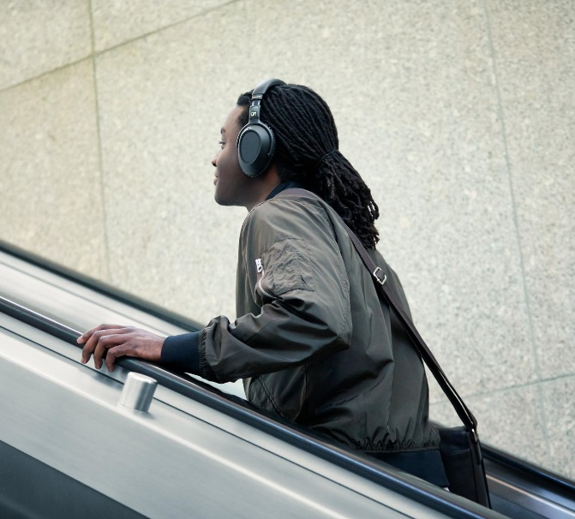
For the frequent traveller
PXC 550-II WIRELESS
+ Wireless headphones created for a smart and sophisticated travel experience – perfect when coming home for the holidays
+ Undisturbed, superior sound in any environment with adaptive noise cancellation
+ Intuitive operation via touch pad
+ Convenient one-touch access to voice assistants
+ Travels the world on a single charge: up to 20 hours of battery life with Bluetooth and ANC switched on, and up to 30 hours when using ANC and a wired connection
MSRP: $549.95 AU

https://en-au.sennheiser.com/pxc-550-ii

About Sennheiser
About Sennheiser Shaping the future of audio and creating unique sound experiences for customers – this aim unites Sennheiser employees and partners worldwide. Founded in 1945, Sennheiser is one of the world’s leading manufacturers of headphones, loudspeakers, microphones and wireless transmission systems. Since 2013, Sennheiser has been managed by Daniel Sennheiser and Dr. Andreas Sennheiser, the third generation of the family to run the company. In 2018, the Sennheiser Group generated turnover totalling €710.7 million. www.sennheiser.com

Press Contacts
Sennheiser Australia & New Zealand Hausmann
Heather Reid Lauren Benson
Public Relations Manager Consultant
T: +61 (0)448 119 609 T: +61 404 242 262
heather.reid@sennheiser.com lauren.benson@hausmann.com.au

