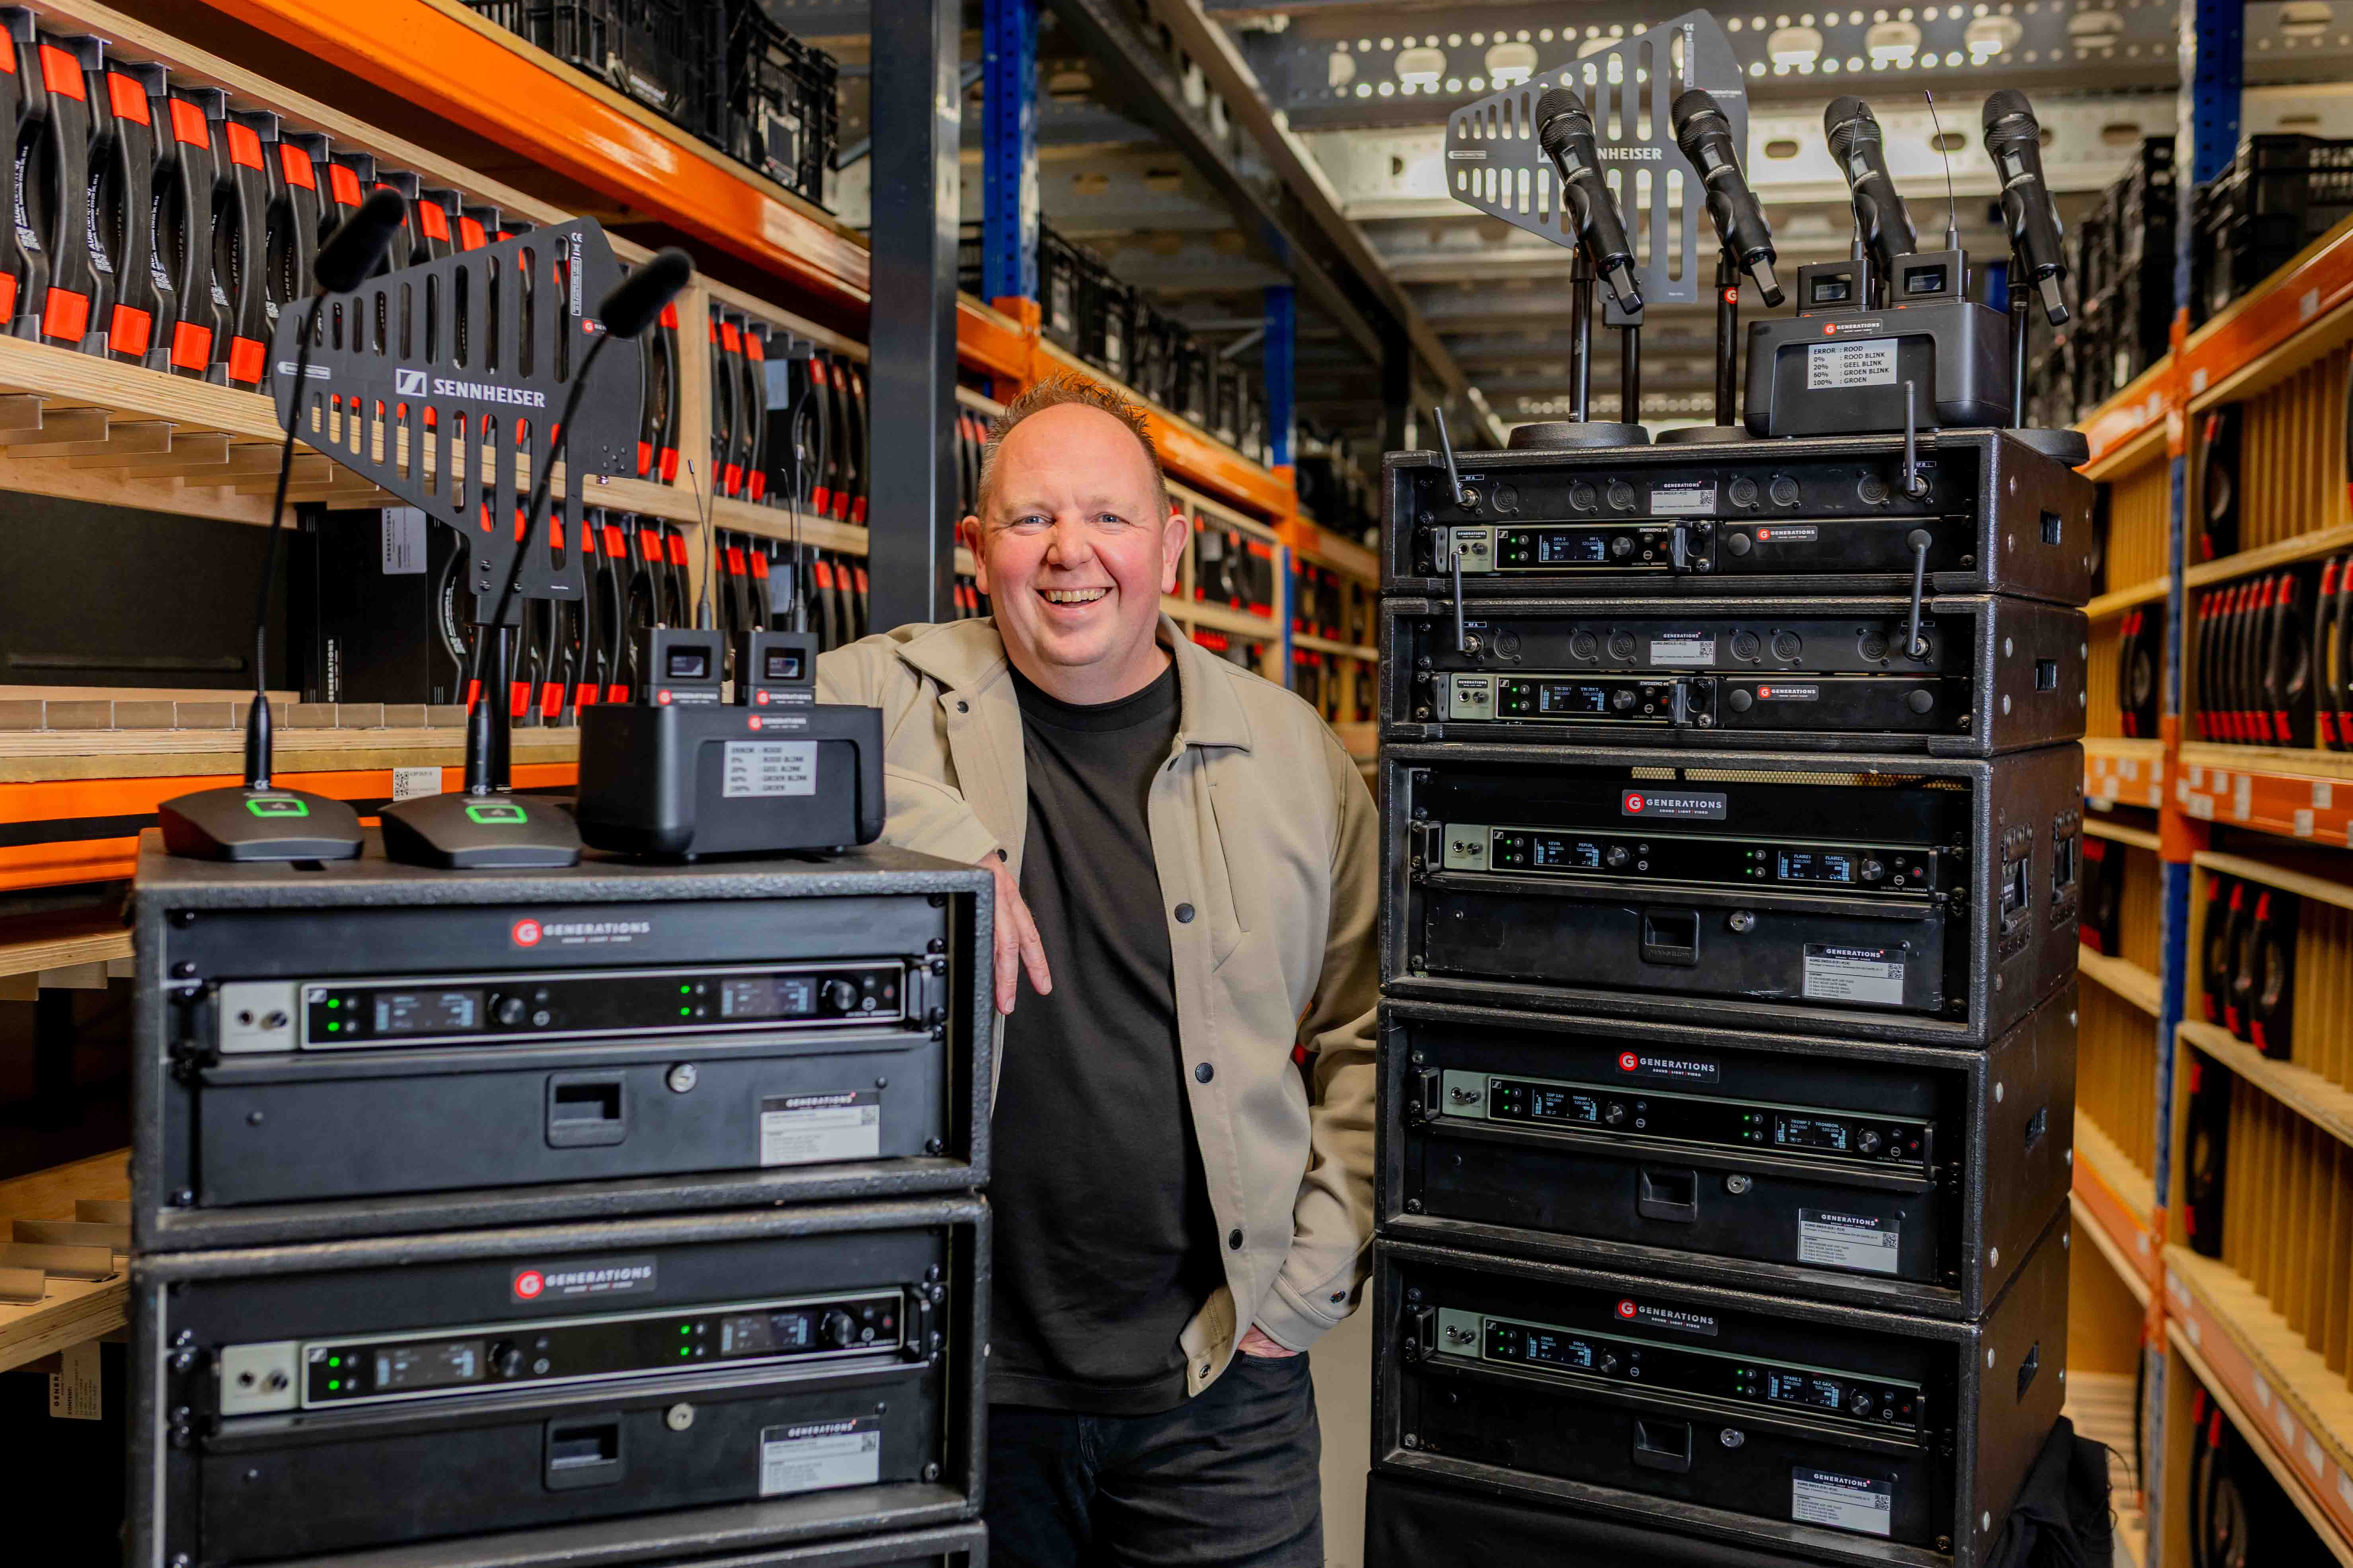

# Generations – Creating unforgettable live experiences in the Netherlands and beyond

**Event technology specialists ramp up on Sennheiser EW-DX systems**

***Wedemark, 3 June 2025* – Generations is one of the Netherlands’ most successful event technology specialists. The 40-strong team around Sander Koers (Operations & Technical Director), Joey Quak (Commercial Director) and Chantée van Amerongen (Personnel and Financial Director) not only provide sound, light, video and rigging rental, but also act as a one-stop solution provider for live audio events, from theatre productions to corporate events, for theme park shows, government installations and sports events. A team of experienced technical producers is at the intersection between the customer and the audience, making breathtaking ideas come to life. Generations was one of the very first customers to add the new Sennheiser EW-DX wireless microphone systems to their audio offering.**

|  |  |
| --- | --- |
|  | At Generations’ new premises in Maasdijk, customers can get anything from rental and installation to a fully-fledged live event service |

“We do a little bit more than dry hire stuff,” says Koers modestly. “We design solutions for customers.” In fact, the customer’s vision and ideas take centre stage when Generations’ sales team and one of the company’s six technical producers put their heads together to work on an ideal production solution. Bringing in their ample expertise, the technical producer will collaborate closely with the customer. Can their client’s bold vision be made reality? Will it respect their budget? Who will set the event up and who will support on site?

Besides the technical production crew and the sales team, Generations features a technical department tasked with fixed installations, a repairs workshop and a warehousing team.

|  |  |
| --- | --- |
|  | Sander Koers, founder and Operations & Technical Director of Generations |

In the warehouse, 48 EW-DX receivers, a combination of two- and four-channel models, are ready to be used on the next job. The EW-DX receivers are regularly used with handhelds and bodypacks, but the wireless table stands are a welcome solution, too, especially for Generations’ government business.

“The foremost reason for investing in EW-DX is its reliability,” explains Koers. “We have projects out there that are running for two to three months without any technical support. An example would be a theme park show. That has, say, three or four actors, but no technician on site. And the only technical problem that we’ve had so far was that actors had forgotten to recharge or change the batteries.

“The advantage of EW-DX is its integration into our Q-SYS environment, so we can see remotely ‘It’s not a wireless issue, they just forgot to change the batteries.’ This saves a lot of labour for the tech support; they don’t have to drive to the location only to find out that the technical failure was actually a mere battery pack problem.

“We’re using Q-SYS, we’re using Yamaha with Dante – it’s great to not have to use old-fashioned analogue plugs and stuff. You stay in the digital domain, and for the management, the technician, this is far more convenient.”

|  |  |
| --- | --- |
|  | Frank Zwinkels, Head of Audio, with the new EW-DX systems |

**Going strong for 25 years**

Coming originally from the theatre world, Koers made his very first foray into the event industry 25 years ago, when he founded “Generations Drive In Show”. In the very same year, he entered a partnership with his theatre colleague Gaby van Amerongen, and the two of them started operations under the business name “Generations Light & Sound” in Maasdijk in 2001. Red Bull became their first major customer; and a little later, they added the first music festivals to their roster. The company continued to grow, adding more and more renowned customers such as Efteling and finally moving into new, bigger premises in 2004.

Back in those days, Generations still used the professional Sennheiser VHF models, and the then brand-new evolution wireless systems that had first hit the market in 1999. “This was a big change, because there were many productions that simply didn’t need or couldn’t afford the high-end stuff but still wanted reliability and a lot of channels. With evolution wireless, we were able to set up more than 80 channels in productions that normally wouldn’t have had the budget for that. I think that was the biggest change for us where Sennheiser helped us grow our business, enabled us to do more things wirelessly but still in a reliable way and also very acceptable soundwise.”

|  |  |
| --- | --- |
|  | Sander Koers (l) and Gaby van Amerongen |

By 2014, the company had expanded so much that it needed to operate three sites to store their equipment. It was time for another move, this time to ‘s-Gravenzande, where all operations were re-united under one roof.

In 2018, the team sadly lost co-owner van Amerongen to cancer. Koers set up a management team with Joey Quak and Chantée van Amerongen. As a tribute to Gaby van Amerongen, the the company’s new CI, which was introduced a year later, included a white G in a red circle.

In 2020, Covid hit, and hard times began for the live industry and in fact the entire economy. Generations set up a pop-up studio in their warehouse, moving it to World Wings Hotel after many successful jobs.

In 2023, another move brought Generations back to Maasdijk, into a yet bigger and more functional building. Ivo Dousi, Generation’s direct contact at Sennheiser, is thrilled: “I’ve known Generations for four years now, they were still in the “old” building then, which was already impressive. But where they are located now is really next level! Sander has built a fantastic company with a large group of enthusiastic engineers.”

|  |  |
| --- | --- |
|  | The lobby at Generations’ new premises in Maasdijk |

**Active in all fields**

Generations sees a healthy growth both with their event customers and their installation clients. “Many customers find us when they are looking for something that is not a standard solution,” says Koers. “We very often find ourselves sitting in special projects, where a director says ‘Hey, I want to do this but I don’t know how – can you do that? Can you fix that?’ And then we usually create something wireless, like recently in a theme park, where two cars had to move around with the same in-sync sound. Our clients often prefer to have time code, too, these are the solutions we’re creating for them.”

“If the customer does not specify one of our various other brands, we will provide Sennheiser wireless because that is the best way for us to ensure we have a reliable installation, we have a product that we know in and out,” he continues. “We also have many units in our rental stock, so if there is a problem, we can easily switch a product with a unit from our rental stock and it’s fixed.”

**The future of rental**

“What is probably special about us is that we offer more programmes than just rental or sales,” says Koers. “We also do ‘pay per use’. A couple of our customers have an event site or venue, which we fully equip with our technical solutions, and they can opt to pay per use. So the equipment is there all year round, but they only pay if and when they are actually using it. With this programme, our customers only have to invest in the venue itself and not in the technical gear. And we can change it whenever needed. I think that will be the new form of business that everybody will be adopting going forward, hardware as a service, and not just hardware but the whole solution.”

Koers sees a mindshift in the business: “All younger generation clients embrace that fully, while older generations still think they are earning more money if they buy the equipment themselves. And it’s really a mindshift to pay for a solution. The solution will be your wireless mic that is working, and it’s not the problem of the customer if we use a transmitter, a receiver, a mixer, and speakers for that. That is our problem. You pay for a solution, you pay for your audience to hear you, that summarises it. That is going to be a big change in our workfield in the next years. Old-fashioned rental companies will have to learn to work with these solutions.”

|  |  |
| --- | --- |
| A lorry is loaded in the Generations warehouse: Reducing logistics movements and the volume and weight of the transported equipment will be key in the years to come |  |

**Going green**

Asked about the biggest challenge for rental and event companies in the next few years, Koers mentions the challenge of going green. “We need to reduce our logistics movements. There might also be a change in venues’ event policies, probably they are going to say ‘It’s more interesting to have our own system again’ instead of having it brought in on a daily or weekly basis, because we will need to reduce the transfers in a city or wherever we are. You can see it starting in all the government-related contracts we get, where we are asked to deliver with an electric vehicle. This limits us regarding space and the amount of gear we can bring. Reducing the volume and weight you are transporting will be one of the challenges that everybody in the live event industry has to tackle.”

“With EW-DX now having four channels in a rack unit, we save a lot of space in transport,” he adds. “It’s probably not the most common thing to think of, but when we are adding up all the small things for a production and we can save 50 rack units with all the products we are bringing, this will help us to win truck space.”

Generations is well equipped for the future, and ready to bring live events to remember to diverse audiences, always in close and pleasant collaboration with its customers.

<https://www.generations.nl/>

(Ends)

The high-resolution images accompanying this media release plus additional images can be downloaded [here](https://sennheiser-brandzone.com/share/cBRwaEvkfHFyddVJoJs9).

**About the Sennheiser Brand – 80 Years of Building the Future of Audio**

We live and breathe audio. We are driven by the passion to create audio solutions that make a difference. This passion has taken us from the world’s greatest stages to the quietest listening rooms **–** and made Sennheiser the name behind audio that doesn’t just sound good: It feels true. In 2025, the Sennheiser brand celebrates its 80th anniversary. Since 1945, we stand for building the future of audio and bringing remarkable sound experiences to our customers. While professional audio solutions such as microphones, meeting solutions, streaming technologies and monitoring systems are part of the business of Sennheiser electronic SE & Co. KG, the business with consumer devices such as headphones, soundbars and speech-enhanced hearables is operated by Sonova Holding AG under the license of Sennheiser.

[www.sennheiser.com](http://www.sennheiser.com)

[www.sennheiser-hearing.com](http://www.sennheiser-hearing.com)

**Global Pro Audio Press Contact**

Stephanie Schmidt

stephanie.schmidt@sennheiser.com

+49 (5130) 600 – 1275