November 10, 2017
Toyota Motor Corporation
GAZOO Racing Company

Rally Australia: Preview
Australia the final test for the Yaris WRC in its development season

The TOYOTA GAZOO Racing World Rally Team will conclude its debut season in the FIA World Rally Championship season at Rally Australia on November 16-19. At the end of a campaign where learning and car development has been the main priority, the Yaris WRC will be put through its paces competitively for one last time this year by Jari-Matti Latvala and Esapekka Lappi.
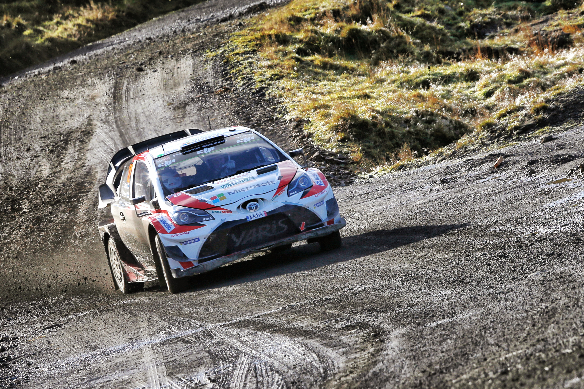

Esapekka Lappi, Janne Ferm

Rally Australia is held in New South Wales on varied gravel roads, with a combination of tight and twisty forest tracks and fast and flowing sections across open countryside. Trees line the side of the roads in many places, ready to catch out the unwary, while hanging dust can also be an added challenge.

The rally is based in the coastal city of Coffs Harbour, and begins just to the north on Friday morning with three new-look stages that are then repeated in the afternoon. Friday and Saturday end with two passes of a sea-front super special stage in Coffs Harbour. The rest of Saturday’s action takes place to the south and includes the 49-kilometre Nambucca stage, which is separated in two for the afternoon pass. There are five stages on Sunday, with the second pass of Wedding Bells as the Power Stage.

Quotes:
Kaj Lindström (Sporting Director)
“I’m very pleased that Tommi asked me to take on the role of Sporting Director. It’s a big challenge for me and I’m really looking forward to it. I’ve been around rallying for a long time as a co-driver, including this year with TOYOTA GAZOO Racing, so I know what happens during a rally weekend. But there are also a few different things that I don't know about yet: a lot happens before the event and during the rally, while I used to be on the stages as a co-driver. So there are things that will be new for me, and I’m going to Rally Australia as a bit of a rookie in the job! The team’s preparation for the event has been good and I believe we can do well there. Jari-Matti has done it many times before, and Esapekka did well there in WRC2 last year. The weather forecast shows that there might be some thunderstorms during the rally, which could make things interesting!”

Jari-Matti Latvala (Driver car 10)
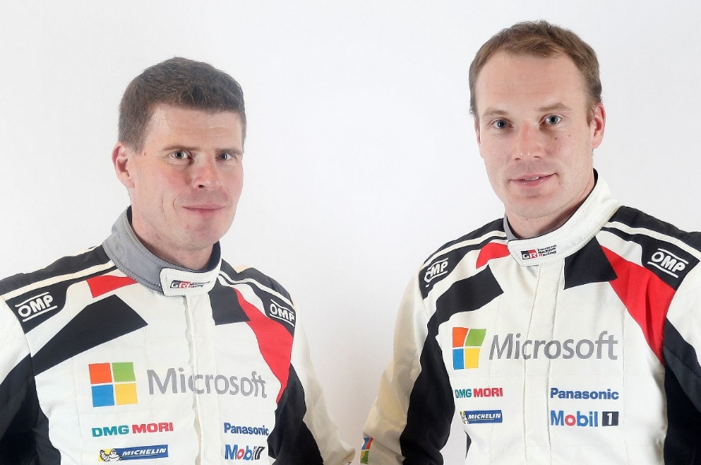
“I’m really looking forward to Rally Australia. It’s a nice event to finish the year, usually in warm conditions and sunshine. The stages are fast and flowing and it’s a rally that I have pretty much always enjoyed. This year there will be some new sections and parts that have not been used for a long time. On Rally GB we struggled slightly but I think the Yaris WRC should be well-suited to the stages in Australia. Personally I want to go out there and really push for the podium, and if we could challenge for the victory that would be even better.”
Miikka Anttila and Jari-Matti Latvala

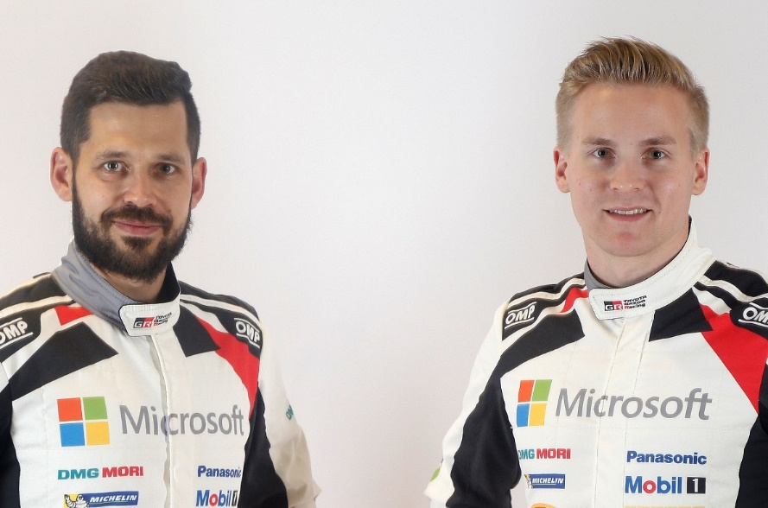
Esapekka Lappi (Driver car 11)
“One of the main characteristics of Rally Australia is the loose gravel on top of the surface, so the first cars have to do a lot of road sweeping. Further down the order it should be better, but it is really important to keep the car on the racing line. Another challenge will be tyre management, as the second pass of the stages can be quite hard for the tyres, and if the weather is warm we will need to look after them. We weren’t so successful in Britain, but it should be better for us in Australia hopefully. We certainly want to have a good season finale.”
Janne Ferm and Esapekka Lappi

The statistics (Rally Australia):
Year | Jari-Matti Latvala | Esapekka Lappi
2016 | 9 | 8
2015 | 2 | -
2014 | 2 | -
2013 | 4 | -
2011 | 2 | -
2009 | 4 | -

2017 FIA World Rally Championship for drivers after round 12:

1 Sebastien Ogier 215
2 Thierry Neuville 183
3 Ott Tanak 169

4 Jari-Matti Latvala 136
5 Elfyn Evans 118

6 Dani Sordo 95

7 Juho Hänninen 71

8 Kris Meeke 70
9 Craig Breen 64

10 Hayden Paddon 59

12 Esapekka Lappi 51

2017 FIA World Rally Championship for manufacturers after round 12:

1 M-Sport World Rally Team 398
2 Hyundai Motorsport 305

3 TOYOTA GAZOO Racing WRT 241

4 Citroen Total Abu Dhabi World Rally Team 210

Team Media Hour – Rally Australia

Wednesday 15 November at the TOYOTA GAZOO Racing World Rally Team hospitality in the service park, with drivers and management present, from 18:30-19:15. All media are welcome.

Press release
URL: http://toyotagazooracing.com/release/2017/wrc/rd13-preview.html

Pictures will be uploaded here during the event
URL: https://www.tgrwrt.com/ ( ID and Password needed)

Follow us!
Follow TOYOTA GAZOO Racing WRT:
∇Facebook: https://www.facebook.com/TOYOTAGAZOORacingWRC
∇Twitter: https://www.twitter.com/TGR_WRC (@TGR_WRC)
∇Instagram: https://www.instagram.com/tgr_wrc/ (@TGR_WRC)
∇YouTube: https://www.youtube.com/channel/UCCtALHup92q5xIFb7n9UXVg

<Contact>

TOYOTA GAZOO Racing PR Office
Email: tgr_pr @rights-apartment.com

TOYOTA GAZOO Racing Official website
http://toyotagazooracing.com/

TOYOTA GAZOO Racing World Rally Team is supported by following partners:

