PR Asset Downloads

PATCH & TWEAK with Moog Is Now Available Worldwide
Author, designer, and electronic musician Kim Bjørn’s highly anticipated book about Moog semi-modular synthesizers, PATCH & TWEAK with Moog, is now available worldwide.
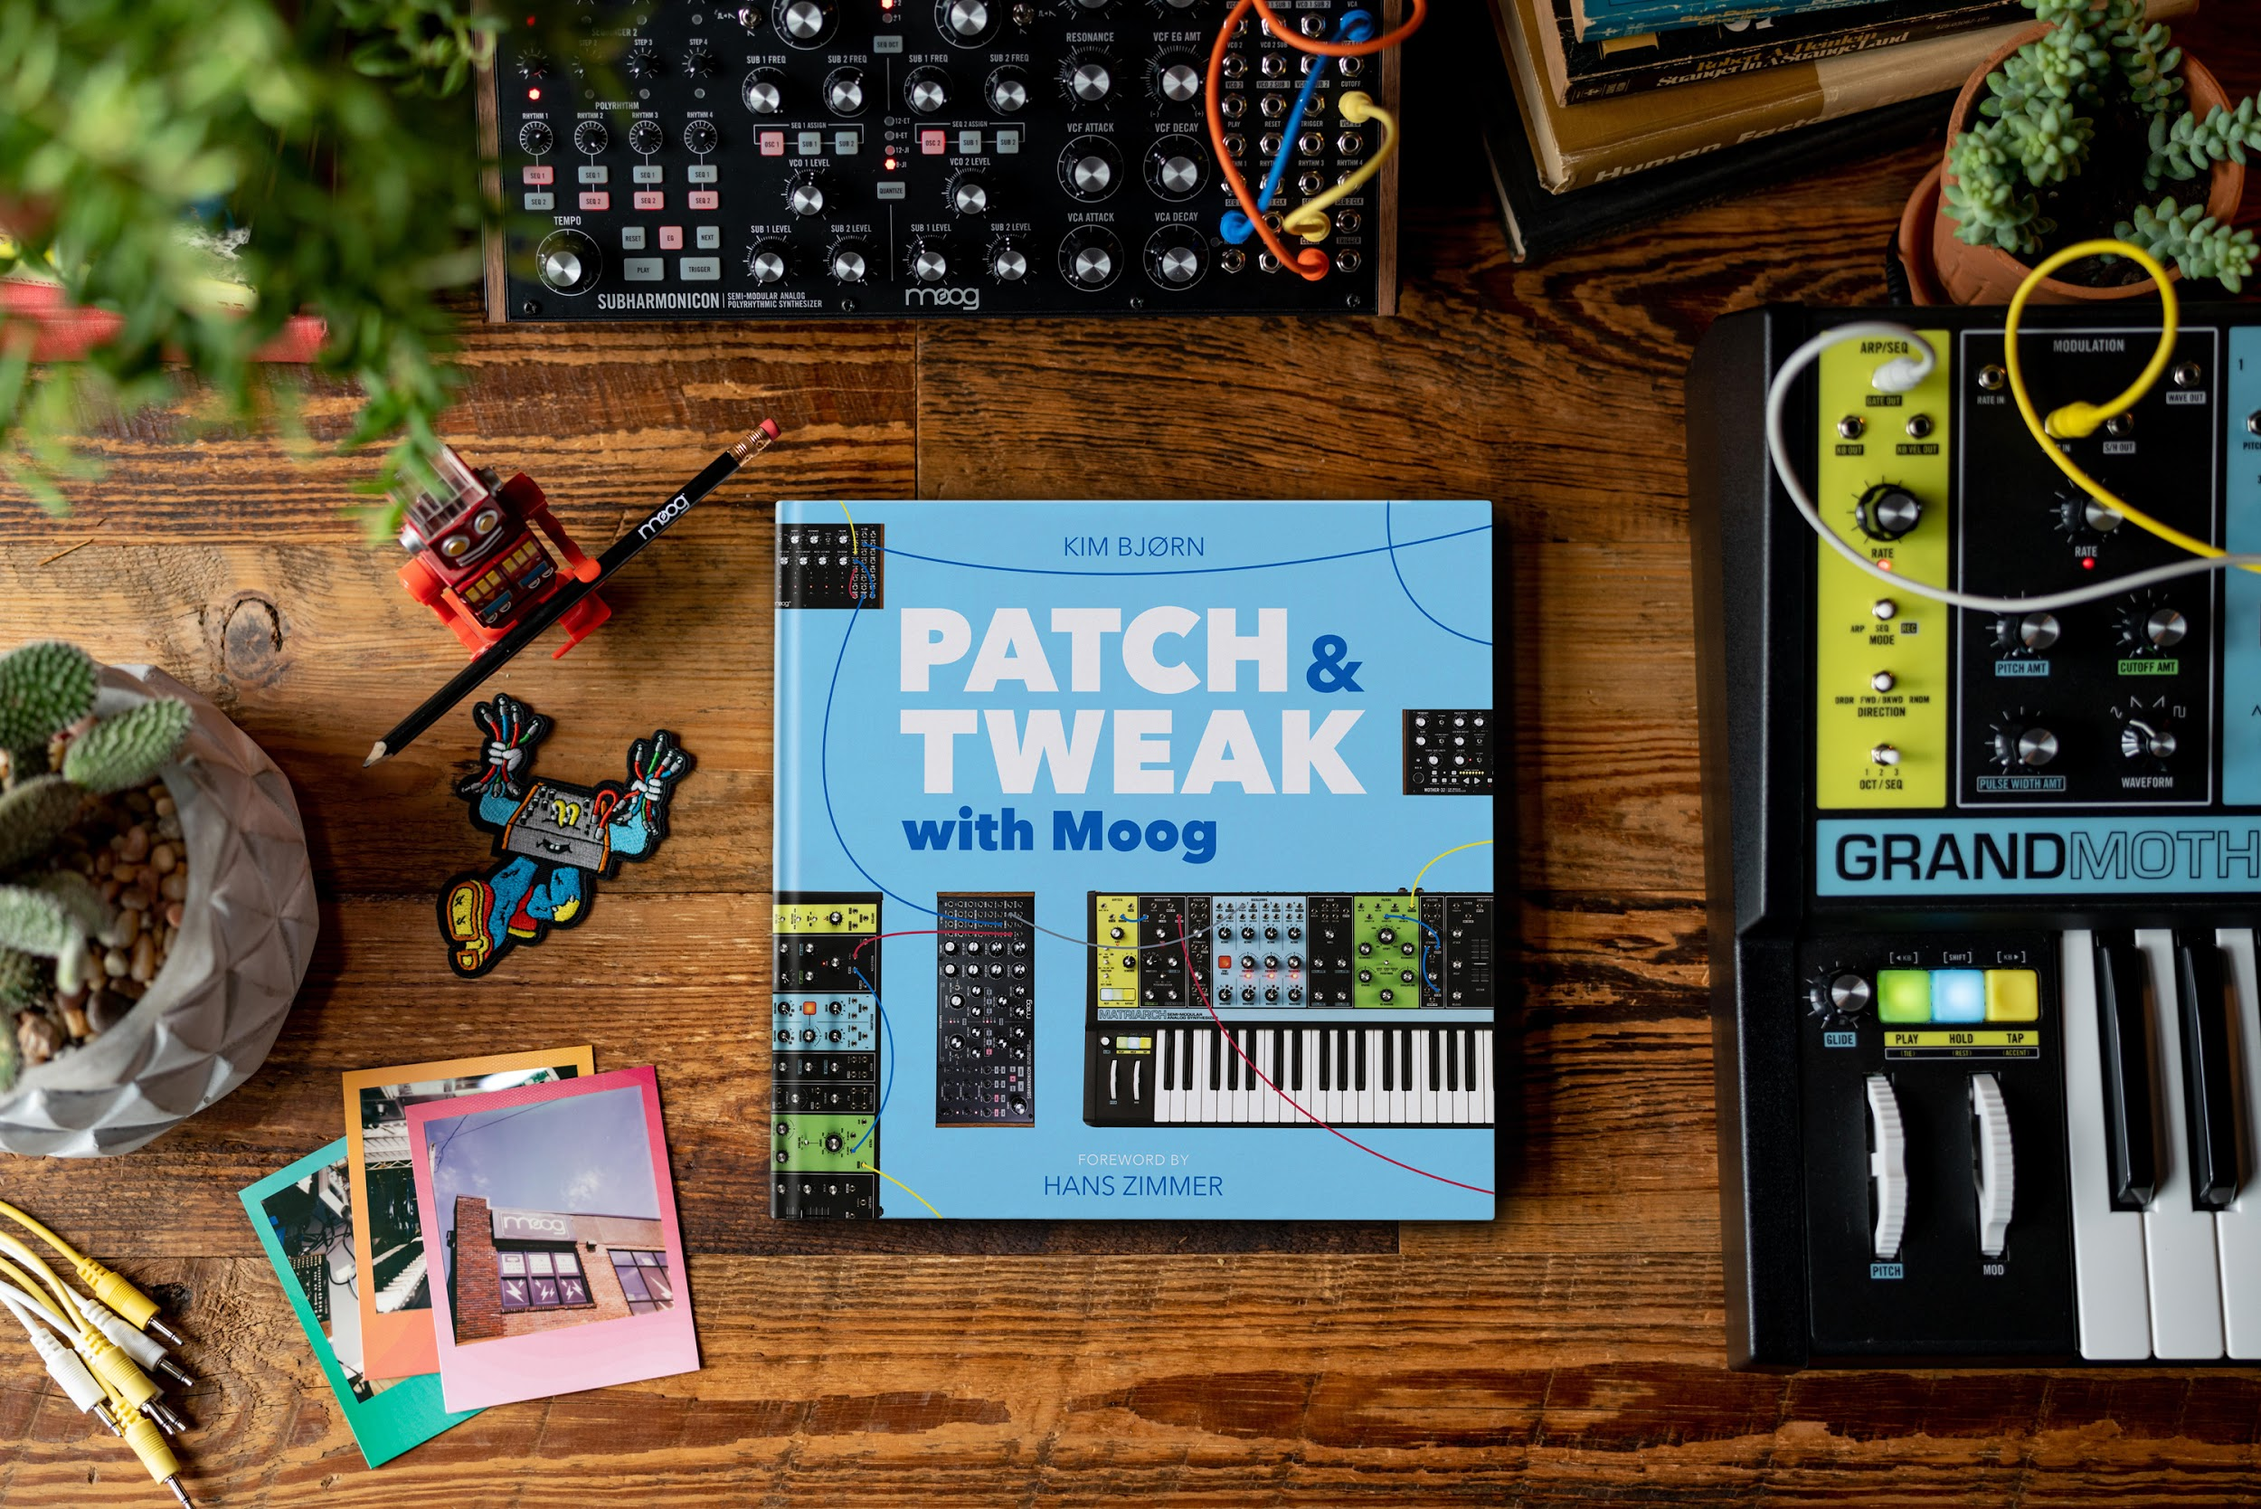
Just in time for the holiday season, PATCH & TWEAK with Moog is the perfect gift for any synthesizer enthusiast. The 200-page book covers everything from electronic music history to modern applications of Moog Music’s newest semi-modular instruments.
Readers will explore more than 100 tips, ideas, and patches to use as creative inspiration on their journey of exploring sound, ensuring artists of any skill level can experience the joy of analog synthesis.
Click here for a sneak peek of PATCH & TWEAK with Moog.
Click here for more details and online ordering.

