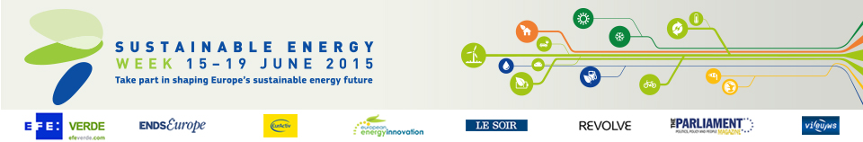

Energy Days in the United Kingdom (11)
- Worcestershire Environmental and Energy Expo
Date: 02/06/2015
Time: From 9:00 to 14:00
Location: Malvern, Worcs.

- Harnessing Community Energies
Date: 04/06/2015 - 05/06/2015
Time: From 9:00 to 17:00
Location: Forres

- Open Forum: Community Energy
Date: 15/06/2015
Time: From 19:00 to 21:00
Location: Swansea

- Planning for a Changing World: new opportunities from energy and adaptation
Date: 16/06/2015
Time: From 10:00 to 17:00
Location: London

- Distributed Energy Generation: Opportunities & Challenges
Date: 17/06/2015
Time: From 7:45 to 10:45
Location: Nottingham

- The Smart Electricity Consumer: Realising the electricity demand-side resource
Date: 17/06/2015
Time: From 18:00 to 19:30
Location: London

- REECH Dissemination Event
Date: 18/06/2015
Time: From 9:30 to 3:30
Location: Liverpool

- Imagining a sustainable future at Warwick
Date: 19/06/2015
Time: From 12:00 to 14:00
Location: Coventry

- Horizon 2020 for offshore renewables - lessons learned & future opportunities
Date: 23/06/2015
Time: From 12:30 to 17:30
Location: Glasgow

- LCRI Report Launch
Date: 24/06/2015
Time: From 9:30 to 14:00
Location: Cardiff

- Your Green Future
Date: 25/06/2015 - 26/06/2015
Time: From 9:00 to 15:00
Location: Cheltenham

