QUEENS OF THE STONE AGE

UNVEIL NEW SONG ‘THE EVIL HAS LANDED’

TAKEN FROM THEIR FORTHCOMING ALBUM ‘VILLAINS’ OUT 25th AUGUST ON MATADOR RECORDS

UK Tour For November - London O2 Arena Sold Out.

Preorders Live Now Including Instant Grat “The Evil Has Landed” and First Single “The Way You Used To Do”

‘Perhaps the most preposterously exciting Queens Of The Stone Age song ever’
MOJO Magazine on ‘The Evil Has Landed’, July 2017

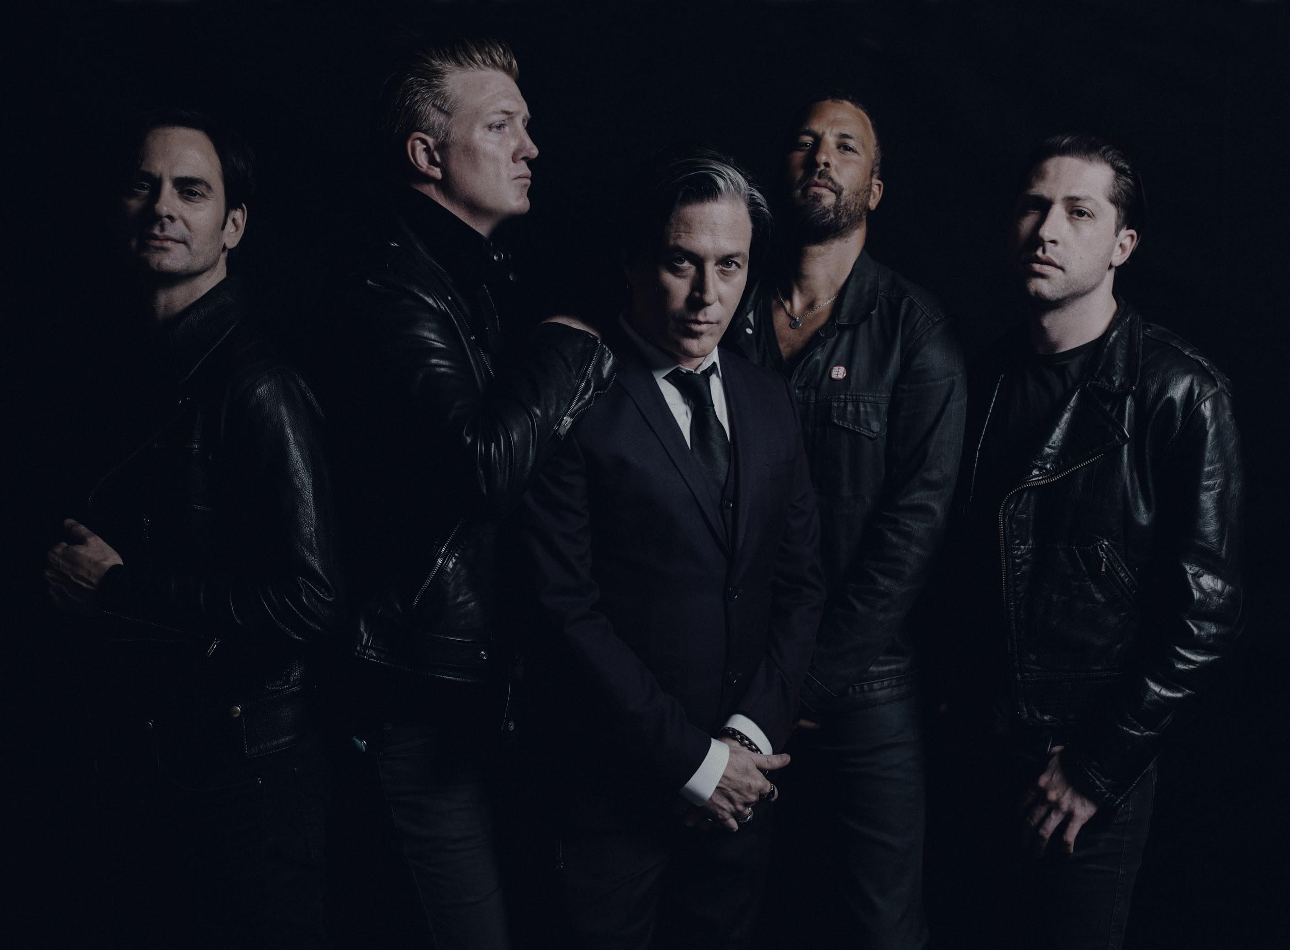

Queens Of The Stone Age today unveil ‘The Evil Has Landed’, premiered by Zane Lowe as his World Record on Beats 1, the second track to be released from their eagerly anticipated album ‘Villains’ (out August 25th on Matador Records). Produced by Mark Ronson, and written by Josh Homme, Dean Fertita, Mikey Shuman and Troy Van Leeuwan, ‘The Evil Has Landed’ sees Queens on classic form in a monstrous six and a half minute epic. Melding fuzzed out melodic guitars, trademark falsetto vocals, and lyrics of hedonistic abandon, the tracks’ grinding groove giving way to a gloriously full blown boogie.

Produced by Mark Ronson and co-produced by Mark Rankin and mixed by Alan Moulder, Villains is the first full album offering from Queens Of The Stone Age since 2013’s …Like Clockwork gave the band its first #1 album in the U.S. (and #1s in Australia, Belgium, Ireland, Portugal, Scotland, #2s in the UK, Canada, Switzerland, Norway, New Zealand, Finland… but really, who’s counting?). Like the stunning artwork of returning illustrator Boneface, the sonic signatures of the lineup that took …Like Clockwork around the world and back—Founder/guitarist/vocalist/lyricist Joshua Homme, Troy Van Leeuwen (guitar, keys), Michael Shuman (bass), Dean Fertita (keys, guitar), Jon Theodore (drums)—are as unmistakable as ever, though coexisting with sufficient new twists to induce recurring double takes.

Already garnering a wealth of critical acclaim ahead of it’s August 25th release, ‘Villains’ is now available for preorder on deluxe vinyl, standard vinyl, CD and digital (all formats include an instant download of first single “The Way You Used To Do”).

QUEENS OF THE STONE AGE VILLAINS UK and Ireland Tour details:

Saturday 18th November London Wembley Arena
Sunday 19th November Manchester Arena
Tuesday 21st November London O2 Arena - SOLD OUT
Thursday 23rd November Edinburgh, Usher Hall - SOLD OUT
Friday 24th November Dublin 3Arena

Remaining tickets on general sale here

Praise for Villains

'Villains is brilliant. It's all the things that make QOTSA such a thrilling band condensed into a jolting, compact rock record'
Q Magazine **** (four stars)

'Heroic stuff.....Homme had already done more than anyone of his generation to pump new heart into rock. Now with an unlikely ally, he's revived the soul too.'
MOJO**** (four stars)

'A surprisingly welcome balance between Black Sabbath and disco'
Uncut 8/10

'A reinvention that manages to sound both quintessentially QOTSA and forward-thinking... Villains cuts comfortably shoulder the best of QOTSA's back-catalogue'
Kerrang **** (four stars)

'(QOTSA's) most danceable offering yet - and all the better for it'
DIY ***** (five stars)

