EMBARGOED UNTIL 11:59AM EDT MARCH 30TH, 2021

Moog Music Introduces Complete Synthesizer Studio Experience

Moog Sound Studio includes all the equipment, cables, accessories, and educational tools needed to enter the world of analog synthesis for the first time or continue to explore sound in an immersive new way. Now shipping.
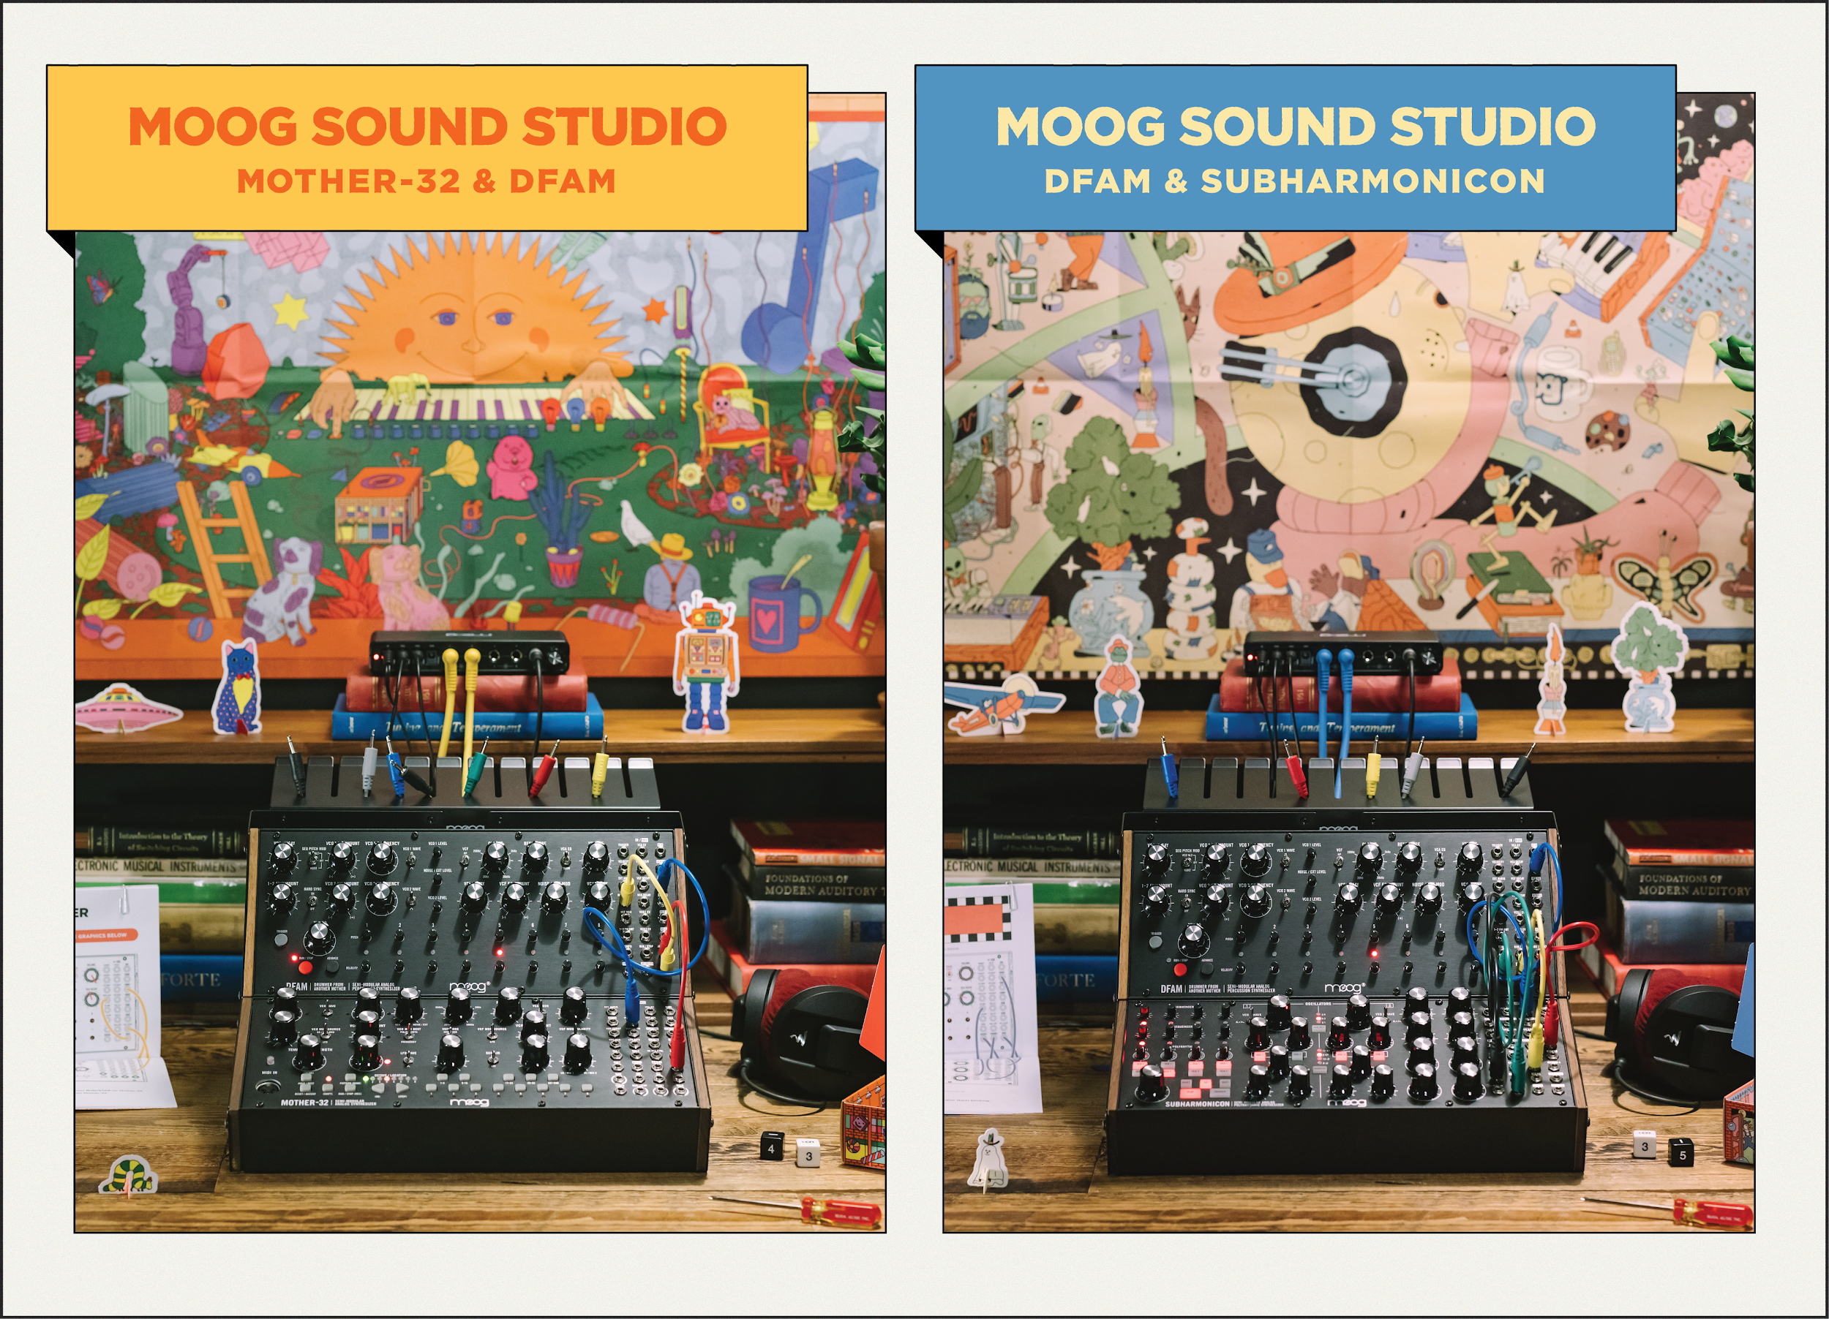
<Hi res images of Moog Sound Studio accompaniments and artwork can be found here>

Moog Sound Studio, a new synthesizer experience from Moog Music, includes all the tools and creative inspiration you need to embark on an immersive sonic adventure. Designed for beginner and seasoned synthesists alike, Moog Sound Studio introduces a uniquely comprehensive approach to exploring modular synthesis.

A Complete Synthesizer Studio Package (Just Add Headphones)
Each user begins their unique Moog Sound Studio journey by selecting an instrument combination that speaks to their musical style or sonic preference: Mother-32 & DFAM or Subharmonicon & DFAM.

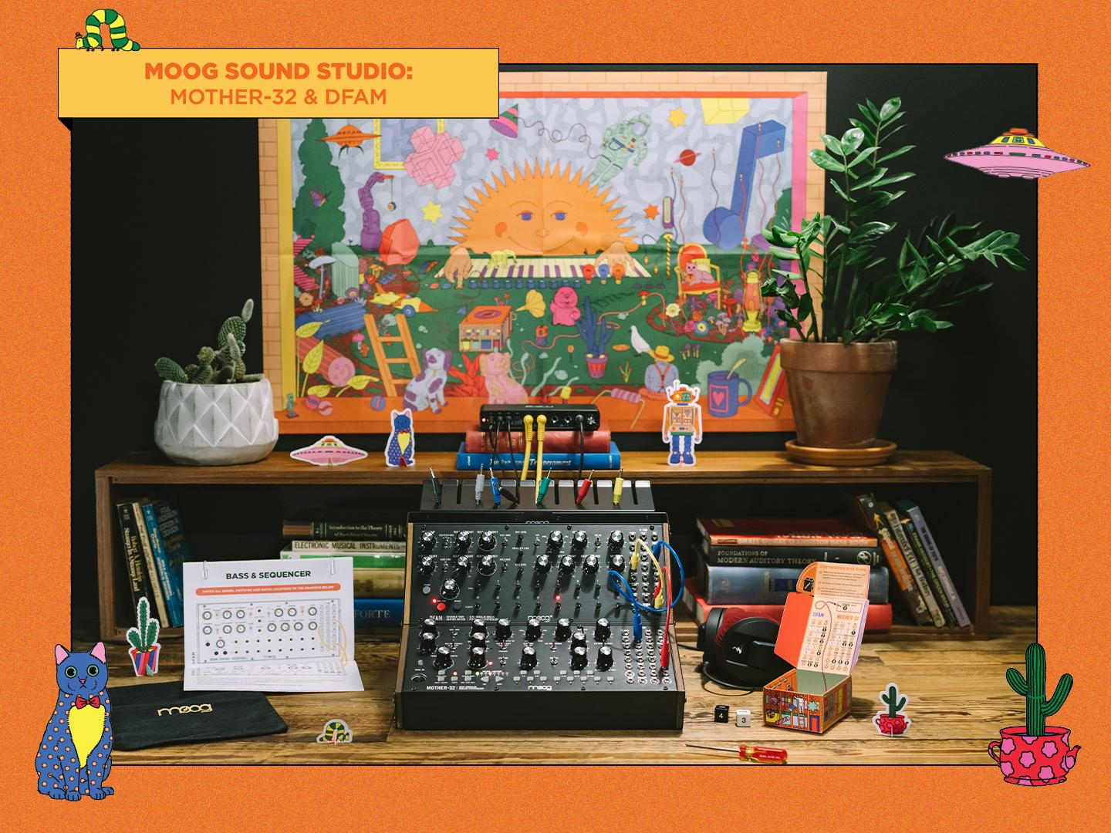

Moog’s Mother-32 and DFAM synthesizers are a perfect pairing to anchor any electronic studio. Mother-32 is a versatile performance and production synthesizer with a powerful step sequencer and 64 slots of sequence memory. Its classic Moog voice delivers raw analog sound, deep Moog bass, and soaring synth leads, which complement DFAM’s rich analog rhythms and percussive patterns.

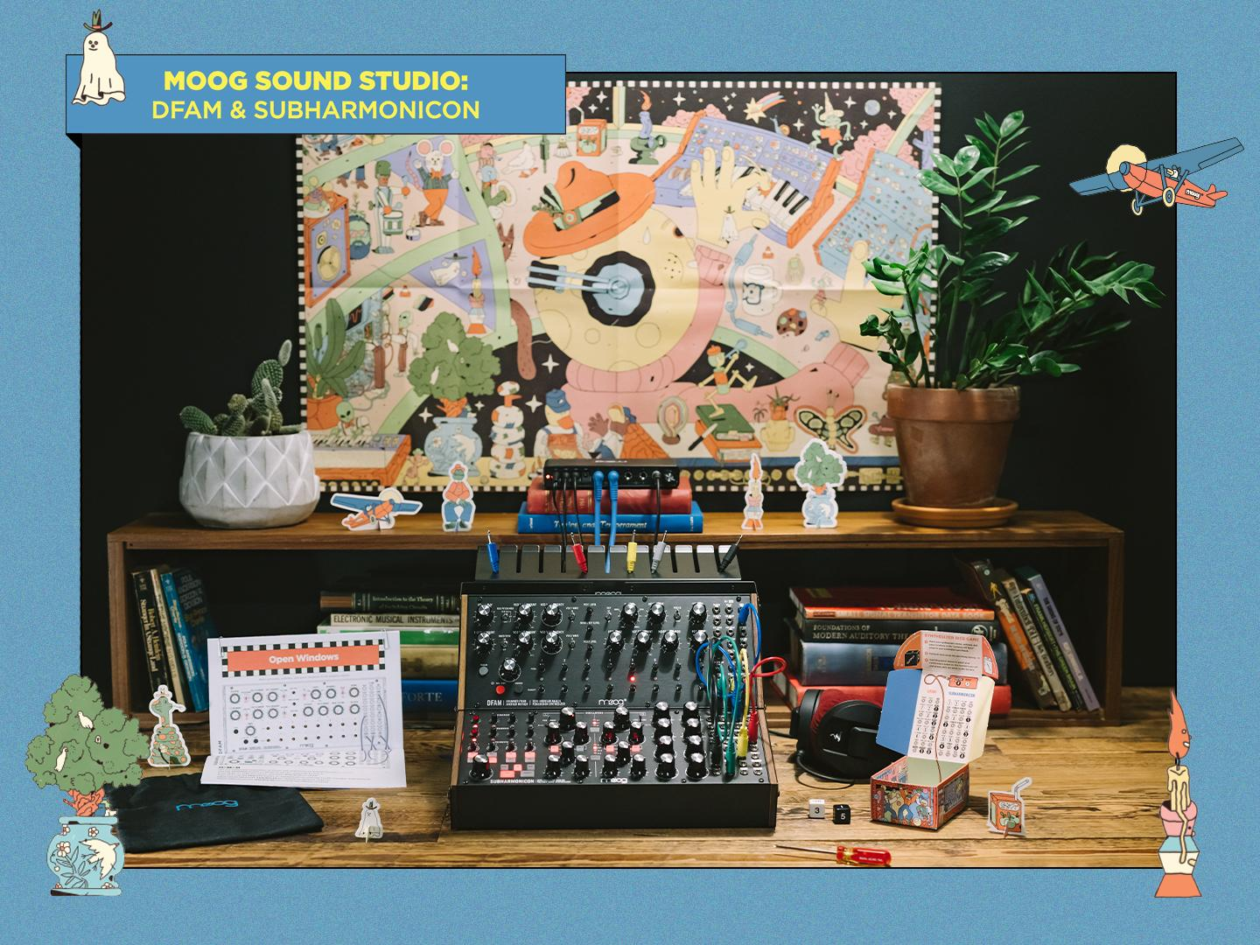

For a more experimental journey with unexpected textures and sounds, choose the magical combination of Subharmonicon and DFAM. Subharmonicon is a rich sonic kaleidoscope of six-tone subharmonic chord shapes and polyrhythmic sequences, while DFAM presents an inspiring approach to drum synthesis and rhythmic pattern creation.

While each instrument is uniquely powerful alone, pairing two together allows for an experience that will inspire you to create new sounds, unlock novel behaviors, synchronize patterns, and explore endless sonic possibilities.

Along with the chosen duo of semi-modular analog synthesizers, each Moog Sound Studio includes an audio mixer and power distribution hub, a two-tier rack mount kit, patch cables and a patch cable organizer, guided exercises and patch book, educational materials, games to encourage experimentation, custom artwork designed exclusively for Moog Sound Studio owners, and plenty of creative inspiration.

The perfect foray into Eurorack for those new to modular, as well as a creative tool for experienced synthesists to grow their sound design skills, Moog Sound Studio offers an inviting creative environment and experience for all.

To learn more about Moog Sound Studio and find an authorized Moog dealer near you, click here.

Developing the Moog Sound Studio Experience
When Moog introduced its Mother-32 semi-modular analog synthesizer in 2015, the instrument helped introduce a whole new community to the limitless world of modular synthesis. Its family of semi-modular synthesizers has since expanded to become a full-fledged ecosystem of powerful, approachable, and inspiring electronic instruments (Mother-32, DFAM, Grandmother, Matriarch, and Subharmonicon).
The creative potential of these instruments led to opportunities for multi-sensory installations at public events worldwide, inviting visitors to discover synthesis through experiences that encourage them to get lost in their surroundings. Through these activities, Moog’s employee-owners quickly learned that users with any level of experience can feel comfortable and excited about sound exploration with the right tools, guidance, and creative space.

Along with these learnings, Moog’s development of the complete sonic exploration station that is Moog Sound Studio is a direct response to years of feedback from the growing synthesizer community. The all-in-one solution for beginning or continuing a journey in sound design includes everything the creator needs for an immersive, self-guided experience from any home or studio.
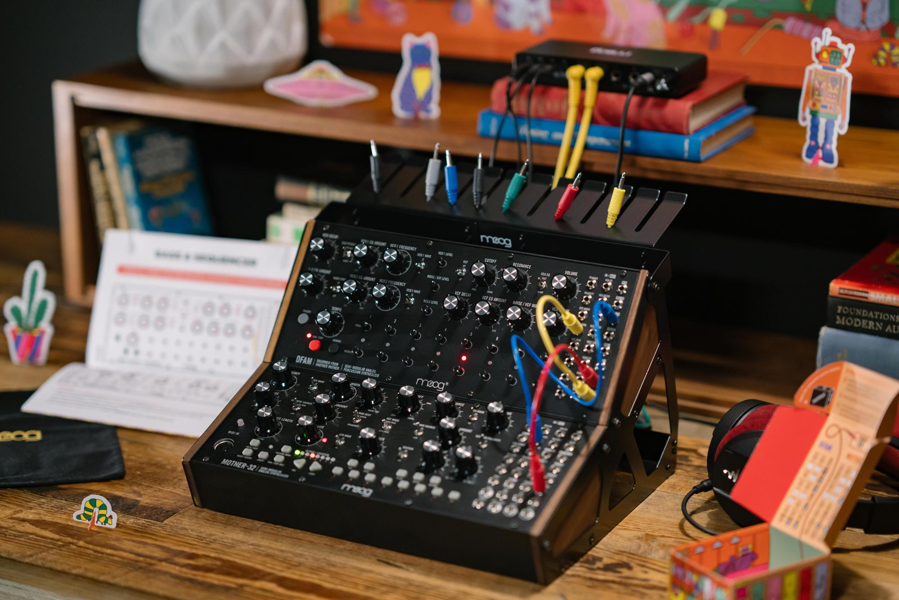

Artist Collaborations: Original Tracks & Visual Artwork
Ever since analog synthesizer pioneer Bob Moog collaborated with composer and educator Herb Deutsch to develop the first Moog modular synthesizer in 1964, artist collaboration has been at the heart of Moog Music’s story.

Moog’s creative team worked with various artists to develop original visuals, characters, learning tools, and tracks to bring the Moog Sound Studio environment to life.

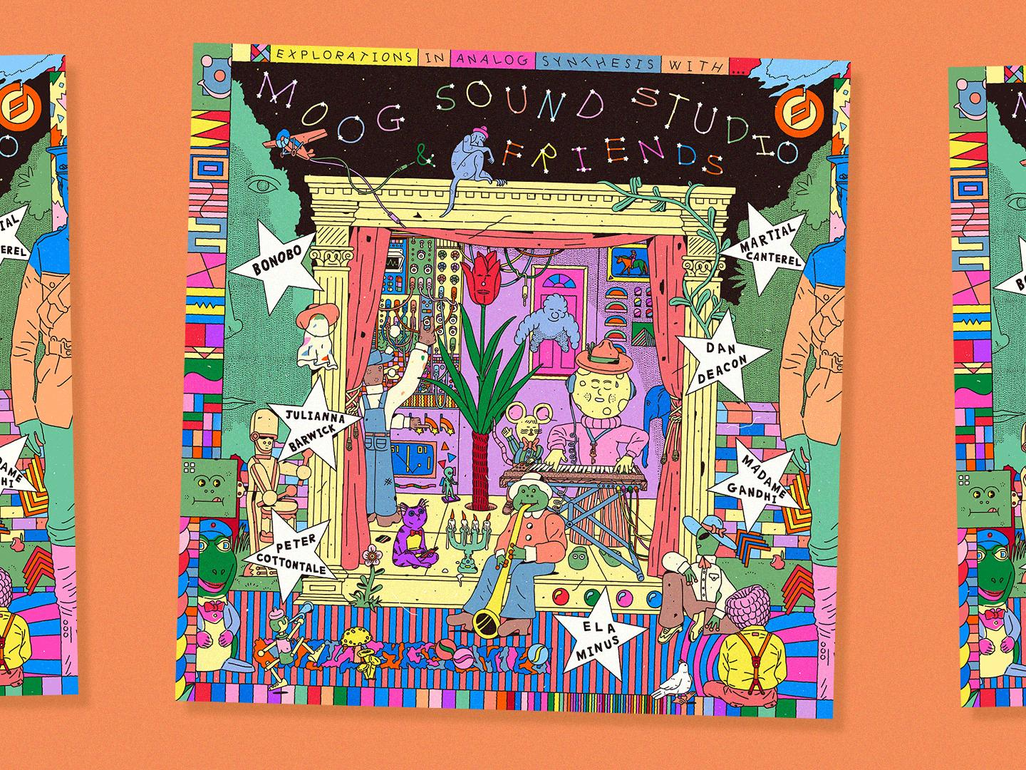

New Compilation EP: Explorations in Analog Synthesis
Explorations in Analog Synthesis is a new seven-song EP created to demonstrate the powerful analog sound and infinite sonic possibilities of both Moog Sound Studio synthesizer combinations.

This genre-bending compilation of original electronic music compositions features a chiptune-inspired head trip from Bonobo, an R&B-influenced synth pop track from Peter Cottontale, an ethereal vocal collage from Julianna Barwick, an evolving psychedelic excursion from Dan Deacon, a driving percussive electronica track from Madame Gandhi, an emotive dark wave song from Martial Canterel, and an industrial-tinged electronic pop track from Ela Minus. Each track was built around the instruments and accessories included in each artist’s Moog Sound Studio of choice: Mother-32 & DFAM or Subharmonicon & DFAM.

Explorations in Analog Synthesis is available to stream for free on Moog’s SoundCloud and Bandcamp.

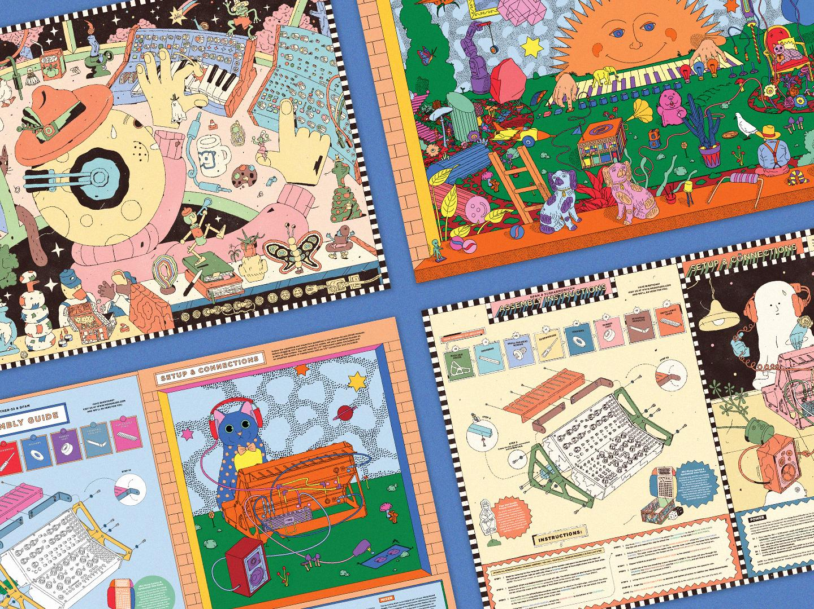

Engaging Visuals to Complement Your Journey in Sound
Each Moog Sound Studio is designed to stimulate a multi-sensory experience. From the instruments’ classic analog tones and textures to the look and feel of designing a new patch, the creative process is just as much about the physical environment as it is about the tools at hand.

To bring this magical world of analog synthesizers to life visually, illustrators Jim Stoten (Mother-32 & DFAM) and Philip Lindeman (Subharmonicon & DFAM) designed custom artwork in the form of characters, posters, and other interactive objects that accompany each instrument setup. These materials were created to be constant sources of inspiration for users while exploring sound in a whole new creative environment.

Now Available at Moog Dealers Worldwide
Each Moog semi-modular synthesizer is built with love by the employee-owners at the Moog factory in Asheville, NC. To order your complete synthesizer studio package of Mother-32 & DFAM or Subharmonicon & DFAM, contact your favorite local Moog dealer.
Click here to find an authorized Moog dealer near you.

More about Moog Music
Moog Music is the world’s leading producer of theremins and analog synthesizers. The employee-owned company and its customers carry on the legacy of its founder, electronic musical instrument pioneer Dr. Bob Moog. All of Moog’s instruments are built with love inside its factory in downtown Asheville, North Carolina. Learn more here.

