

Biuro prasowe better. gaming agency
bettergamingagency.prowly.com

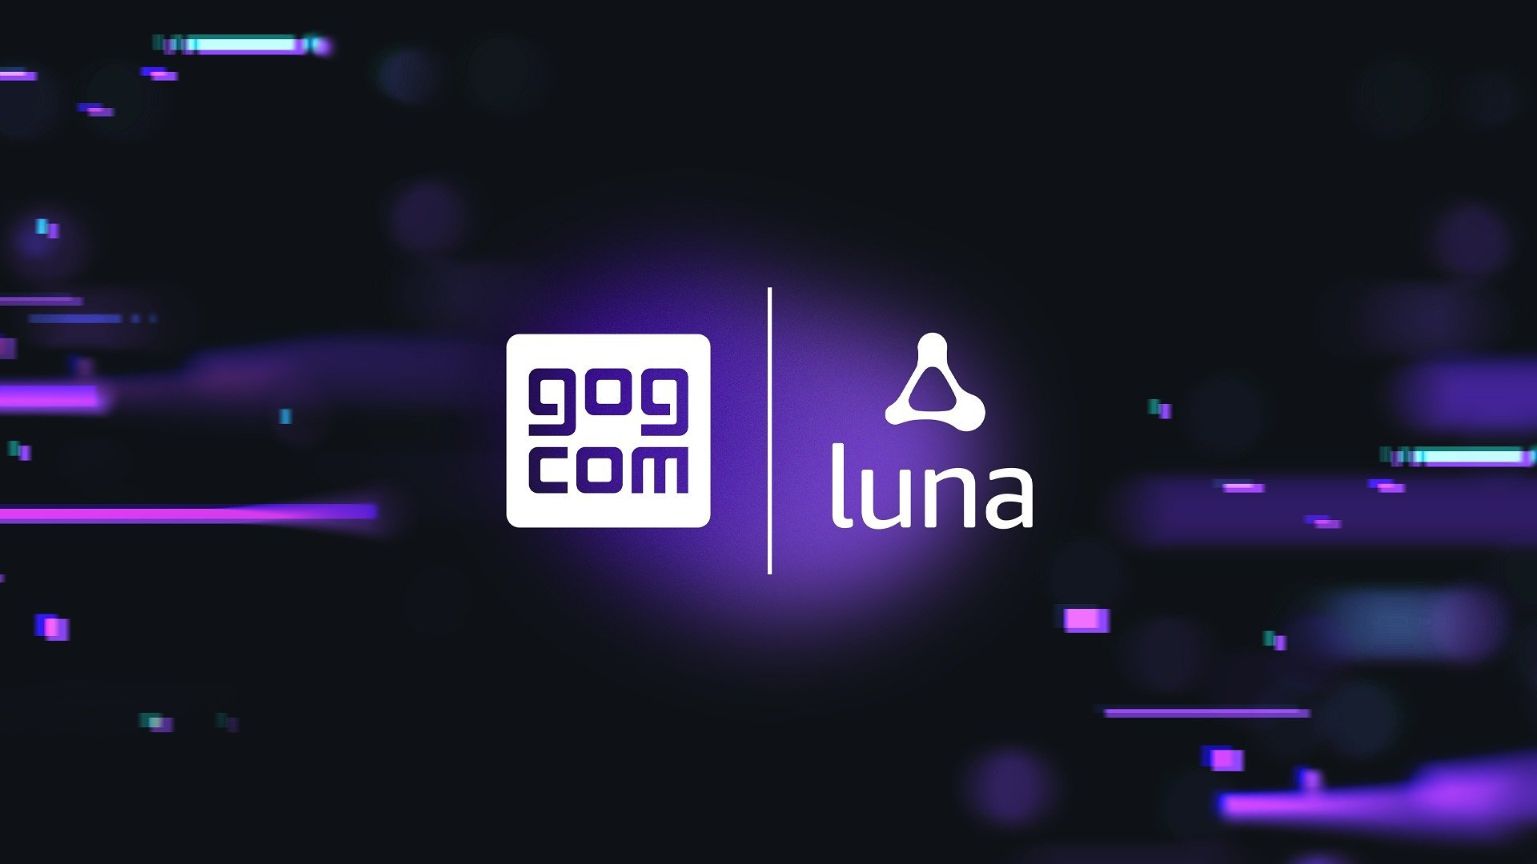

GOG joins forces with Luna – millions of Amazon Prime members can now play DRM-free games on more devices and wherever they want!

With GOG and Amazon’s partnership continuously blooming, even more opportunities appear on the horizon. The next step is teaming up with Amazon Luna to bring GOG’s catalog to the cloud gaming service. This should please not only gamers but also developers who have been given a new way to reach millions of users.

Soon, players will be able to play their favorite games from GOG, such as the Witcher series or Cyberpunk 2077, on multiple devices of their choice. With Amazon Luna cloud gaming service, offering even more ways to enjoy games and DRM-free gaming.

Through Luna players will be allowed to play every game already owned on GOG (and that is also available on Luna). There’s absolutely no requirement to purchase anything twice – once bought on GOG, it belongs to the owner forever. Moreover, it works both ways - games available on GOG can be purchased through Luna’s client, seamlessly integrating into the store library.

In other words, buying games on GOG (directly on our service or via Luna) will give players the best of both worlds – enjoying them on Luna’s cloud gaming service, as well as via offline installers or GOG GALAXY. All DRM-free benefits of owning games on GOG will still be there, offering more ways to play your favorite titles.

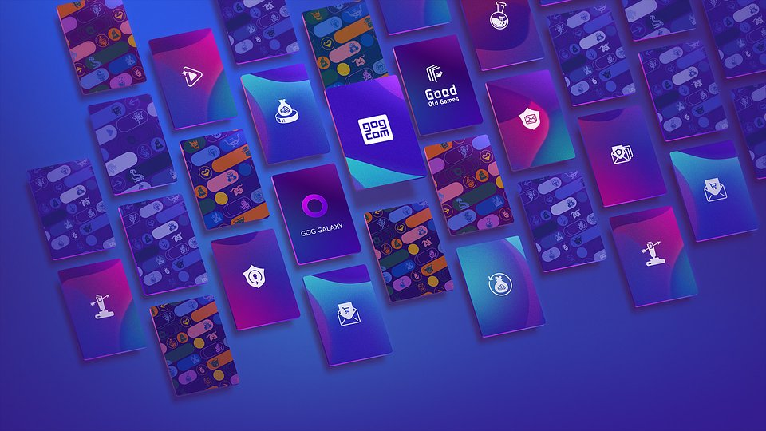

Already owned devices (PCs, smart phones, tablets, Fire TV devices and smart TVs) can become new gaming setups, and Luna also supports peripherals, such as Xbox One and Playstation 4 controllers, and mouse + keyboard. Luna also offers its own Luna Controller, which makes it even easier to seamlessly transition a game from one screen to the next.

For developers and publishers, this is a perfect way to expand the reach of their games. It’s easy to opt-out, and doesn't have any additional build requirements. On top of that, it’s the same agreement with additional revenue. Luna’s cloud gaming service is already operational and expanding across multiple countries. Here’s what Luna offers to its game developers, publishers, and titles today:

● Luna games are prominently featured on Amazon devices like Fire TV and Fire Tablets with 200+ million devices sold globally.● Access to reaching Amazon Prime customers through Prime Gaming.● Dedicated marketing support and packages for games across critical touch points including: Amazon.com, Luna merchandising, socials, and more.● Ability for players to enjoy games across any Luna-compatible device, unlocking new ways to play their favourites.

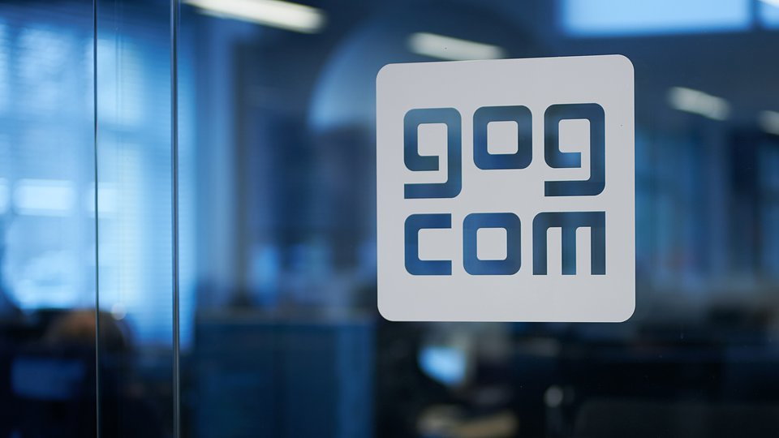

While it’s a great opportunity for game creators and publishers, this partnership offers a fair amount of perks for the players’ community, too. For those whose current gaming rig isn’t powerful enough to handle the latest releases, for gamers who are often away from home and still want to play, or for those who sometimes just want to change their environment while continuing to play – Luna is the perfect solution in all those scenarios.

Developers can freely submit their games by using this form.

More details can be found on GOG's official blog. Check out GOG's extensive library of DRM-free games and play them on Luna now!



Jakub Smolak
PR Specialist at better. gaming agency
jakub.smolak@bettergaming.pro
Twitter

