Please note that this information is strictly embargoed until April 21, 2023, 19:30 CET

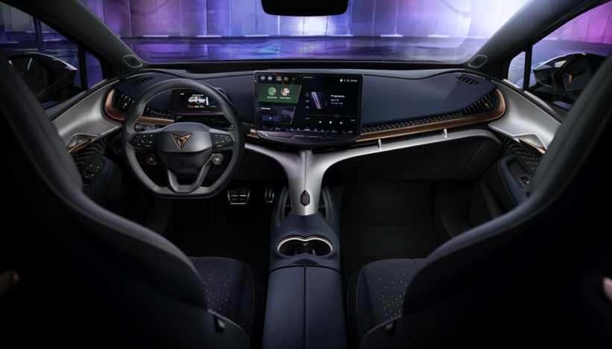
Sennheiser brings audio magic to CUPRA Tavascan, the brand’s first all-electric SUV coupe
Joining the CUPRA tribe, the audio specialist helps deliver an emotional driving experience for the challenger brand’s first hero of a new era

Wedemark, April 21, 2023 – Sennheiser, the globally renowned audio specialist, has joined forces with CUPRA, the unconventional and emotionally-driven challenger brand in the automotive world, to deliver an outstanding immersive sound experience to CUPRA's first all-electric SUV coupe, the CUPRA Tavascan. With its performance, the Tavascan is a game-changer in the world of electrification, breaking conventional rules and delivering for a new generation of car lovers. The partnership between Sennheiser and CUPRA is a perfect match, with both brands sharing a passion for offering technical solutions that are unique in their execution and sophisticated in their design, which are woven into their DNA and culture. And this is just the start: this collaboration is set to redefine the in-car audio experience and push the boundaries of what is possible in the automotive space.

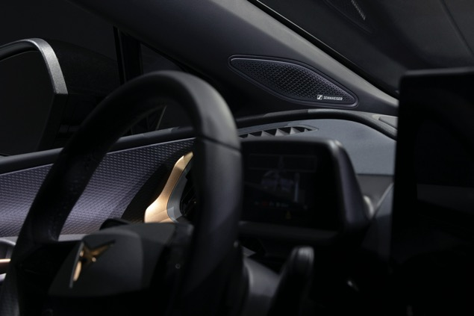 | The partnership between Sennheiser and CUPRA is a perfect match, with both brands sharing a passion for offering technical solutions that are unique in their execution and sophisticated in their design

Digitalisation takes centre stage in the CUPRA Tavascan, an all-electric SUV coupe that seamlessly integrates advanced technology for a truly immersive driving experience. It boasts a state-of-the-art 15-inch infotainment system that is the largest ever seen in a CUPRA model. This highly customisable system is complemented by a newly designed and developed Human Machine Interface (HMI), allowing for seamless interaction with the car's various functions. In particular, the CUPRA Tavascan is equipped with a high-fidelity 12-speaker audio system, with Sennheiser bringing its expertise and experience into the automotive space with AMBEO Concerto, the company’s latest software innovation for immersive audio.

"Both brands share a deep passion for music as an integral part of their brand identity. Through this partnership, we aim to unlock the full potential of audio in-car entertainment," says Veronique Larcher, Director of Sennheiser Mobility. "Our approach is disruptive, rebellious, and unconventional, which is reflected in the unique sound experience we've created for the CUPRA Tavascan."

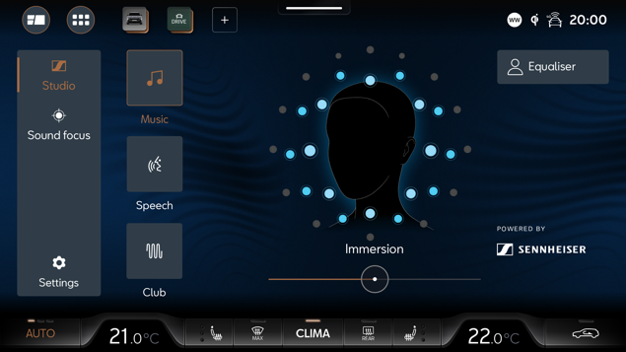 | Sennheiser's AMBEO Concerto software distills the fundamental components of any piece of music, including different instruments and room information, and redistributes them throughout the car

Renowned as a global leader and trailblazer in immersive audio, with a range of category-defining products in both professional and consumer audio, Sennheiser has taken a unique approach to sound quality with the Tavascan, one that goes beyond simply adding more loudspeakers. Instead, the exceptional immersive sound experience is achieved through sophisticated proprietary software, meticulously tuned by Sennheiser’s expert sound engineers.

To achieve this level of audio quality, Sennheiser's AMBEO Concerto software distills the fundamental components of any piece of music, including different instruments and room information, and redistributes them throughout the car. This results in a sound experience that is unlike anything ever heard in a CUPRA before.

The customisation options are equally impressive. The Tavascan's head unit allows users to customise the level of immersion and fine-tune the sound to their individual preferences.

“This is all part of CUPRA’s and Sennheiser's commitment to delivering a premium audio experience that is truly personalised,” says Larcher. “Together, we are setting a new standard for the automotive industry, providing an immersive and unique music experience."

Sennheiser has taken a unique approach to sound quality with the CUPRA Tavascan, one that goes beyond simply adding more loudspeakers | 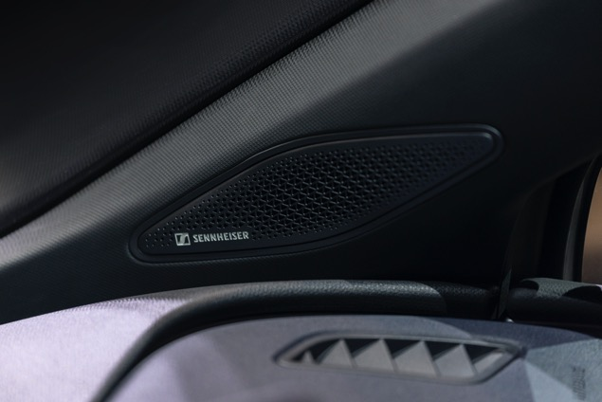

“We are thrilled to have Sennheiser on board, with their expertise in creating innovative audio solutions that have shaped the sound of modern entertainment and earned the company a distinguished reputation as the product of choice for music icons worldwide,” concludes Dr.
Werner Tietz, Executive Vice-President for R&D at CUPRA. “Our vision in 2019 was to reinvent electrification. We wanted to show the world that electric cars could be fun and sexy, with a great design, while providing unique sportiness. It was a dream back then, but with the CUPRA Tavascan, that dream is now a reality. Not only does our Tavascan look great, but it also sounds amazing, thanks to Sennheiser’s exceptional audio expertise.”

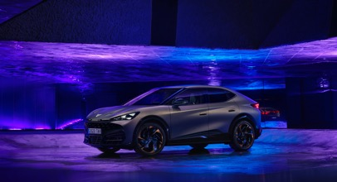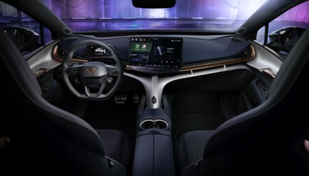

Designed and developed in Barcelona, the CUPRA Tavascan will be produced at the Volkswagen Group’s Anhui factory in China, a state-of-the-art innovation hub for e-mobility.

(Ends)

About the Sennheiser brand
We live and breathe audio. We are driven by the passion to create audio solutions that make a difference. Building the future of audio and bringing remarkable sound experiences to our customers – this is what the Sennheiser brand has represented for more than 75 years. While professional audio solutions such as microphones, meeting solutions, streaming technologies and monitoring systems are part of the business of Sennheiser electronic GmbH & Co. KG, the brand licensing for automotive is operated by Sennheiser Mobility, and the business with consumer devices such as headphones, soundbars and speech-enhanced hearables is operated by Sonova Holding AG under the license of Sennheiser.

About Sennheiser Mobility
With Sennheiser Mobility, Sennheiser brings 75 years of audio excellence and its unique audio software portfolio to everyday driving. The Sennheiser Mobility software delivers the ultimate in audio capture and reproduction to transform the way that people experience content or communicate from the car. As a scalable and adaptive system, Sennheiser Mobility supports the evolution of transportation needs and redefines the in-vehicle audio experience for entertainment and communication.

www.sennheiser.com
www.sennheiser-hearing.com

Global Pro Audio Press Contact
Maik Robbe
maik.robbe@sennheiser.com
+49 (5130) 600 – 1028

