JUAN AYOSO

Gou Estilistas

Juan Ayoso Cerezo is the definition of a hairdresser by vocation. His passion for the trade is innate, and since childhood he has had an insatiable interest in hair and styling. Throughout his childhood he would style both his relatives and himself, always taking care of even the smallest details, and it was clear that his enthusiasm for hairdressing was only going to grow. At eighteen years old he took his first serious step into the profession by deciding to study for a vocational education and training certificate in hairdressing at an Academy in Córdoba.

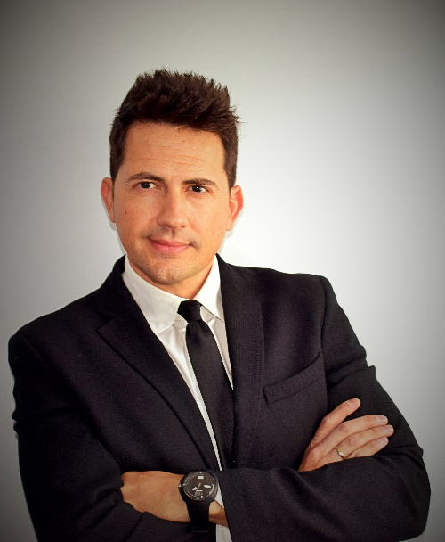
Ayoso has been consolidating his knowledge by attending training courses in different fields such as a session on Monna Lisa extension techniques; a Master Class on up-dos with Estela Guerisoli; Fashion & Color step-by-step training with ALFAPARF; design training at the Pivot Point forum; up-dos training with Pascal Oriani; different workshops about up-dos as well as an Image Consulting course organized by Intercosmo. In his desire to constantly improve, he receives training from international leaders such as Vidal Sassoon, among others.

Juan Ayoso founded GOU Estilistas in 2001, which currently has two salons located in Adamuz and Cabra (Córdoba). The two salons base their work on a philosophy that consists of offering a personalized service. Quality products and thorough work are typical of this brand, combined with an impassioned up-dos experience, and with its own cutting technique based on the methodology of the creator of the firm.

Juan Ayoso has worked for designers such as Tuca Román, María Diván and Norma Azucena, and has taken part in various television programmes in his professional capacity. In addition, he shares his knowledge in training aimed at professionals on topics such as trends, avant-garde or communication skills, face-to-face classes to an online format.

A tireless creator, Ayoso combines his work in the salon with the creation of his own hairdressing collections. Avant-garde, bridal, up-dos… his skills know no boundaries, and his creations have earned him numerous awards and recognitions:

JUAN AYOSO

Gou Estilistas

2020: AIPP Awards Finalist, Avant-Garde category
2020 Finalist at International Visionary Awards, Avant – Garde category.
2020 Finalist at Galardón Nacional Awards Best Educator category.
2019 Semi-Finalist at the TCT Awards, Avant-Garde category.
2019: Andalusian Hairdresser of the Year – Picasso Awards.
2018: Finalist for Andalusian Hairdresser of the Year – Picasso Awards.
2017: Finalist for Andalusian Hairdresser of the Year – Picasso Awards.
2017 Spanish Runner-up in the General Classification (National Association of Personal Image Companies).
2015 Spanish Champion in Cut & Colour (National Association of Personal Image Companies).
2015: Spanish Runner-up in the Classification (National Association of Personal Image Companies).
2012: Champion in Colour at the Lorca Hairdressing Championships.
2012: Third Place in the Lorca Hairdressing Championships.
2011: Third Place in the Santomera Hairdressing Championships.

