

Biuro prasowe better. gaming agency
bettergamingagency.prowly.com

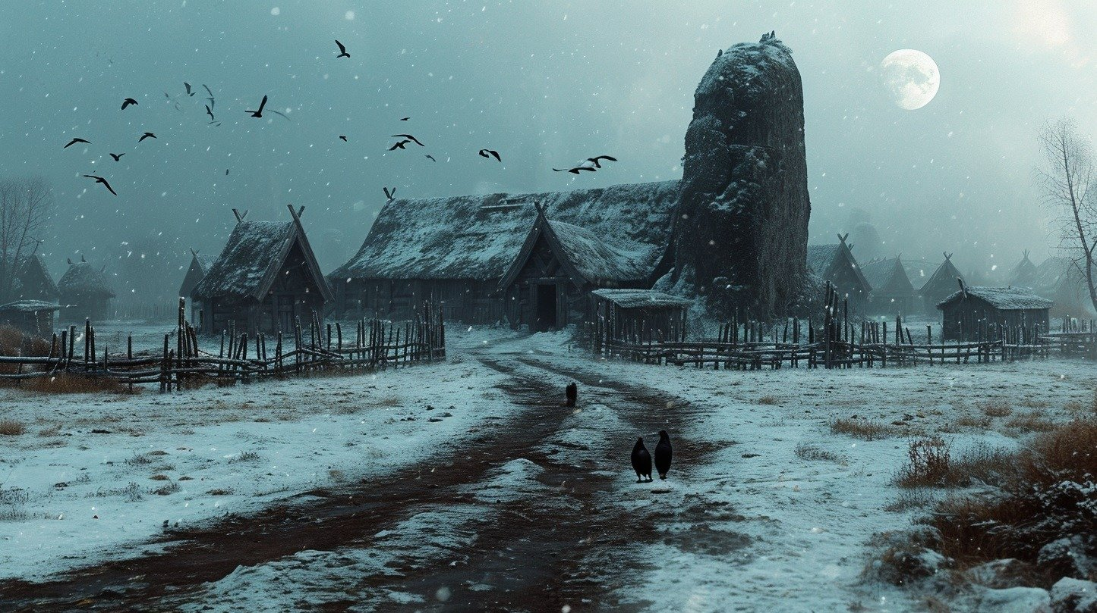

Mighty Koi announces The Night Wanderer and Thorgal - two games based on iconic fantasy settings

The developers from the Polish studio Mighty Koi announced two ambitious projects set in well-established universes. The first one allows gamers to wander as Vuko, the protagonist from the bestselling “Lord of the Ice Garden” book series by Jarosław Grzędowicz. The second title is a game adaptation of the cult adventures of Thorgal – the legend of European comics. Both titles are headed for PC, PlayStation 5 and Xbox Series X|S.

The Night Wandererlets players experience the world known from “The Lord of the Ice Garden” book series. The author, Jarosław Grzędowicz, blends genres and introduces readers to a specific mixture of sci-fi and fantasy, gaining huge popularity in his native Poland and other central and eastern European countries.

Vuko, the protagonist of the books as well as the game, is part of a space expedition with the mission to uncover the fate of previous explorers sent to the planet of Midgaard. At the time of his mission, the alien civilization's technological level can be compared to the early Middle Ages on Earth.

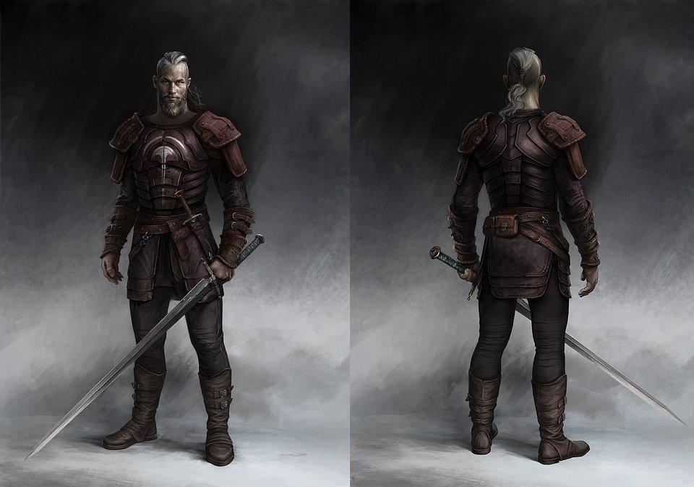

The protagonist has to give up all modern inventions and try to blend in with the inhabitants, without interfering with their rate of development. His only help is a fungi-based biochip, which gives him some superhuman abilities. Upon arrival, Vuko realizes that Midgaard is ravaged by unexplained, almost magical anomalies, which might be linked to the disappearance of the previous expedition.

Mighty Koi promises a dynamic and innovative combat system, which blends soulslike gameplay with RPG and adventure game elements.

The Night Wanderer - announcement trailer

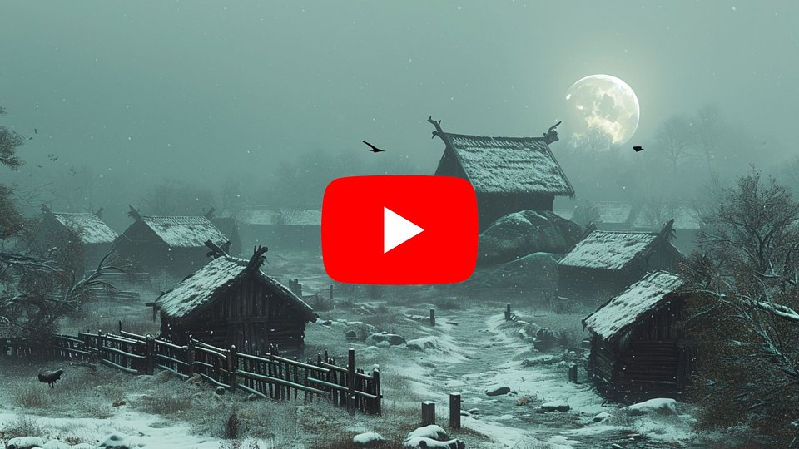
https://www.youtube.com/watch?v=2dlg1jfbvuo

Thorgal is an action RPG set in the mythical norse world, known from comics written by Jean Van Hamme and illustrated by the legendary Grzegorz Rosiński. The adventures of Thorgal were translated into 18 languages and sold in over 20M copies. Now gamers can expect to experience the digital version of this epic saga, which captivated comic fans for decades.

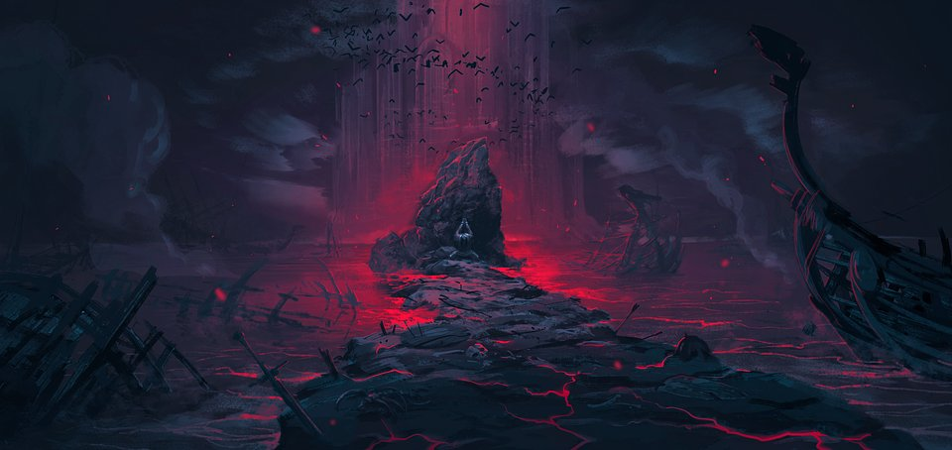

The hero, the mysterious “star child”, must protect his loved ones not only against humans, monsters, but also vengeful gods. Long-time readers will encounter many events and characters from the comics, and newcomers will be introduced to a rich fantasy world, which is being constantly developed since 1977.

Thorgal - announcement trailer

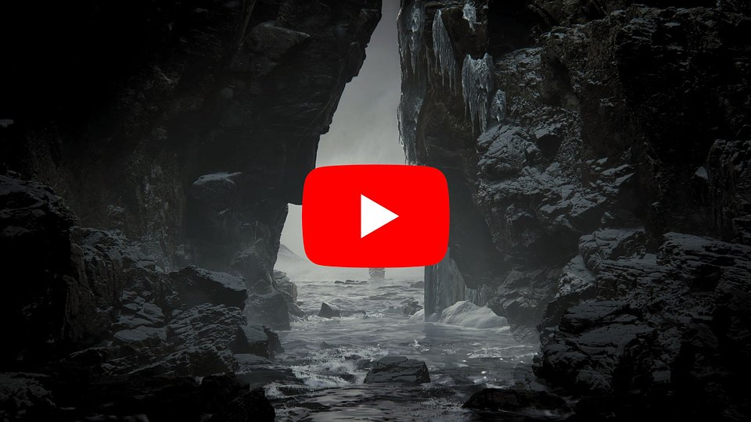
https://www.youtube.com/watch?v=RHAm8lK5pLs

Press kits for both games are available here.

About Mighty KoiFounded in 2022, the studio consists of ca. 100 industry veterans. Some key figures includeCedric Danneels (previously Bandai Namco, From Software), Kiryl Drazdowich (ex-Wargaming), Rafał Gosieniecki (previously Konami, Square Enix), Alex Kozyrev, Sergey Dovgan (both ex-Wargaming) or Maciej Zawitaj (ex-Ubisoft).The goal of Mighty Koi is to develop complex titles with intriguing stories and grand characters - based on established fiction.In its productions it aims to use the latest tech, including photogrammetric and AI tools.



Jakub Smolak
PR Specialist at better. gaming agency
jakub.smolak@bettergaming.pro
Twitter

 | Mighty Koi announces The Night Wanderer and Thorgal - two games based on iconic fantasy settings.docx | Download

