NEW CHAIRMAN OF THE SUPERVISORY BOARD AT SENNHEISER
Dr. Frank Heinricht hands over to Andreas Dornbracht

Wedemark, March 31, 2021 – On March 31, Dr. Frank Heinricht hands over his position as Chairman of the Supervisory Board of the Sennheiser Group to Andreas Dornbracht. Frank Heinricht is thus retiring from the Sennheiser Supervisory Board after a total of 12 years, six of them as Chairman. He will devote himself to his new role on the German government's Science Council in future.
"We sincerely thank Frank Heinricht for an excellent collaboration that has been defined by mutual trust and respect. Together, we have made many forward looking decisions over the years," said Daniel Sennheiser, Co-CEO at Sennheiser. "Frank Heinricht impressively combines rational decision-making power with great empathy and humanity." Co-CEO Dr. Andreas Sennheiser added: "At the same time, we welcome Andreas Dornbracht in his new role as Chairman of the Sennheiser Supervisory Board. We look forward to continue working together and leading the company into the future."
Frank Heinricht, who heads the specialty glass manufacturer SCHOTT AG as Chairman of the Executive Board, was appointed to the German government's Science Council last year. In view of this, he has decided to resign from his position at Sennheiser in order to be able to fulfill his duties and time commitments at SCHOTT and on the Science Council.

Andreas Dornbracht, Managing Director of Dornbracht Invest GmbH, has already been a member of the Sennheiser Supervisory Board since 2009 and now takes over as its Chairman. "I have already been able to accompany the company and the family as a member of the Supervisory Board in recent years. I am very pleased to now take on the responsibility as Chairman of the Supervisory Board and would like to thank the shareholders for their trust," says Andreas Dornbracht.
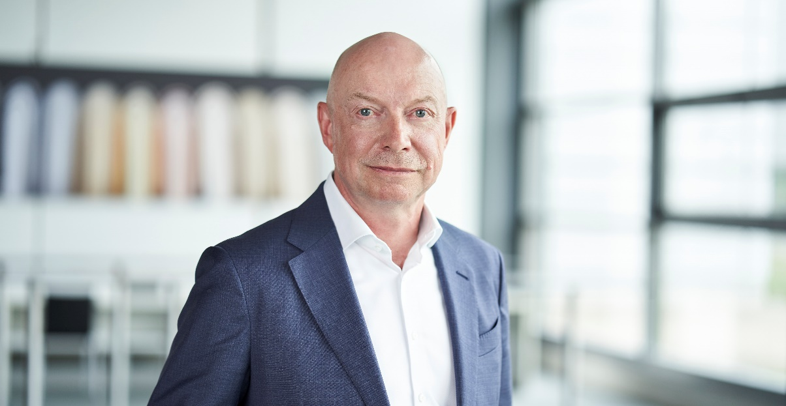
Andreas Dornbracht is the new chairman of the supervisory board at Sennheiser

The Sennheiser Supervisory Board now consists of Andreas Dornbracht (Chairman), Prof. Dr. Jörg Sennheiser and Johann Soder; a fourth member will be appointed shortly. The Supervisory Board maintains a close exchange with the management of the Sennheiser Group and provides ongoing support.

About Sennheiser
Founded in 1945, Sennheiser is celebrating its 75th anniversary this year. Shaping the future of audio and creating unique sound experiences for customers – this aim unites Sennheiser employees and partners worldwide. The independent family company, which is managed in the third generation by Dr. Andreas Sennheiser and Daniel Sennheiser, is today one of the world’s leading manufacturers of headphones, loudspeakers, microphones and wireless transmission systems. In 2019, the Sennheiser Group generated turnover totaling €756.7 million. www.sennheiser.com
Press Contact
Sennheiser electronic GmbH & Co. KG
Mareike Oer
Head of Corporate Communications
T +49 (0)5130 600-1719
mareike.oer@sennheiser.com

