Earbuds that put sound first
Sennheiser once again sets new standards in audio quality with MOMENTUM True Wireless 2

Wedemark, Germany, March 13, 2020 – True wireless headphones aren’t only about style and convenience. With Sennheiser’s new MOMENTUM True Wireless 2, they also let you put sound first. Created for discerning audio lovers, the second generation of the acclaimed MOMENTUM True Wireless from audio specialist Sennheiser take premium true wireless earphones to new heights of performance: the finely crafted earbuds ensure the best possible listening experience at any time with enhancements such as Active Noise Cancellation, refined ergonomics and an outstanding 7-hour battery life that can be extended to up to 28 hours by charging on the go using the supplied case.

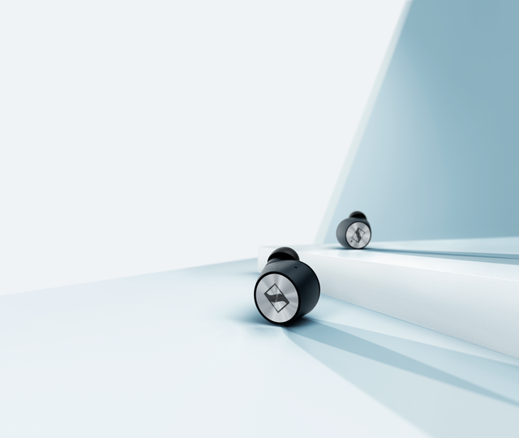
Indulge in exceptional sound quality
The MOMENTUM True Wireless 2 delivers exceptional sound quality thanks to superior audio technology that redefines the standard for true wireless earphones: Sennheiser’s 7mm dynamic drivers create outstanding stereo sound with deep bass, natural mids and clear, detailed treble. Thanks to the built-in equalizer and Sennheiser’s Smart Control App this sound experience
can be perfectly tailored to your taste.

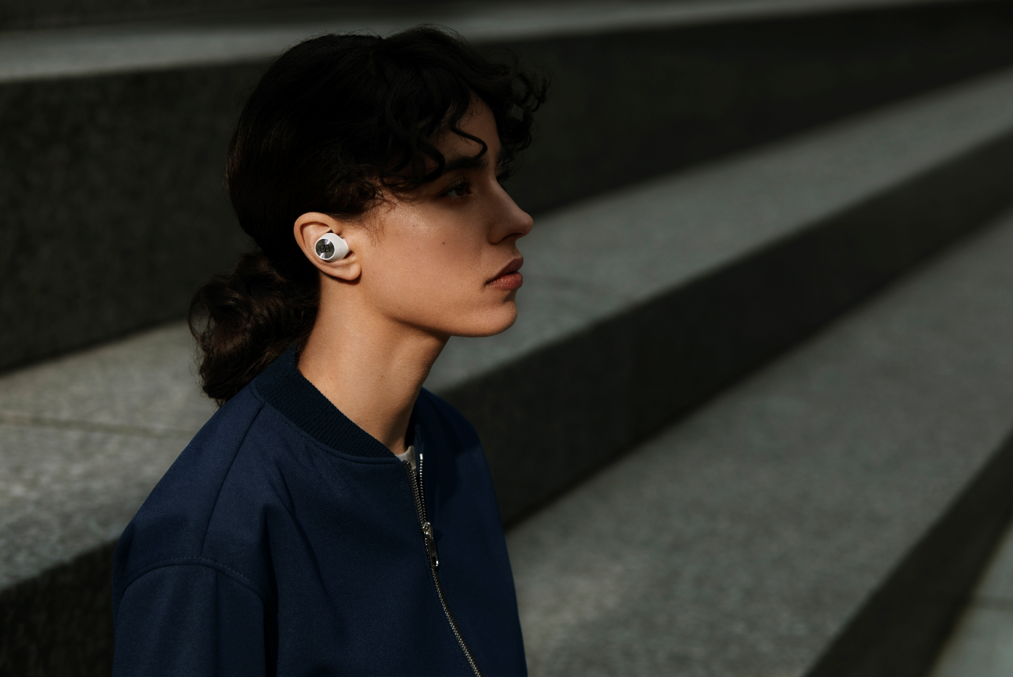
Tune out, tune in – listen your way
The new Active Noise Cancellation ensures that you can enjoy incredible high-fidelity sound even in noisy environments. And, when greater situational awareness is needed, the Transparent Hearing feature lets you blend in outside ambient sound at a touch, so you can have natural conversations in comfort without even needing to remove the earbuds.
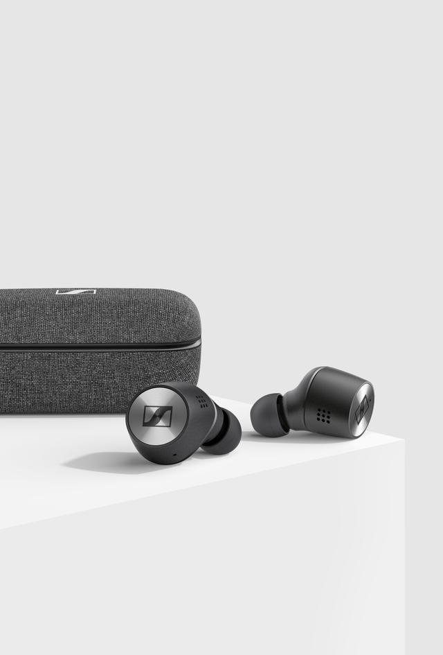
Enjoy them all day
For all-day listening, MOMENTUM True Wireless 2 delivers 7 hours of playback time. This can even be extended to up to 28 hours by charging on the go using the supplied case.

Experience perfect comfort in style
The new MOMENTUM True Wireless 2 has been refined for all-day wearing comfort. The exquisitely crafted earbuds are 2mm smaller than the previous model to improve ergonomics for the best possible fit and to minimize fatigue. And they look great too, featuring premium materials such as the iconic Sennheiser spin design rendered in a high-quality metallic finish and gold-plated charging pins. In addition to the classic black edition, the MOMENTUM True Wireless 2 will be available in a stylish white color scheme, with coordinating fabric finishes on the slim charging case.

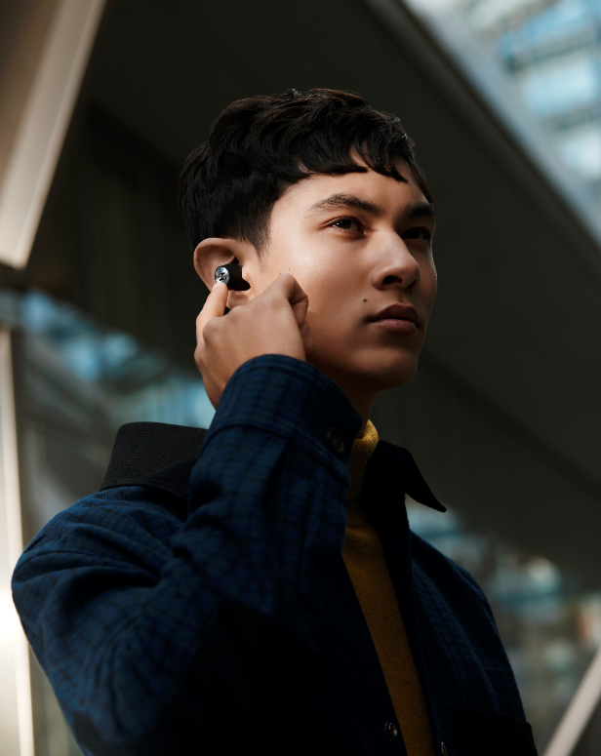

Smarter earphones, simpler for you
Every interaction is effortless thanks to intuitive, customizable touch controls that place control of audio, calls and activating voice assistants like Google Assistant or Apple Siri at your fingertips. They also anticipate your needs: a convenient Smart Pause feature automatically pauses audio playback when you remove the earbuds and seamlessly resumes when you replace them in your ear.

Priced at 299 EUR (MSRP), MOMENTUM True Wireless 2 will be available in black from April,
while the white color variant will be available at a later point.

about Sennheiser
Founded in 1945, Sennheiser is celebrating its 75th anniversary this year. Shaping the future of audio and creating unique sound experiences for customers – this aim unites Sennheiser employees and partners worldwide. The independent family company, which is managed in the third generation by Dr. Andreas Sennheiser and Daniel Sennheiser, is today one of the world’s leading manufacturers of headphones, loudspeakers, microphones and wireless transmission systems. In 2018, the Sennheiser Group generated turnover totaling €710.7 million. www.sennheiser.com

Global Press Contact
Sennheiser electronic GmbH & Co. KG
Jacqueline Gusmag
Communications Manager Consumer
T +49 (0)5130 600-1540
jacqueline.gusmag@sennheiser.com

