April 21, 2017
Toyota Motor Corporation
GAZOO Racing Company
Rally Argentina: Preview
TOYOTA GAZOO Racing eyes more progress on gravel return

The gravel stages of Rally Argentina will provide the next challenge for TOYOTA GAZOO Racing World Rally Team with drivers Jari-Matti Latvala and Juho Hänninen from April 27 to 30. After the asphalt test of Corsica, round five of the FIA World Rally Championship (WRC) means a return to gravel action and a return to Latin America, where the team will look to build upon the lessons learnt on March’s Rally Mexico and further the development of the Yaris WRC.
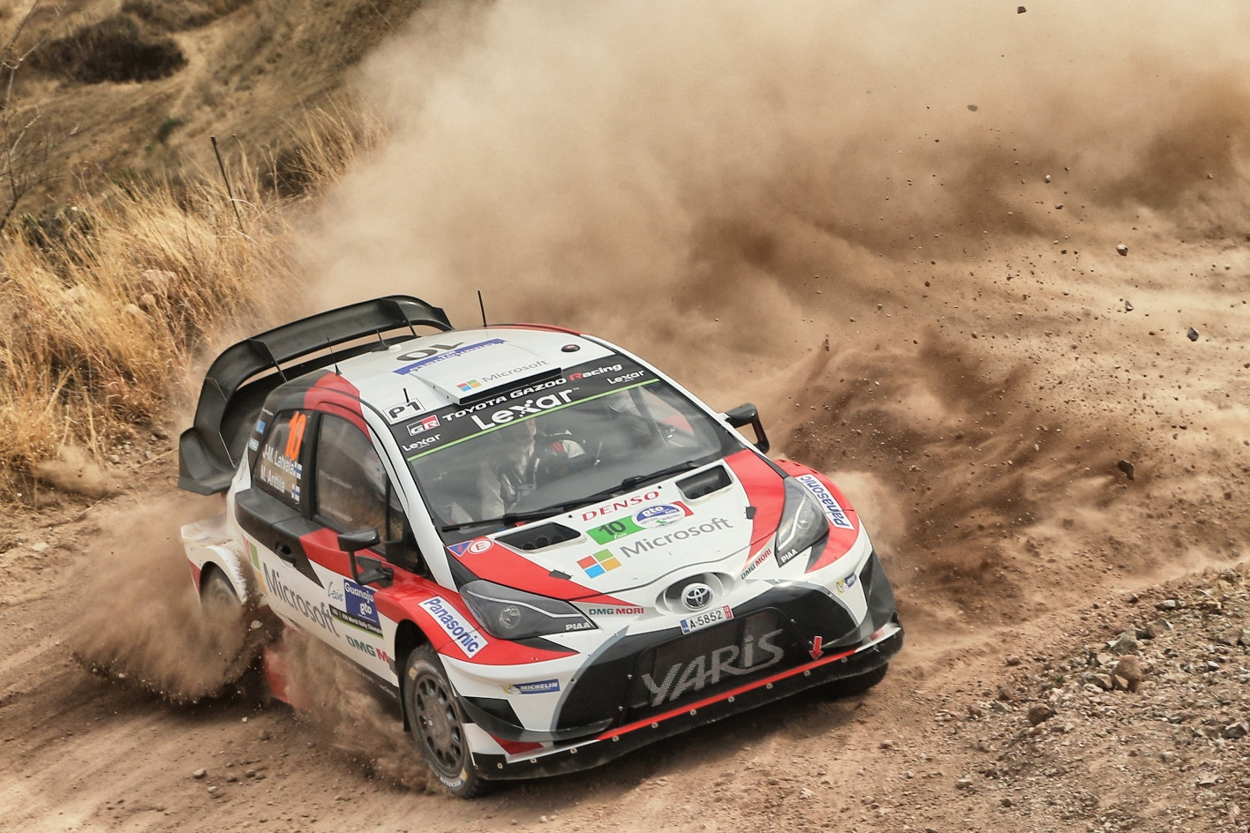

Car 10（Jari-Matti Latvala, Miikka Anttila）

Rally Argentina features varied gravel stages: some take place on high-speed soft and sandy roads in the valleys, while others are run on rocky mountain tracks. This can make car set up and tyre choice more difficult, as each type of stage poses its own challenges. The softer stages are prone to becoming heavily rutted as more cars pass over them, while fog and even ice can sometimes be found in the mountain sections, with weather conditions often changeable.

Rally Argentina is based out of Villa Carlos Paz, around a 30-minute drive from the city of Cordoba, where the rally will begin on the evening of Thursday April 27 with a super special stage. Friday features two loops of stages, which consist of three tests in Santa Rosa de Calamuchita valley followed by a super special at Parque Tematico (a Villa Carlos Paz theme park). Saturday has six stages in the Punilla valley, forming the longest day of the rally at 160 kilometres. The rally then goes up into the Traslasierra region on Sunday for three more stages including two runs of the famous El Condor – the latter as the event-closing Power Stage, with extra championship points on offer.

Latvala took victory in Argentina in 2014, while Hänninen is also a previous winner, in 2010 when the event was not part of the WRC schedule but instead belonged to the Intercontinental Rally Challenge.

In order to prepare for Rally Argentina, both drivers took part in a pre-event test on the Italian island of Sardinia, which is quite representative of the roads in Argentina, and will also host round seven of the World Rally Championship in June.

Quotes:
Tommi Mäkinen (Team Principal)
“As a driver, I always thought that Argentina was a fantastic rally, with gravel and cool conditions, so it’s likely that we can expect mixed weather once again this time. We learned many useful things from Mexico in particular, with the gravel and high altitude, which will be useful for Argentina. We’ve been improving the car with every rally, so our goal is to see another improvement in Argentina. I think we’re in a stronger position now than we were going into Mexico, so we can aim for a good result.”

Jari-Matti Latvala (Driver car 10)
“I’ve always had a very good feeling with Rally Argentina. We’ve won it before, and even last year we were leading until we had a problem and went off on Saturday afternoon. The first two days are fast and flowing, then the last day is slower and more technical, with tricky stages featuring lots of corners and the possibility of very bad weather conditions, especially fog. Although the roads tend to be soft and sandy there is generally quite good grip, I have been working on the differential settings in particular: I didn’t feel that they were the best for me in Mexico, so that is something I really wanted to improve for Argentina, and we have some good solutions now.”

Juho Hänninen (Driver car 11)
“I have many fond memories of Argentina, so I’m really looking forward to getting back there after many years away as it’s one of my favourite gravel rallies. It’s not just the stages that are fantastic, but also the fans, who are so passionate about rallying: even on the road sections. Of course, one big unknown is the weather because everything is possible over there, which makes it difficult if the stage conditions change after the recce. In any case, it won’t affect our set-up a lot: if it’s really muddy you can make the car a bit softer but we won't make any big changes. Whatever happens, it’s important just to drive naturally without feeling too much pressure.”

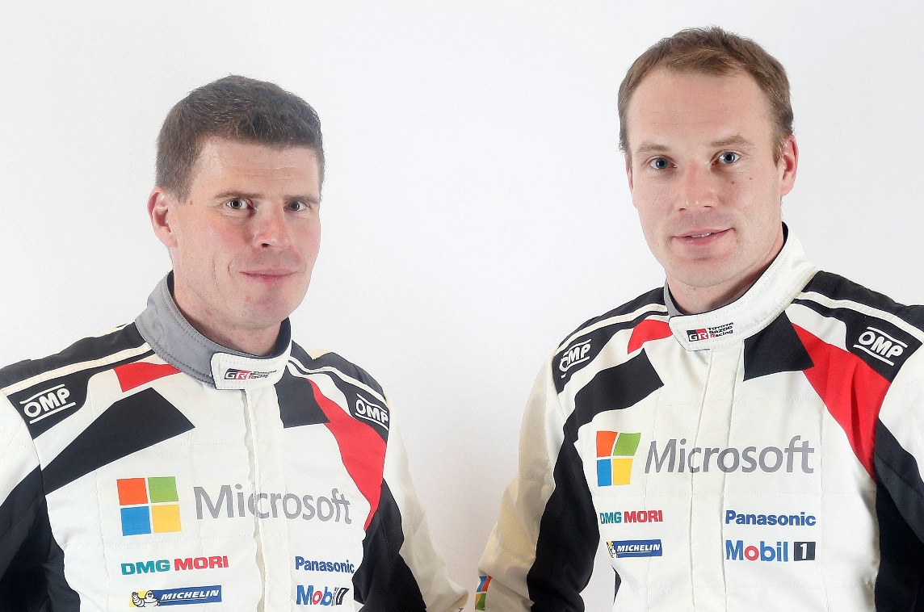
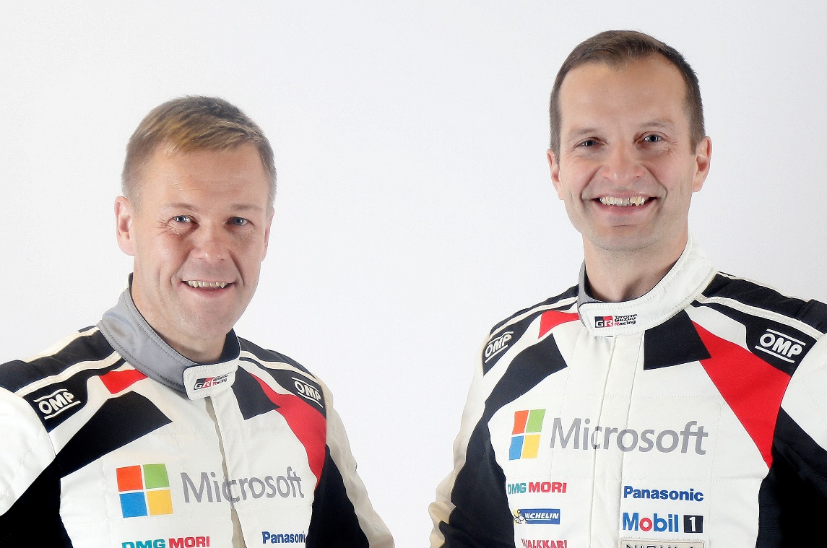
Miikka Anttila and Jari-Matti Latvala
Kaj Lindström and Juho Hänninen

The statistics (Rally Argentina):
Year | Jari-Matti Latvala | Juho Hänninen
2016 | 16 | -
2015 | DNF | -
2014 | 1 | -
2013 | 3 | -
2012 | - | -
2011 | 7 | -

2017 FIA World Rally Championship for drivers after round four:
1 Sebastien Ogier 88
2 Jari-Matti Latvala 75
3 Thierry Neuville 54
4 Ott Tanak 48
5 Dani Sordo 47
6 Craig Breen 33
7 Kris Meeke 27
8 Hayden Paddon 25
9 Elfyn Evans 20
10 Andreas Mikkelsen 12
12 Juho Hänninen 9

2017 FIA World Rally Championship for manufacturers after round four:
1 M-Sport World Rally Team 129
2 Hyundai Motorsport 105
3 TOYOTA GAZOO Racing WRT 79
4 Citroen Total Abu Dhabi World Rally Team 71

Press release
URL: http://toyotagazooracing.com/release/2017/wrc/rd05-preview.html

Pictures will be uploaded here during the event
URL: https://www.tgrwrt.com/ ( ID and Password needed)

Follow us!
Follow TOYOTA GAZOO Racing WRT:
∇Facebook: https://www.facebook.com/TOYOTAGAZOORacingWRC
∇Twitter: https://www.twitter.com/TGR_WRC (@TGR_WRC)
∇Instagram: https://www.instagram.com/tgr_wrc/ (@TGR_WRC)
∇YouTube: https://www.youtube.com/channel/UCCtALHup92q5xIFb7n9UXVg

<Contact>

TOYOTA GAZOO Racing PR Office
Email: tgr_pr @rights-apartment.com

TOYOTA GAZOO Racing Official website
http://toyotagazooracing.com/

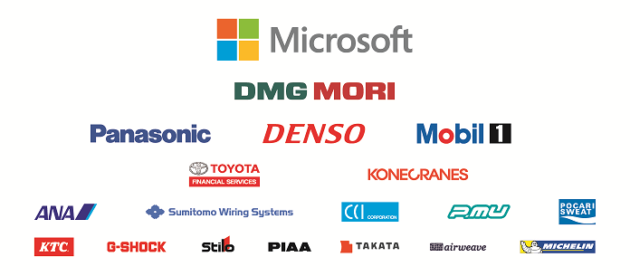
TOYOTA GAZOO Racing World Rally Team is supported by following partners:

