**Celebrate the Holidays with iFi**

*For the audio enthusiast in your life, give the gift of high-fidelity sound whether on-the-go or for the home*

***Southport, England, December 5, 2023— With the holidays just around the corner give the gift of high-fidelity sound. iFi has entry-level offerings as well as premium products for the experienced audiophile. Music will never be the same.***

**On the Go**

### Go Link

### *For Music lovers dipping a toe in the audio-verse*

### 

### This entry level DAC dongle connects corded headphones to digital devices via USB-C for a big sonic upgrade. Equipped with a high-performance DAC chip from ESS Sabre (the ES9219MQ/Q) combined with iFi’s dedicated clock circuitry the Go Link delivers ultra-low distortion, excellent clarity and impressive dynamic range. The cable consists of silver-plated copper conductors with individual polymer insulation in a ‘twisted’ configuration to optimize inductance and aids with noise rejections. This DAC supports all music formats for streaming services like Apply Music, Spotify, Tidal, Netflix, Disney+ and more.

### Available for $59.00 via [Amazon](https://www.amazon.com/iFi-link-Amplifier-Gold-plated-Hi-Resolution/dp/B0BN6MM822/ref=sr_1_1?hvadid=639714423993&hvdev=c&hvlocphy=9004405&hvnetw=g&hvqmt=e&hvrand=922825048626545041&hvtargid=kwd-1928575114971&hydadcr=7698_13469236&keywords=ifi+go+link&qid=1701701418&sr=8-1" \t "_blank) and [B&H](https://www.bhphotovideo.com/c/product/1734433-REG/ifi_audio_0312006_go_link_usb_dac.html" \t "_blank) or directly through [iFi](https://ifi-audio.com/products/go-link/).

**Go Pod**

*For the IEM-obsessed, lose the cord without sacrificing the quality*

*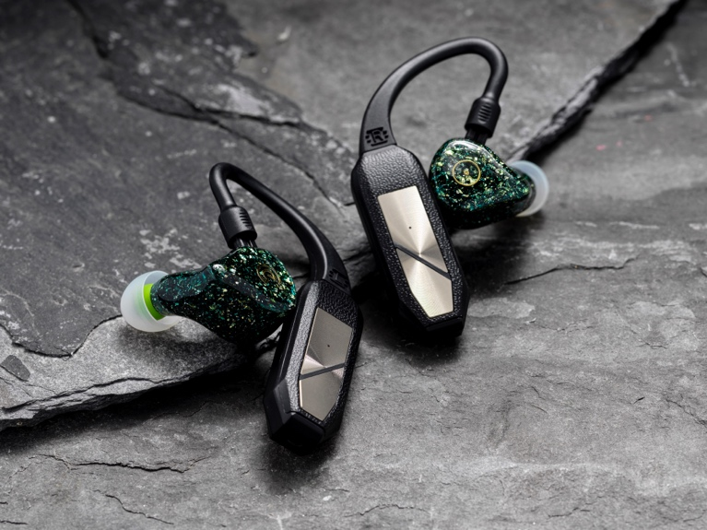*

This wearable Bluetooth DAC/ headphone amp transforms premium IEMs into a wireless pair of hi-res Bluetooth earbuds. Detach the cord and connect the earpieces to the left and right pod with the ergonomically designed ear loops that ensure a comfortable fit for unrivaled True Wireless Stereo (TWS) sound. With Qualcomm’s 24-bit aptX adaptive format offering sample rates of up to 96kHZ/24bits the Go Pod supports a wide range of IEMs with different connectors. Play up to 7 hours on a single charge, but the QI wireless and USB-C fast charging case offers up to 35 hours of playback.

Available for $399 through [iFi](https://ifi-audio.com/products/go-pod-iem-bundle/), [Amazon](https://www.amazon.com/iFi-Bluetooth-Unrivalled-Interchangeable-Connectors/dp/B0CBR52VRW?ref_=ast_sto_dp) and [B&H](https://www.bhphotovideo.com/c/product/1770273-REG/ifi_audio_0312004_0002_go_pod_wearable_hd.html/?ap=y&ap=y&smp=y&smp=y&smpm=ba_f2_lar&lsft=BI%3A6879&gad_source=1&gclid=CjwKCAiAjrarBhAWEiwA2qWdCEIwRd2_tKrPIZMP32I4jzrcdRVfaM0FYgIq84yxmBkPPIMAqvLHWBoCW-AQAvD_BwE).

**Go Bar**

*For the power-hungry headphone lover. Small and mighty. Best Bar none.*

*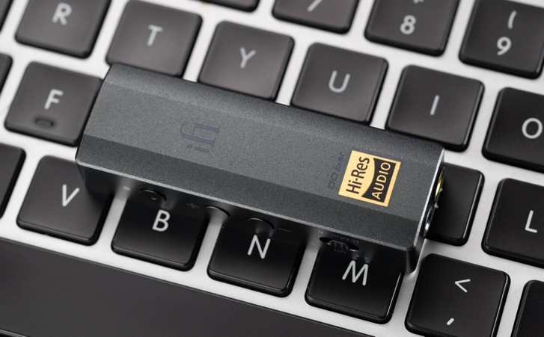*

The GO Bar is the top-of-the-line ultraportable USB DAC/headphone amp that grants access to high-fidelity audio by connecting directly to a laptop, tablet or smart phone through the USB port. Whether you’re commuting, working, or traveling, the compact alloy case sports physical buttons for volume adjustments in addition to controls to select between various tuning options. The colored LED light column provides a clear guide to format and sample rate of the digital audio currently playing, showing whether XBass+ and/or XSpace are engaged.

Available for $329 from [iFi](https://ifi-audio.com/products/go-bar/) and [Amazon](https://www.amazon.com/iFi-GO-bar-Ultraportable-Headphone/dp/B09X62666T).

**For The Home**

**Uno**

*The numero uno for the hi-fi newcomer, a perfect companion for PC’s and MAC’s*

*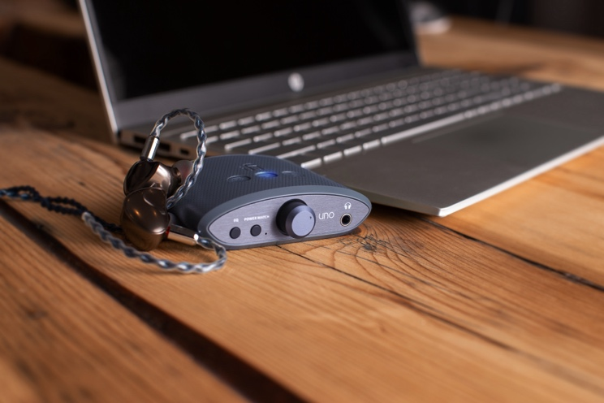*

This sonic supercharger is great for gaming, music and movies on Windows PC or MAC equipped via USB-C with a 3.5 mm and RCA outputs to connect to active speakers. Simply plug in your headphones, adjust the front knob and experience unparalleled audio quality. There are three EQ mode buttons. Music mode enhances track details while Movie Mode boosts dialogue clarity and Game Mode clarifies the subtle sound effects to help the gamer hear approaching enemies. With the PowerMatch switch you can optimize power deliver for headphones, but keep it off for IEMs.

Available for $79.00 from [iFi](https://ifi-audio.com/products/uno/), [Amazon](https://www.amazon.com/iFi-uno-Headphone-Lacklustre-Streaming/dp/B0BM52VPM1/ref=sr_1_1?hvadid=634502594815&hvdev=c&hvlocphy=9004405&hvnetw=g&hvqmt=e&hvrand=2781950395194784483&hvtargid=kwd-1880542917346&hydadcr=2104_13554295&keywords=ifi+uno&qid=1701718306&sr=8-1) and [B&H](https://www.bhphotovideo.com/c/product/1734432-REG/ifi_audio_0316001_uno_dac_and_headphone.html).

**ZEN DAC v2**

*The compact desktop DAC for the seasoned music lover*

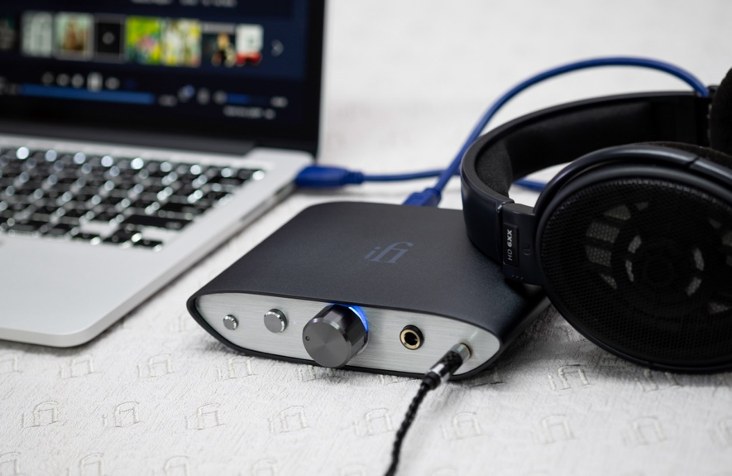

Gift this superb affordable compact hi-res USB headphone amp that delivers specification and performance that punches well above its price tag. Through USB connection connect it to a head-fi system or pair it with active speakers using the 4.4 balanced output or RCA output for a desktop-fi system. The Zen DAC v2 features TrueBass that boosts bass to enhance lower frequencies without affecting the mid-range making it ideal for IEMs or open-back headphones. The balanced design is perfect for the analog stage.

Available for $199.00 from [iFi](https://ifi-audio.com/products/zen-dac-v2/), [Amazon](https://www.amazon.com/iFi-Desktop-Digital-Converter-Outputs/dp/B091B2JCXQ/ref=sr_1_2?crid=1L9WR7SP3Y1VJ&keywords=ifi+zen+dac+v2&qid=1701718399&sprefix=ifi+zen+%2Caps%2C83&sr=8-2) and [B&H](https://www.bhphotovideo.com/c/product/1635820-REG/ifi_audio_0311002_n00004_zen_dac_v2.html).

**About iFi**

iFi Audio is a subsidiary of the AMR group (Abbingdon Music Research Group)—an audio equipment manufacturer based in Southport, UK. iFi Audio produces several award-winning DACs and amplifiers, as well as other accessories for computer and home audio. For more information, please visit— <https://ifi-audio.com/>

**Media Contacts**

Shelby Coppola  
Hummingbird Media  
+1 (203) 598-8167  
[shelby@hummingbirdmedia.com](mailto:shelby@hummingbirdmedia.com)

Jeff Touzeau

Hummingbird Media

+1 (914) 602-2913  
[jeff@hummingbirdmedia.com](mailto:jeff@hummingbirdmedia.com)