For immediate distribution

Heavier Strings: SonoTone Introduces SonoCore Series Premium Electric Guitar Strings
Featuring custom round cores and a pure nickel wrap, SonoCore series strings offer bold tones, plus balanced tension across string-sets for better intonation on any electric guitar

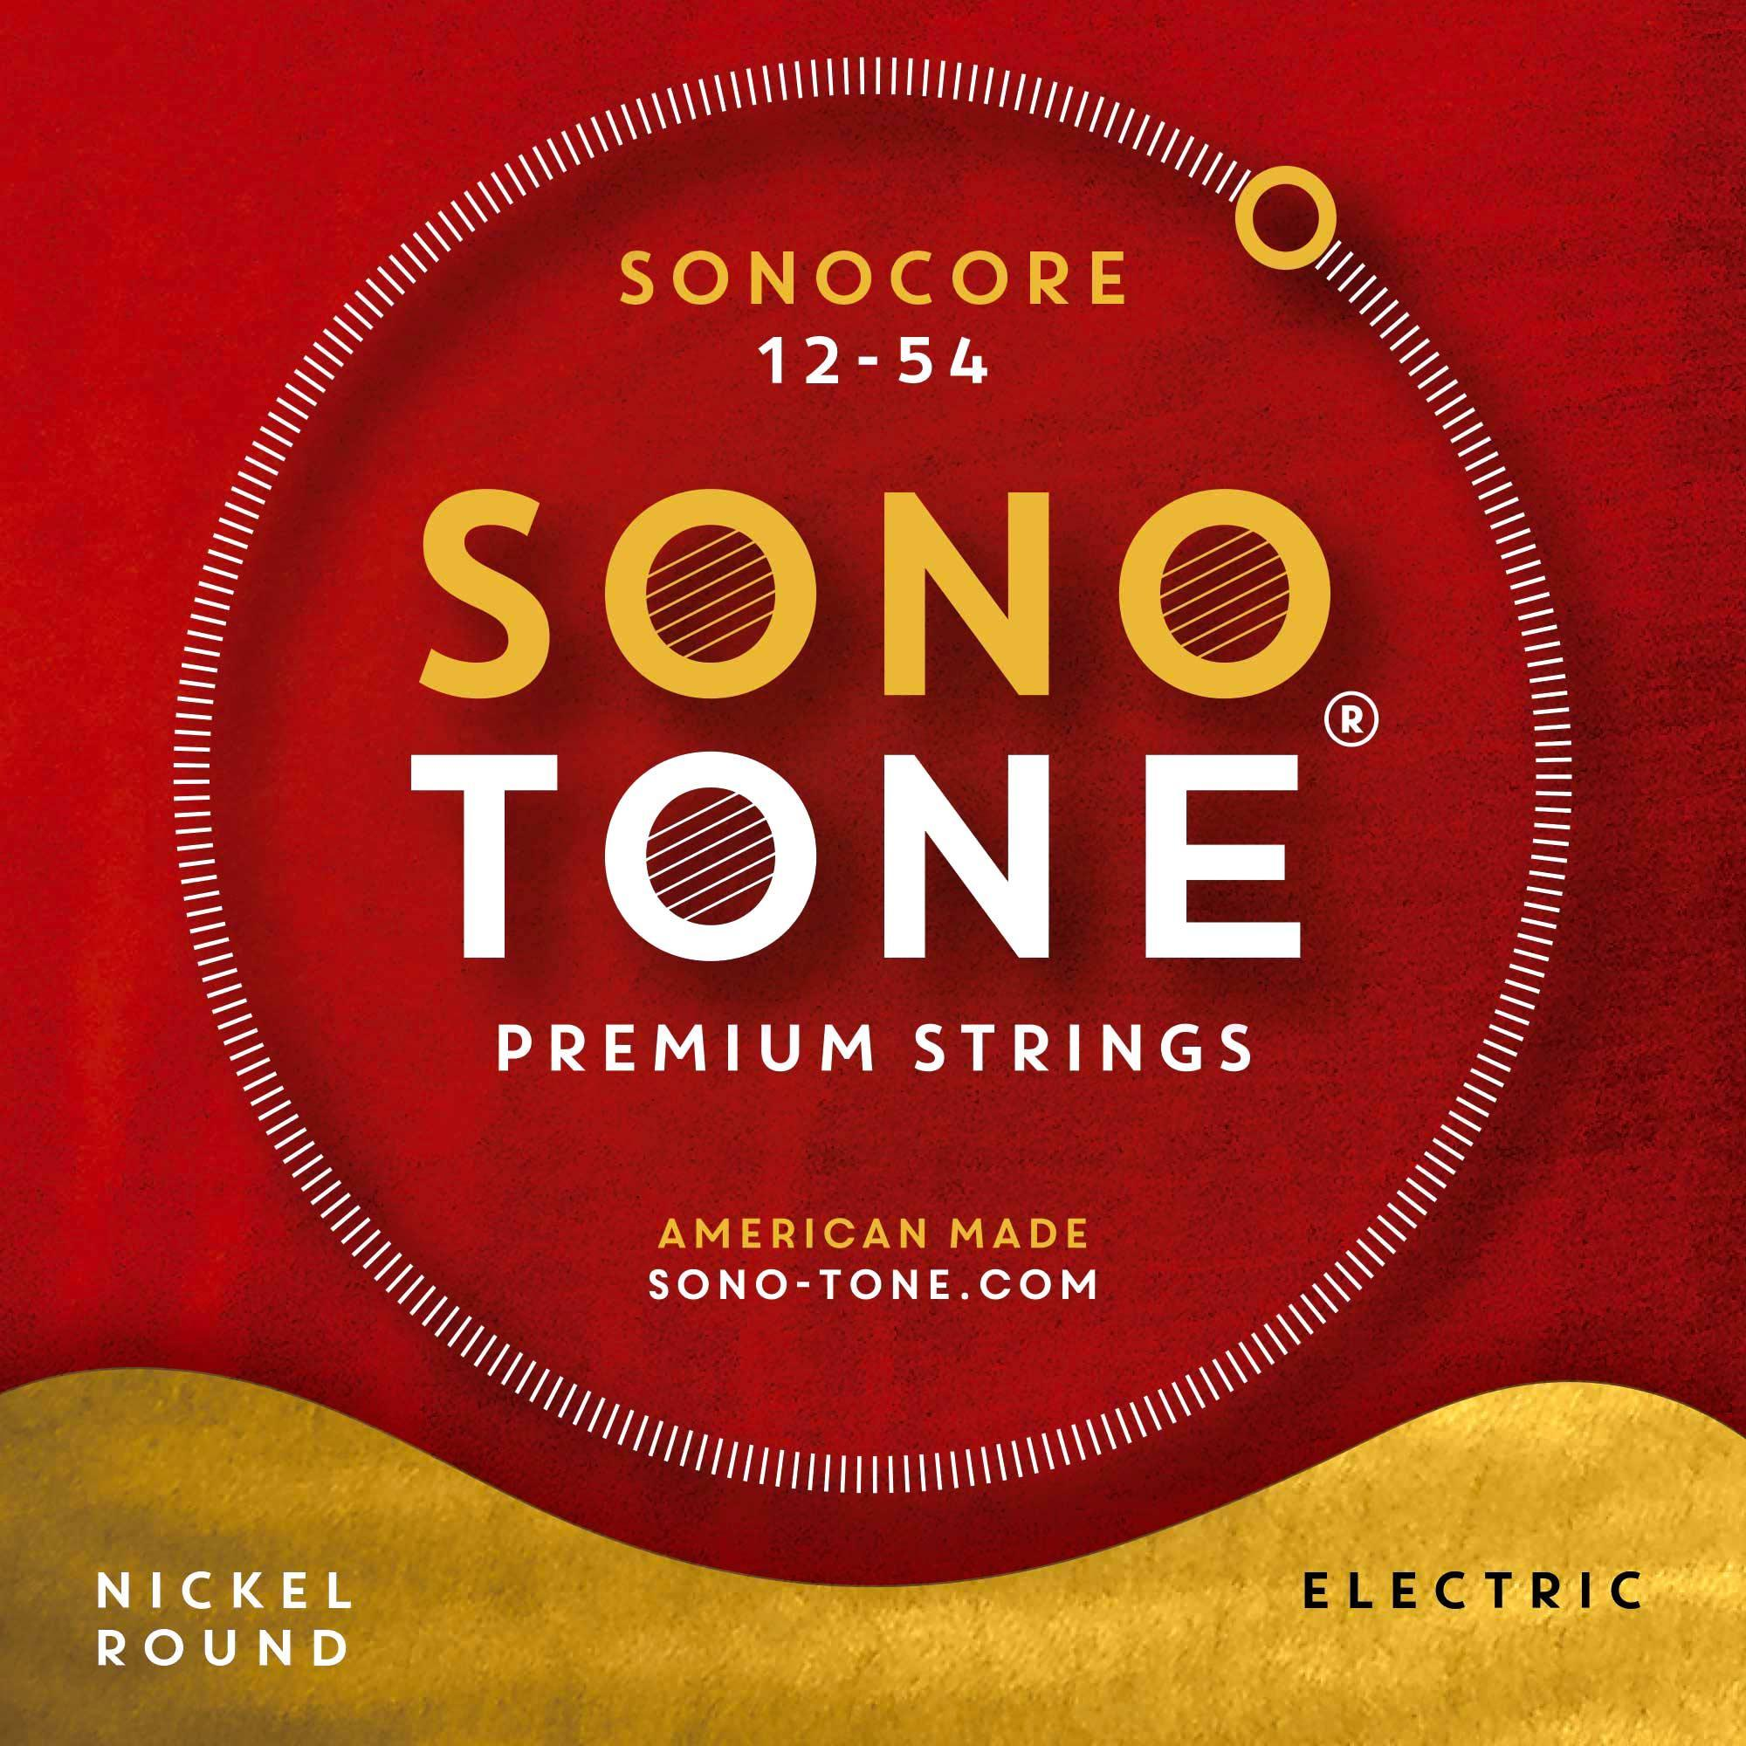
Allston, Massachusetts — June 24, 2020 — SonoTone, the Massachusetts-based manufacturer of boutique, premium guitar strings, has unveiled its SonoCore series of electric guitar. SonoCore premium strings offer professional musicians, hobbyist players and vintage gear collectors the opportunity to outfit their new, used or vintage instruments with strings formulated to bring out the full power and potential out of any electric guitar, using custom gauge-sets designed to balance string-tension across the neck, improving the strings’ overall feel and playability while providing better intonation.

Now the string of choice for professional guitar players and high-end luthiers like Marchione Guitars, in addition to a growing legion of professional and amateur musicians, vintage instrument collectors and tone aficionados, SonoTone SonoCore series strings are available in three gauge sets: 10-48 (10, 13, 17, 28, 38, 48); 12-54 (12, 15, 25, 34, 44, 54); and 13-53 (13, 17, 21, 30, 38, 53).
Manufactured by hand in the U.S. using pure nickel and custom round cores, SonoCore series are similar to other SonoTone premium strings, in that they provide pristine, bell-like tones — but SonoCore series strings stand out by bringing bigger, bolder sine waves out of any solid-body, semi-hollow or hollow-body electric guitar, pushing them past their previous tonal limitations.
In addition to improving a guitar's overall sound, players will feel the difference as soon as SonoTone SonoCore series strings have “settled in” to the guitar. Whether players prefer the lighter 10-48 sets (with an unwound G), the heavier, balanced tension (with a wound G) in the 12-54 set, or the medium-tension (with a wound G) in the 13-53 balanced gauge-set, SonoCore series strings are not just for jazz, blues, or fusion, but also for country and rock players — or for all the above, and everything in between. Regardless of the style of music they’re used to play, SonoTone strings remain powerful and harmonically rich for the entire duration of each string-set's lifespan.
Now available directly from www.sono-tone.com in the U.S. and in select European countries through Fulfillment by Amazon, as well as in Japan through the manufacturer's distribution partner, SonoTone SonoCore series electric guitar strings are available for $18.99 each.
SonoTone series offers bigger and more balanced guitar tone
The SonoTone SonoCore series represents the culmination of over three years of experimentation with various materials and manufacturing techniques by SonoTone founder P.K. Pandey. Having spent more than 25 years on a quest for impeccable tone, both as a studio recording engineer and A/V systems design/build engineer, Pandey's journey eventually led him to reconsider the fundamental medium and point-of-contact between the player and the guitar, the material source of the instrument's "voice" — the taut, vibrating metal wires fastened to the bridge on one end and to the headstock on the other — i.e., the guitar strings.
Starting from this fundamental level, Pandey tested different metals, amalgams, and manufacturing processes until he eventually found the hard-won formula, known only to him, which at last recreated the vintage tone and feel of the guitars he remembered playing as a kid.
Unlike many contemporary, machine-made strings produced in bulk quantities outside the U.S. at mass-market, commodity prices, SonoTone SonoCore strings use only the highest-quality materials available, with additional measures taken throughout the manufacturing process to optimize string behavior, playability, tuning stability and longevity — without using any coatings, so that only the pure elements that make up the string-wire ring out, unencumbered, through the entire body of the guitar.
To find out how SonoTone SonoCore series strings will enhance the sound of your own new, used or vintage instrument, please visit www.sono-tone.com for more information.

About SonoTone
SonoTone is a small batch high-quality string manufacturer based in Massachusetts. In a world of commoditized, all-purpose guitar strings sold to the mass market, SonoTone strings are authentic, comfortable and expressive and sold directly to the customer. For more about SonoTone, please visit our website at www.sono-tone.com

Media contacts:
Jeff Touzeau
Public Relations
Hummingbird Media
+1 (914) 602 2913
jeff@hummingbirdmedia.com

David Ball
Public Relations
Hummingbird Media
+1 (630) 885-1795
david@hummingbirdmedia.com

