Embargoed until November 17, 2020, 10 a.m. CET

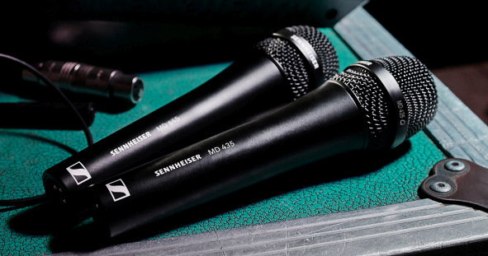

New Sennheiser MD 435 vocal mic
Get the famous MD 9235 capsule sound in a wired microphone

Wedemark, November 17, 2020 – Until now, this outstanding sound has been exclusively reserved for top-end live sound and broadcast productions – now, Sennheiser is bringing the sound of its dynamic MD 9235 capsule to a wired vocal microphone. The new MD 435 large-diaphragm microphone brings accentuated presence, sparkle and pleasant detail to every voice.

“With the MD 435 cardioid high-end microphone, even soft voices will effortlessly assert themselves,” says Kai Lange, senior product manager with Sennheiser. “Singers will not only cut through the mix, their voices will also retain that natural quality and detail that the MD 9235 is so famous for.”

The MD 435’s lightweight aluminium-copper voice coil ensures fast transient response, resulting in a very detailed, nuanced and transparent sound, especially in the treble. The large-diaphragm microphone features very wide dynamics of 146 dB(A) and can handle sound pressure levels of up to 163 dB/1 kHz. The outstanding acoustics come with a mechanical design created to take on the rigors of life on tour: The MD 435 features a metal casing and has a shock-mounted capsule to protect it from structure-borne noise. A hum-compensating coil protects the microphone against electromagnetic interference.

The cardioid MD 435 features a very pleasant proximity effect and the microphone is very tolerant of sound hitting the capsule at different angles. It reproduces vocals clearly and confidently even in loud live settings.

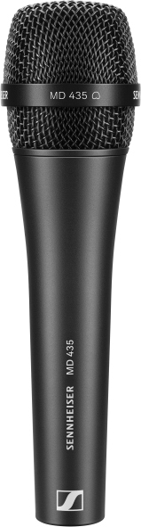 | 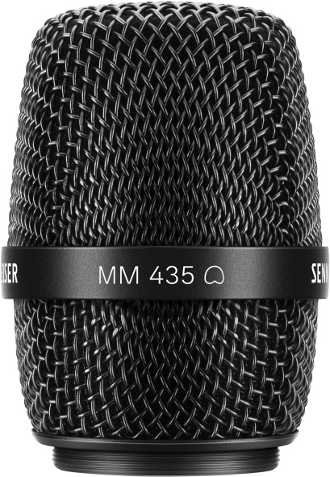  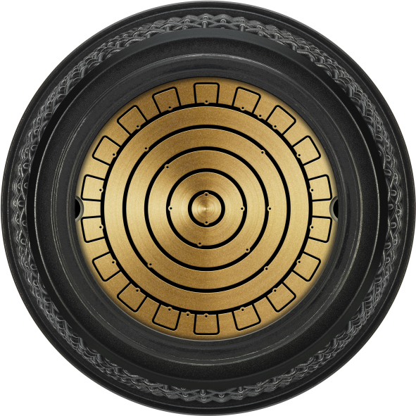 | The wired MD 435 cardioid vocal microphone and the MM 435 microphone head (pictured with the capsule interface) for use with Sennheiser wireless transmitters

For use with Sennheiser’s wireless transmitters, the capsule of the MD 435 is also available as the MM 435 microphone head. Benefitting from an improved production process, it will soon replace the existing MD 9235 capsule. The MM 435 features Sennheiser’s standard capsule interface, ready for use with Sennheiser wireless series ranging from the evolution wireless G4 and 2000 series to Digital 6000 and Digital 9000.

The MD 435 microphone and MM 435 microphone head retail at EUR 499 (MSRP) each.

MD 435 Technical Data
Transducer principle dynamic
Frequency response 40 – 20,000 Hz
Pick-up pattern cardioid
Diaphragm diameter 25,4 mm / 1”
Sensitivity (free field, at 1 kHz) 1.8 mV/Pa; -54.9 dBV/Pa
Max. SPL (at 1 kHz) 163 dB
Equivalent noise level 17 dB(A)
Dynamic range 146 dB(A)
Nominal impedance (at 1 kHz) 245 Ω
Min. terminating impedance 1 kΩ
Connector XLR-3M
Dimensions ⌀ 47.5 mm x 181 mm
Weight 350 g

The high-resolution images accompanying this press release plus additional images can be downloaded at https://sennheiser-brandzone.com/c/181/CmgayXqy.

About Sennheiser
Founded in 1945, Sennheiser is celebrating its 75th anniversary this year. Shaping the future of audio and creating unique sound experiences for customers – this aim unites Sennheiser employees and partners worldwide. The independent family company, which is managed in the third generation by Dr. Andreas Sennheiser and Daniel Sennheiser, is today one of the world’s leading manufacturers of headphones, loudspeakers, microphones and wireless transmission systems. In 2019, the Sennheiser Group generated turnover totaling €756.7 million. www.sennheiser.com

Global Press Contact

Stephanie Schmidt
Stephanie.schmidt@sennheiser.com
+49 (5130) 600 – 1275

