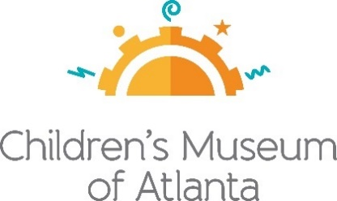
For more information:
Jennifer Walker / Helen Wilson
BRAVE Public Relations
404.233.3993
jwalker@emailbrave /
hwilson@emailbrave.com
**MEDIA ADVISORY**

Children’s Museum of Atlanta launches virtual learning program #CMAatHome

Experts help keep education at the forefront with daily online activities

ATLANTA (March 18, 2020) – To help families keep their little ones engaged in the current landscape, Children’s Museum of Atlanta has debuted a new virtual program called #CMAatHome. Each weekday at 11 a.m., the Museum will provide an interactive activity, vocabulary list, song list or book recommendation to help parents and kids stay engaged with education. Additional programming is expected to launch in the coming days, including live singing and story time with the Imaginators, Q&A sessions with Professor Labcoat and more. Children’s Museum of Atlanta will continue to serve as a beacon of learning through the power of play, with activities continuing on digital platforms until the Museum is able to resume its regular onsite programming schedule.

WHAT: #CMAatHome
Virtual educational activities to help keep little ones engaged in learning and play

WHEN: Weekdays at 11 a.m.

WHERE: Online at childrensmuseumatlanta.org/blog or by following #CMAatHome on Facebook, Instagram and Twitter

HOW: This programming is free! Voluntary contributions are accepted by visiting childrensmuseumatlanta.org/make-play-possible

###

ABOUT CHILDREN'S MUSEUM OF ATLANTA
Children’s Museum of Atlanta is the only educational venue of its kind in Atlanta, presenting educational programs and exhibits designed for young children ages 0-9. The mission of Children's Museum of Atlanta is to change the world by sparking every child's imagination, sense of discovery and learning through the power of play. With six permanent learning zones consisting of bright, creative and hands-on exhibits, the Museum supports inventive play-based exploration and experiential learning focused on the whole child. Core competencies for literacy, math and science are promoted throughout all exhibits and programming in alignment with the state and national Core Performance Standards. Children’s Museum of Atlanta also offers parties, memberships, field trips, summer camp and private events. For more information or to support Children's Museum of Atlanta, visit childrensmuseumatlanta.org or call 404.659.KIDS [5437].

