Sennheiser TO PRESENT 'CITIZENS OF SOUND' EXHIBIT at the liberty fashion & lifestyle fairs, LAS VEGAS
Exhibit produced by The Brooklyn Circus captures emotions of listeners experiencing their favorite songs for the first time — through Sennheiser HD1 and HD 800 headphones

Las Vegas, August 9, 2017 – Next week at the Liberty Fashion & Lifestyle Fairs in Las Vegas [Hall C, Booth 100], audio specialist Sennheiser will present 'Citizens of Sound' (#CitizensofSound): an exhibit produced by The Brooklyn Circus in collaboration with film photographers Rog & Bee Walker + Aeric Meredith-Goujon. The engagement next week follows a successful exhibition at the Liberty Fashion & Lifestyle Fairs in New York City last month.

The Las Vegas exhibit, which takes place at the Sands Expo | Venetian between Monday, August 14th and Wednesday, August 16th, brings together a community of music lovers, artists & experts as they experience their favorite song for the first time — listening through a pair of Sennheiser HD1 or HD 800 headphones. The studio portrait collection, which was photographed with medium format film, captures the emotions behind today's music loving culture while capturing the "#Sennheiser1st" experience.

During the exhibition, attendees will have the opportunity to experience their own #Sennheiser1st moments through a variety of Sennheiser's premium headphones to be showcased, including the HD 800S, HD 1 Wireless and others.

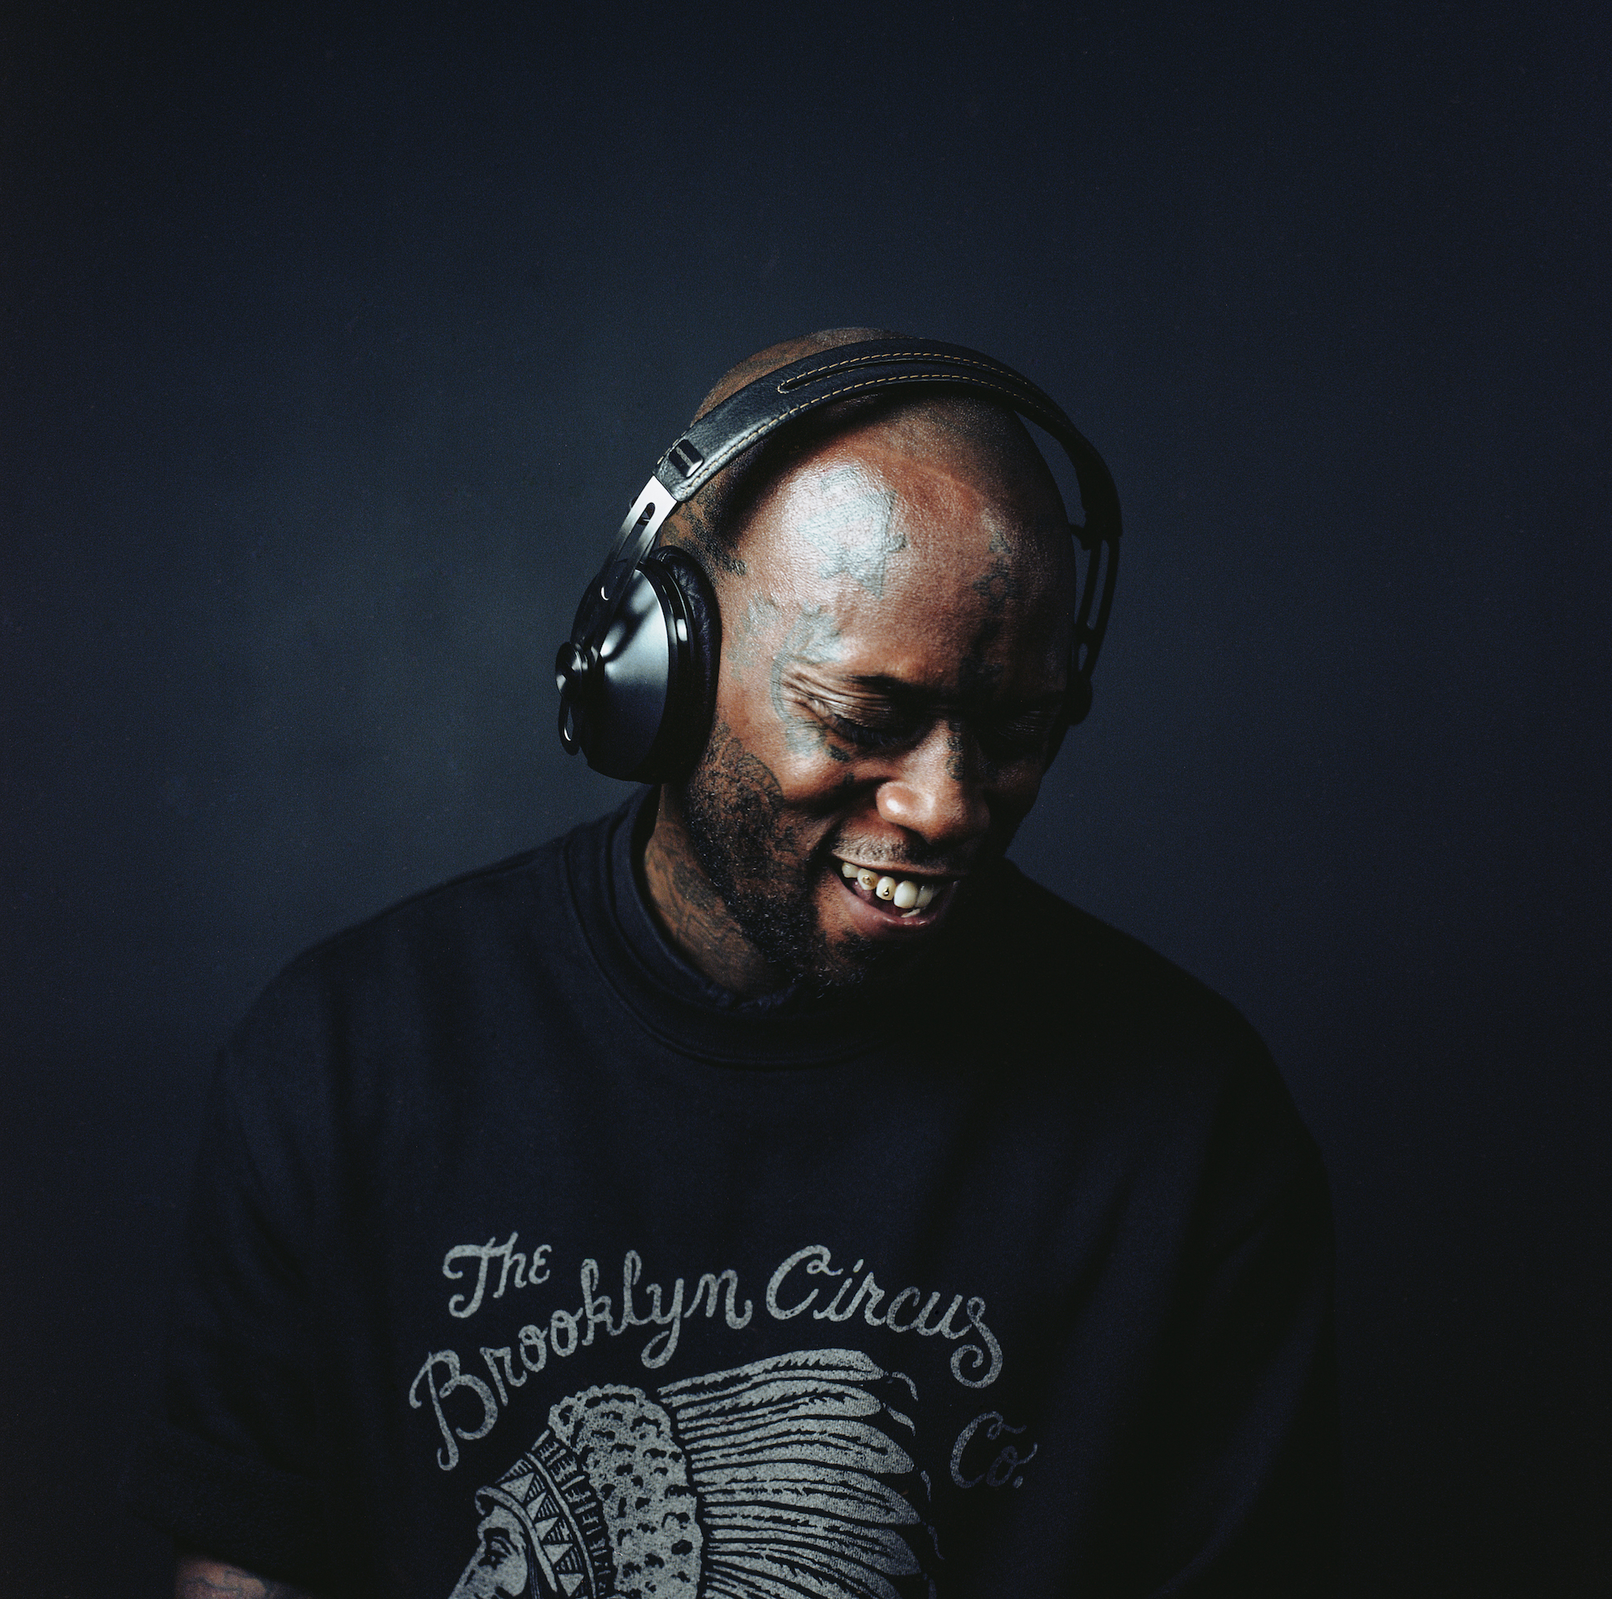 | Next week, Sennheiser will present 'Citizens of Sound': an exhibit produced by The Brooklyn Circus in collaboration with film photographers Rog & Bee Walker + Aeric Meredith-Goujon.

Who:
Sennheiser in cooperation with The Brooklyn Circus and film photographers Rog & Bee Walker + Aeric Meredith-Goujon.

What:
"Citizens of Sound" studio portrait exhibit

When:
Monday and Tuesday, August 14th & 15th; 9:00 a.m. to 6:00 p.m.
Wednesday, August 16th; 9:00 a.m. to 4:00 p.m.

Where:
Sands Expo | Venetian, Las Vegas, Hall C, Booth 100
"We are pleased to cooperate with The Brooklyn Circus to bring 'Citizens of Sound' exhibit to the Liberty Fair," commented Stefanie Reichert, Director Trade Marketing, Retail, Americas. "This moving tableau of portraits by photographers by Rog & Bee Walker + Aeric Meredith-Goujon capture the essence of today's sound culture — and how the listening experience can be emotionally enhanced with Sennheiser."

"We connected with Sennheiser because we wanted to evoke the emotion of sound in a visually compelling way — this was our goal and why the project was important to us," says Ouigi Theodore, founder of The Brooklyn Circus. "The subjects that were photographed each represent what a heightened audio experience looks like visually, and we were able to capture the beauty of this heightened audio experience. The music they were listening to in those moments sounded so much better than they've ever heard it before, and this beauty is in the sound."
For more information or to RSVP, please follow this link.

About Sennheiser
Sennheiser is shaping the future of audio – a vision built on more than 70 years of innovation culture, which is deeply rooted within the family-owned company. Founded in 1945, Sennheiser is one of the world’s leading manufacturers of headphones, microphones and wireless transmission systems. With 20 sales subsidiaries and long-established trading partners, the company is active in more than 50 countries and operates its own production facilities in Germany, Ireland and the USA. Sennheiser has around 2,800 employees around the world that share a passion for audio excellence. Since 2013, Sennheiser has been managed by Daniel Sennheiser and Dr. Andreas Sennheiser, the third generation of the family to run the company. In 2016, the Sennheiser Group had sales totaling €658.4 million. www.sennheiser.com

Press Contact

Jeff Touzeau
jeff@hummingbirdmedia.com
+1 (914) 602-2913

