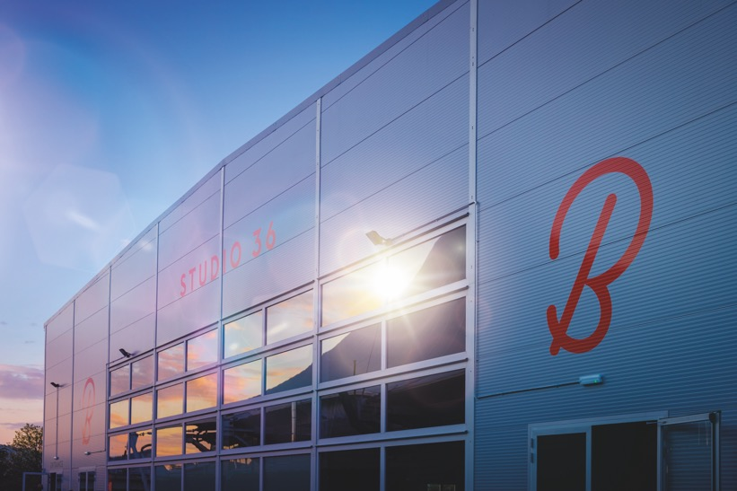
(Picture courtesy of Butlin’s)
Sennheiser Digital 6000's exceptional audio quality transforms Butlin's resorts into top event and conference destinations
The home of entertainment takes the lead in the hospitality holiday sector with state-of-the-art audio and video equipment, supplied by Sound of Music

Marlow, UK, May 2023 – Renowned as one of the most well-known holiday destinations in the UK, Butlin's offers action packed family breaks, adult only Big Weekenders and memorable conferences and events. To enhance the overall guest experience, Butlin's has partnered with Sound of Music, a top-tier technical production and AV hire company, to introduce industry reference Sennheiser Digital 6000 wireless microphone systems across all three resorts. In addition to providing exceptional audio quality, the rider-friendly Digital 6000 offers unparalleled flexibility and versatility for hosting events of varying sizes in Butlin's entertainment venues. Whether it is a large conference or an intimate gathering, Digital 6000 can be easily adapted to meet the needs of any event.

Andrew Sugg, Technical Entertainments Manager at Butlin’s, was first introduced to the Digital 6000 just before the COVID-19 pandemic began. The team were experiencing interference issues, so Kevin Gwyther-Brown, Sennheiser UK’s Business Development Manager, visited Butlin’s resort in Minehead, Somerset, to perform a demo. The system's flexibility in terms of RF was immediately apparent with positive feedback received from the internal teams operating the equipment in the Centre Stage venue. With Studio 36, a new entertainment venue, opening at all three resorts this convinced Sugg to go with Sennheiser.

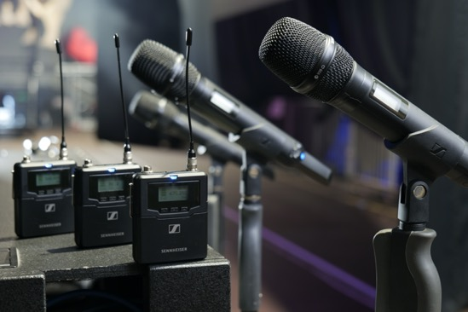 | To enhance the overall guest experience, Butlin's has partnered with Sound of Music to introduce industry reference Sennheiser Digital 6000 wireless microphone systems across all three resorts  (Picture credit: James Cumpsty)

“Each resort has four entertainment venues, so our aim was to standardise the audio equipment across our three sites,” Sugg explains. “We wanted a system that gives us scope to grow and is versatile, and Digital 6000 does exactly that. With Digital 6000, we have consistency in all the entertainment venues across our resorts. With the high calibre of performances we put on during our family and Big Weekender breaks, we’ve invested in the future by using a professional grade system that is well known in the industry.”

The implementation of Digital 6000 systems also resolved the issue of wireless interference. Sugg adds, “We’ve received positive feedback from the team, and the systems have been highly reliable.”

The Butlin’s resorts in Bognor Regis, Minehead, and Skegness have also been equipped with an extensive range of Sennheiser products. These include EM 6000 Dante Receivers, SKM 6000 Handheld Transmitters featuring MMD 935 and 965 capsules, SK 6000 and SK 6213 Bodypack Transmitters, along with HSP 4/3 Headworn Microphones, L 6000 Chargers and Charging Modules, and AD 3700 Antennas. Additionally, the Sound of Music team has supplied SR 2050 IEM Transmitters, EK 2000 IEM Receivers, AC 3200-II Antenna Combiners, and A 5000-CP Antennas to all three resorts.

The Butlin’s resorts in Bognor Regis, Minehead, and Skegness have been equipped with an extensive range of Sennheiser products  (Picture credit: James Cumpsty) | 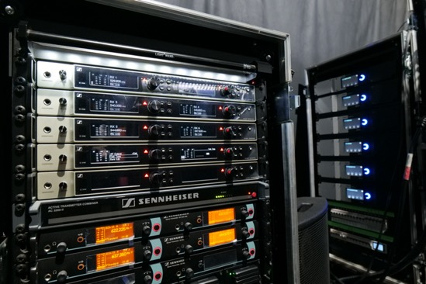

Sugg notes that investing in a reliable and high-end audio system has the added benefit of alleviating concerns about accommodating visiting artists and bands. To ensure they can meet everyone’s needs during family breaks and Butlin’s Big Weekends, the team wanted to be as rider friendly as possible.

Ed Gamble of Sound of Music shares Sugg's perspective and emphasises the importance of rider-friendliness and consistency at the entertainment venues across Butlin’s resorts. “Digital 6000 ensures a smooth transition for visiting artists and bands, reducing change-over times and eliminating the need for the artists’ technical teams to bring unnecessary audio equipment with them. The industry standard quality of Digital 6000 is widely recognised, which makes it easier for everyone involved," he says.

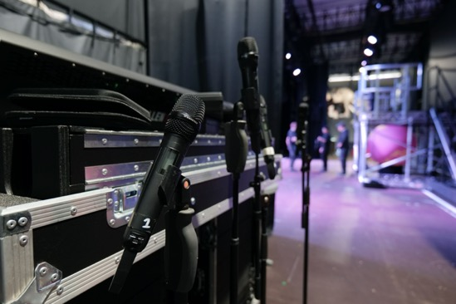 | Digital 6000 ensures a smooth transition for visiting artists and bands, reducing change-over times and eliminating the need for the artists’ technical teams to bring unnecessary audio equipment with them  (Picture credit: James Cumpsty)

Gwyther-Brown worked closely with Gamble on the project, also shares his thoughts: “I’ve spoken to people in the industry that have worked with Butlin’s, and the feedback I’m getting is that after seeing the quality of AV equipment at Butlin’s resorts, it has completely changed rental companies’ mindsets and their professional approach to Butlin’s.”

Sugg agrees, “For those that don’t know the Butlin’s of today, there’s still a historic perception. By working with some of the best names in the business we’re shifting that perception. From an industry perspective, we’re investing to ensure we put on the best shows for our guests, no matter what break they’re on. We’re market leading when it comes to the level of production and audio, video, and lighting equipment we use in our venues. It’s something we’re very proud of!”

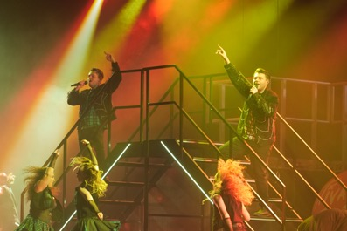
As the home of entertainment, Butlin’s takes the lead in the hospitality holiday sector with state-of-the-art audio and video equipment (Picture credit: James Cumpsty)

Praising the team at Butlin’s for their unwavering commitment to selecting top-quality AV packages for their venues, Gwyther-Brown adds that it provides great comfort both to the internal team and externally to partners, as they know that the equipment is of the highest quality and there is no compromise on any aspect.

With an impressive line-up of acts on the adults only Big Weekender breaks, including Peter Andre and Wet Wet Wet, this year’s roster of artists and events looks as impressive as ever. New for 2023 is the DJ Spoony Presents A House Full of Garage break and, following a successful launch last year, the multi-era Replay Weekender and Oktoberfest weekenders are back alongside popular 90s Reloaded, Back To The 2000s, Absolute 80s Weekender, We love Ibiza, and many others taking place across the three resorts.

“It doesn’t matter which act is in which resort, they can just turn up and play,” says Gamble.

Sugg enthusiastically adds: “We can switch from family-friendly shows and adults only Big Weekenders with multiple live performances or a conference. Acts performing vary from leading family entertainment and the biggest names in the music industry, to large organisations hosting conferences or events at our resorts. With multiple shows throughout the day, we can run for up to 16 hours a day, seven days a week. As a result, the duty cycle of the Digital 6000 was crucial for us. Being the home of entertainment, we need to ensure that we use the best technology so that our guests have the best experience whether that’s on a family break, Big Weekender or delegates attending a corporate conference."

With multiple shows throughout the day, Butlin’s can run for up to 16 hours a day, seven days a week. As a result, the duty cycle of the Digital 6000 was crucial for the in-house team  (Picture credit: James Cumpsty) | 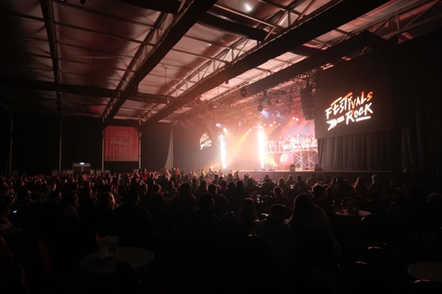

“Sound of Music’s involvement did not stop at the point of delivery and installation of the microphones,” adds Sugg. “They worked to bring the entire AV setup together, delivering everything on time and integrating it professionally within the venues’ existing AV eco-systems.”

With the Sennheiser Digital 6000 running smoothly and performing well, Sugg emphasises that, apart from the ongoing support they have been receiving from the team at Sound of Music, it is also highly beneficial for the end-user to have a close relationship with the manufacturer. "It allows us to communicate our needs and concerns directly. I also believe it's beneficial for the manufacturer to understand the end-user's requirements. It’s very useful for both parties."

“The better we understand end-users, the better it is for us as a brand,” exclaims Gwyther-Brown. “We also have a strong loyalty to our dealer network at Sennheiser. By working with them, we can provide ongoing support to both them and the end-user. Whether that involves spending the day with a venue’s technical team discussing capsule options - which I did at the Minehead resort - or meeting for coffee to talk about future projects, issues, or support needed, it's all about adding value to everyone involved in the project.”

With the Sennheiser Digital 6000 running smoothly and performing well, Andrew Sugg [Technical Entertainments Manager, Butlin’s] emphasises that, apart from the ongoing support they have been receiving from the team at Sound of Music, it is also highly beneficial for the end-user to have a close relationship with the manufacturer  (Picture credit: James Cumpsty) | 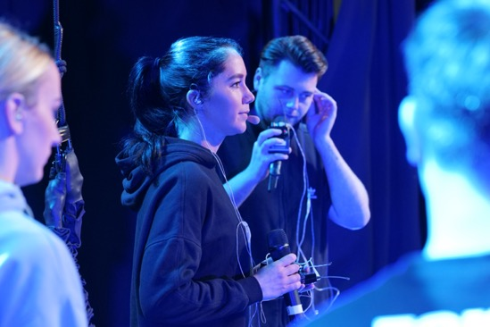

Looking into the near future, Sugg is enthusiastic about recruiting new team members to maintain the equipment and support Butlin’s resorts with its extensive events programme. “As a credible performance venue, we are keen to bring some fresh faces to our team who are interested in working with some of the industry’s best audio-visual solutions,” he states.

One of Sugg’s key objectives includes continuing developing close relationship with Sennheiser by offering in-house training with the audio manufacturer’s team.

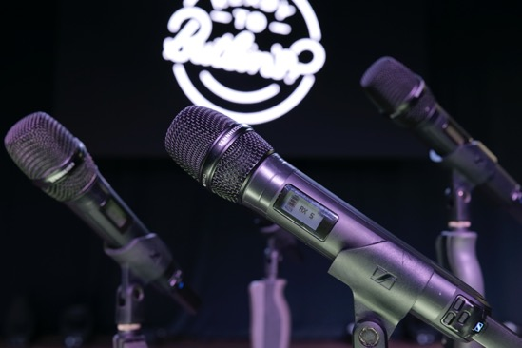 | As a credible performance venue, Butlin’s is keen to bring some fresh faces to its team who are interested in working with some of the industry’s best audio-visual solutions  (Picture credit: James Cumpsty)

"This will be incredibly valuable for our expanding team,” Sugg says. “Many of the team members we hire are starting their careers with Butlin’s, and it's fantastic that we can provide them with top-of-the-line equipment. Understanding the equipment and the manufacturers behind them is crucial and by working at Butlin’s you’re exposed to the best the industry has to offer.”

Having won a dealer award with Sennheiser for their excellent work on the on-going project at Butlin’s, Gwyther-Brown says that it is the efforts of Sound of Music’s team, as well as the close collaboration between all parties involved that has made this project a success.

“When the end-user, the dealer, the installer, and the manufacturer all work together, it leads to a much more efficient and productive workforce where everyone benefits,” Gwyther-Brown concludes. “As a company, we feel privileged to have such great relationships with both Sound of Music and Butlin’s, and we hope this collaboration will continue for many years to come.”

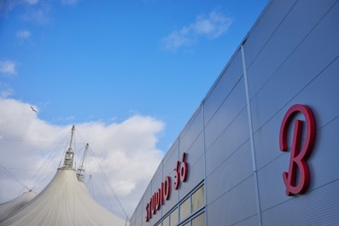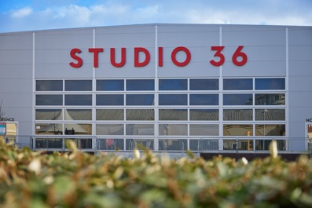
Kevin Gwyther-Brown [Business Development Manager - UK, Sennheiser] believes that “When the end-user, the dealer, the installer, and the manufacturer all work together, it leads to a much more efficient and productive workforce where everyone benefits.” (Pictures courtesy of Butlin’s)

About the Sennheiser Group

Building the future of audio and creating unique sound experiences for our customers - this is the aspiration that unites the employees of the Sennheiser Group worldwide. The independent family-owned company Sennheiser was founded in 1945. Today, it is managed in the third generation by Dr. Andreas Sennheiser and Daniel Sennheiser, and is one of the leading manufacturers in the field of professional audio technology. Within the Sennheiser Group are Georg Neumann GmbH (Berlin, Germany), manufacturer of studio-grade audio equipment; Dear Reality GmbH (Düsseldorf, Germany), known for its binaural, Ambisonics, and multichannel encoders with realistic room virtualization; and Merging Technologies SA (Puidoux, Switzerland), specialist in high-resolution digital audio recording systems.
sennheiser.com | neumann.com | dear-reality.com | merging.com

Local Pro Audio Press Contact
Maik Robbe
maik.robbe@sennheiser.com
+49 (5130) 600 – 1028

