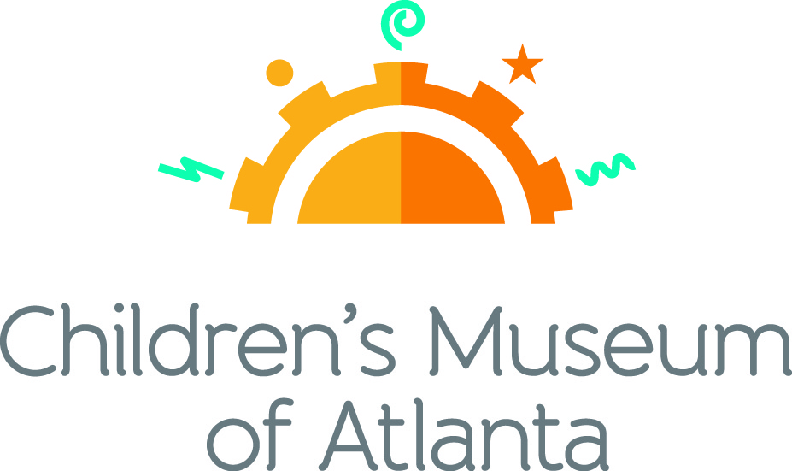

FOR MORE INFORMATION:
Becca Meyer/Jennifer Walker
BRAVE Public Relations, 404.233.3993
bmeyer@bravepublicrelations.com/
jwalker@bravepublicrelations.com

FOR IMMEDIATE RELEASE

Savor the final weeks of summer with Children’s Museum of Atlanta’s August programming
Families can celebrate music, friendship and Fido with special programs

ATLANTA (July 13, 2017) –The Children’s Museum of Atlanta invites families to keep the summer fun afloat with a month filled with sun-sational events. Little ones will have the opportunity to play with puppies, celebrate their besties, explore multi-sensory exhibits and dance along to silly songs while they soak up the last few weeks of the season!

Feature Exhibit: Blue Man Group – Making Waves
Through September 4, 2017
The national touring exhibit, supported by Harman/Becker Automotive Systems and created by the Boston Children’s Museum and Blue Man Group and powered by JBL®, will take the whole family through a multi-sensory exploration of sound that provides an opportunity for everyone to play together while discovering the fun of music. The 1,500 square foot exhibit features six interactive stations where children will have an opportunity to see, feel and create sound just like the Blue Man Group.

Themed daily programming during Blue Man Group – Making Waves exhibit will occur through September 4, 2017. Programming subject to change and may be altered during special events. All programs included with admission unless otherwise noted.

Mini-Musical: A Sound Connection
Weekdays at 11 a.m., noon and 2 p.m.; Saturday at 11 a.m. and 2 p.m.; Sunday at noon and 2 p.m.
Children will join robot W.A.V.E. and Caveperson Sonar on a journey through the Earie Canal to experience the wonder of sound by listening to animals in the wild and learning to dance like a sounds wave!

Story Time
Weekends at 1 p.m.
“Zoola Palooza: A Book of Homographs” by Gene Barretta
An exclusively animal musical group, Zoola Palooza is in town to teach little ones all about homographs – words that are spelled the same but pronounced differently and have separate meanings.

Music & Movement: Surround Sound
Weekdays at 1 p.m.; Saturday at 11 a.m. and 3 p.m.; Sunday at 11 a.m.
What sound is created when a stick crashes into a trash can? What happens when a pencil hits a coffee cup? Children can join the Imaginators in learning that sound is all around us when making music through found objects!

Super Spectacular Science Show
Weekdays at 3 p.m. and Weekends at 4 p.m.
Professor Lab Coat and his assistants will lead a mesmerizing science demonstration for the entire Museum.
Eat A Georgia Rainbow
Sunday at 3 p.m.
Children will embark on a scavenger hunt and cold cooking activity with the Imaginators to learn more about fruits and veggies harvested in Georgia throughout the year.
Art Studio Projects
Weekdays 10:30 a.m. –3:30 p.m.; Weekends 11 a.m. –4 p.m.
Little ones can discover colors and explore artists from around the world through various crafts like making and decorating a banjo, experimenting with powder paint, blow paint and splatter paint as well as creating a noise maker from recycled objects.
Build It Lab
Weekdays, 10:30 a.m. –3:30 p.m.; Weekends 11 a.m. –4 p.m.
Children will put their woodworking and creative tools to the test in this supervised space where they have access to real tools and materials. Encouraging inventions, this Build It Lab will spark creativity by allowing young innovators to build items such as a rain stick and drum.
Science Bar
Weekdays 10:30 a.m. –2:30 p.m.; Weekends 11 a.m. –3:30 p.m.
Science is everywhere, especially on the mezzanine at the Museum! Step Up to Science is the new STEM exhibit area and features interactive exhibits about light, robotics and how the human body works! Families can saddle up to the science bar for a full menu of fun activities, knowledge and have their questions turned into answers by one of the STEM educators.

August Special Programming

Friendship Days
Sunday, August 6 and Monday, August 7
Kick off National Friendship Day at Children’s Museum of Atlanta with family-friendly workshops that focus on the value of friendship. Continue the celebration on Monday with the Museum’s first annual Member Friends and Family Day when current Museum members can bring up to four friends to the event for FREE!
- Special Story Time
Sunday at 1 p.m.
The Rainbow Fish by Marcus Pfister shares the story of a beautiful fish that learns to make friends through sharing his most prized possessions.
- Special Music and Movement
Sunday at 11 a.m.; Monday at 1 p.m.
Children can hop over to the start line to compete in the three-legged race with the Imaginators and other friends. Little ones are invited to continue the fun by dancing along with friends to some groovy tunes!
- Special Mini Musical: Big Hearts
Sunday at noon and 2 p.m.; Monday at 11 a.m., noon and 2 p.m.
Kelly the Knuckle Cruncher loves to frighten other kids into handing over their toys and favorite lunchtime treats. Guests will take a journey with Auburn and her best friend Skipper as they navigate the ways to change the school bully’s heart and teach him how to be a friend.
- Art Studio
Sunday from 11 a.m. – 4 p.m.; Monday from 10:30 a.m. – 4:30 p.m.
Little ones can design a personalized puzzle to gift in honor of National Friendship Day!
- Build It Lab
Sunday from 11 a.m. – 4.p.m.; Monday from 10:30 a.m. – 4:30 p.m.
Children will construct a tic-tac-toe board using different types of wood and colored stones. When the board is complete, they can challenge a bestie to a friendly game!

Visiting Artist
Saturday, August 12
- Miss Gail and the Jumpin’ Jam Band
Noon
Little ones can wiggle, hop and sing along to Miss Gail and her Jumpin’ Jam Band’s silly songs. Created especially for children, their original songs help with early development to keep them moving throughout the performance.

Total Eclipse Takeover
Saturday, August 19 –Monday, August 21
In honor of the total solar eclipse that will be visible across the continental United States on Monday, August 21, children can learn more about the special event through dancing, special story times and more. As a special treat, kids 12 and under will receive solar eclipse glasses on Saturday and Sunday while supplies last!
- Special Story Time
Saturday and Sunday at 1 p.m.
Children can follow along as a charismatic cast of animals travel the path of the 2017 eclipse across the United States in The Big Eclipse by Nancy Coffelt, all while learning what causes eclipses, their strange effects, common myths and even what hippos do when day turns to night!
- Special Music and Movement: Glow in the Dark Dance Party
Saturday at 11 a.m. and 3 p.m.; Sunday at 11 a.m.; Monday at 1 p.m.
Kids can grab neon, glow in the dark accessories and join the Imaginators for a dance party featuring songs that are inspired by the sun and the moon!
- Super Spectacular Science Show
Saturday and Sunday at 4 p.m.; Monday at 3 p.m.
Every afternoon, Professor Labcoat shares a fascinating science demonstration with the whole museum! Families can join him to see what kind of fun he and his assistants have cooked up as they explain the total solar eclipse through science!
- Art Studio
Saturday and Sunday from 11 a.m. – 4 p.m.; Monday from 10:30 a.m. – 3:30 p.m.
Children will create and customize their very own spaceship to celebrate the eclipse!
- Build-It Lab
Saturday and Sunday from 11 a.m. – 4 p.m.; Monday from 10:30 a.m. – 3:30 p.m.
Little ones will construct a star using nails, wood and yarn to use as décor for the big day.

National Dog Day Celebration
Saturday, August 26
Dog lovers are in for a treat with a full day of face-licking, tail wagging puppy fun! Children’s Museum of Atlanta will host Canine Companions for Indepenence and their furry friends as they teach little ones about the importance of an assistance dogs’ voyage from puppy hood to hero! Please leave furry friends at home as no outside dogs are permitted in the Museum.
- From Puppy to Hero
Noon and 2 p.m.
Staff members and volunteers from Canine Companions for Independence will be at the museum to inform children about the journey dogs complete to become an assistance dog.
- Special Story Time
1 p.m.
Little Critter just got his very own puppy and can’t wait to teach him tricks, give him a bath and curl up with him at bedtime. A reading of Just Me and My Puppy by Mercer Mayer will teach children the responsibility of caring for a pet.
- Special Music and Movement: Who Let the Dogs Out
11 a.m. and 3 p.m.
Kids are invited to help the Imaginators investigate who let the dogs out as little ones search for clues to bring the puppies back safe and sound!
- Art Studio
11 a.m. – 4 p.m.
Children will get creative when they design a toy or exceptional accessory for their favorite stuffed animal dog!
- Build It Lab
11 a.m. – 4 p.m.
Little ones will construct and decorate a wooden dog leash holder exclusively for their adored pup!

For more information on the April program offerings or to support Children's Museum of Atlanta, visit childrensmuseumatlanta.org or call 404.659.KIDS [5437].

About Children’s Museum of Atlanta:
Children’s Museum of Atlanta is the only educational venue of its kind in Atlanta, presenting educational programs and exhibits designed for young children ages 0-8. The Museum’s mission is to spark imagination and inspire discovery and learning for all children through the power of play. With six permanent learning zones consisting of bright, creative and hands-on exhibits, the Museum supports inventive play-based exploration and experiential learning focused on the whole child. Core competencies for literacy, math and science are promoted throughout all exhibits and programming in alignment with the state and national Core Performance Standards. The Children’s Museum of Atlanta also offers parties, memberships, field trips, summer camp and private events. For more information or to support Children's Museum of Atlanta, visit childrensmuseumatlanta.org or call 404.659.KIDS [5437].

Museum Admission: General Admission is $15.95 (plus tax) for anyone 1 – 100 years old. Babies and members are admitted for free. All daily programs are included in price of admission. Group rates and military discounts are available. For more information regarding ticket and membership options, visit childrensmuseumatlanta.org/plan-your-visit/faqs/.

Museum Hours: Monday, Tuesday, Thursday and Friday 10:00 a.m. – 4:00 p.m.; Saturday and Sunday 10:00 a.m. – 5:00 p.m.; Closed on Wednesdays. Please check the Museum website to confirm hours of operation.

Facebook: https://www.facebook.com/childrensmuseumatlanta
Twitter: https://twitter.com/ChildMuseumATL
Instagram: https://www.instagram.com/childrensmuseumatlanta
Pinterest: http://pinterest.com/cmatlanta
###

