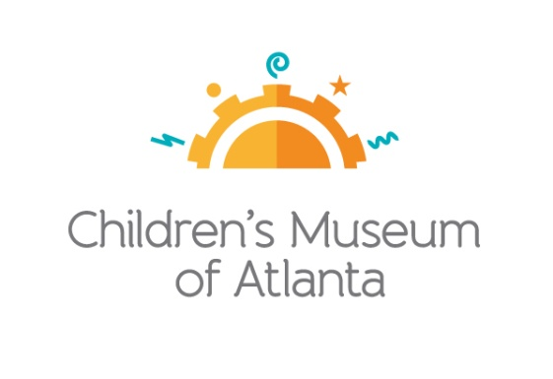

CONTACT
Alison Wentley
BRAVE Public Relations
404.233.3993
awentley@emailbrave.com

*MEDIA ADVISORY*
Family Free Day returns to Children’s Museum of Atlanta on Feb. 5
PNC Foundation, The Coca-Cola Foundation and CareSource fund kindness-themed day of learning

ATLANTA (January 22, 2020) –Families are invited to visit Children’s Museum of Atlanta free of charge during Family Free Day on Wednesday, Feb. 5. With programming centered around compassion and generosity, kids will have the opportunity to dance on stage with Mr. Greg’s Musical Madness, create cards for others with Open Hand Atlanta, learn how to help their community with Hands on Atlanta and more. Made possible by the support of the PNC Foundation, The Coca-Cola Foundation and CareSource, the three sessions will also offer the chance for kids to explore the Museum’s six permanent, interactive exhibits as well as Nickelodeon’s Teenage Mutant Ninja Turtles™: Secrets of the Sewer™, which will be featured at the Museum for a limited time, through May 10, 2020.
To guarantee entrance, families must pre-register online, beginning at 7 a.m. on Tuesday, Feb. 4 for Session One, Two or Three. Families may not register for multiple sessions.

WHAT: Family Free Days
Atlantans and their little ones are invited to experience a kindness-themed admission-free visit to the only educational venue of its kind in Atlanta

WHEN: Wednesday, Feb. 5
Session One: 10 a.m.-12:30 p.m.
Session Two: 1-3:30 p.m.
Session Three: 4-6:30 p.m.

WHERE: Children’s Museum of Atlanta
275 Centennial Olympic Park Drive, NW
Atlanta, GA 30313

HOW: For more information or to register, visit childrensmuseumatlanta.org/familyfreeday.

For more information or to support Children's Museum of Atlanta, visit childrensmuseumatlanta.org
or call 404.659.KIDS [5437]

###

