Panasonic teams up with Spider-Man: Homecoming
Zellik, 11 May 2017 - Panasonic Energy Europe announces that it is joining forces with the new Spider-Man: Homecoming movie in an exclusive European co-promotion campaign. As part of the agreement, Panasonic will organise an interactive online competition: whoever builds the biggest online web wins a city trip to New York.

Spider-Man welcomes winners to his hometown
To enter the competition, contestants sign up to start their digital web on spiderman.panasonic-batteries.com. Panasonic then encourages them to invite friends and family (via email or social media) to join – and by doing so expand – their web. The person who “catches” the most people in his/her web will win a city trip to New York for 4 people. Runners-up receive several fun Panasonic/Spider-Man: Homecoming-themed prizes.

In most European countries, the Spider-Man: Homecoming movie premiere is scheduled for 6 and 7 July 2017. The online competition will run from 8 May through 31 December 2017. Read more about the competition rules here.

Expanding the web
The competition is supported by a wide range of eye-catching POS materials to be used in stores in more than 30 European countries. All Panasonic/Spider-Man: Homecoming co-branded, attention-grabbing POS materials feature a dynamic image of the Spider-Man character alongside the Panasonic logo and images of Panasonic batteries, as well as a call to action for the competition and the movie.

Dedicated packs
Packaging for Panasonic batteries is also illustrated with the Spider-Man: Homecoming theme. Each pack features Spider-Man in an energetic pose (with his hometown of New York in the background) as well as the corresponding logos and an invitation to join the competition. Moreover, each Spider-Man: Homecoming-themed pack of Evolta, Pro Power and Everyday Power batteries comes with a special advantage of free batteries.

As is standard for all Panasonic battery packs, the basic principles for the design concept are customer convenience and transparency, which is shown in the clear communication on the product (size and quantity) and by depicting possible appliances to use the batteries for. Packs look both modern and dynamic, and there is a clear colour distinction between the different types.
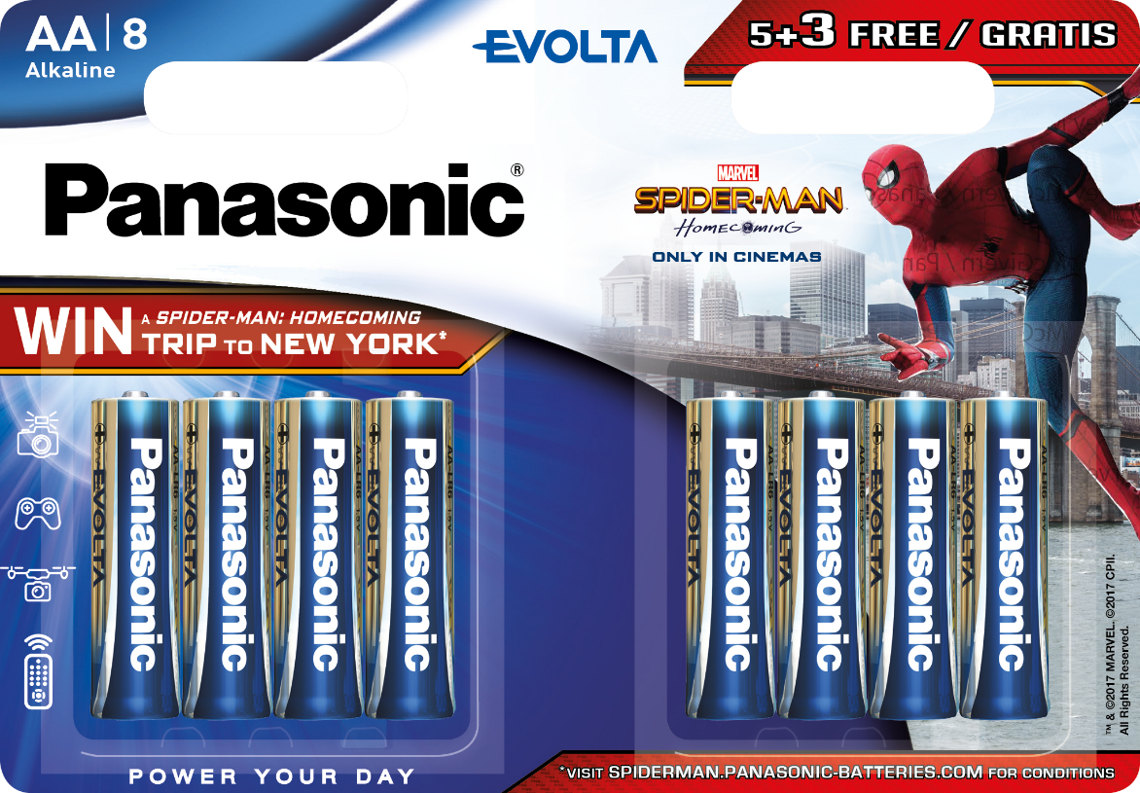

Both endowed with superpowers, it’s no surprise that Spider-Man is a perfect match for Panasonic batteries. The co-branding with the energetic hero helps Panasonic appeal to a wide audience and thus significantly increases consumer awareness of its extensive range of advanced battery solutions.

ABOUT PANASONIC ENERGY EUROPE
Panasonic Energy Europe is headquartered in Zellik, near Brussels, Belgium. The company is part of the Panasonic Corporation, a leading global manufacturer of electronic and electrical goods. Panasonic’s vast and lengthy experience in the consumer electronics field has helped make Panasonic the largest battery manufacturer in Europe today. The European production facilities are located in Tessenderlo, Belgium, and Gniezno, Poland. Panasonic Energy Europe supplies ‘mobile’ energy solutions to more than 30 European countries. The company’s diverse product range includes rechargeable, chargers, zinc carbon, alkaline and specialty batteries (such as zinc air, photo lithium, lithium coin, micro alkaline, silver oxide). For more information, visit: www.panasonic-batteries.com.

ABOUT PANASONIC
The Panasonic Corporation is a leading company worldwide in the development and manufacture of electronic goods for a wide range of private, trade and industrial uses. Panasonic, based in Osaka, Japan, in financial year ended 31 March 2015 posted consolidated net sales of around 57.28 billion EUR. Panasonic is committed to creating a better life and a better world, continuously contributing to the evolution of society and to the happiness of people around the globe.
More information about the company and the Panasonic brand name at www.panasonic.net.

ABOUT SONY PICTURES ENTERTAINMENT
Sony Pictures Entertainment (SPE) is a subsidiary of Sony Corporation of America, a subsidiary of Tokyo-based Sony Corporation. SPE's global operations encompass motion picture production and distribution; television production and distribution; home entertainment acquisition and distribution; a global channel network; digital content creation and distribution; operation of studio facilities; development of new entertainment products, services and technologies; and distribution of entertainment in more than 142 countries. For additional information, go to http://www.sonypictures.com.

ABOUT SPIDER-MAN: HOMECOMING
A young Peter Parker/Spider-Man (Tom Holland), who made his sensational debut in Captain America: Civil War, begins to navigate his newfound identity as the web-slinging super hero in Spider-Man: Homecoming. Thrilled by his experience with the Avengers, Peter returns home, where he lives with his Aunt May (Marisa Tomei), under the watchful eye of his new mentor Tony Stark (Robert Downey, Jr.). Peter tries to fall back into his normal daily routine – distracted by thoughts of proving himself to be more than just your friendly neighborhood Spider-Man – but when the Vulture (Michael Keaton) emerges as a new villain, everything that Peter holds most important will be threatened.

Spider-Man: Homecoming stars Tom Holland, Michael Keaton, Jon Favreau, Zendaya, Donald Glover, Tyne Daly with Marisa Tomei and Robert Downey Jr.

Spider-Man: Homecoming is directed by Jon Watts. The screenplay is by Jonathan Goldstein & John Francis Daley and Jon Watts & Christopher Ford and Chris McKenna & Erik Sommers, from a Screen Story by Jonathan Goldstein & John Francis Daley, based on the Marvel Comic Book by Stan Lee and Steve Ditko. The film is produced by Kevin Feige and Amy Pascal and executive produced by Louis D’Esposito, Victoria Alonso, Patricia Whitcher, Jeremy Latcham and Stan Lee.

PRESS CONTACT

ARK Communication
Ann-Sophie Cardoen
Content & PR Consultant
T +32 3 780 96 96

ann-sophie@ark.be
www.ark.be

Panasonic Energy Europe NV

Vicky Raman
Brand Marketing Manager
T +32 2 467 84 35
vicky.raman@eu.panasonic.com www.panasonic-batteries.com

