For more information, please contact Marta de Paco
On +34 670 780 664 or email press@comunicahair.com

Important:
These images are only available for editorial content.
Credits must be included.
Notification of their publication is expected.

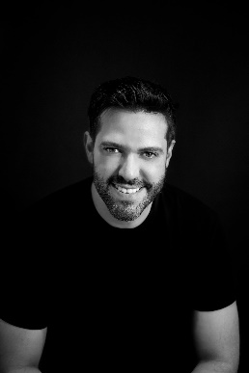
IVAN RODRÍGUEZ
MÉXICO
Warriors Collection

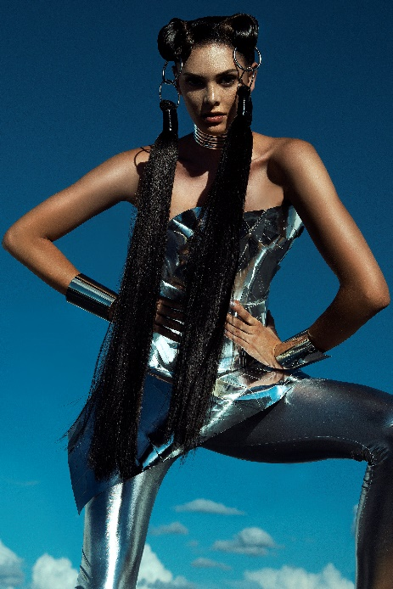
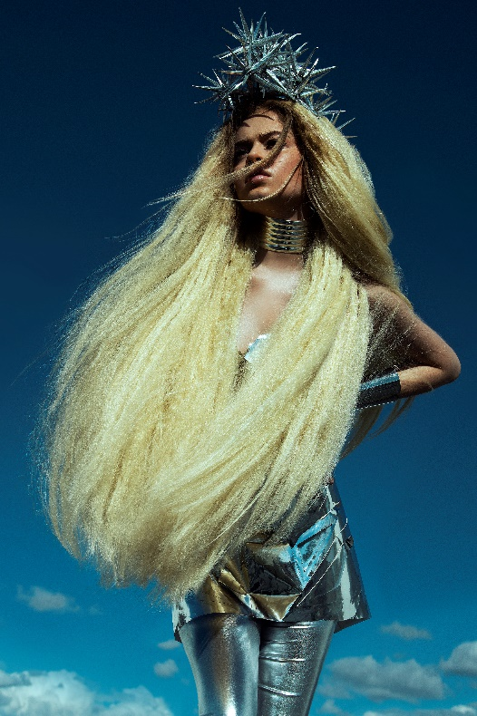
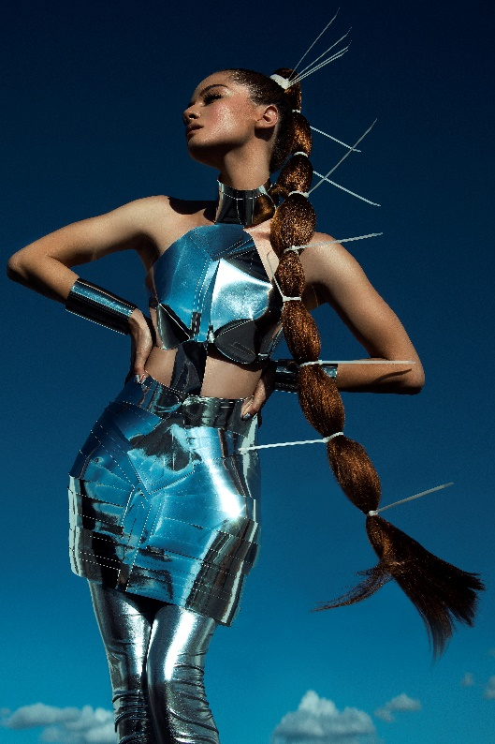
Hair: Ivan Rodríguez @ivanrohair
Photography: Jell Loya @jellloya
Make up: Thessa Peralta & Greg del Toro @thessaperalta_mua
Styling: Roberto de la Nuva

#ivanrohair #ivanrodriguezhairdresser

IVAN RODRÍGUEZ
MÉXICO
Warriors Collection

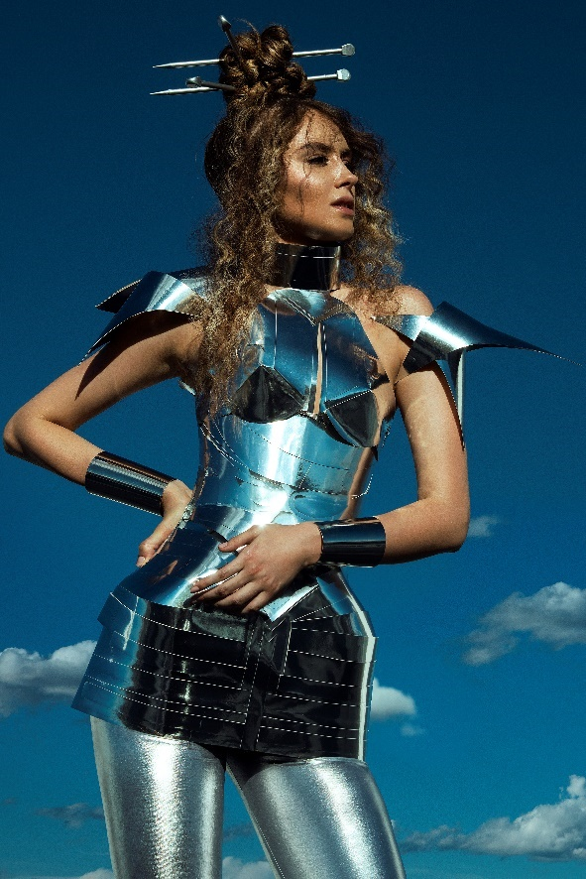

Future has a feminine outline, full of strength and power. Only through the awareness of this force can the powerful rise of these warriors be understood.
An exercise of confidence in themselves, knowing their victory and the prominence they already deserve. To prove it, they appear accompanied by sharp details, in a confident attitude and with long manes, like the scope of their power. The different updos blur the strength of their manes, but enhance their beauty even more.

