Embargoed until October 1, 2020, 10 a.m. CEST

Concentrated control

Special anniversary offers for the Sennheiser HMD 300 PRO and HMD 301 PRO broadcast and production headsets

Wedemark, October 1, 2020 – Sennheiser is adding broadcast products to its special anniversary deals: From October 1 through December 31, the HMD 300 and HMD 301 PRO broadcast and production headsets will be offered at a special price to celebrate the company’s 75th anniversary. Both models will be available as bundles complete with connection cable and clear nameplate(s) for personalization. Covering the most popular connector types in production environments, the HMD 300 PRO dual-sided headset will be available with either an XLR-3 and ¼” connector or a 4-pin female XLR. The single-sided HMD 301 PRO will be bundled with a 4-pin XLR-connector. These bundles will retail at EUR 249 (MSRP, instead of an MSRP of EUR 299, 388, and 358, respectively), saving you up to 36%. Please visit www.sennheiser.com/special-deals for a list of dealers offering this promotion.

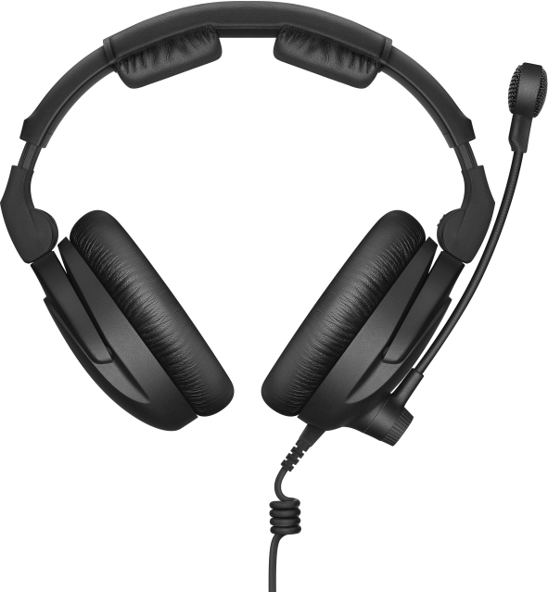 | 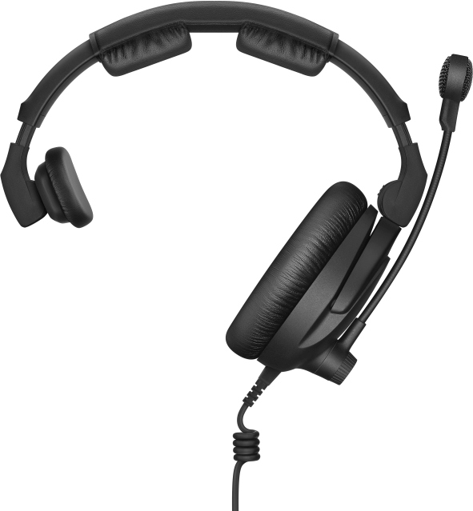 | Professional monitoring and communication with the Sennheiser 300 PRO series

Featuring everything important to pros
Whether it’s monitoring, camera operation or backstage communications, Sennheiser’s 300 PRO series has been fine-tuned to deliver precise and detailed sound reproduction, excellent shielding and outstanding comfort.

The closed, circumaural headsets are a pleasure to wear due to carefully selected padding material, a comfort zone for the temples of glasses and split headband padding that removes any pressure from the sensitive area of the fontanelle. Their special fork design ensures that the headphones’ contact pressure is evenly distributed over the entire ear pad, ensuring both increased comfort and excellent sealing against outside noise.

The headsets feature a noise-compensated, super-cardioid boom microphone for clear communications in loud production environments; their headbands are rugged, bendable and twistable.

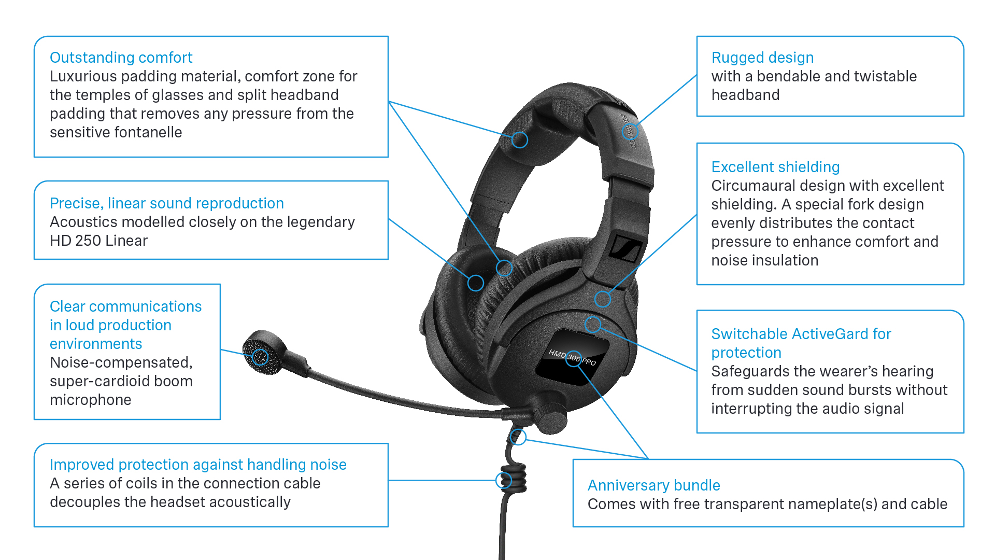

Safety in the workplace
The HMD 300 PRO headset is fitted with Sennheiser’s ActiveGard™ technology, which protects the wearer’s hearing from sudden sound bursts without interrupting the audio signal – an added safety feature that differs from traditional acoustic shock clipping circuitry. For European professionals, this ActiveGard™-equipped model supports you in fulfilling the EC’s directive on safety at the workplace.

Included in the bundle
The detachable cable included in each bundle offers improved protection against handling noise thanks to a small series of coils that acoustically decouple the cable from the headset. Transparent nameplates are included too for product customization.

(Ends)

The images accompanying this press release can be downloaded at https://sennheiser-brandzone.com/c/181/8H6NoRhR.

About Sennheiser
Founded in 1945, Sennheiser is celebrating its 75th anniversary this year. Shaping the future of audio and creating unique sound experiences for customers – this aim unites Sennheiser employees and partners worldwide. The independent family company, which is managed in the third generation by Dr. Andreas Sennheiser and Daniel Sennheiser, is today one of the world’s leading manufacturers of headphones, loudspeakers, microphones and wireless transmission systems. In 2019, the Sennheiser Group generated turnover totaling €756.7 million.
www.sennheiser.com

Global Press Contact

Stephanie Schmidt
Stephanie.schmidt@sennheiser.com
+49 (5130) 600 – 1275

