Gimlet Media Sets Standard for Podcast Production with Groundbreaking WSDG-Designed Facility
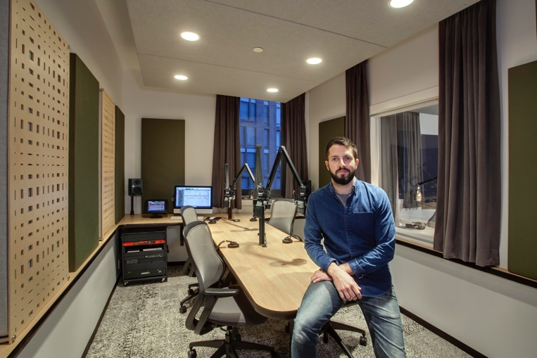
Brooklyn, NY – December 6, 2018 – According to recent statistics, more than a quarter of the population now listen to podcasts regularly, and that number is only increasing as the now 20-year old format takes hold of a new generation of media consumers. Brooklyn, NY-based Gimlet Media, the award-winning podcast production company behind hit podcasts like Reply All, Homecoming, and Science Vs, is setting a new standard in podcast creation with its new 28,000 square foot production facility based in downtown Brooklyn which opened on August 13, 2018.

Designed in tandem with the acoustic architectural firm WSDG (Walters-Storyk Design Group) — which is famous for its acoustic work on recording studios and performances spaces worldwide, the new facility catapults Gimlet’s podcasting operations from a modest studio operation to a commercial-grade, custom-built space which promises to take its content to the next level — from both a quality and efficiency perspective.

For Gimlet Technical Director Austin Thompson, this is a realization of what Gimlet has always strived to achieve: “The mission here is to be the best in class in podcasting,” Thompson says. “So when we outgrew our previous facility, I knew we had to get the best people we could get our hands on to design our new home.”

World Class Podcasting in Brooklyn
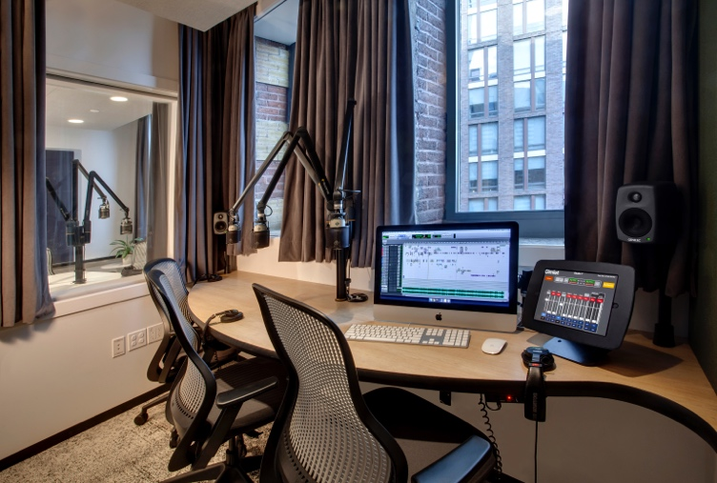
The new Brooklyn facility features no less than 12 podcast studios, custom designed for different production needs, with each aligning to a consistent sonic signature. The studios fit together in a honeycomb fashion, maximizing the use of the available space while providing supreme comfort and an abundance of natural light. “Gimlet’s needs grew very quickly,” says WSDG Project Manager Romina Larregina, who spearheaded the design. “When they started they had 30 people, and now they have over 100. Therefore, they required a space that not only allowed them to keep growing but remain on the cutting edge of what they wanted to accomplish.”

Each studio is outfitted with top of the line microphones and recording equipment, and all of the sound is routed digitally through a customized Q-SYS Platform, designed specifically for Gimlet’s unique needs by Thompson and Matt Gajowniczek of Chicago-based integrator SPL. This provides podcast producers with the ability to work in rooms specifically designed for their needs, taking advantage of state-of-the-art technological advances in soundproofing, digital recording, mixing, and monitoring.
License to thrill
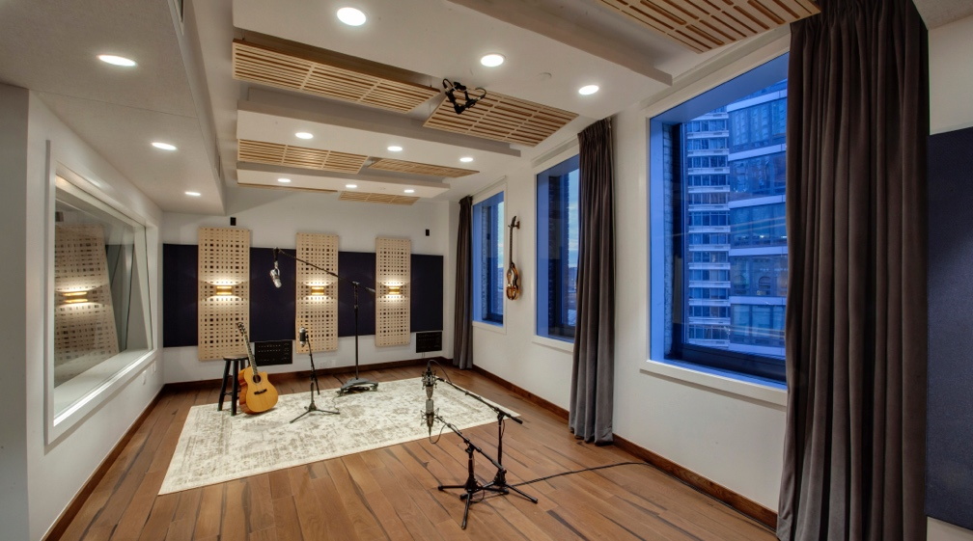
In addition to the specially designed podcast spaces, the production facility also boasts a traditional recording studio with additional soundproofing and a 375 square foot live room. The abundance of space allows ample room for unique needs – like Gimlet’s scripted fiction shows, while enabling in-house recording of music for their various podcasts. “Licensing music can get very expensive and good content is tough to find,” explains Thompson, “Having our own studio allows us to compose custom music at a larger scale.” Aside from efficiency and the embrace of a “self-op” approach to studio workflow, Thompson notes that the new technology allows producers to focus on telling great stories, while audio engineers focus on the creative sound design, mixing, and composition that takes the medium to the next level.

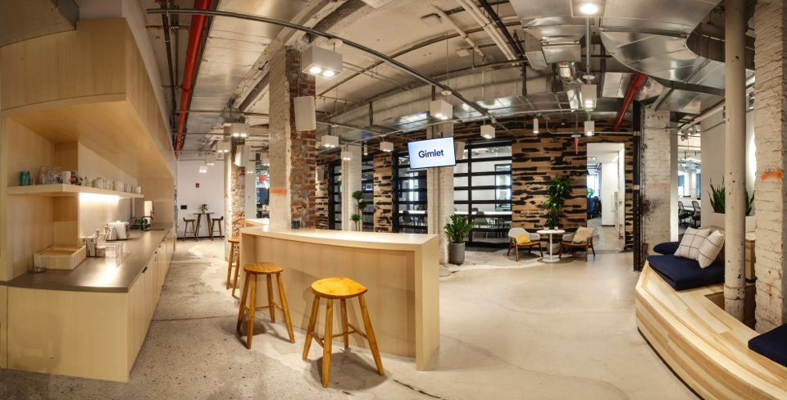
Gimlet’s new facility is a shining example of how podcasting has emerged into a mainstream media channel over the last two decades — a vast departure from its humble beginnings in the basements and garages around the U.S. With the new studios open since August and the recent coup of their podcast Homecoming being adapted to a television series on Amazon Prime, Gimlet has hit the ground running on new productions. “When you are able to work in a space like this, it’s hard not to get excited about what you are creating,” Thompson says.

For more information about Gimlet Media, please visit https://www.gimletmedia.com/

Photos:
- Gimlet Technical Director Austin Thompson in Gimlet’s Studio 3
- Gimlet’s Studio 7 - Another 3 person studio boasting exterior windows with tons of daylight (8 of 12 studios have exterior windows)
- Gimlet’s Studio 788 (Referred to as Studio A) Gimlet’s 375 sq/ft live room used for music production and complex projects that require more space and flexibility
- Gimlet’s Community Room - Entrance to the Gimlet space. This communal cafe / meeting space is outfitted with A/V distribution linked to 'The Garage’ (background) and is used for all-staff meetings

All photos credits to Cheryl Fleming Photography

ABOUT WSDG, LLC
For nearly 50 years WSDG has been designing media production facilities worldwide, over 3500, and counting. Projects range from Jimi Hendrix’s Electric Lady Studio and Jazz At Lincoln Center in New York, to broadcast facilities for The Food Network, CBS and WNET, over twenty teaching studios for The Art Institutes, and corporate clients such as Sony, IBM and Novartis. Recent credits include Jungle City in New York, The Church Studio, in London, private studios for Green Day, Jay-Z, Bruce Springsteen, Alicia Keys and Academy Award-nominated film composer Carter Burwell. WSDG has collaborated with such noted architects as Frank Gehry, Philippe Stark, Rafael Viñoly, Santiago Calatrava, Grimshaw, and Norman Foster. An eleven-time winner of the prestigious pro audio NAMM TEC Award for outstanding achievement in Acoustics/Facility Design, WSDG maintains U.S. offices in New York, Washington, DC, San Francisco and Miami and global offices in Barcelona, Basel, Berlin, Belo Horizonte, Buenos Aires, Guangzhou, Mexico City and Mumbai.

Contact:
Steve Bailey
Hummingbird Media, Inc.
+1 (508) 596-9321
steve@hummingbirdmedia.com

Jeff Touzeau
Hummingbird Media, Inc.
+1 (914) 602-2913
jeff@hummingbirdmedia.com

