Rapper & Producer Alexander Star Uses His Recording Skills & RME’s Babyface Pro Interface to Bring Musical Therapy to Miami-Area Troubled Youth
Star travels to juvenile detention centers and trauma treatment centers across Miami recording teen’s musical creations — offering them a creative outlet to work through trauma

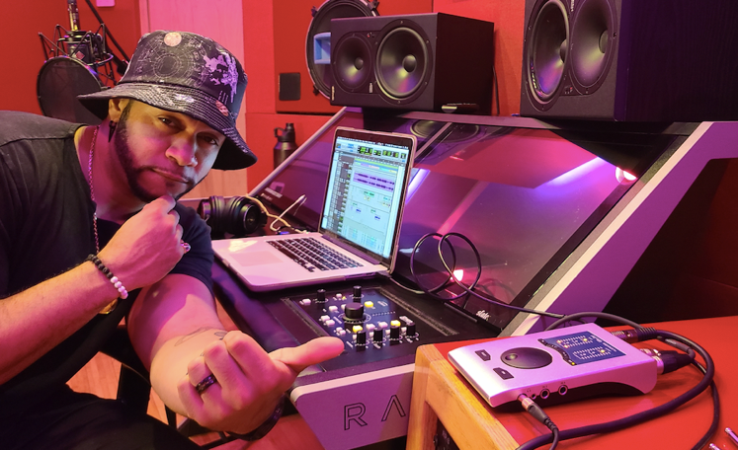
MIAMI, March 23, 2021 — Producer and impact artist Alexander Star has musical credits ranging from a Super Bowl LIV campaign for the NFL to a #1 rated French TV series to his recently released self-recorded album “Five Star General.” But he’s possibly most proud of his work with The Motivational Edge — a non-profit that empowers youth through the arts. Through Motivational Edge’s Lyrical Expression program, Star travels across the greater Miami area, working with teens who have experienced abuse or are spending time in juvenile detention centers and helps them express themselves through music. Thanks to the portability of his Babyface Pro USB audio interface, he is able to record the youth's musical creations on the spot, providing them with a project they can be proud to share with family and friends.
“I’ve worked with kids who've completely shut adults out due to what they've been through; and using music, a transparent and relatable language, I've gotten them to open up,” Star said. “I've recorded somewhere around 350–400 kids and helped them to not only tap into their creative side, but also unpack heavy baggage they've had on their minds but didn't quite know how to express. The Babyface Pro is a great companion for this kind of work because it fits right into my bag, and with a little mixing expertise on my end, I'm able to give these kids vocal recordings so crisp you'd think we made them in a $1 million studio. And hearing themselves back for the first time ever — on a radio-quality recording like the artists they look up to — immediately enhances the way these teens see themselves. It's a huge boost of much-needed self-confidence.”
For more on Alexander Star, visit alexanderstar.com
For more on RME, visit rme-usa.com

About Synthax, Incorporated
Synthax Inc. is the exclusive USA distributor for RME digital audio solutions, Digigram broadcast audio systems, Appsys digital audio tools, Ferrofish advanced audio applications, myMix personal monitoring systems and ALVA cableware. We supply a nationwide network of dealers with these products for professional audio, broadcast, music industry, commercial audio, theater, military and government applications. For additional information, visit the company online at http://www.synthax.com.

Media Contacts:
Katie Kailus
Public Relations
Hummingbird Media
+1 (630) 319-5226
katie@hummingbirdmedia.com

Jeff Touzeau
Public Relations
Hummingbird Media
+1 (914) 602 2913
jeff@hummingbirdmedia.com

