RME Holds Audio Networking Workshop at Westlake Pro in Hollywood
The workshop focused on “unraveling audio networking” and helped attendees discover which system best fits their application

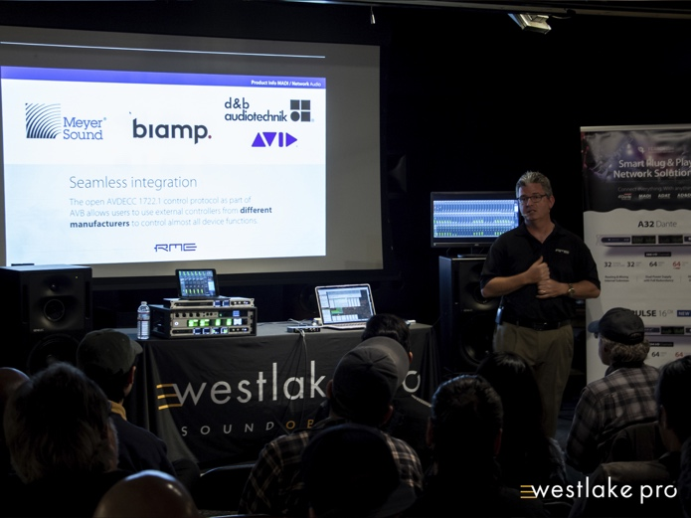
North Hollywood, California, March 11, 2019 – Premium German interface manufacturer RME held a workshop on the latest networking solutions at Westlake Pro in North Hollywood on Feb. 27 as part of the leading pro-audio retailer’s Sound Bites workshop series.
RME’s Derek Badala, who serves as Director of Sales for Synthax, RME and Ferrofish’s distributor, presented “Unraveling Audio Networking: An In-Depth Look at Dante, AVB and MAD” to a capacity crowd of 38 attendees discussing the advantages each system offers while explaining how to best employ them in a setup.
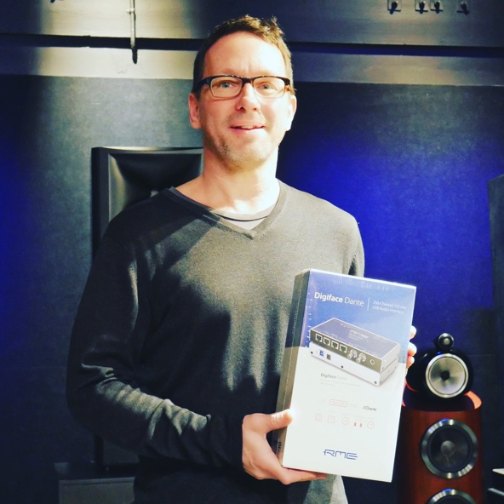
“RME is focusing on the future of audio which right now is centered around the latest in networking,” Badala said. “This workshop helped inform users on which system would work best for their application. And while these systems might be new to some, they offer a plethora of benefits such as easy operation and shorter setup times.”
AVIXA members also received two Certified Technology Specialist renewal units for attending.
‘Geared Up’ for Networking
During the workshop, attendee Don Barrett of Don Barrett Music was the giveaway winner, receiving a Digiface Dante audio interface of which was also on display during the workshop. Barrett said he attended the workshop to receive a solid primer on audio networking and get a professional take on the distinctive differences between Dante, AVB and MADI.
“The workshop skillfully — and painlessly — demystified the concept in an accessible way,” he said. “It was the perfect appetizer of the basics — which, in turn, was plenty to spark my own investigation of the more complicated nuts and bolts.”
Barrett continued, “The workshop left me thinking that audio networking is the future of single flow — at least for me — a composer with a modest project studio.”
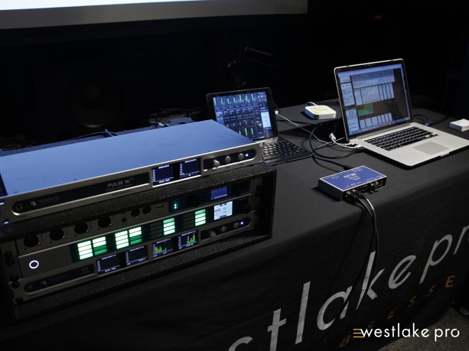
In addition to the Digiface Dante, RME also showcased the Digiface AVB audio interface along with the new M-32 Pro Series which includes the M-32 Pro AD and M-32 Pro DA, two high-end, 32-channel 192 kHz converters.
Also on display was the Ferrofish PULSE 16 DX, a Dante-compatible version of the company’s popular PULSE line of 16-channel, AD/DA, MADI and ADAT converters.
For more information on RME, visit http://www.rme-usa.com/
For more information on Ferrofish, visit https://ferrofish.com/en/
About Synthax, Incorporated
Synthax Inc. is the exclusive USA distributor for RME digital audio solutions, Ferrofish advanced audio applications, myMix audio products, and ALVA cableware. We supply a nationwide network of dealers with these products for professional audio, broadcast, music industry, commercial audio, theater, military and government applications. For additional information, visit the company online at http://www.synthax.com.

Media Contacts:
Katie Kailus
Public Relations
Hummingbird Media
+1 (630) 319-5226
katie@hummingbirdmedia.com

Jeff Touzeau
Public Relations
Hummingbird Media
+1 (914) 602 2913
jeff@hummingbirdmedia.com

