EMBARGOED UNTIL JUNE 3rd, 2022 @ 9a PDT
RME Unveils 12Mic with Dante at the NAMM 2022 Show
The newest generation in the Dante line-up, powered by Audinate’s Dante IP Core, is perfect for live sound, broadcast, install, and studios

NAMM 2022, Los Angeles, CA, June 3, 2022 — RME, the German manufacturer of premium digital audio solutions, debuts the 12Mic Dante as the latest pre-amp to RME’s Dante lineup at the 2022 NAMM Show. The new iteration incorporates a custom-built RME designed FPGA platform utilizing Audinate’s Dante IP Core, a solution that circumvents current and future chip shortages by eliminating the need for an Audinate Dante chip, assuring consistent production of the product. The highly flexible Dante solution will be on display at the RME booth #14704, in the ACC North Hall, during NAMM 2022.

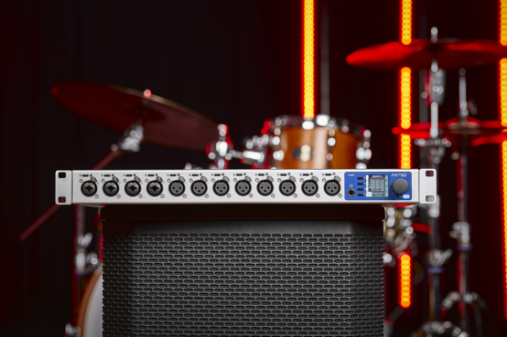
Custom-Built RME Platform
The 12MIC-Dante is a digitally controlled 12-channel mic preamp with no compromise AD-DA conversion as well as high channel density audio format conversion between Analog, MADI, Dante and ADAT. By including Audinate’s Dante IP Core on a custom-built RME FPGA platform, RME is not only delivering a highly flexible solution, but is one step closer to achieving a universal audio networking experience. The 12MIC-Dante offers 64x64 Dante I/O, 128x128 MADI I/O, 24 outputs of ADAT and a user assignable headphone monitoring output. Unlike the predecessor the 12MIC, introduced in 2020, the new 12MIC-D does not support AVB.

The 12Mic-D is RME’s response to the high demand of users who wanted to integrate the 12Mic into existing Dante systems. Visually, the 12Mic-D is almost identical to the 12Mic (128 AVB channels), with 12 analogue XLR inputs, with up to 75 dB gain and an exceptional signal-to-noise radio of over 120 dB(A) after AD conversion. The intuitive operating concept with front panel display allows users to check and configure the 12 channels directly on the unit, both individually and in groups. Both the 12MIC and 12MIC Dante will be available to customers depending on which audio networking format they choose—Dante or AVB.

Essential at Home or on Stage
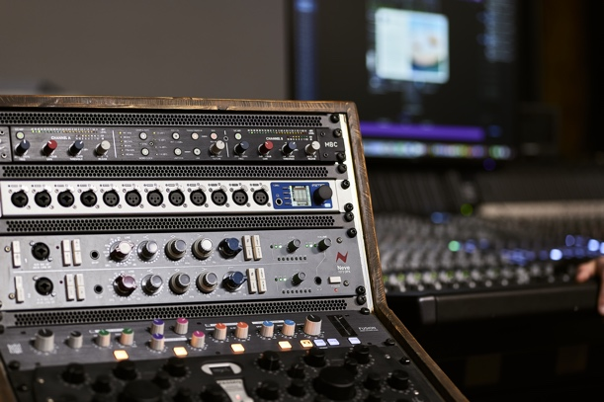
The fan-less RME 12Mic-D is a reliable solution that meets the highest professional demands on stage and in the studio. During product development, close attention was paid to important features for live applications. One key feature is the lockable front panel that offers ‘Dark Mode’, a new option to switch off all light elements. Also, two RJ-45 amplified network ports (with additional locking) were added to enable reliable and redundant transmission ensuring flawless compatibility within existing network infrastructures. The dual power supplies are also fully redundant (100-240 V AC, 12 V DC) while simultaneously providing an option for battery-powered mobile recording.
The 12MIC Dante features two types of remote control. Through web GUI, users control of all the internal functions including routing, metering, format conversion routings, and mic preamp settings. Whereas the stand-alone software REMOTE application is designed for Mic preamp control/metering and is accessed over the MADI port as is especially useful when controlling several 12MICs at one time.
“We are very excited to showcase the new 12MIC-Dante at this year’s NAMM show,” said Derek Badala, Director of Sales for Synthax, Americas. RME has always been in a unique market position because we operate in 3 of the most popular audio networking worlds…Dante, AVB, and MADI. Many of our customers trust RME technology for 24/7/365 operation and now with the addition of the 12MIC Dante, our customers can utilize a powerful mic pre on-ramp to their audio network. The 12MIC Dante incorporates 12 reference class mic preamps while also giving users the functionality of Dante<to>MADI<to>ADAT conversion all in a 1RU solution so this one solution can solve a lot of issues for both integrators and audio professionals alike.”
To Pre order the 12Mic-D and for additional information, please visit— rme-usa.com.
About Synthax, Incorporated
Synthax Inc. is the exclusive USA distributor for RME digital audio solutions, Digigram broadcast audio systems, Appsys digital audio tools, Ferrofish advanced audio applications, myMix personal monitoring systems and ALVA cableware. We supply a nationwide network of dealers with these products for professional audio, broadcast, music industry, commercial audio, theater, military and government applications. For additional information, visit the company online at http://www.synthax.com.

Media Contacts:
Shelby Coppola
Public Relations
Hummingbird Media
+1 (203) 598- 8167
shelby@hummingbirdmedia.com

Jeff Touzeau
Public Relations
Hummingbird Media
+1 (914) 602 2913
jeff@hummingbirdmedia.com

