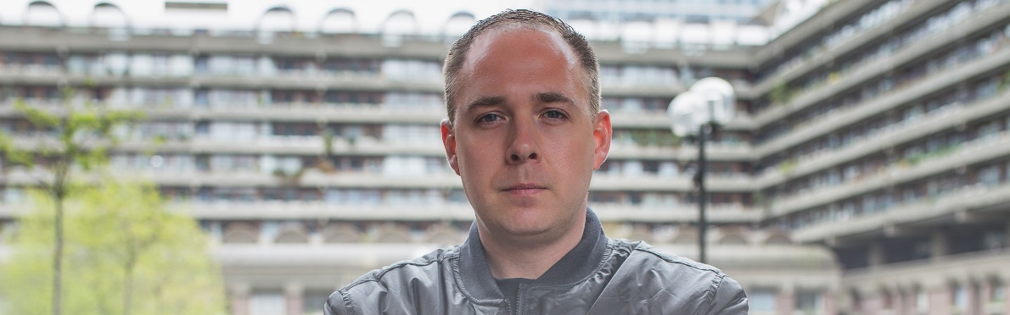#DontStopTheMusic
Sennheiser initiates a series of exclusive streaming concerts on Instagram: The concert series continues today, March 20, at 3 p.m. (EST) / 7 p.m. (GMT) with Logan D.

Wedemark/Germany, March 20, 2020 – Many artists have recently cancelled or postponed their live tours. In many countries around the globe, public life as we know it no longer takes place – and yet, now more than ever, the music must not stop! Therefore, Sennheiser is initiating a series of exclusive streaming concerts on the company’s Instagram account, which will be broadcasted via IGTV (Instagram TV). After kicking off yesterday, the concert series continues today, March 20, at 3 p.m. (EST) / 7 p.m. (GMT) with Drum & Bass DJ Logan D.

Further dates will be announced soon on http://www.sennheiser.com/anniversary. Beyond announcements of dates, the website contains numerous music videos with immersive recordings from jazz clubs, electro sets in a living room atmosphere as well as live recordings from recording studios. Just put on your headphones or turn up the speakers and dive into the music.

For your social media channels:
Exclusive concert with Logan D. (@logand1983) today, March 20, at 3 p.m. (EST) / 7 p.m. (GMT) as part of the new streaming concert series on IGTV by Sennheiser (@Sennheiser) – live from the UK. #DontStopTheMusic #TogetherAtHome
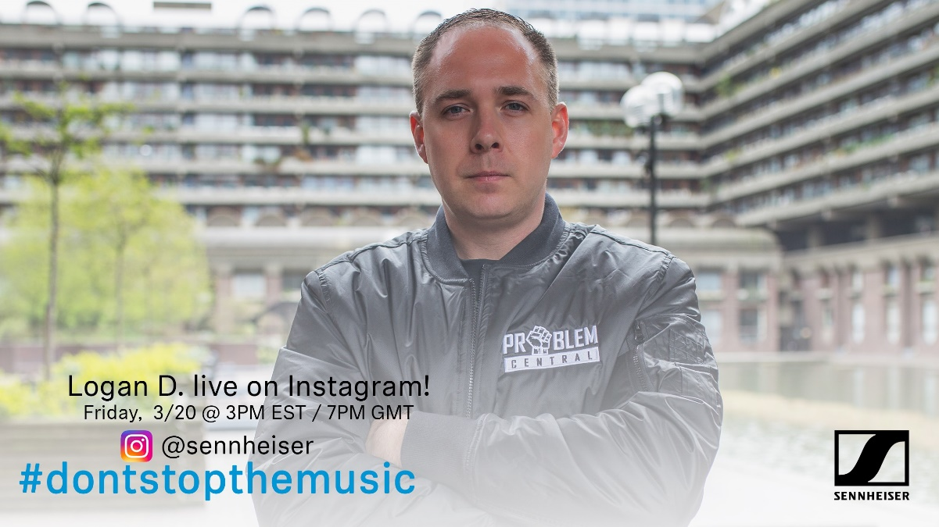

about Sennheiser
Founded in 1945, Sennheiser is celebrating its 75th anniversary this year. Shaping the future of audio and creating unique sound experiences for customers – this aim unites Sennheiser employees and partners worldwide. The independent family company, which is managed in the third generation by Dr. Andreas Sennheiser and Daniel Sennheiser, is today one of the world’s leading manufacturers of headphones, loudspeakers, microphones and wireless transmission systems. In 2018, the Sennheiser Group generated turnover totaling €710.7 million. www.sennheiser.com

Press Contact

Mareike Oer Stephanie Schmidt
mareike.oer@sennheiser.com stephanie.schmidt@sennheiser.com
T +49 0(5130) 600 – 1719 T +49 0(5130) 600 – 1275

