Neumann Receives Multiple Honors at NAMM 2026
Best of Show Award for VIS, U 47 fet inducted into the TECnology Hall of Fame, and U 87 named Microphone of the Year
ANAHEIM, January 26, 2026 – Neumann.Berlin is proud to announce several major honors received at this year’s NAMM Show. VIS, Neumann’s groundbreaking immersive mixing environment, has been awarded Future’s Best of Show Award, presented by Mix. In addition, the legendary U 47 fet microphone was inducted into the prestigious TECnology Hall of Fame, marking the tenth Neumann product to receive this distinction. Moreover, the U 87 has been selected as Microphone of the Year in the 33rd Annual Dealers Choice Awards.

VIS Honored with Future’s Best of Show Award
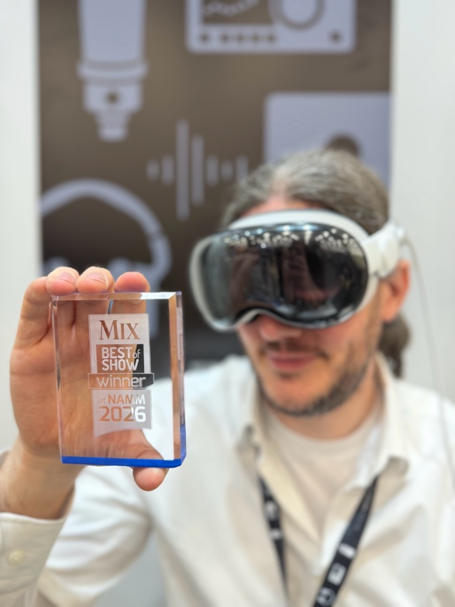
Developed by Neumann.Berlin, VIS – virtual Immersive Studio – represents a bold step into the future of immersive audio production. Leveraging Apple Vision Pro, VIS enables audio professionals to view and position sound sources freely within a spatial environment using natural hand gestures. The result is a new level of intuitive creative control, merging spatial computing with spatial audio in an unprecedented way.

“The products nominated for the Best of Show program provide an outstanding overview of new technology at the show and recognize the very best products and solutions on display,” stated the awards editorial team.
Future’s Best of Show Awards are judged by a panel of industry editors and experts, evaluating each entry on innovation, feature set, value, and contribution to the professional audio industry.

U 47 fet Enters the TECnology Hall of Fame
Neumann’s classic U 47 fet microphone was formally inducted into the TECnology Hall of Fame on January 22, 2026, in Anaheim. Neumann CEO Yasmine Riechers accepted the award on behalf of the entire Neumann team—past and present. This induction follows the M 49, which joined the Hall of Fame just two years earlier, further solidifying Neumann’s leadership in microphone innovation. With ten products now honored, Neumann is the most decorated manufacturer in the TECnology Hall of Fame’s history.

Originally introduced in 1972, the U 47 fet was designed as a solid state successor to the iconic tube based U 47. The adoption of FET technology enabled the microphone to withstand extreme sound pressure levels—up to 147 dB—making it a go to choice for loud singers, bass drums, guitar amps, and other high SPL applications. Its renowned K 47 capsule delivers a smooth, rich mid range with a subtle presence boost between 2–5 kHz, contributing to the microphone’s unmistakable sonic character.

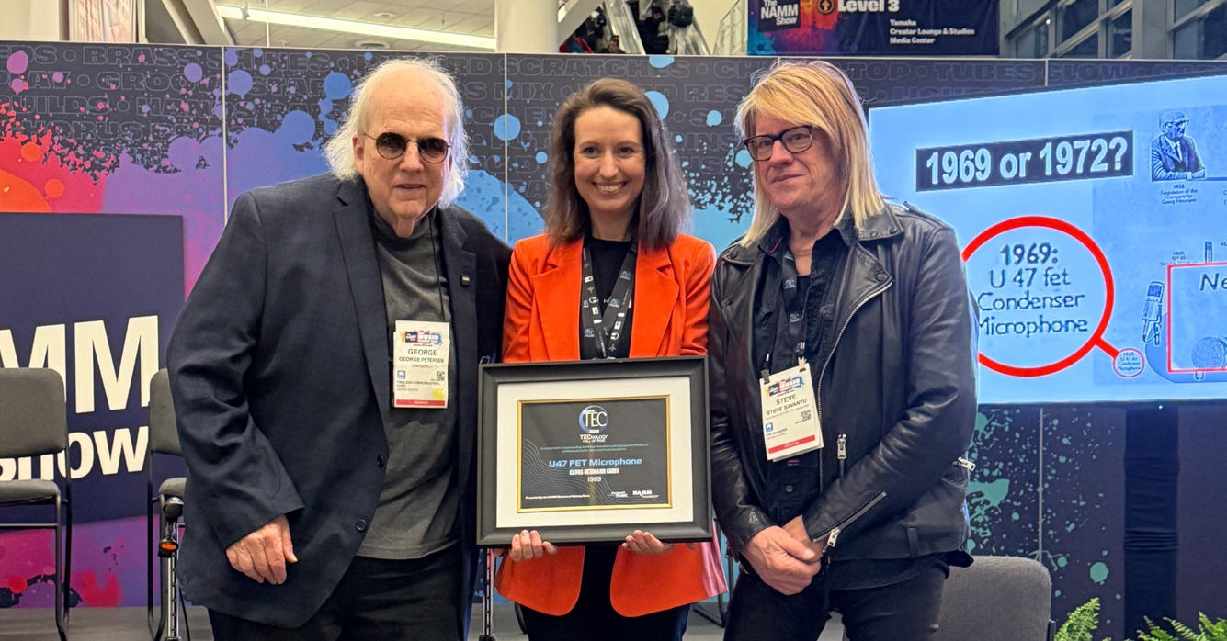

It is an exceptional honor to be recognized for both where we come from and where we are going,” commented Neumann CEO Yasmine Riechers, “At Neumann, tradition and pioneering are part of the same DNA. The U 47 fet was groundbreaking when it debuted in 1972 – so much so that we could reissue it in its original form in 2014. In the same pioneering spirit, VIS represents our bold vision for the future of immersive audio. Being celebrated for both is a powerful reminder that our legacy is alive not only in our history, but in every step we take forward.”

U 87 Named Microphone of the Year
Also at NAMM, the Neumann U 87 was honored as “Microphone of the Year” in the 33rd annual Dealer's Choice Awards presented by Musical Merchandise Review. “This award from the dealer community is no small feat, considering the U 87 was introduced in 1967 and updated only once, in 1986,” commented Product Manager Jorma Marquardt. “As a famous producer once said: ‘Get it right the first time, and don't change something that excites you’.“

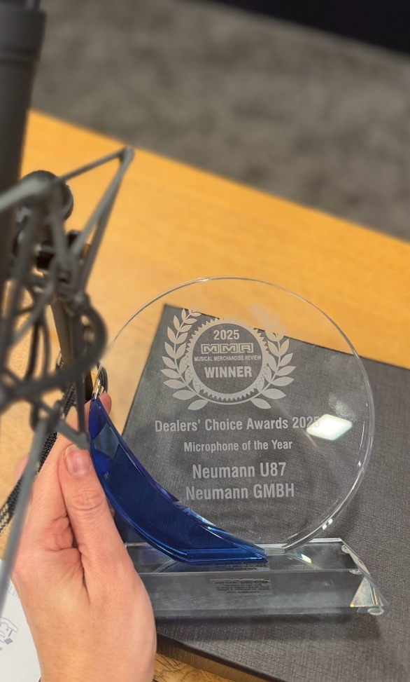
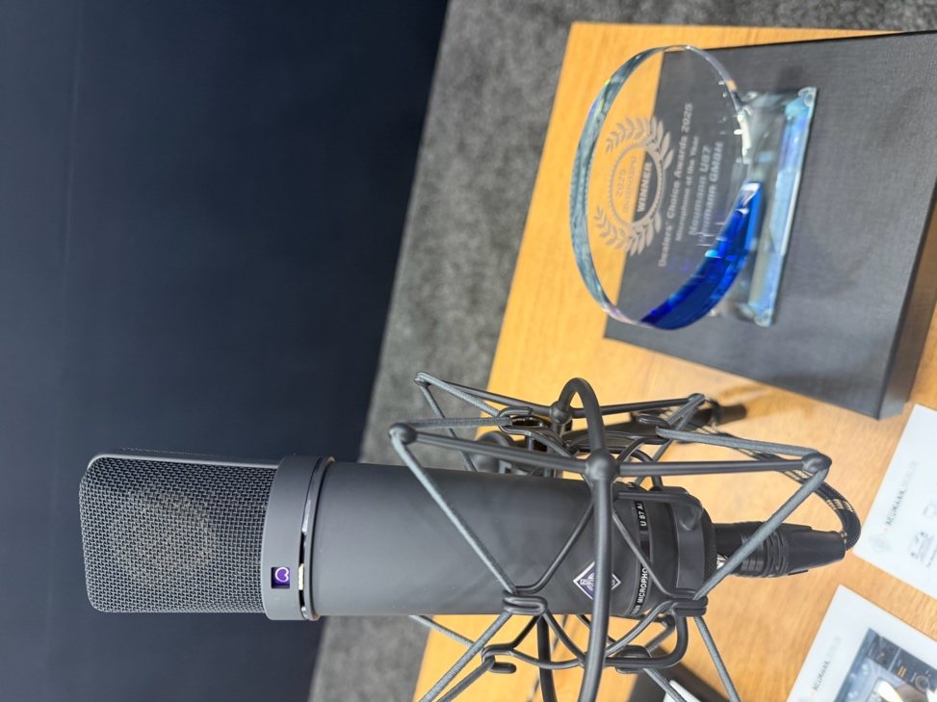

About Neumann
Georg Neumann GmbH, known as “Neumann.Berlin”, is one of the world’s leading manufacturers of studio-grade audio equipment and the creator of recording microphone legends such as the U 47, M 49, U 67, and U 87. Founded in 1928, the company has been recognized with numerous international awards for its technological innovations. Since 2010, Neumann.Berlin has expanded its expertise in electro-acoustic transducer design to also include the studio monitor market, building upon the legacy of the legendary loudspeaker innovator Klein + Hummel. The first Neumann studio headphones were introduced in 2019, and since 2022, the company has increased its focus on reference solutions for live audio. With the introduction of the first audio interface MT 48, and its revolutionary converter technology, Neumann now offers all the necessary technologies needed to capture and deliver sound at the highest level. Georg Neumann GmbH has been part of the Sennheiser Group since 1991 and is represented worldwide by the Sennheiser network of subsidiaries and long-standing trading partners. www.neumann.com
Stay up to date and follow us on: FACEBOOK I INSTAGRAM I YOUTUBE

Press Contact Neumann:
Raphael Tschernuth
raphael.tschernuth@neumann.com
+49 (030) 41772467

